**­**

**Chapter-8**

**Testing**

**5.1 Test Schedule**

**Module 1: Customer Registration**

|  |  |  |  |
| --- | --- | --- | --- |
| **Test Script** | **Description** | **Date** | **Tester** |
| 1.1 | Customer would have their ID automatically | 13 Jun 2017 | AYE CHAN NAING MAR LAR |
| 1.2 | Customer is not allowed to skip to fill in the **Name** **field** | 13 Jun 2017 | AYE CHAN NAING MAR LAR |
| 1.3 | Customer is not allowed to skip to fill in the **NRC** **field** | 13 Jun 2017 | AYE CHAN NAING MAR LAR |
| 1.4 | Customer is not allowed to skip to fill in the **Email** **field** | 13 Jun 2017 | AYE CHAN NAING MAR LAR |
| 1.5 | Email must be in **email format** | 13 Jun 2017 | AYE CHAN NAING MAR LAR |
| 1.6 | Customer is not allowed to skip to fill in the **Password** **field** | 13 Jun 2017 | AYE CHAN NAING MAR LAR |
| 1.7 | Customer is not allowed to skip to fill in the **Retype Password** **field** | 13 Jun 2017 | AYE CHAN NAING MAR LAR |
| 1.8 | **Password** and **Retype Password** must match | 13 Jun 2017 | AYE CHAN NAING MAR LAR |
| 1.9 | Customer is not allowed to skip to fill in the **Phone** **field** | 13 Jun 2017 | AYE CHAN NAING MAR LAR |
| 1.10 | Customer is not allowed to skip to fill in the **Address** **field** | 13 Jun 2017 | AYE CHAN NAING MAR LAR |
| 1.11 | A customer is not allowed to register twice | 13 Jun 2017 | AYE CHAN NAING MAR LAR |
| 1.12 | All information will be saved properly in customer table in database when **Register** button is clicked | 13 Jun 2017 | AYE CHAN NAING MAR LAR |
| 1.13 | All of filled fields will be empty when **Clear** button is clicked | 13 Jun 2017 | AYE CHAN NAING MAR LAR |
| 1.14 | Customer will get to login form when he/she click **Login** button | 13 Jun 2017 | AYE CHAN NAING MAR LAR |

**Module 2: Customer Login**

|  |  |  |  |
| --- | --- | --- | --- |
| **Test Script** | **Description** | **Date** | **Tester** |
| 2.1 | Customer is not allowed to skip to in the **Email** field | 13 Jun 2017 | AYE CHAN NAING MAR LAR |
| 2.2 | Email must be in **Email format** | 13 Jun 2017 | AYE CHAN NAING MAR LAR |
| 2.3 | Customer is not allowed to skip to fill in **Password** field | 13 Jun 2017 | AYE CHAN NAING MAR LAR |
| 2.4 | Clicking login button without filling any fields is not allowed | 13 Jun 2017 | AYE CHAN NAING MAR LAR |
| 2.5 | Customer cannot login when his account has not been registered yet | 13 Jun 2017 | AYE CHAN NAING MAR LAR |
| 2.6 | All filled information will be clear when **Clear** button is clicked | 13 Jun 2017 | AYE CHAN NAING MAR LAR |
| 2.7 | Customer will get to Registration form when he/she click **Register** button | 13 Jun 2017 | AYE CHAN NAING MAR LAR |
| 2.8 | Customer will get to **Display** page once he/she login | 13 Jun 2017 | AYE CHAN NAING MAR LAR |

**Test Script**

|  |  |  |  |  |
| --- | --- | --- | --- | --- |
| Unit Test 1 | | Test Case: Data entry for customer registration | Designed by:  AYE CHAN­ NAING MAR LAR | |
| Data Source: Customer Registration Form | | Objective: To make sure that customer registration form works properly. | Tester: AYE CHAN NAING MAR LAR | |
| Test Case | Description | Test Procedure | Expected Result | Actual Results |
| 1.1 | Customer would have their ID automatically | **CustomerID** field would not be shown. But fill the rest fields in customer registration form. Then click **Register** button and check the ID field in database. | Customer will own an ID automatically. | See Fig 1.1 and 1.2 |

Before Testing

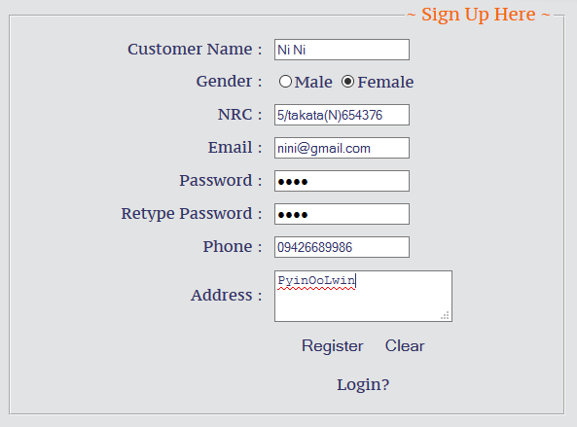

Fig (1.1)

After Testing

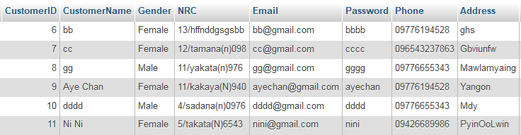

Fig (1.2)

|  |  |  |  |  |
| --- | --- | --- | --- | --- |
| Test Case | Description | Test Procedure | Expected Result | Actual Result |
| 1.2 | Customer is not allowed to skip to fill in **Name field** | Fill other fields except Name field and click register button | Alarm that Name field must not be empty. | See Fig 1.1 and 1.2 |

Before Testing

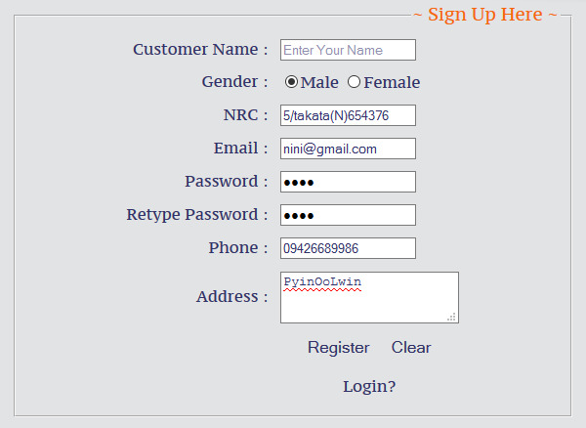

Fig (1.1)

After Testing

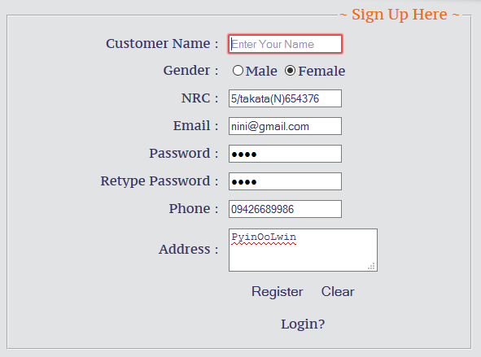

Fig (1.2)