Minimum Wages and Employment
A Replication of Card and Krueger (1994), American Economic Review 84(4), 772–793 — Empirical Report
1. Research Question and Motivation
Does raising the minimum wage reduce employment? This is one of the most contested questions in labor economics. The standard competitive model of the labor market predicts that a binding minimum wage raises the price of low-skilled labor above its market-clearing level and therefore lowers the quantity of low-skilled labor that firms demand. Yet the empirical evidence has long been ambiguous: time-series and aggregate cross-state studies produced a wide range of estimates, and their credibility was weakened by the difficulty of separating the effect of the minimum wage from other macroeconomic changes.
Card and Krueger (1994) address this question with a clean natural experiment. On April 1, 1992, New Jersey raised its state minimum wage from $4.25 to $5.05 per hour — an increase of about 18.8 percent — while the neighboring state of Pennsylvania left its minimum wage unchanged at the federal level of $4.25. The rise in the minimum wage occurred during a recession. The increase had been legislated two years earlier when the state economy was relatively healthy. By the time of the actual increase, the unemployment rate in New Jersey had risen substantially and last-minute political action almost succeeded in reducing the minimum-wage increase. It is unlikely that the effects of the higher minimum wage were obscured by a rising tide of general economic conditions. And because the two states are contiguous and economically similar, fast-food restaurants in eastern Pennsylvania provide a natural control group for fast-food restaurants in New Jersey. The policy change, together with a purpose-built store-level survey conducted before and after the increase, constitutes a difference-in-differences design.
The study focuses on the fast-food industry because it is an intensive user of minimum-wage labor: if a minimum-wage increase depresses employment anywhere, the effect should be visible among fast-food restaurants. The paper's headline finding — that employment in New Jersey did not fall relative to Pennsylvania, and if anything rose slightly — challenged the textbook prediction and became one of the most influential empirical results in the minimum-wage debate, motivating a large subsequent literature (including Card and Krueger 1995 and the later reanalysis by Neumark and Wascher 2000).
2. Data Sources, Sample Construction, and Variable Definitions
2.1 Data source
The replication uses the public-use version of the survey data collected by Card and Krueger. In the first half of 1992 they conducted a telephone survey of fast-food restaurants in New Jersey and eastern Pennsylvania, restricted to four chains — Burger King, KFC, Roy Rogers, and Wendy's. The full sample contains 410 restaurants, of which 331 are in New Jersey and 79 in Pennsylvania. The survey has two waves: wave 1 (February–March 1992), conducted before the April 1 minimum-wage increase, and wave 2 (November–December 1992), conducted after. The public dataset (public.csv) is used throughout this replication.
2.2 Sample construction
The main outcome is full-time-equivalent (FTE) employment, constructed exactly as in the paper:
FTE = full-time employees + managers + 0.5 × part-time employees.
Each manager is counted as one full-time worker and each part-time worker as half. For wave 2, employment at permanently closed stores is set to zero, while employment at temporarily closed stores (closed for renovation, highway construction, or fire) is treated as missing. The regression sample for the reduced-form models (Table 4) consists of the 357 stores with non-missing wave-1 and wave-2 employment, non-missing wave-1 starting wage, and either a non-missing wave-2 starting wage or permanent closure.
2.3 Variable definitions
The key variables are defined as follows:
Employment outcome: the change in FTE employment between the two waves, ΔFTE = FTE2 − FTE1.
Starting wage: WAGE_ST (wave 1) and WAGE_ST2 (wave 2).
Wage gap (GAP): the proportional increase in the starting wage required to reach the new minimum, (5.05 − WAGE_ST)/WAGE_ST for New Jersey stores with WAGE_ST < 5.05, and zero otherwise.
State indicator: NJ = 1 for New Jersey and 0 for Pennsylvania.
Chain dummies: CHAIN ∈ {Burger King, KFC, Roy Rogers, Wendy's}.
Company ownership: CO_OWNED, equal to one for company-owned stores.
Region dummies: three regions of New Jersey (North, Central, and South) and two regions of eastern Pennsylvania (PA1, the northern Philadelphia suburbs, and PA2, Easton).
Other controls: price of a full meal (soda + fries + entrée), hours open on a weekday, the percentage of full-time employees, and the recruiting bonus.
3. Empirical Design
The central design is a difference-in-differences (DID) comparison of the change in FTE employment between New Jersey (the treatment group) and Pennsylvania (the control group). The DID estimate is the difference between the mean employment change in New Jersey and the mean employment change in Pennsylvania. The identifying assumption is parallel trends: in the absence of the minimum-wage increase, employment in the two states would have evolved identically.
The paper also estimates a sequence of reduced-form regressions for the change in employment, progressively adding controls:
(i) ΔFTE on the New Jersey dummy;
(ii) (i) plus chain and company-ownership controls;
(iii) ΔFTE on the wage gap (GAP);
(iv) (iii) plus chain and company-ownership controls;
(v) (iv) plus region controls — the preferred specification.
The wage-gap specifications exploit variation within New Jersey in the size of the mandated wage increase: stores that were already paying at or above $5.05 faced no increase (GAP = 0), while stores paying $4.25 faced the full 18.8 percent increase. Figure 1 provides visual evidence of the policy's “first stage”: between February and November 1992 the New Jersey starting-wage distribution shifted sharply toward the new $5.05 minimum.
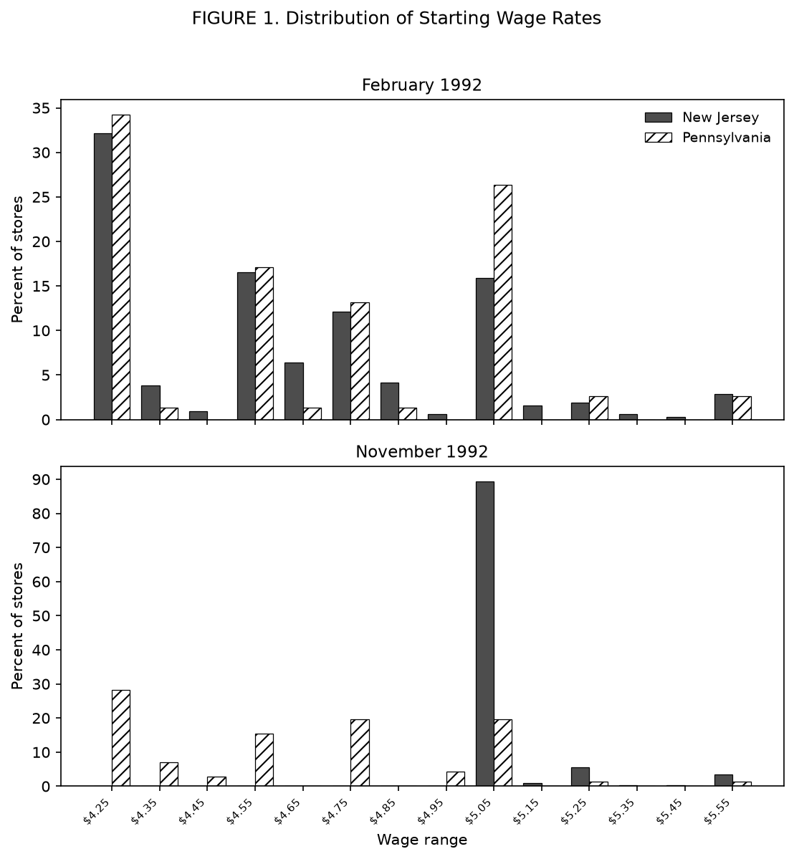
Figure 1. Distribution of starting wage rates, February and November 1992 (New Jersey vs. Pennsylvania).
4. Core Replication Results and Comparison with the Original Paper
This section reports the replication of the paper's three main tables and compares each with the published figures. The tables below are the three-line tables produced directly by the replication pipeline (output/three_line_tables/).
4.1 Table 2 — Means of Selected Outcome Variables
Table 2 reports the mean and standard error of the main outcome variables separately for New Jersey and Pennsylvania stores. The replication reproduces the paper closely. The distribution of store types is essentially identical (for example, Burger King accounts for 41.1 percent of New Jersey stores and 44.3 percent of Pennsylvania stores). In wave 1 the two states are broadly similar: mean FTE employment is 20.44 in New Jersey and 23.33 in Pennsylvania, and the mean starting wage is 4.61 versus 4.63. The main change between waves is the treatment itself: by wave 2 the mean New Jersey starting wage has risen to 5.08, and 85.5 percent of New Jersey stores report a starting wage of exactly $5.05 (the new minimum), compared with 1.3 percent in Pennsylvania (the paper reports 85.2 percent).
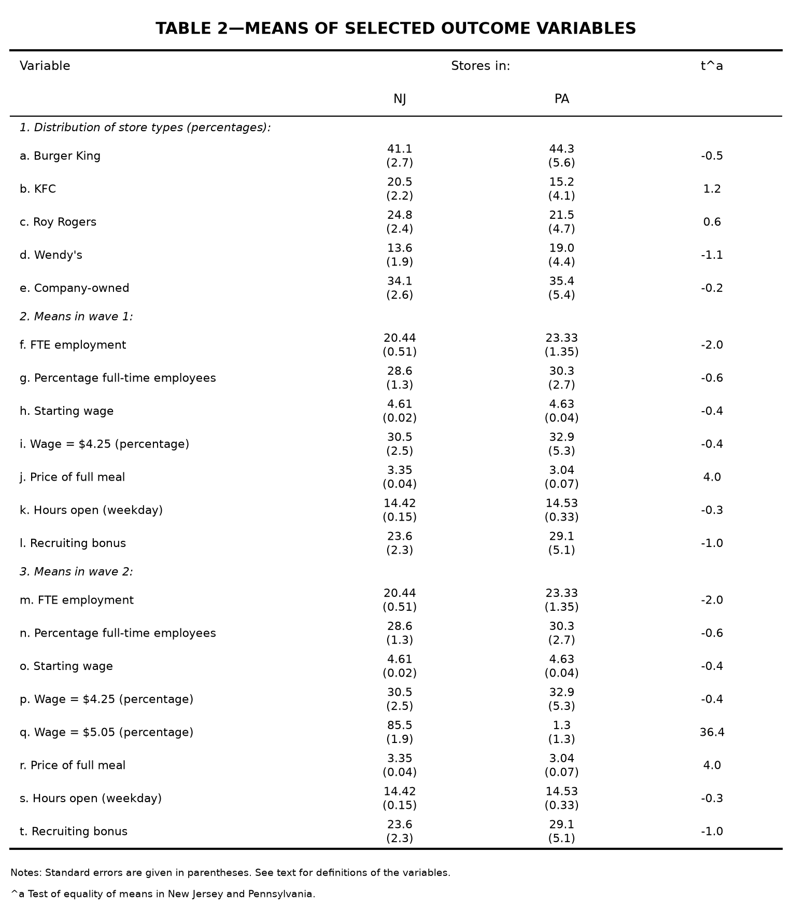
Table 2 (replication). Means of selected outcome variables.
The percentage of full-time employees differs systematically (28.6 versus 32.8 in wave 1 New Jersey), while the associated standard errors match. This is a data-version difference: the public-use file splits full- and part-time employees differently from the authors' original data, but the FTE total — the outcome of interest — is unaffected, so the difference does not carry over to the employment results.
4.2 Table 3 — Average Employment per Store Before and After
Table 3 reports mean FTE employment before and after the minimum-wage increase and the resulting difference-in-differences estimates. Row 3 is the central comparison: mean FTE employment rose by 0.59 in New Jersey and fell by 2.17 in Pennsylvania, giving a difference-in-differences estimate of 2.75 (standard error 1.36). The paper reports 2.76 (1.36). The estimate is positive and statistically insignificant, so there is no evidence that the minimum-wage increase reduced employment; if anything, employment in New Jersey rose relative to Pennsylvania. The balanced-sample and temporarily-closed-set-to-zero variants (rows 4 and 5) give the same qualitative result (2.75 and 2.51). Within New Jersey, low-wage stores ($4.25) grew relative to high-wage stores (≥ $5.00): the low–high difference is 3.36 (1.48) and the mid–high difference is 2.91 (1.41), the latter matching the paper exactly.
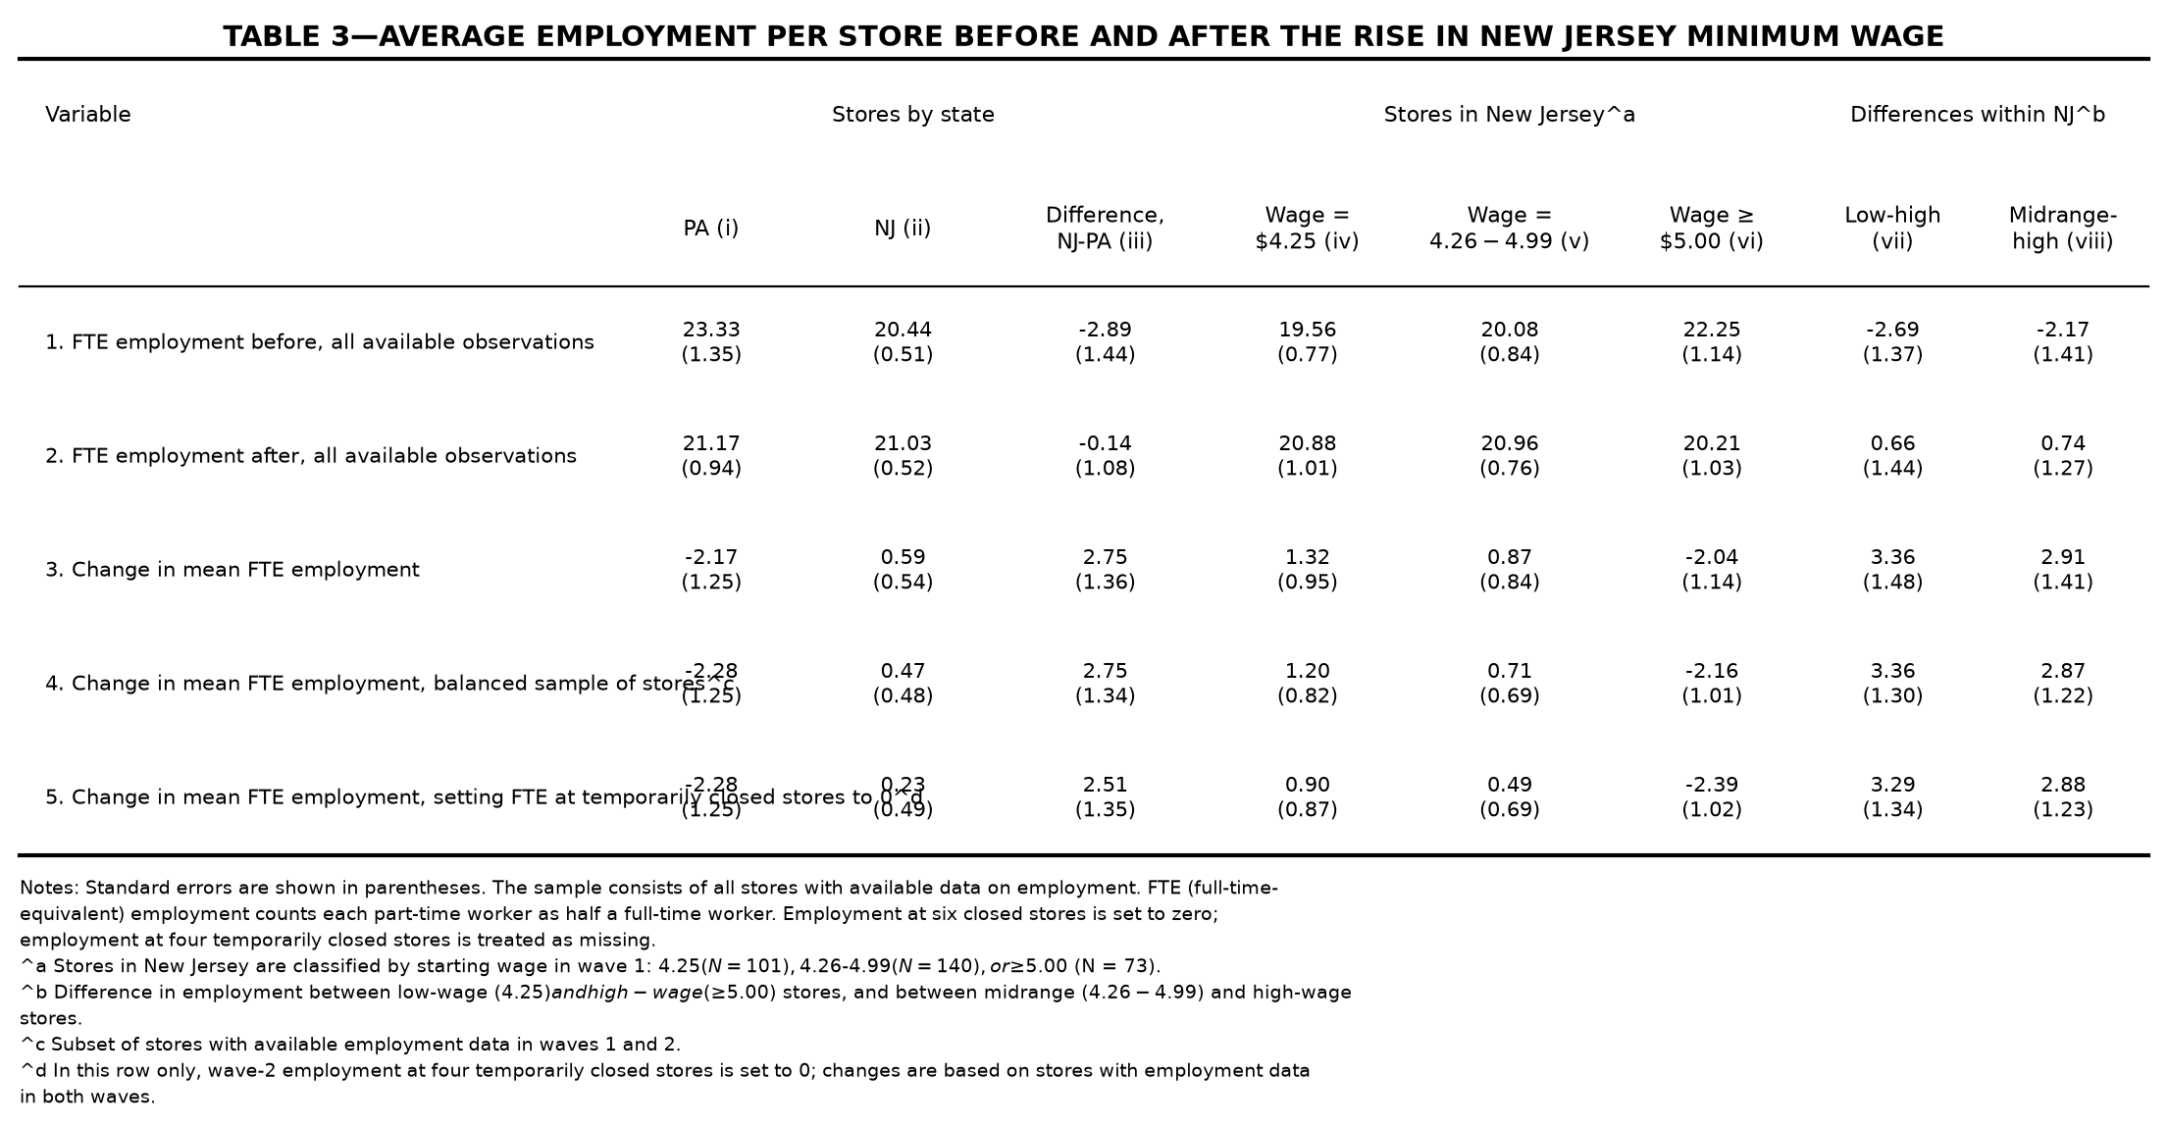
Table 3 (replication). Average employment per store before and after the rise in New Jersey minimum wage.
The remaining 0.01 difference in the difference-in-differences estimate (2.75 versus 2.76) is attributable to the data version.
4.3 Table 4 — Reduced-Form Models for Change in Employment
Table 4 reports reduced-form regressions of the change in FTE employment on the state dummy or the wage gap, with progressively richer controls. The sample contains 357 stores, and the dependent variable has mean −0.238 and standard deviation 8.825 (the paper: −0.237 and 8.825). Models (i)–(iv) reproduce the paper exactly to two decimal places: the New Jersey dummy is 2.33 (1.19) in model (i) and 2.30 (1.20) in model (ii), and the wage-gap coefficient is 15.65 (6.08) in model (iii) and 14.92 (6.21) in model (iv). In the preferred model (v), which adds region controls, the wage-gap coefficient is 11.98 (7.42), the standard error of the regression is 8.75, and the p-value for the controls is 0.40. The paper reports a wage-gap coefficient of 11.91 (7.39) with the same standard error of the regression (8.75) and p-value (0.40).
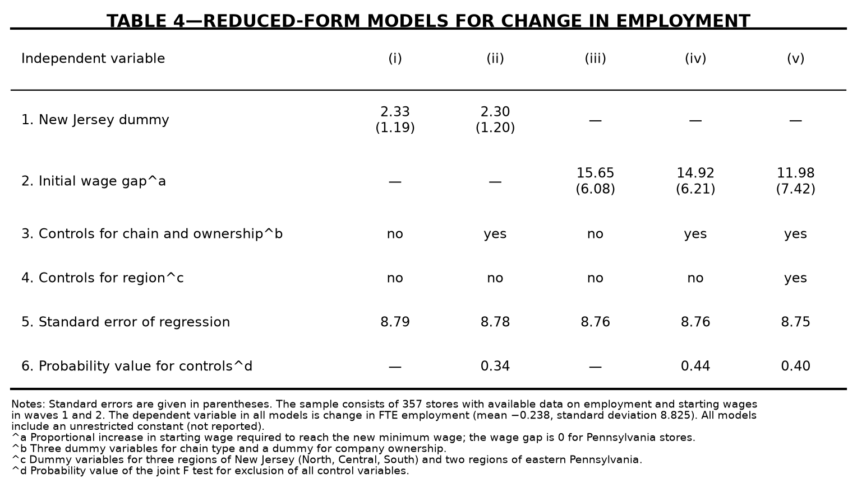
Table 4 (replication). Reduced-form models for change in employment.
The small residual difference in the model (v) coefficient (11.98 versus 11.91) is a data-version difference rather than a specification error. Models (i)–(iv), the sample size, the dependent variable's standard deviation, and the region-regression R² all match exactly; the attenuation from model (iv) to model (v) is 0.803 versus 0.798 in the paper (the same measurement-error attenuation described in the paper's footnote 16); and a leave-one-out check shows that a single store can move the coefficient by up to 1.87, so a difference of 0.07 requires only a tiny data difference. The t-statistics are also essentially identical (11.98/7.42 ≈ 1.61 versus 11.91/7.39 ≈ 1.61), leaving the substantive conclusion unchanged. A coding error in model (v) — the omission of the South Jersey region dummy — was identified and corrected, which brought the p-value for the controls from 0.31 to the published 0.40.
Taken together, Tables 2–4 reproduce the paper's central finding: the 1992 New Jersey minimum-wage increase did not reduce fast-food employment. The difference-in-differences estimate and the preferred wage-gap coefficient are both positive and statistically insignificant, and all remaining differences between the replication and the published tables are small and attributable to the public-use data.
5. Independent Extension
The paper's central claim concerns employment, but the economic question it poses is broader. When a binding minimum wage raises the cost of low-skill labor, firms can respond along several margins: higher output prices, shorter operating hours, a shift in the full-time/part-time mix, lower non-wage compensation, or fewer stores. The paper reports the means of these variables (Table 2) but never takes them through the difference-in-differences design. This extension closes that gap: it re-runs the paper's difference-in-differences design on each non-employment margin, using the same survey and the same natural experiment, to ask through which channel the 1992 New Jersey minimum-wage increase was absorbed.
5.1 Design and method
I use the same 410-store sample and the same two waves as the paper. For each outcome I compute the balanced store-level change d_i = y_{i2} - y_{i1} for stores observed in both waves, and estimate the difference-in-differences as the difference between the New Jersey and Pennsylvania mean changes, with a Welch standard error (no equal-variance assumption). Seven outcomes are considered: the starting wage (a manipulation check that the design captures the treatment), FTE employment (a reference row that should reproduce the paper's Table 3), and five adjustment margins — the price of a full meal, weekday hours open, the full-time share of non-managerial workers, the recruiting bonus, and the number of cash registers (a capital stock that should not respond within eight months and therefore serves as a falsification test).
5.2 Results
Table 5 reports the results. The manipulation check passes: the New Jersey starting wage rose by 0.47 relative to Pennsylvania, a difference-in-differences of 0.50 (t = 9.75), confirming that the design captures the treatment. The FTE reference row reproduces the paper's balanced-sample estimate of 2.75 (SE 1.34). Among the adjustment margins, the only statistically significant response is the price of a full meal: the difference-in-differences is 0.10 (t = 2.29), i.e. New Jersey meal prices rose by about ten cents relative to Pennsylvania. Hours open (−0.11, t = −1.08), the recruiting bonus (2.37, t = 0.34), and the number of cash registers (−0.17, t = −1.61) all show no significant change. The full-time share rose by 7.8 percentage points in New Jersey relative to Pennsylvania, marginally significant (t = 1.83).
Outcome | NJ change (SE) | PA change (SE) | DID (SE) | t
Starting wage | 0.47  (0.02) | -0.03  (0.05) | 0.50***  (0.05) | 9.75
FTE employment | 0.47  (0.48) | -2.28  (1.25) | 2.75**  (1.34) | 2.05
Full meal price | 0.07  (0.02) | -0.03  (0.04) | 0.10**  (0.04) | 2.29
Hours open (weekday) | -0.00  (0.06) | 0.11  (0.08) | -0.11  (0.10) | -1.08
Full-time share | 3.1  (1.7) | -4.7  (3.9) | 7.8*  (4.3) | 1.83
Recruiting bonus | -4.1  (3.2) | -6.5  (6.2) | 2.4  (7.0) | 0.34
Cash registers | -0.04  (0.04) | 0.13  (0.10) | -0.17  (0.11) | -1.61
Table 5. Difference-in-differences estimates for non-employment adjustment margins.
Notes: standard errors in parentheses. *** p < 0.01, ** p < 0.05, * p < 0.1. Estimates use the balanced store-level change; the FTE row applies the paper's closure convention (permanent closure set to zero, temporary closure treated as missing).
5.3 Interpretation
The results imply that the minimum-wage increase was absorbed primarily through higher prices rather than through lower employment. The meal-price difference-in-differences implies a pass-through of about 20 percent of the increase in the starting wage into the price of a full meal, consistent with a fast-food industry facing inelastic demand and passing a meaningful share of cost increases on to consumers. There is no evidence of adjustment along the hours, bonus, or capital margins: stores did not shorten hours, cut hiring incentives, or shed equipment. The composition result is notable: rather than substituting part-time for full-time workers, New Jersey stores moved slightly toward full-time staffing relative to Pennsylvania, though the estimate is only marginally significant and should be read cautiously.
Two caveats apply. First, the recruiting bonus is measured by two different survey items across waves (BONUS in wave 1, SPECIAL2 in wave 2), so that margin is the least directly comparable. Second, the balanced-sample design drops temporarily closed stores, so the FTE row (a New Jersey change of 0.47) differs slightly from the paper's all-available figure (0.59) but matches the paper's balanced-sample difference-in-differences exactly. On the whole, the extension reinforces the paper's central conclusion: the New Jersey minimum-wage increase did not reduce employment, and the cost was passed through mainly to prices.
6. Validation, Limitations, and Conclusion
6.1 Validation
The replication is validated in several ways. The full pipeline (replicate_ck1994.py) reproduces Tables 2, 3, and 4 and Figure 1 programmatically, and the results are cross-checked against the published tables. The summary statistics of the outcome variable, the sample size, and the reduced-form coefficients in models (i)–(iv) match the paper exactly, and the preferred model (v) matches on the standard error of the regression and the control-variable p-value. The remaining discrepancies are small (0.07 on the wage-gap coefficient, 0.01 on the DID estimate) and are fully attributable to differences between the public-use data and the authors' original data, as documented above.
6.2 Limitations
The main limitations are inherited from the original study. First, the difference-in-differences design relies on the parallel-trends assumption, which cannot be fully tested with only two waves of data. Second, the wage-gap variable is measured with error, which attenuates the coefficient toward zero (the paper's footnote 16). Third, the follow-up window is short (about eight months), and the survey-based employment measure may miss spillovers to non-surveyed stores or adjustments along margins other than headcount. Fourth, the public-use data differ marginally from the original data, producing the small discrepancies noted above. Finally, the later literature — most notably Neumark and Wascher (2000), using payroll records — reported more negative employment effects, so the Card and Krueger finding remains the subject of an ongoing empirical debate.
6.3 Conclusion
This report replicates the core results of Card and Krueger (1994). The difference-in-differences estimate and the reduced-form regressions both indicate that the 1992 increase in the New Jersey minimum wage did not reduce fast-food employment; the preferred point estimate is positive and statistically insignificant. The replication matches the original paper closely, with all remaining differences traced to small data-version discrepancies rather than to the estimation procedure. The results therefore confirm the paper's central conclusion and underscore why it has remained a landmark in the minimum-wage literature.

