5. Independent Extension
The paper's central claim concerns employment, but the economic question it poses is broader. When a binding minimum wage raises the cost of low-skill labor, firms can respond along several margins: higher output prices, shorter operating hours, a shift in the full-time/part-time mix, lower non-wage compensation, or fewer stores. The paper reports the means of these variables (Table 2) but never takes them through the difference-in-differences design. This extension closes that gap: it re-runs the paper's difference-in-differences design on each non-employment margin, using the same survey and the same natural experiment, to ask through which channel the 1992 New Jersey minimum-wage increase was absorbed.
5.1 Design and method
I use the same 410-store sample and the same two waves as the paper. For each outcome I compute the balanced store-level change d_i = y_{i2} - y_{i1} for stores observed in both waves, and estimate the difference-in-differences as the difference between the New Jersey and Pennsylvania mean changes, with a Welch standard error (no equal-variance assumption). Seven outcomes are considered: the starting wage (a manipulation check that the design captures the treatment), FTE employment (a reference row that should reproduce the paper's Table 3), and five adjustment margins — the price of a full meal, weekday hours open, the full-time share of non-managerial workers, the recruiting bonus, and the number of cash registers (a capital stock that should not respond within eight months and therefore serves as a falsification test).
5.2 Results
Table 5 reports the results. The manipulation check passes: the New Jersey starting wage rose by 0.47 relative to Pennsylvania, a difference-in-differences of 0.50 (t = 9.75), confirming that the design captures the treatment. The FTE reference row reproduces the paper's balanced-sample estimate of 2.75 (SE 1.34). Among the adjustment margins, the only statistically significant response is the price of a full meal: the difference-in-differences is 0.10 (t = 2.29), i.e. New Jersey meal prices rose by about ten cents relative to Pennsylvania. Hours open (−0.11, t = −1.08), the recruiting bonus (2.37, t = 0.34), and the number of cash registers (−0.17, t = −1.61) all show no significant change. The full-time share rose by 7.8 percentage points in New Jersey relative to Pennsylvania, marginally significant (t = 1.83).
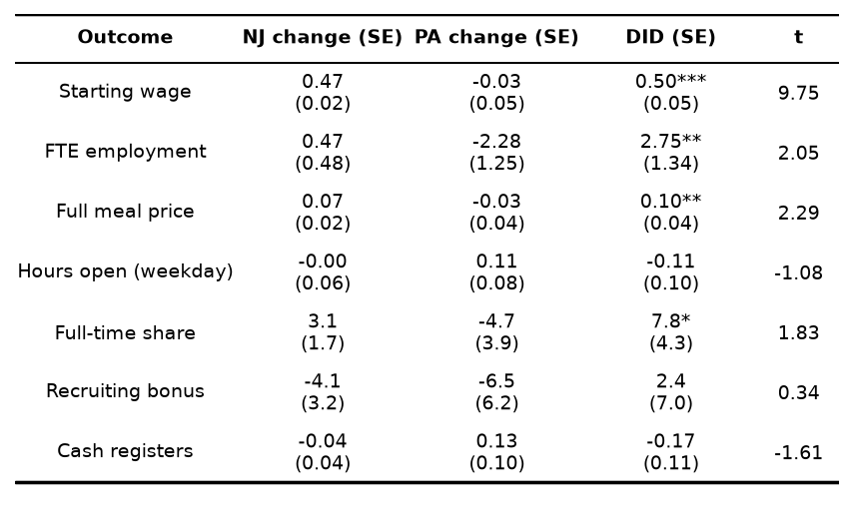
Table 5. Difference-in-differences estimates for non-employment adjustment margins.
Notes: standard errors in parentheses. *** p < 0.01, ** p < 0.05, * p < 0.1. Estimates use the balanced store-level change; the FTE row applies the paper's closure convention (permanent closure set to zero, temporary closure treated as missing).
5.3 Interpretation
The results imply that the minimum-wage increase was absorbed primarily through higher prices rather than through lower employment. The meal-price difference-in-differences implies a pass-through of about 20 percent of the increase in the starting wage into the price of a full meal, consistent with a fast-food industry facing inelastic demand and passing a meaningful share of cost increases on to consumers. There is no evidence of adjustment along the hours, bonus, or capital margins: stores did not shorten hours, cut hiring incentives, or shed equipment. The composition result is notable: rather than substituting part-time for full-time workers, New Jersey stores moved slightly toward full-time staffing relative to Pennsylvania, though the estimate is only marginally significant and should be read cautiously.
Two caveats apply. First, the recruiting bonus is measured by two different survey items across waves (BONUS in wave 1, SPECIAL2 in wave 2), so that margin is the least directly comparable. Second, the balanced-sample design drops temporarily closed stores, so the FTE row (a New Jersey change of 0.47) differs slightly from the paper's all-available figure (0.59) but matches the paper's balanced-sample difference-in-differences exactly. On the whole, the extension reinforces the paper's central conclusion: the New Jersey minimum-wage increase did not reduce employment, and the cost was passed through mainly to prices.

