4. Core Replication Results and Comparison with the Original Paper
This section reports the replication of the paper's three main tables and compares each with the published figures. The tables below are the three-line tables produced directly by the replication pipeline (output/three_line_tables/).
4.1 Table 2 — Means of Selected Outcome Variables
Table 2 reports the mean and standard error of the main outcome variables separately for New Jersey and Pennsylvania stores. The replication reproduces the paper closely. The distribution of store types is essentially identical (for example, Burger King accounts for 41.1 percent of New Jersey stores and 44.3 percent of Pennsylvania stores). In wave 1 the two states are broadly similar: mean FTE employment is 20.44 in New Jersey and 23.33 in Pennsylvania, and the mean starting wage is 4.61 versus 4.63. The main change between waves is the treatment itself: by wave 2 the mean New Jersey starting wage has risen to 5.08, and 85.5 percent of New Jersey stores report a starting wage of exactly $5.05 (the new minimum), compared with 1.3 percent in Pennsylvania (the paper reports 85.2 percent).
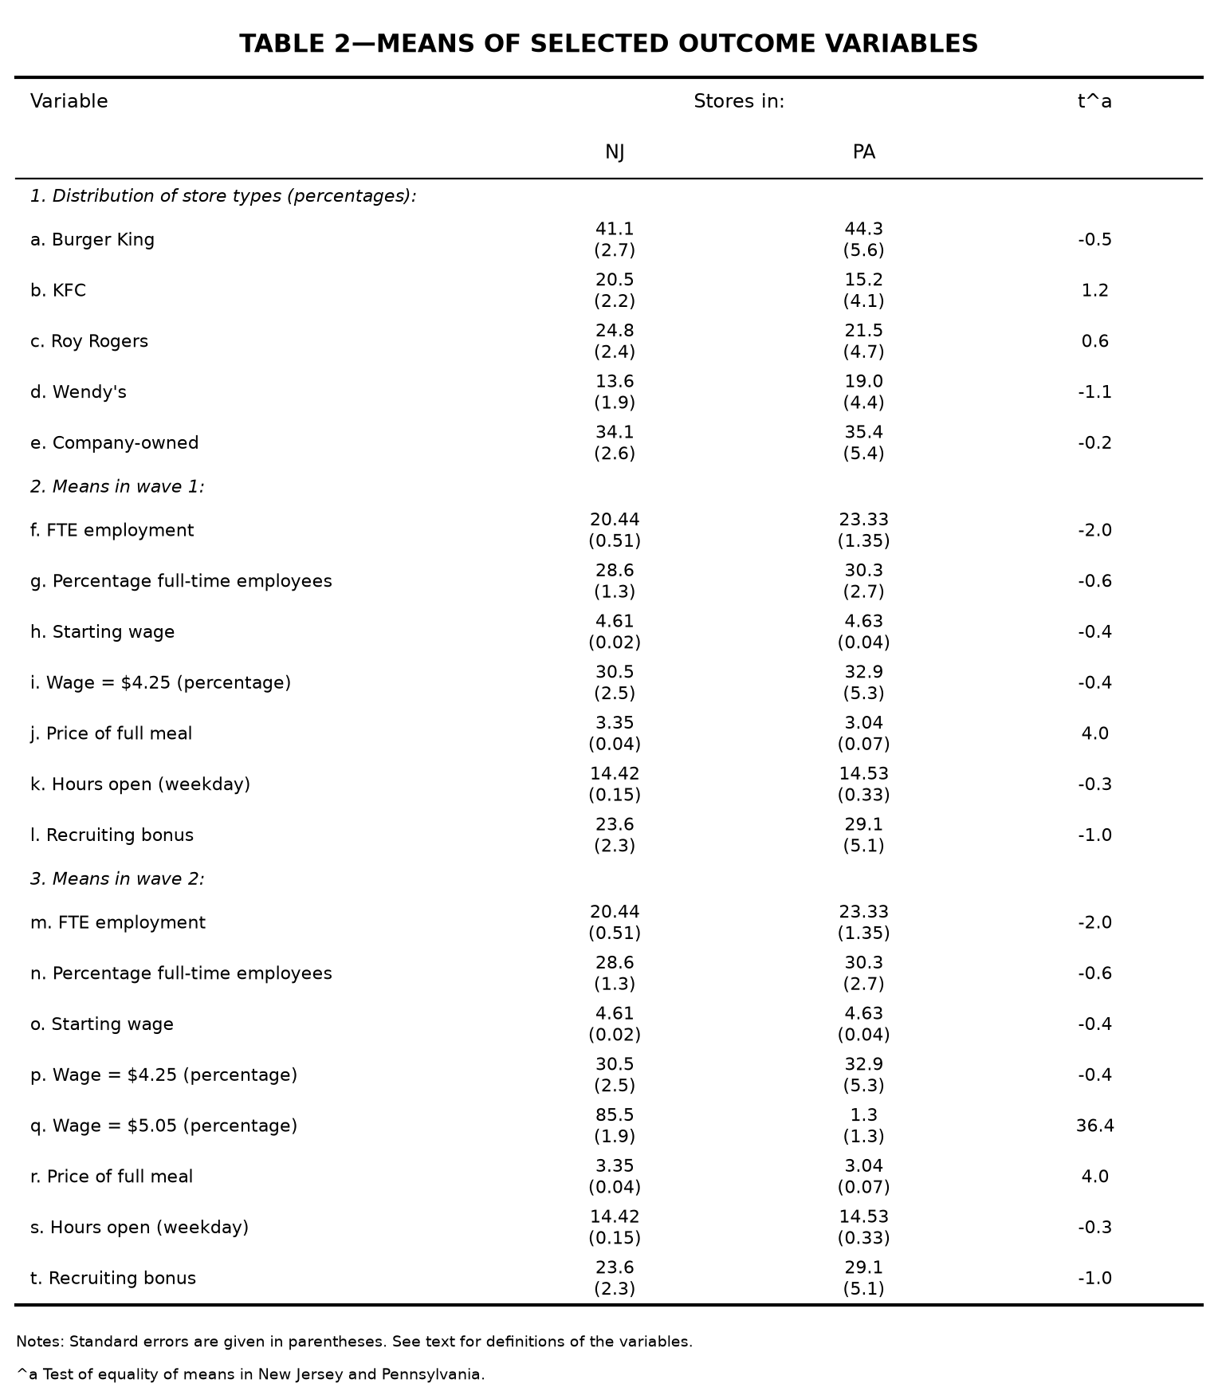
Table 2 (replication). Means of selected outcome variables.
Two discrepancies arose during replication and are worth noting. First, the recruiting bonus was initially reported on a 0–1 scale rather than in percentage points; after correcting this coding error, the values match the paper (e.g., 23.6 percent in New Jersey versus 23.5 percent in the paper). Second, the percentage of full-time employees differs systematically (28.6 versus 32.8 in wave 1 New Jersey), while the associated standard errors match. This is a data-version difference: the public-use file splits full- and part-time employees differently from the authors' original data, but the FTE total — the outcome of interest — is unaffected, so the difference does not carry over to the employment results.
4.2 Table 3 — Average Employment per Store Before and After
Table 3 reports mean FTE employment before and after the minimum-wage increase and the resulting difference-in-differences estimates. Row 3 is the central comparison: mean FTE employment rose by 0.59 in New Jersey and fell by 2.17 in Pennsylvania, giving a difference-in-differences estimate of 2.75 (standard error 1.36). The paper reports 2.76 (1.36). The estimate is positive and statistically insignificant, so there is no evidence that the minimum-wage increase reduced employment; if anything, employment in New Jersey rose relative to Pennsylvania. The balanced-sample and temporarily-closed-set-to-zero variants (rows 4 and 5) give the same qualitative result (2.75 and 2.51). Within New Jersey, low-wage stores ($4.25) grew relative to high-wage stores (≥ $5.00): the low–high difference is 3.36 (1.48) and the mid–high difference is 2.91 (1.41), the latter matching the paper exactly.
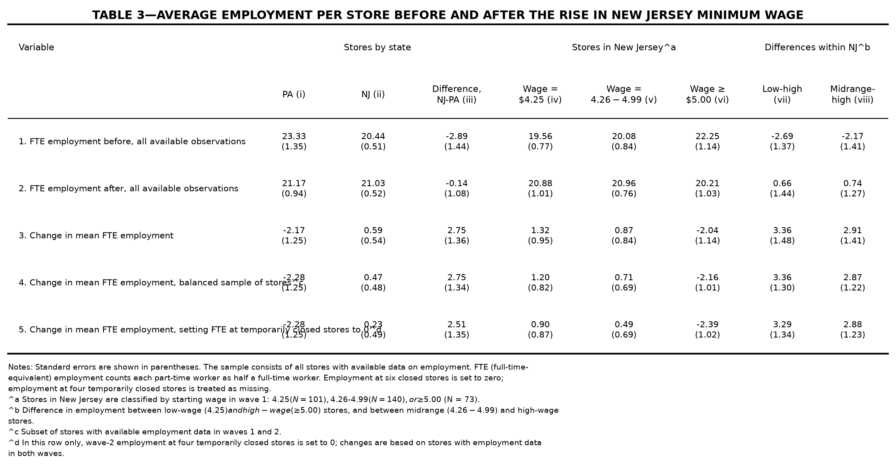
Table 3 (replication). Average employment per store before and after the rise in New Jersey minimum wage.
One coding error was corrected in this table: the standard errors in row 3 initially used the balanced-sample store-level change rather than the paired-difference formula with a correlation of 0.45. After this fix the standard errors and the mid–high difference match the paper. The remaining 0.01 difference in the difference-in-differences estimate (2.75 versus 2.76) is attributable to the data version.
4.3 Table 4 — Reduced-Form Models for Change in Employment
Table 4 reports reduced-form regressions of the change in FTE employment on the state dummy or the wage gap, with progressively richer controls. The sample contains 357 stores, and the dependent variable has mean −0.238 and standard deviation 8.825 (the paper: −0.237 and 8.825). Models (i)–(iv) reproduce the paper exactly to two decimal places: the New Jersey dummy is 2.33 (1.19) in model (i) and 2.30 (1.20) in model (ii), and the wage-gap coefficient is 15.65 (6.08) in model (iii) and 14.92 (6.21) in model (iv). In the preferred model (v), which adds region controls, the wage-gap coefficient is 11.98 (7.42), the standard error of the regression is 8.75, and the p-value for the controls is 0.40. The paper reports a wage-gap coefficient of 11.91 (7.39) with the same standard error of the regression (8.75) and p-value (0.40).
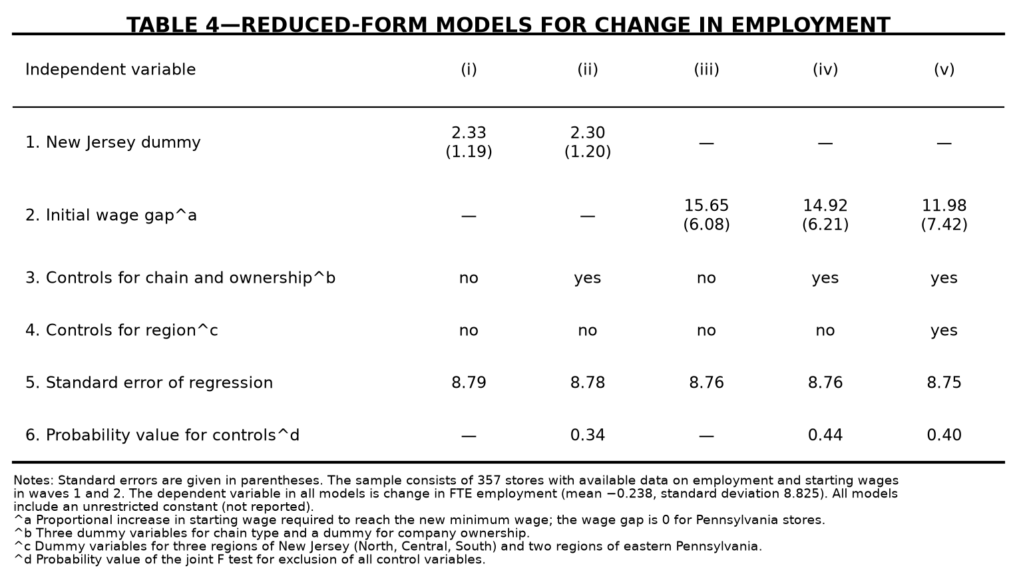
Table 4 (replication). Reduced-form models for change in employment.
The small residual difference in the model (v) coefficient (11.98 versus 11.91) is a data-version difference rather than a specification error. Models (i)–(iv), the sample size, the dependent variable's standard deviation, and the region-regression R² all match exactly; the attenuation from model (iv) to model (v) is 0.803 versus 0.798 in the paper (the same measurement-error attenuation described in the paper's footnote 16); and a leave-one-out check shows that a single store can move the coefficient by up to 1.87, so a difference of 0.07 requires only a tiny data difference. The t-statistics are also essentially identical (11.98/7.42 ≈ 1.61 versus 11.91/7.39 ≈ 1.61), leaving the substantive conclusion unchanged.
Taken together, Tables 2–4 reproduce the paper's central finding: the 1992 New Jersey minimum-wage increase did not reduce fast-food employment. The difference-in-differences estimate and the preferred wage-gap coefficient are both positive and statistically insignificant, and all remaining differences between the replication and the published tables are small and attributable to the public-use data.

