How to use TWSLink with MetaTrader 4

1. Installation

Assume your MetaTrader 4 is installed to c:\MT 4. Open a command Window in the Sample Directory and type:

installmt4.bat “c:\mt 4”

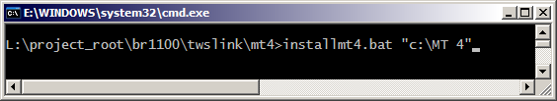

or copy files manually.

Open Meta Trader 4 and expand Expert Adisors Node (Advisors) in Navigator Window (normally lower Right). You see twslinkdemo greyed out. This means that twslinkdemo was not yet compiled.

2. Compilation

To do this, right Click on Node and select change or edit. This opens the MT 4 Editor/Compiler with twslinkdemo loaded.

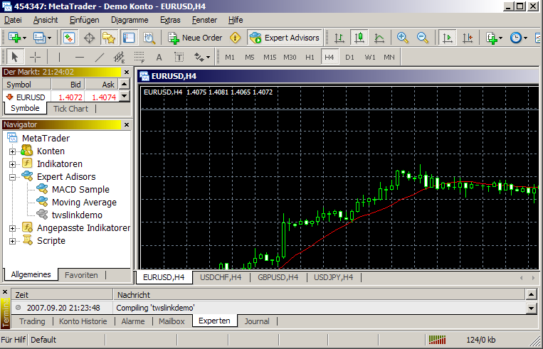

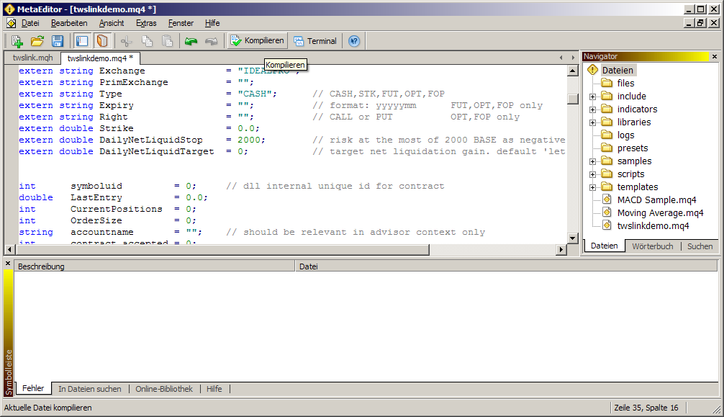

Click on Compile. Go Back to MT 4 Terminal, you can see twslinkdemo colored now, thus its ready for using.

3. Application

Right Click on twslinkdemo and selecting “Apply to Chart”, starts the Script.

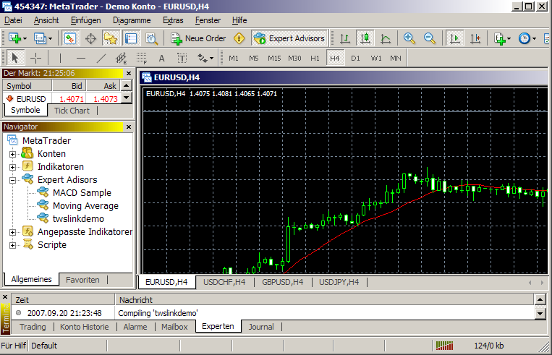

Note: For a proper Functioning, you must enable DLL Usage. For this call Extras\Options\Expert Advisors and check “Allow DLL Import”. Or check it every Time when attaching to a Chart.

