How to Setup the Sample.

1. Import Sample Signal and Strategy

At first you have to import the twslinksamples.els File. For that open EasyLanguage Editor and go to File/Import Export…

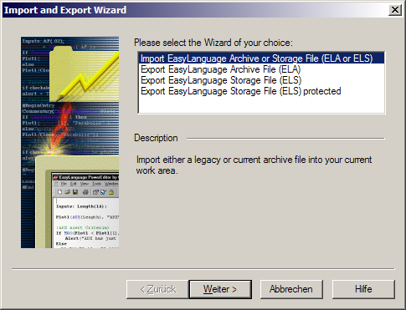

Go On

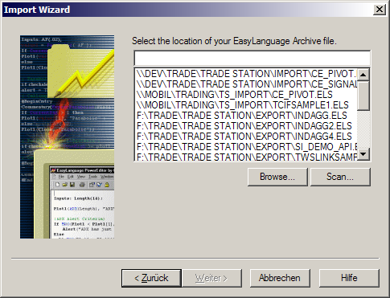

Click on Browse to select Folder and File where the sample is located.

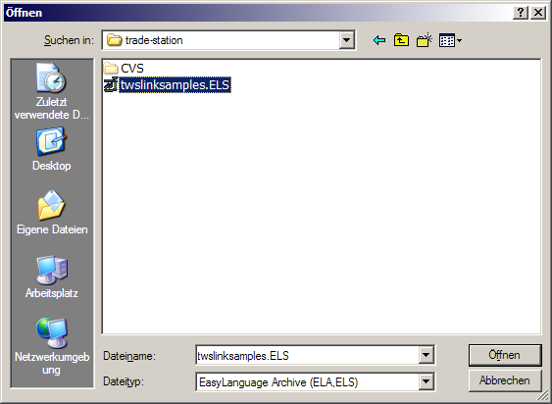

Select File and press Open

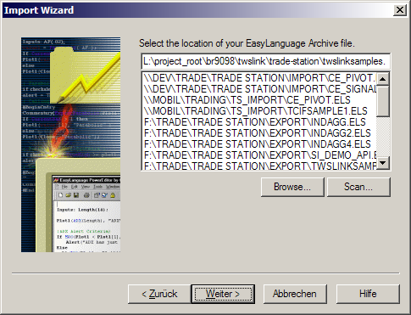

Go On

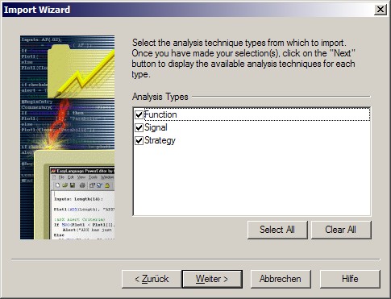

Go On

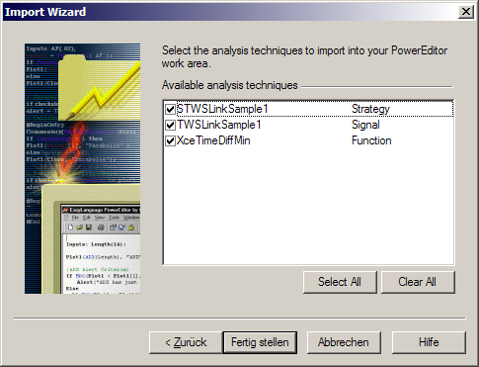

Go On

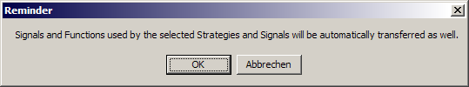

Press OK

You should see
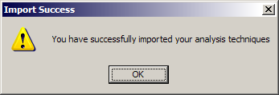

Press OK

Now the Sample is available in Trade Station as Signal and Strategy.

2. Using Sample Strategy

Open Trade Station and a Chart Window you want the Sample apply to. Here EUR/USD.

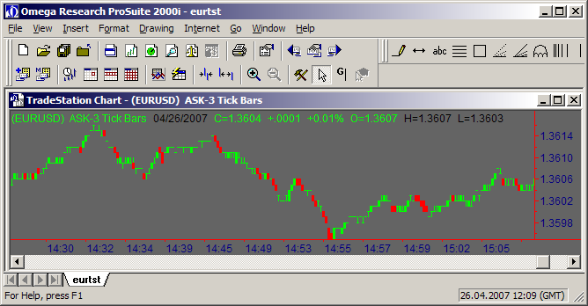

Right Click on the Chart and select “Insert Analysis Techniques…” or press F7

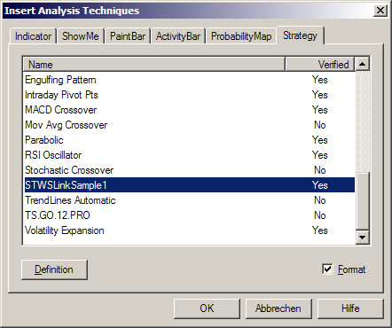,

Select Tab “Strategy” and scroll to STWSLinkSample1. Select it and press Ok.

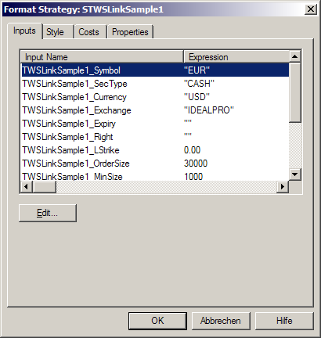

Change the Parameter to your Demands by Double Clicking on Item Row. If you do not apply the Sample to EUR.USD, Change the Symbol, Sectype (STK for Stocks, OPT for Options, FOP for Future Options, FUT for Futures) , Currency, Exchange, Order Size and MinSize. The last 5 Parameter decide about the Frequency how often Trades gets generated.
Press Ok.

You will hear a Beep indicating DLL been loaded and see a Trace Window coming up. Now the Strategy works.

Note: This Sample mostly generates Casualties. It is thought as an Sample how to use TWSLink with TradeStation and not as an productive Strategy. Thus is should be applied only to DEMO or PAPER-TRADING ACCOUNTS.

