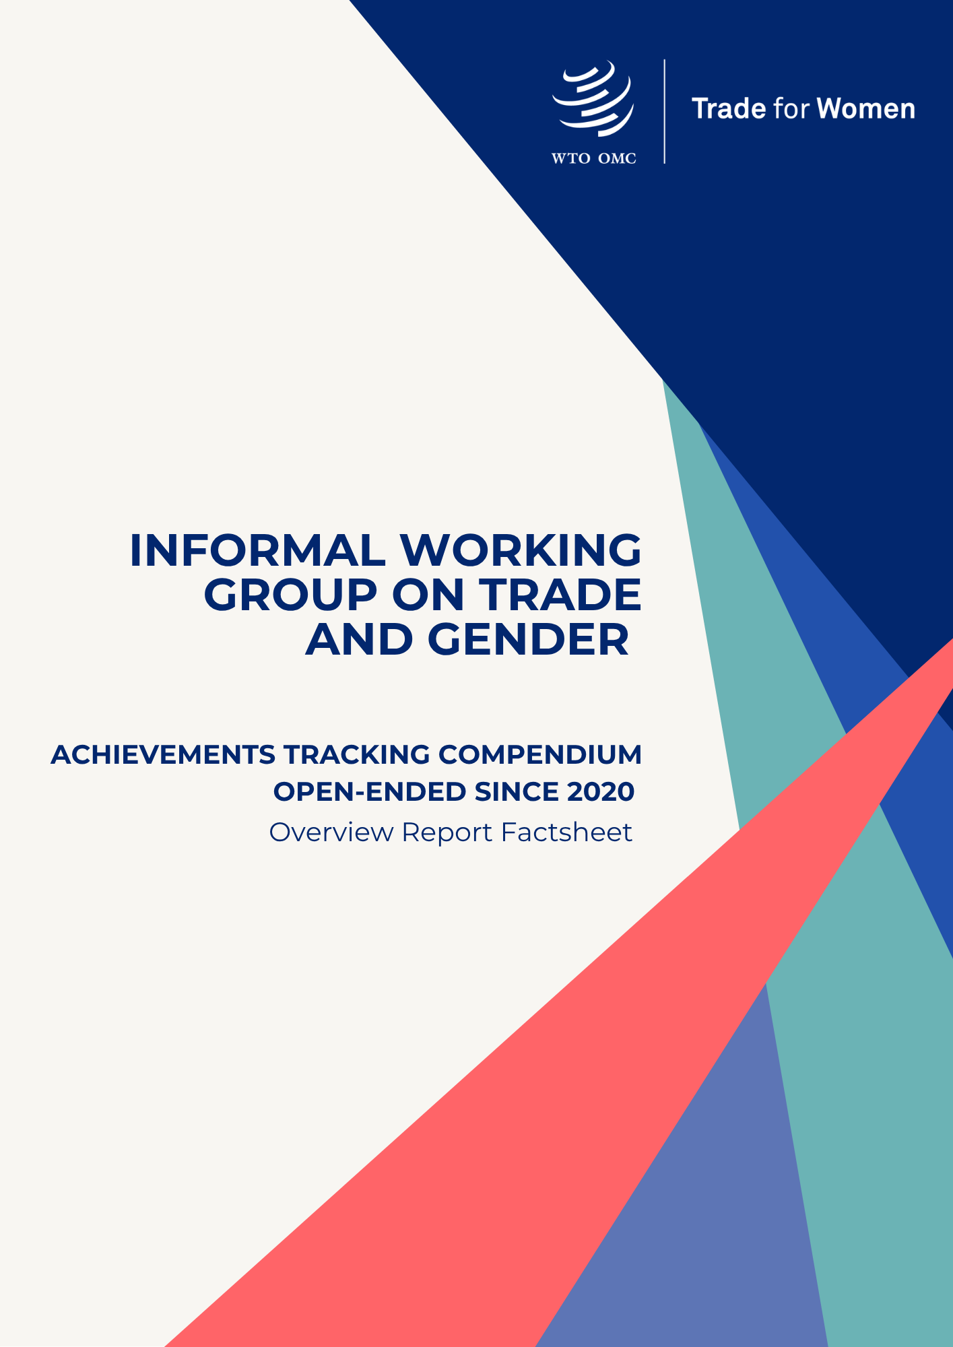

Established by 130 WTO members in September 2020, the Informal Working Group on Trade and Gender (IWG) has advanced discussions and initiatives aimed at increasing women’s participation in trade. At the WTO’s 14th Ministerial Conference in Yaoundé, Cameroon, the Group released its Achievements Tracking Compendium, which maps and categorizes its activities over the past five years, including consolidated information on gender-responsive trade policy initiatives.

While the Compendium’s overview report provides detailed analysis and practical guidance on how to navigate its content, this factsheet offers a concise snapshot of the main findings and highlights. It presents the key themes, milestones, leadership contributions and policy initiatives that have shaped the IWG’s efforts since its establishment.

When women can equally engage in trade, they do more than export, they fuel growth and expand what's possible. Investing in women is a risk-free undertaking! Open markets to them, and trade becomes a catalyst for development. This is the course we have set with the WTO Informal Working Group on Trade and Gender (IWG).

Over the last five years, the IWG has reshaped the conversation on gender equality in trade and has achieved measurable impact. The compendium marks a critical milestone in the IWG work, providing a clear, organized overview of ongoing initiatives, projects, and priorities. By methodically compiling this information, the compendium enhances transparency and advocacy, supports strategic policy making decisions, transfers knowledge, and strengthens the WTO. It also highlights the vital role women play in shaping fair and inclusive trade systems.

We are proud to lead this Group. By highlighting these achievements and recognizing these inspiring changemakers in the compendium, we hope to inspire continued progress toward a gender equality in trade, reshaping trade for the benefits of all.

Ambassador Baxter, Australia
Ambassador Delgado, Cabo Verde
Ambassador Benedetti, El Salvador
Co-Chairs of the Informal Working Group on Trade and Gender
25 March 2026, WTO 14th Ministerial Conference, Yaoundé, Cameroon

Informal Working Group on Trade and Gender Co-Chairs since 2020
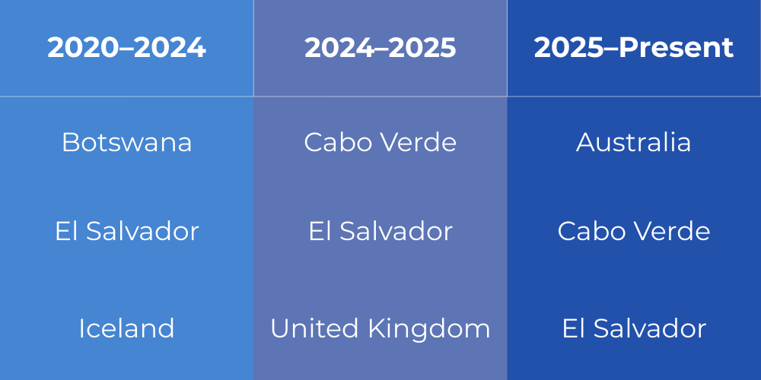

The following infographic provides a snapshot of the IWG’s engagement and outputs since 2020, highlighting participation levels, regional contributions and key policy themes addressed through its work.
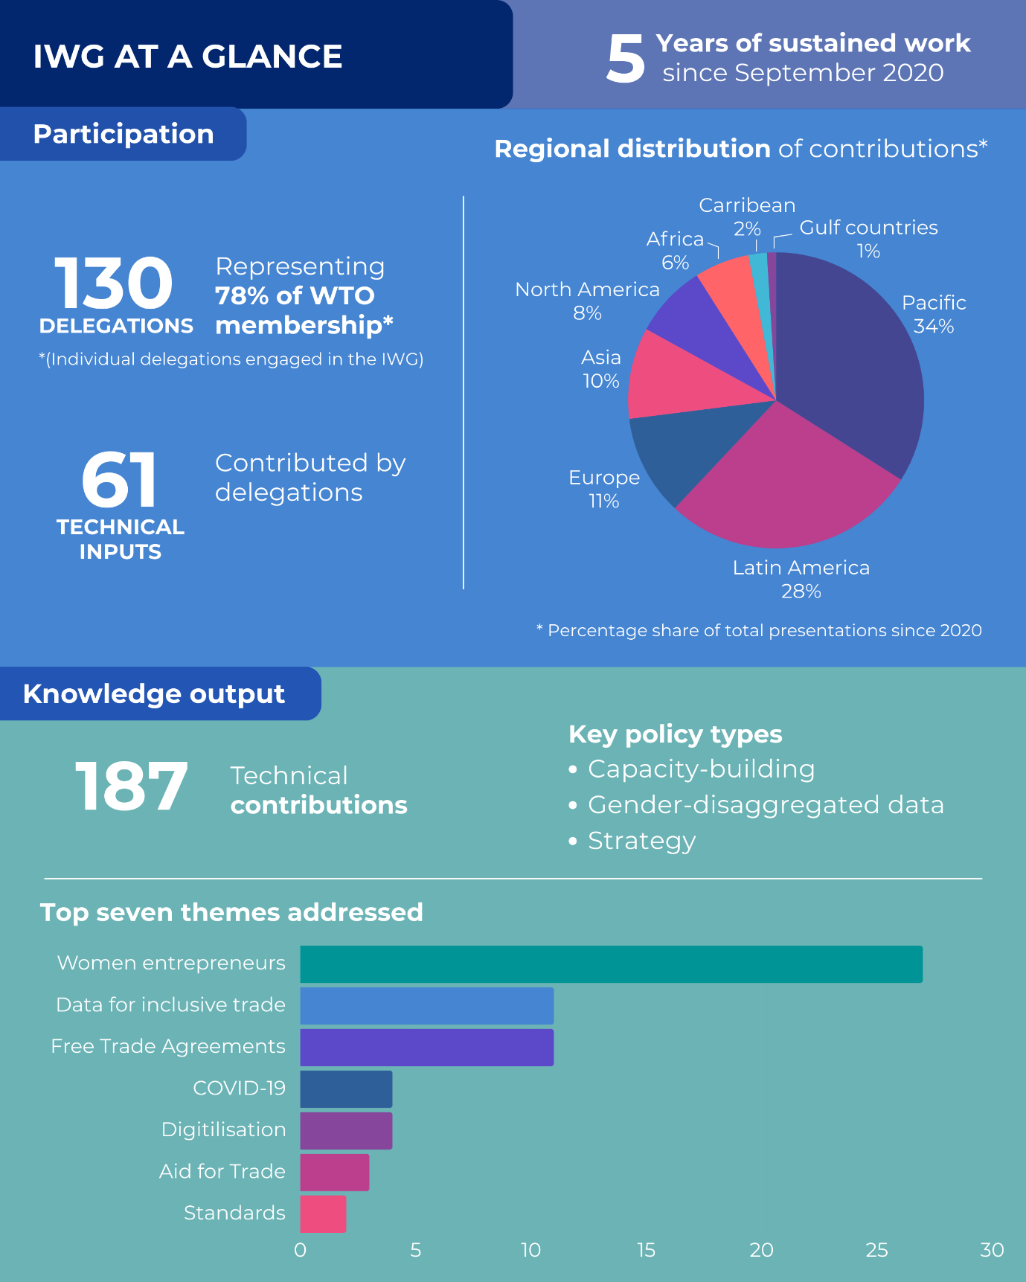

Major milestones

Since 2017, gender considerations have been progressively integrated into the work of the WTO through political commitments, technical policy discussions, work plans, research initiatives, capacity-building activities and the development of practical trade policy tools. The timeline below highlights key milestones that have shaped the evolution of this agenda within the WTO.

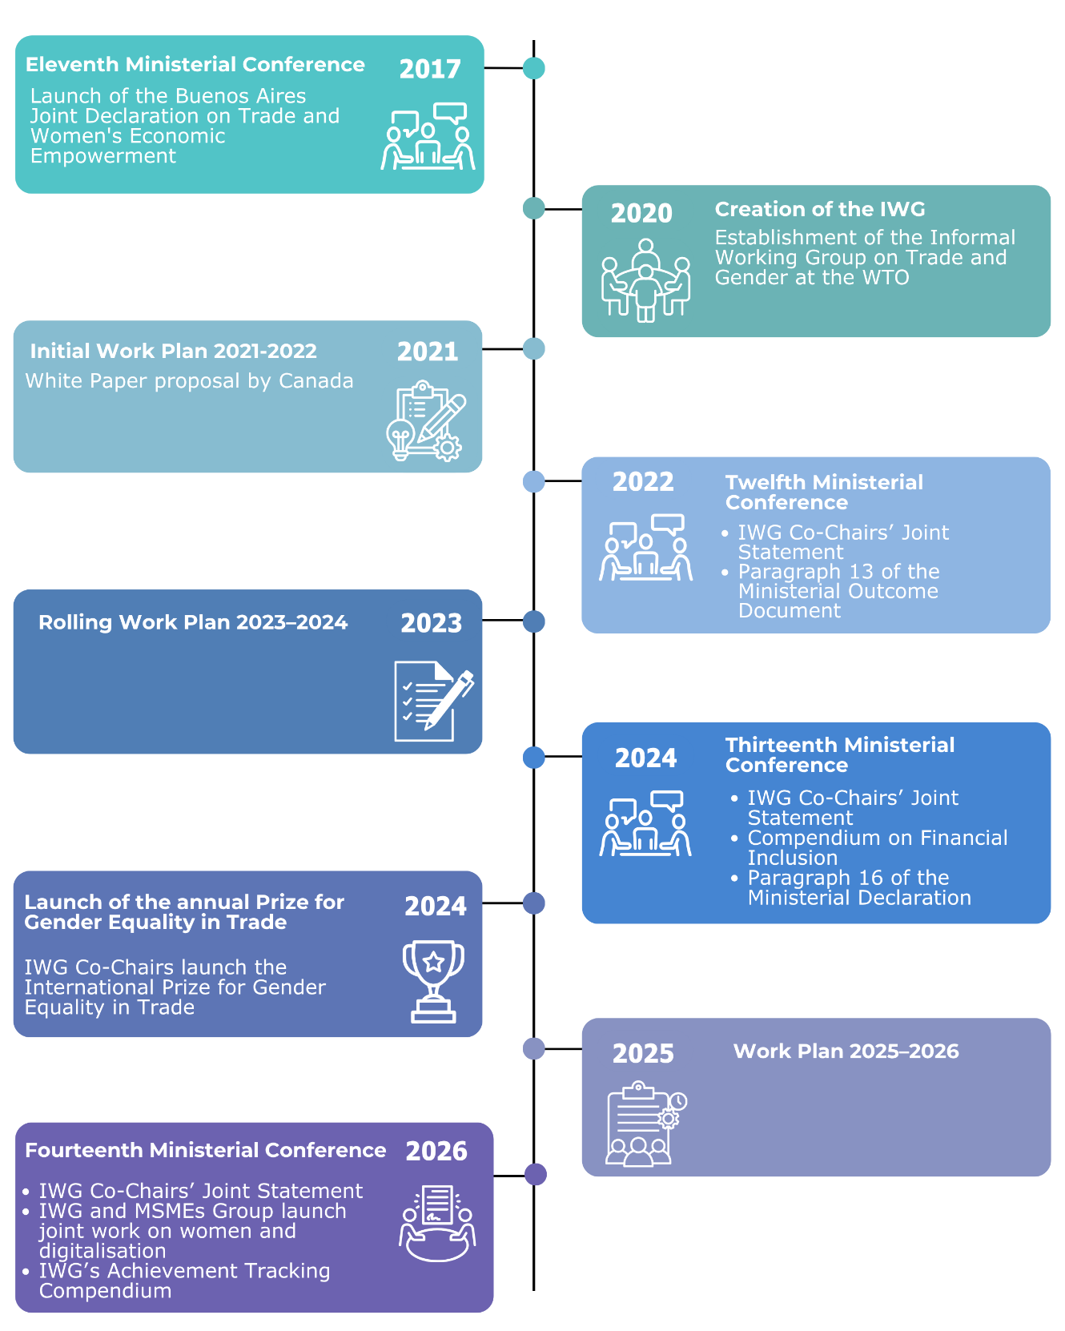

17 core themes

The IWG’s work has addressed a broad range of themes, reflecting the multifaceted links between trade and gender. These include sector-specific development initiatives, gender integration in trade policies and agreements, research and data collection, women’s economic empowerment, as well as the effects of major global events affecting trade, including the COVID-19 pandemic.
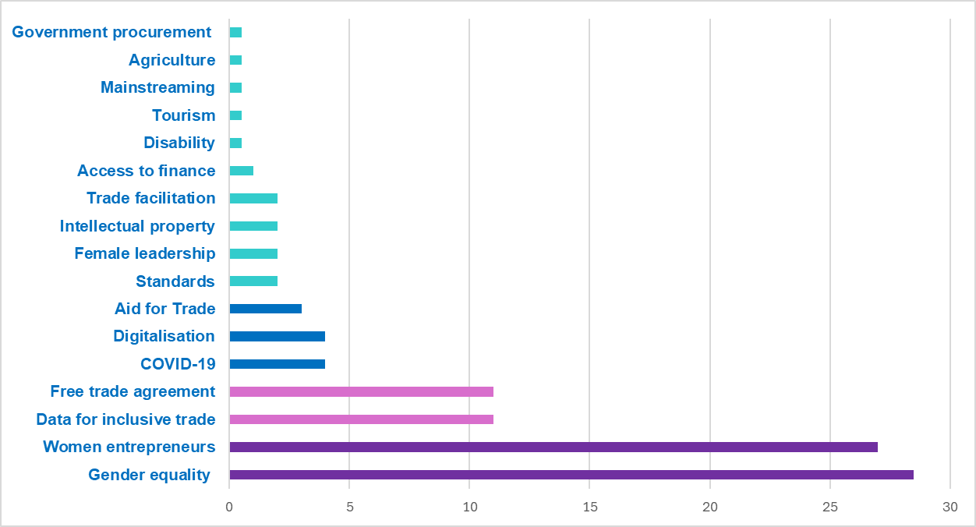

In % of total IWG presentations

33 types of policy measures

Over the past five years, the IWG has discussed a wide range of policy measures aimed at advancing gender-responsive trade policies and increasing women’s participation in trade. These measures span strategic commitments and high-level policy dialogues, cooperation platforms, capacity-building programmes, legal and regulatory instruments, dedicated initiatives for women entrepreneurs, and research and data-related initiatives.
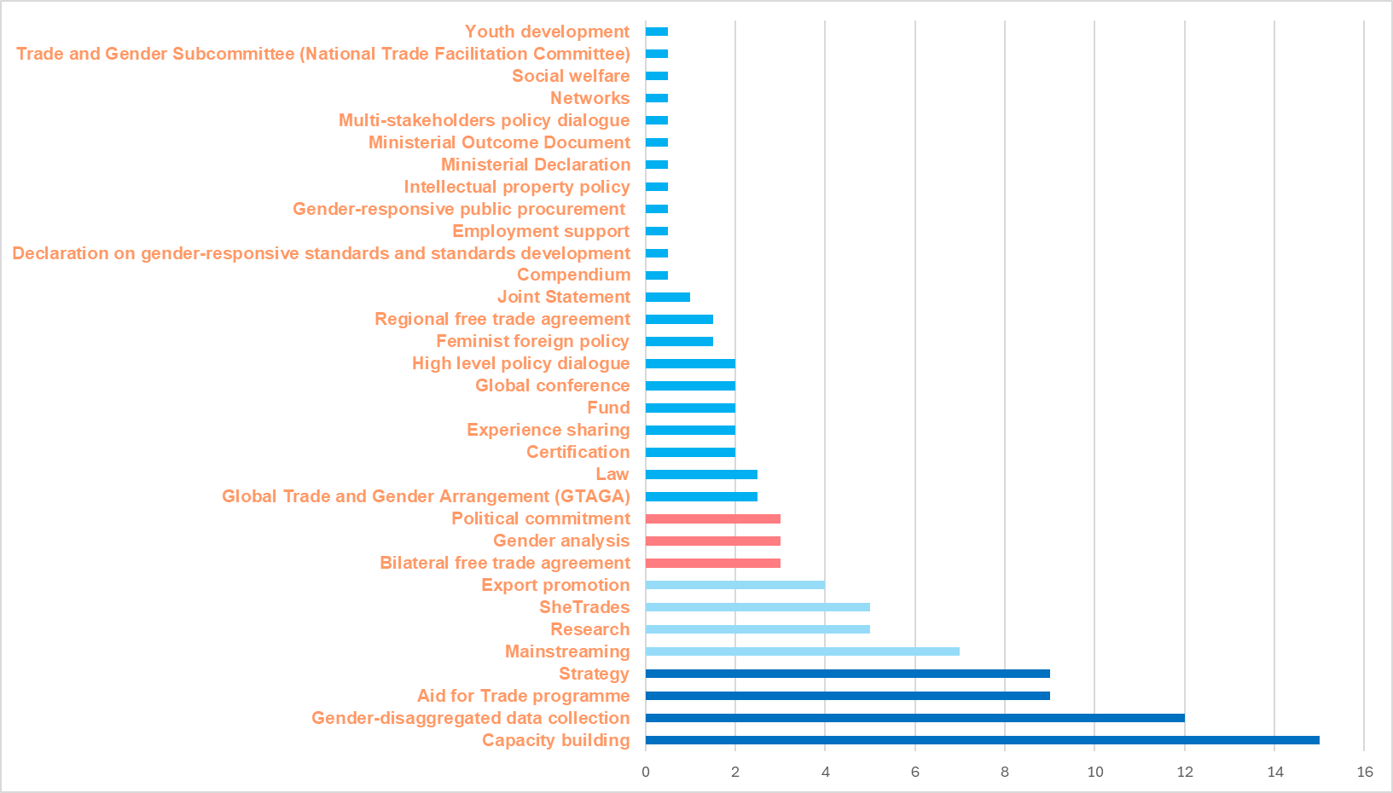
In % of total IWG presentations

For further information on the gender-related outcomes of the WTO’s 14th Ministerial Conference, including the IWG’s Achievements Tracking Compendium and related joint initiatives, scan the QR code below.

