INFORMAL WORKING GROUP ON TRADE AND GENDER (IWG):
ACHIEVEMENTS TRACKING COMPENDIUM - OPEN ENDED SINCE 2020
Overview Report: Insights and Guidance
The IWG Achievements Tracking Compendium maps and categorizes the work of the IWG undertaken since its establishment in 2020 in the World Trade Organization (WTO). It centralizes, organizes and consolidates information on the gender-responsive policy initiatives designed and implemented by IWG members.

This overview report summarizes in detail the content of the Compendium, by topic, policy measures and types. It outlines the purpose of the Compendium and explains the meaning of its various segments, which categorize and clarify information on the members' policy initiatives. It assists users to navigate, understand, and use the Compendium.

BACKGROUND
            - Gender has been integrated into the work of the WTO gradually since 2017 through political commitments, technical policy work, research, capacity-building, and the development of practical trade policy tools.
            - In the margins of the WTO 11th Ministerial Conference, 118 Members endorsed the Buenos Aires Declaration on Trade and Women's Economic Empowerment in December 2017.
            - This was the first recognition inside the WTO that trade rules and policies affect women and men differently.
            - Through the Buenos Aires Declaration, this group of WTO Members agreed to collaborate to:
- share best practices on gender-responsive trade policy;
- share ways of collecting sex-disaggregated data;
- encourage women's participation in international trade; and
- make WTO activities and work more inclusive.
            - The Buenos Aires Declaration was a significant milestone as it launched the institutional agenda and ultimately led to the creation of the Informal Working Group on Trade and Gender in the WTO, making gender a permanent cross-cutting issue in the organization.
            - Accordingly, on 23 September 2020, the coalition of 118 Members (since 2024, there are 130) formed the IWG in the WTO, focusing on four work pillars:
- Trade policy making and experience sharing
- Mainstreaming gender in the WTO
- Reviewing analytical work
- Aid for Trade
            - The approach of the IWG on trade and gender is and remains based on soft-law cooperation and focussed on policy making practice.
            - Since 2020, the IWG has become the main forum platform where gender is discussed at the WTO. Building on this role, mainstreaming efforts in the WTO originate from and are coordinated by the Group, gradually embedding gender into WTO processes and technical work.

COMPENDIUM HIGHLIGHTS
            - Between 2020 and 2025, a total of 187 technical presentations and policy dialogue sessions were delivered, centred around 17 core themes and showcasing 33 types of policy measures.

Core themes
            - The IWG focused its work on 17 core themes. These themes are listed in the third column of the Compendium.
Core themes | Details
Gender equality | Themes capturing initiatives cutting across multiple sectors, more than the others do.
Women entrepreneurs
Agriculture | Themes associated with specific trade-related sectors supporting development.
Tourism
Digitalization | Themes linked to supporting women's participation in global trade.
Access to finance
Free trade agreement | Themes connected to how gender is integrated into trade rules, free trade agreements, and regulatory frameworks.
Standards
Intellectual property
Trade facilitation
Government procurement
Data for inclusive trade | Themes related to academic and Members' research to advance policy-making practices and innovative data collection approaches and gender analysis.
Mainstreaming
Aid for Trade
Female leadership | Themes associated with developing women's untapped potential in society and the economy.
Disability
COVID-19 | Theme linked to major global events affecting trade.

Types of policy measures implemented to support women in trade
            - The Compendium has captured the wide range of 33 types of policy measures, which were presented and discussed in the IWG over the last 5 years. These types can be regrouped into 6 categories:
- Strategic and political commitments such as multi-stakeholder dialogues, joint statements, WTO ministerial outcomes, feminist foreign policies.
- Platforms for cooperation such as high-level policy dialogues, national bodies such as the Trade and Gender Subcommittee of the Trade Facilitation National Committee, free trade agreements, mainstreaming.
- Capacity building programmes such as Aid-for-Trade programmes, networks, Youth development.
- Legal and regulatory instruments such as gender equality laws, employment policy, standards, public procurement.
- Dedicated initiatives essentially targeting women entrepreneurs such as export promotion, intellectual property policy, funds, SheTrades, certification, experience sharing.
- Research, data and knowledge such as gender analysis, gender-disaggregated data collection, publications (government, international organizations), global research conferences (i.e. WTO World Trade Congress on Gender).

Showcasing the work of the IWG on various WTO platforms
            - Various WTO platforms have been established or used to showcase the work of the IWG, including regular IWG meetings, technical IWG workshops, the International Prize for Gender Equality in Trade, and WTO Ministerial Conferences.
            - Additionally, the IWG was previously actively engaged in the WTO Public Forum highlighting solutions for women entrepreneurs' access to global markets, the integration of gender in trade policy making and research on trade and gender, such as the joint launch of the World Trade Congress on Gender publication in 2023.
            - Other global and WTO platforms have been used to highlight the IWG's activities.
            - Since 2021, the IWG has also contributed to the International Women's Day through technical discussions, political dialogues and celebratory events. In 2024, this global platform served as a springboard for the first edition of the International Prize for Gender Equality in Trade in 2024.
            - The IWG also contributed to the International Day for Women in Diplomacy in 2024 with a panel discussion on what women's leadership brings to trade.
            - The IWG, jointly with the WTO Secretariat, has also created dedicated global events to advance research on trade and gender and to connect academic experts with trade policy makers. Such events were the 2022 World Trade Congress on Gender, the 2023 Youth Trade Summit on Gender and the 2025 Symposium on Trade and Women's Economic Empowerment. All three events led to specific outcomes such as various publications, and the creation in 2024 of a new programme targeting your professionals in academia and government.

Collaborations and external stakeholder engagement
            - The International Trade Centre (ITC) plays a leading role as the external partner of the IWG. Members of the IWG have been closely collaborating with ITC on specific projects supporting women entrepreneurs in trade (SheTrades initiatives), gender-responsive policy making (SheTrades Outlook), gender mainstreaming research activities (gender lens reports 2021-2023) and trade policy mapping ("Access to Finance for Women-Led Micro, Small and Medium-Sized Enterprises (MSMEs): A Compendium of Financial Inclusion Initiatives").
            - The Organisation for Economic Cooperation and Development (OECD), UN Trade and Development (UNCTAD) and the United Nations Economic Commission for Europe (UNECE) have also served as key external partners supporting the IWG since its creation.
- The OECD has been contributing to the work of the IWG on gender-disaggregated data collection, the development of gender-disaggregated statistics, and gender reviews, notably through its Trade and Gender Framework for Gender Analysis.
- Through its extensive research on free trade agreements and e-commerce and its capacity-building activities, UNCTAD has technically supported the IWG's four work pillars and objectives.
- With its leadership work on gender-responsive standards, the UNECE has provided the IWG with key insights on the topic, including in relation with AI and standards.
            - Other international organizations supported the IWG work such as the World Bank Group on research and strategy; the World Customs Organization on trade facilitation; UN Women on gender-based violence and economic empowerment and female leadership; United Nations Development Programme on Aid for Trade, strategy and capacity building; Universal Postal Union on women entrepreneurs, e-commerce and trade facilitation; Economic Commission for Latin America and the Caribbean on research and gender mainstreaming; Food and Agriculture Organization of the United Nations on the status of women in agri-food systems; and World Intellectual Property Organization on women entrepreneurs.
            - Academic perspectives from Latin America and Asia, together with contributions from women entrepreneurs across Africa, Asia, Europe, the Pacific, and Latin America, have been included in the IWG's technical discussions.

COMPENDIUM STRUCTURE AND USAGE GUIDANCE
            - This section explains how the Compendium can be used for various purposes and details the meaning of its different columns which categorize the information.

Purpose and usage
            - The Compendium has been designed to serve as a versatile instrument with multiple purposes:
- Capacity building tool: facilitates learning and skill development for stakeholders engaged on issues related to trade and gender and working on the IWG.
- Knowledge resource: provides a better comprehensive understanding of the IWG work, how it operates and how it contributes to the overall work of the WTO on sustainable development.
- Trade policy-making instrument: showcases various models and types of trade policies across many sectors and themes that provide guidance and inspirations for governments when including gender considerations into their trade policies.
- Archival resource: documents the history of the IWG, its evolution and major milestones and contributions to gender equality in trade.

Exploring the Compendium
            - The Compendium has been organized into 13 columns, which allows the policies to be filtered into separate categories:
Columns | Details
Year | Year when the technical presentations were made, the policy dialogues occurred or events were held.
WTO platform | A variety of WTO platforms have been considered for Members' policy exchanges, such as IWG regular meetings, consultations with co-Chairs, technical workshops, and the International Prize for Gender Equality on Trade. Members have also considered WTO bodies such as Ministerial Conferences and WTO Members' outreach events such as the Public Forum or the Aid for Trade Global Review.
Theme | One of the 17 core themes listed above (Section 2.1).
Policy measure | Specific actions, tools, methodologies or strategies, implemented by governments to achieve goals, and shape economic and social outcomes levelling the trading field in favour of women.  (Section 2.2).
Policy support instrument | Specific tool, mechanism or methodology that helps implement a policy measure.
Objective | Outlines the purpose of the policy. Some objectives have been harmonized, especially when they were not stated in the presentations and discussions, with the purpose of making the Compendium more coherent.
Description | Detailed explanation of the policy or initiative and how it has been operationalized and implemented.
Policy outcome | In some instances, the implementation of gender-responsive policies led to additional, complementary or more targeted measures adopted by governments. This column captures those instances. Not all presentations reported a specific policy outcome.
Outcome in data | Results of the policy implementation in data (quantitative approach). Not all presentations reported a specific outcome in data.
WTO Members | Member(s) presenting the policy.
Target group | Details the specific group/s that benefit from the policy measure.
Policy actors | Details the governments and other policy-making stakeholder involvement in the policy process.
IWG work pillars | Links the policy to the four IWG work pillars. In some instances, the policies relate to all or a combination of the work pillars.

_______________

annex

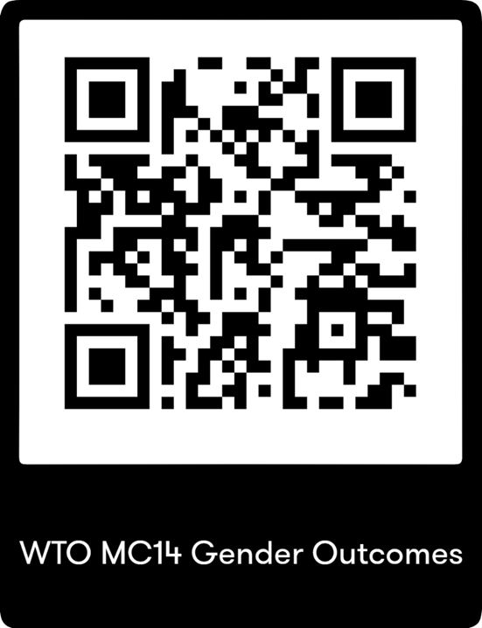

__________

Many activities identified when the Compendium was developed are not confined to a single policy area, such as overarching strategies, high-level political dialogues, legislative and regulatory frameworks. The gender equality theme therefore serves as an umbrella classification, ensuring that the IWG work is accurately reflected in the Compendium, while preserving the analytical clarity of this instrument.
See Section 3.2 for more details.
INF/MSME/W/46/Rev.5; INF/TGE/W/7/Rev.5

