

|  |  |
| --- | --- |
| **Web technologies | Front-End** | |
| Student(s’) name(s): | Kissami Gurkhan, Seit Ruslan, Mukhanov Sayat |
| Teacher name: | Dariya Bissengaliyeva |
| Project name: | Books of different genres |
| Project type: | Group / Individual |

**INTRODUCTION**

*Some people watch successful people on YouTube or they have a relative or friend who becomes successful. Because of this, people are motivated to do something. To succeed, they immediately want to start reading a book. Well, imagine that he or she has never read and does not know where to start. But to the joy of our site will help such people. When you visit the site, you immediately see popular books. And on the right there are genres that you can select by clicking on them, you will be able to see the best books about these genres. Genres are different. People read a book for different purposes. Someone wants to start a business, someone wants to develop their speech, that is, to enrich themselves, someone wants to improve their imagination. And when you choose the book you want to read. You can read it in pdf format or buy it in this store. With our promo code, you will get a big discount on this book.You can buy an electronic version of books in PDF file format at our link, it is very convenient and comfortable. There are more than 2000 different books in our store, according to your taste. There are many genres and types of publishing houses, you will definitely be delighted*

**MAIN PART (Practical) | Information about developers and their responsibilities.**

*We've been thinking a lot about the topic we're going to tackle. It took 2 days. We argued a lot. But in the end they chose the topic of the book. After that, we started sharing the work. But first we decided to watch a video about bootstrap and learn more about it. Here we see the code in which they wrote everything in one file.*



*Before that, when we were doing 1 task, we created 2 files for css.*

 *But this time we used <style> to write it to a file.*

*With the help of lessons that the teacher uploaded mudl. We found out about the Bootstrap. Now we know how to make buttons in the site. These lessons helped us to make the site more original.*

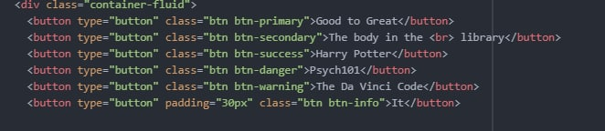

*But the other codes that we wrote, we knew this before when we wrote 1 assignment. Here we also got a lot of knowledge. Here we worked with CSS. The website helped us here w3schools.com .*

**PROGRESS [optional]**

*Now we know how to build a website. And we want to say thank you for this lesson. Since he will help us in the future. In the future, if we open a business. This knowledge that we received at the university will help us. And we can make a website without any problems. Kisami Nurkhan, Mukhanov Sayat, Ruslan Website, all these guys worked the same way. We wrote codes together. And watching lessons on YouTube, getting knowledge, we shared with the team members. And we wrote the report together. In discord, we broadcast the screen, and wrote together.*

|  |  |
| --- | --- |
| 12.11.2020 | Here we argued about topic. |
| 13.11.2020 | Here we shared work for 3 students. |
| 14.11.2020 | Sharing knowledges. |
| 15.11.2020 | We wrote code. And we wrote report. |
| 16.11.2020 | We wrote code. Here we got result. |