Minh Tran – CSCI 585 – Homework 1

Final Report

1. **Problem statement**

The goal of HW1 is to create a database modeling for an online forum that facilitates the exchange and use of ideas. The interaction between user/admin and thread/tag/reply/announcement/like is implemented in an entity relational database model.

1. **Tables and diagrams**

Table : Entity, attribute and key of an online forum

Table : Entity, relationship, connectivity and bridge table of an online forum (if needed)



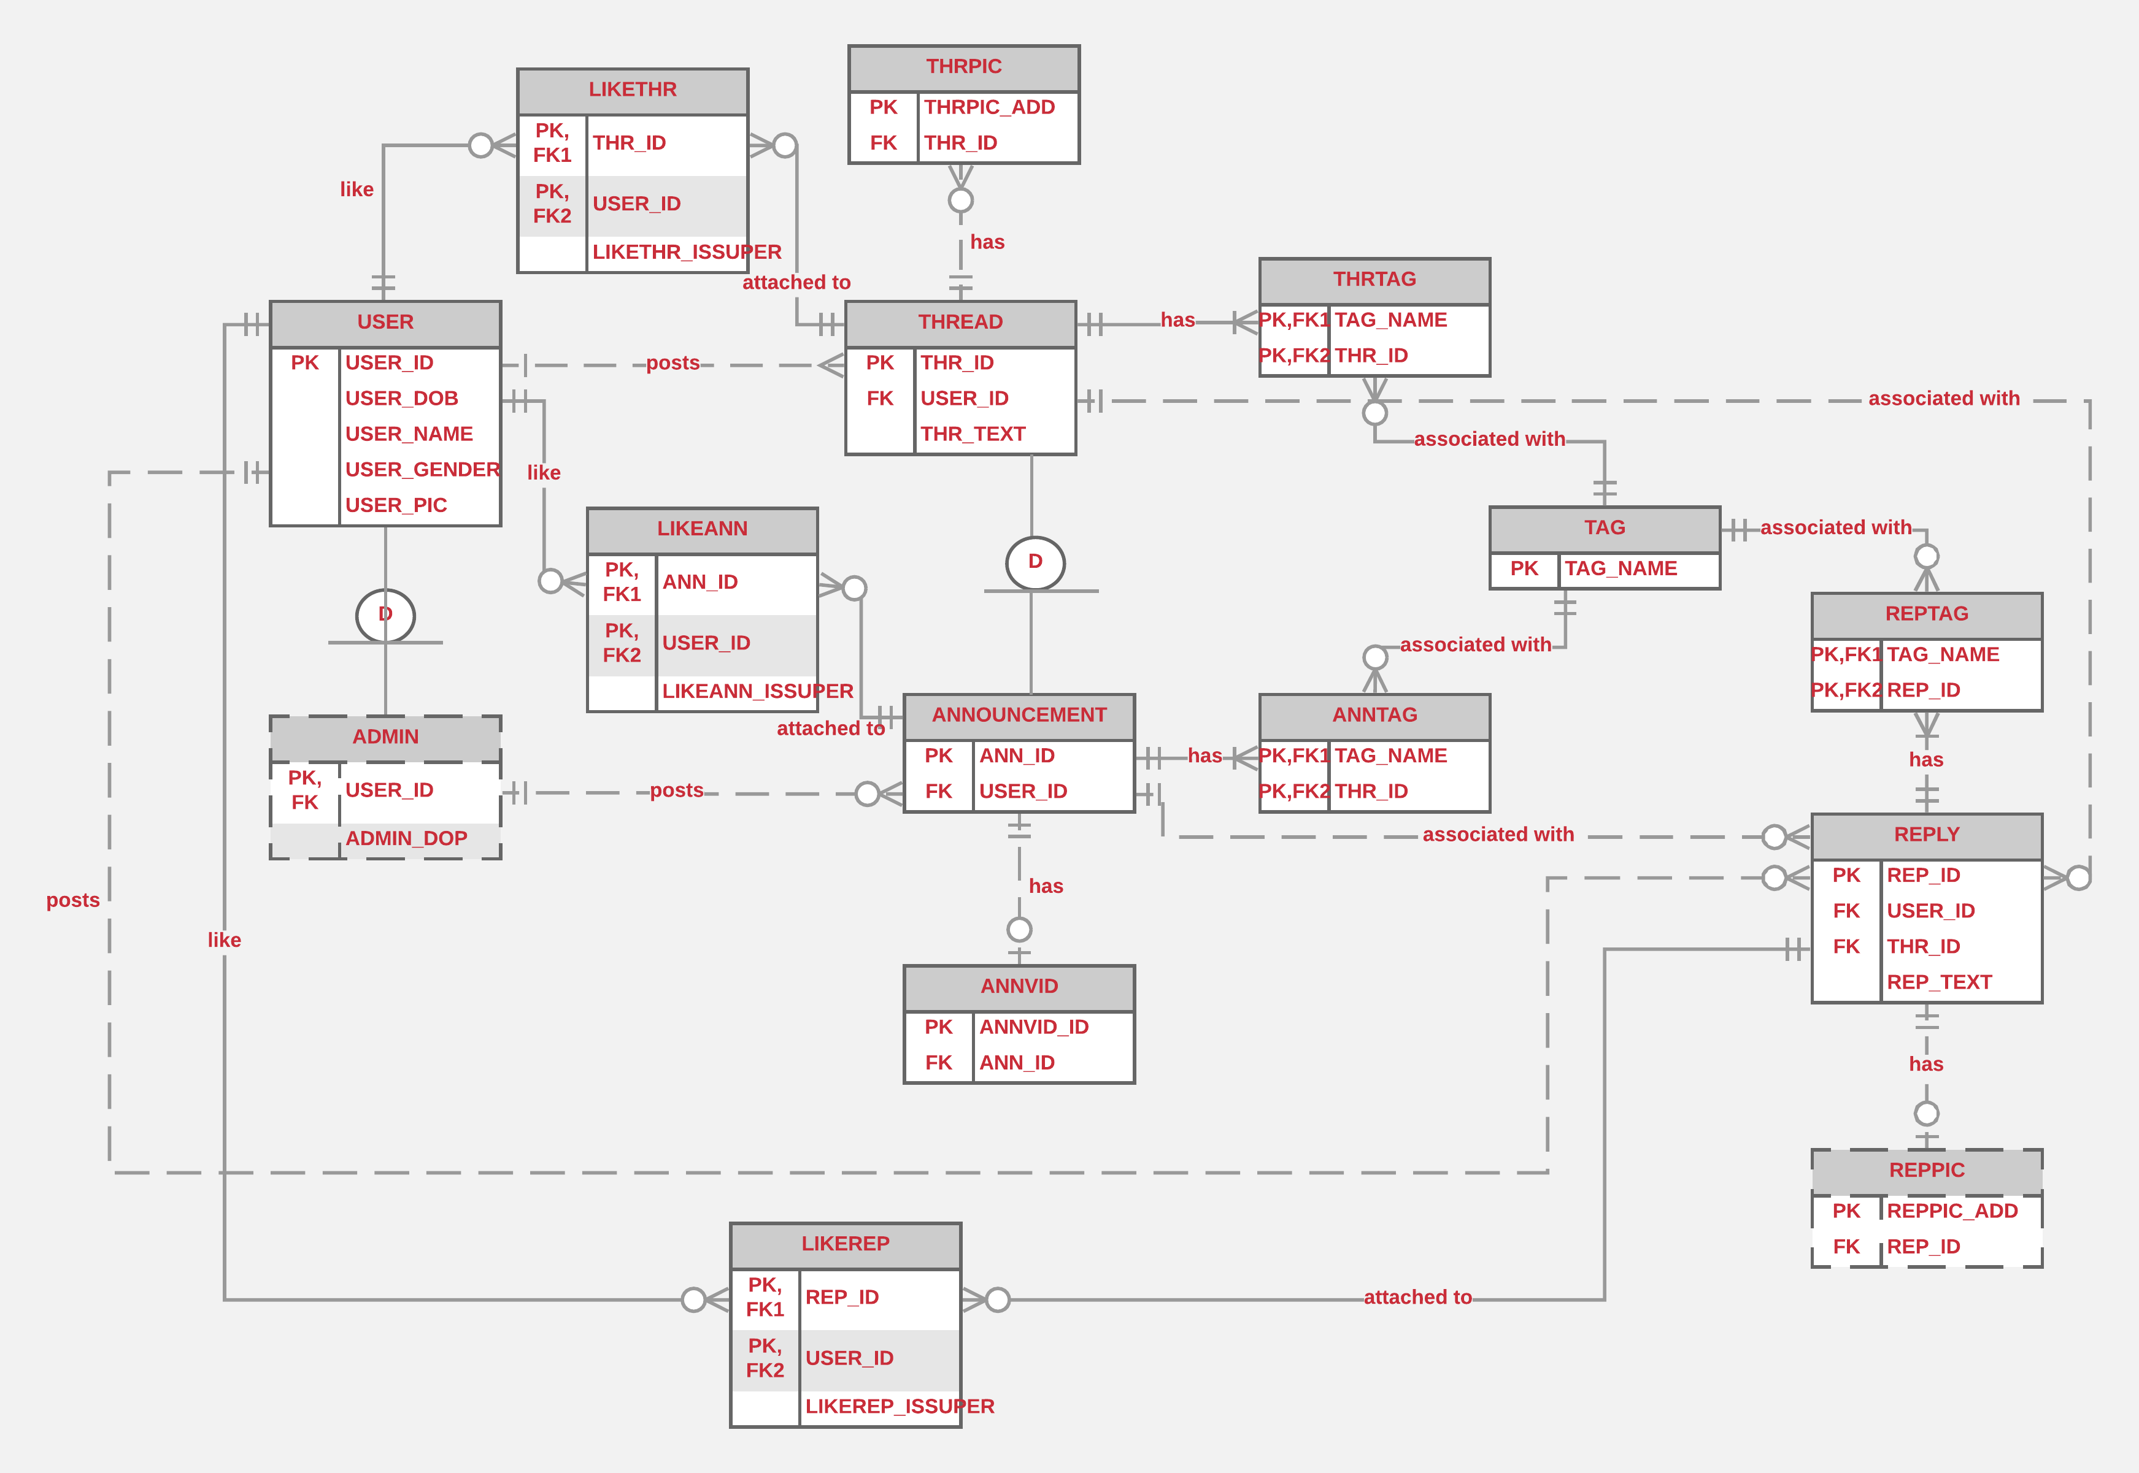

Figure : ER Diagram for an online forum (created by LucidChart)

1. **Model justification**

There are two subtypes in the ER diagram:

* An administrator (admin) is a subtype of a USER. Any admin is a user while a user can either be an admin or not, thus the 1:01 relationship. An admin has an extra attribute, which is DOP (date of promotion). A user can also have a Boolean attribute named USER_ISADMIN to easily pick out the users who are admins. This hierarchy does not need disjoint/overlapping definition because only one subtype exists under USER. An admin is a partial subtype of user because not all USERs are ADMIN.
* An announcement is a subtype of a thread, with an extra attribute of a possible video (thus the 1:01 relationship between ANNOUNCEMENT and ANNVID). An announcement is a partial subtype of a thread because not all threads are announcement. Because only one subtype of thread exists, the hierarchy relationship does not have to be defined as disjoint or overlapping.

A user can do all the following:

* Post multiple threads or replies. Each thread or reply can only be posted by one user. Thus, these are 1:0N relationship because a user can post no thread/reply whatsoever.
* Like multiple announcements, threads or replies. On the other hand, each announcement, thread or reply can be liked by multiple users. Each M:N relationship needs a bridge table (see LIKEANN, LIKETHR, LIKEREP). Note that a superlike is inserted as an extra attribute of all LIKE-related entities such as LIKETHREAD.

An admin can perform all of the following tasks:

* Because each admin is also a user, he can perform all the tasks that a user can.
* Post multiple announcements but each announcement can only be associated with 1 admin, thus the 1:0N relationship.

Another situation arises that requires the use of a bridge table:

* Each announcement, reply or thread can have multiple tags while each tag can be associated with multiple announcements, replies or threads. Thus there is a need for a bridge table for each of these relationships (see ANNTAG, REPTAG, THRTAG)

Each reply can have at most one pic, thus a 1:01 relationship is needed between REPLY and REPPIC.

There are no optional or multi-valued attributes in this design.

All the relationships are weak relationships except in the bridge table (ANNTAG, REPTAG, THRTAG, LIKEANN, LIKETHR, LIKEREP). These bridge tables require strong relationships to connect to associated entities because they transform M:N relationship to 2 1:N relationships.