***Minh Tran – HW6: Support Vector Machine***

1. **Part 1: Implementation:**
2. **Linear SVM:**
   * Libraries:

Pycharm IDE is used with Python 3.6 as the programming language. Basic libraries such as numpy, matplotlib and sys are used to facilitate the program. CVXOPT (convex optimization) library is used for constrained optimization solver.

* + Linear SVM details:
* Using linear kernel (dot product)

* + Data structure:
    - * The given txt files are read by np.loadtxt, then separates into X and y
      * Train_test_split is used to separate the given dataset to train and test sets with random seed embedded in the function to ensure controlled randomization
  + Files included:
* svmMT.py - Contains the implementation of SVM from scratch
  + Class SupportVectorMachine:
  + initialization (kernel type, kernel parameters including power for polynomial and gamma for rbf, penalty term C, intercept, weights, support vector sv)
  + fit (with embedded cvxopt optimizer and kernel calculation)
  + predict: classify a new point
  + predict_X2: strictly for linear kernel plotting
  + plot_linear_SVM, plot_nonlinear_SVM, display: for plotting purposes
  + main: prepare data, build svm engine, train, test and plot.
* utils.py:
  + Different types of kernel functions: linear, polynomial, rbf
  + Accuracy_score function
  + Data preparation functions: shuffle_data, train_test_split, normalize, standardize
  + Code-level optimization:
    - Only the Lagrange multipler greater than certain threshold is selected to make the solution scalable.
    - Penalty terms are added to further constrain the lagrange multiplers if needed
    - Different test sizes are tested to observe the robustness of the svm engine
  + Challenges:
    - Dataset is quite small so if we trained only a subset of data (say 30%), then testing error may be high.
  + Results:
* Original dataset is plotted:

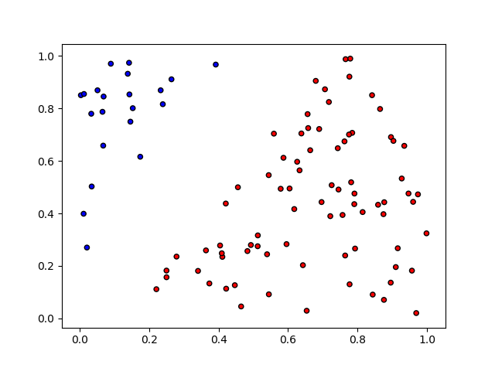

* Setting the test size to be 30%, then the linear SVM plane is plotted with the support vectors circled

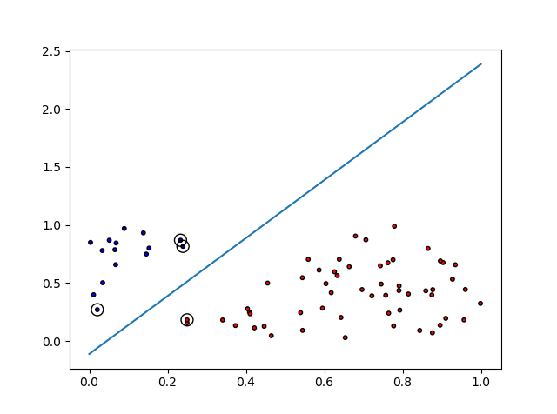

* Testing accuracy: 100% (because the data is well linearly separated)
* Training accuracy: 100%
* Support vectors:

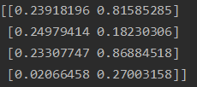

With corresponding labels {-1, 1, -1, -1}, so 3 points on the one side and the other point on the other side.

1. **Nonlinear SVM:**
   * Nonlinear SVM details:

* Using polynomial kernel (power=2, coefficient=0) and rbf kernel (gamma=0.4)
  + Results:
* Original data:

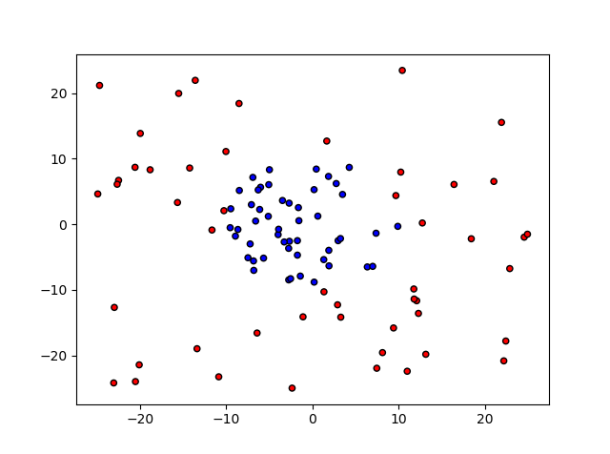

* Setting the test size to be 30%, then the nonlinear polynomial SVM plane is plotted with the support vectors circled

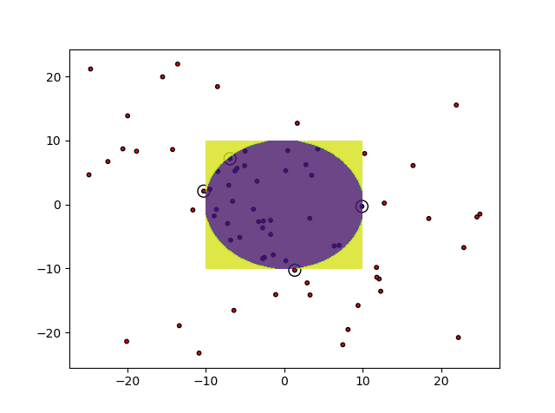

* Testing accuracy: 100% (because the data is well linearly separated)
* Training accuracy: 100%
* Support vectors:



With corresponding labels {1, 1, -1, -1}, so 2 points on the one side and the other 2 points on the other side.

1. **Part 2: Software familiarization**
2. **Sklearn for SVM:**

* Scikit-Learn offers useful built-in packages to implement SVM with the ability to tune different parameters
* 3 simple steps are needed:
  + Import data
  + Create model using the module svm.SVC

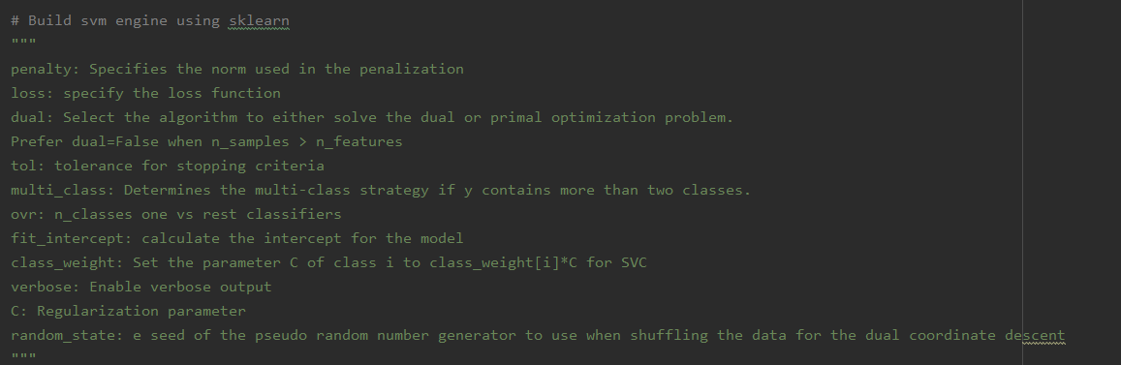

Linear model

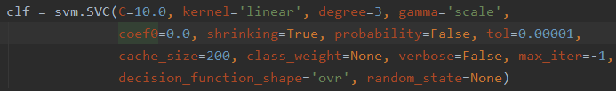

Nonlinear model

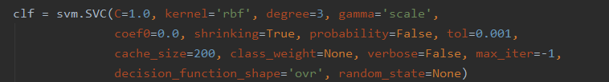

* Fit the model
* Calculate the accuracy rate on test data
* Linear SVM Results
  + Run file svm_MT_SK.py

Support vectors for linear SVM

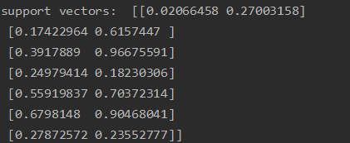

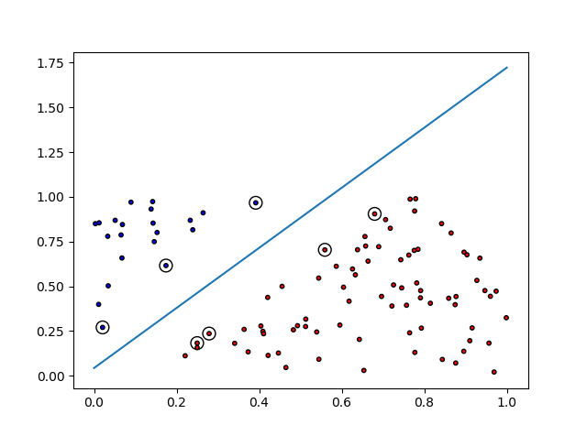

Support vectors for nonlinear SVM

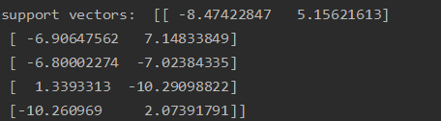

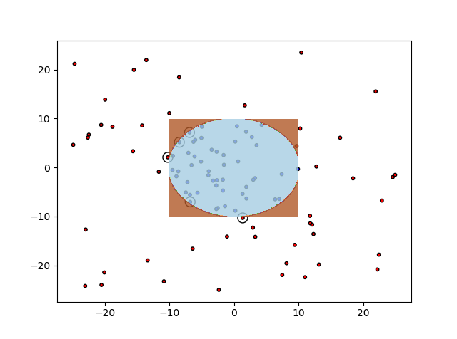

1. **Applications**

The aim of using SVM is to correctly classify unseen data. SVMs have a number of applications in several fields. Some common applications of SVM are:

* Face detection – SVM classify parts of the image as a face and non-face and create a square boundary around the face.
* Text and hypertext categorization.
* Classification of images – Use of SVMs provides better search accuracy for image classification. It provides better accuracy in comparison to the traditional query-based searching techniques.
* Bioinformatics – It includes protein classification and cancer classification. We use SVM for identifying the classification of genes, patients on the basis of genes and other biological problems.
* Protein fold and remote homology detection – Apply SVM algorithms for protein remote homology detection.
* Handwriting recognition – We use SVMs to recognize handwritten characters used widely.
* Generalized predictive control(GPC) – Use SVM based GPC to control chaotic dynamics with useful parameters.