Minh Tran

Assignment 1 CSCI 596

1. Measuring computational complexity

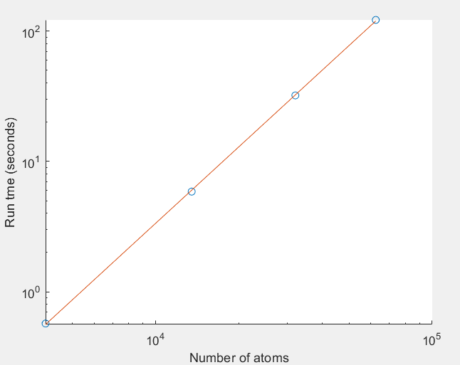

The fitted value of α is **1.9506**

1. Theoretical Flop/s Performance

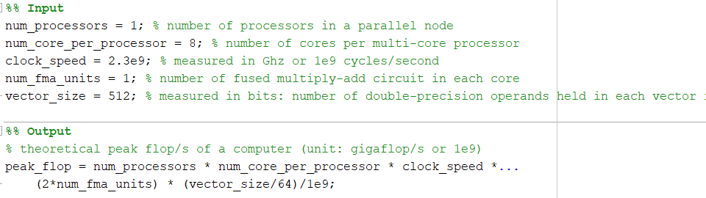

My computer’s theoretical peak performance is: 294.4 gigaflop/s

1. Optional part: Linked-list-cell molecular dynamics lmd-sqrt-flop.c
   1. Compile the program:
      1. In visual studio: run **gcc -o lmd_sqrt_flop lmd_sqrt_flop.c -lm** where gcc is the compiler, -0 stands for optimizer, then executable file name, then source file name, then -lm for library math
      2. Modify the input (if needed) in the **lmd_sqrt_flop.in**. Detailed information is extracted from the header file

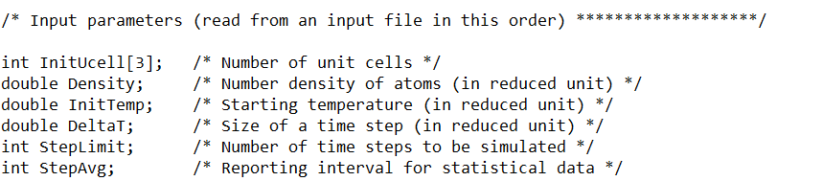

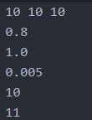

So there are 1000 cells, density of 0.8 atom/cell

* + 1. Run the program by: **cmd /c ‘lmd_sqrt_flop < lmd_sqrt_flop.in’**
  1. The running time, along with measured flop/s performance, will be reported in the standard output of the program.

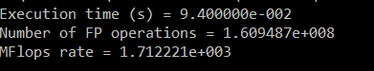

Number of FP/sec = 1.609487e8/9.4e-2 = 1.71e9 flop/s = 1.71 gigaflop/s

So the % of theoretical peak flop/s performance I achieved is: 1.71/294.4 = 0.6%