Minh Tran

Assignment 2 CSCI 596: Message Passing Interface

Goal: Implement your own global summation with MPI

1. Implement the function global_sum using MPI_send and MPI_recv

Below is the image of the source code:

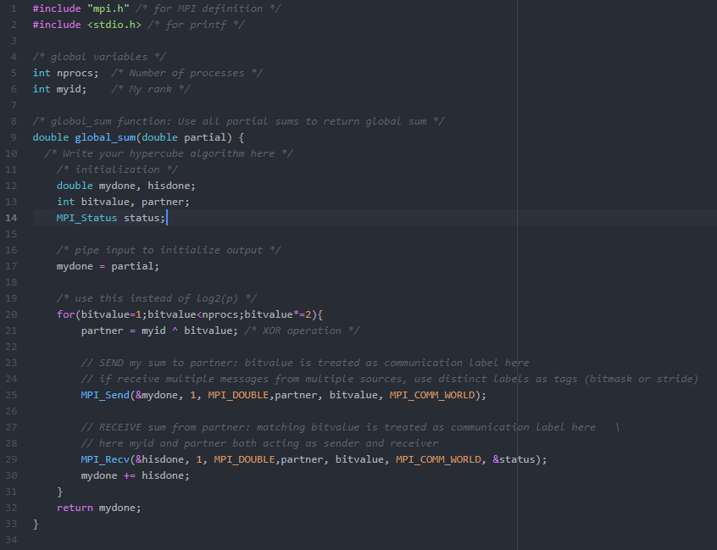

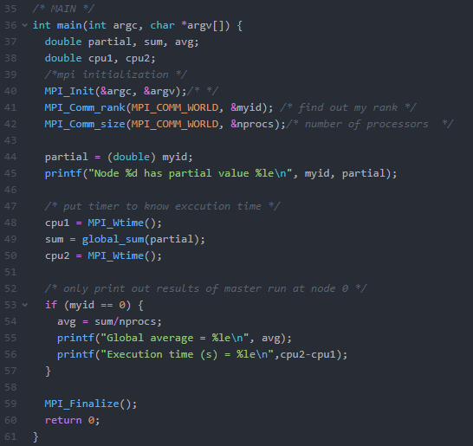

To compile this program, on discovery cluster node run:

**Mpicc -o global_avg global_avg_blank.c**

To submit the job run:

**Sbatch global_avg.sl**

1. Printout: run: **more global_avg.out**

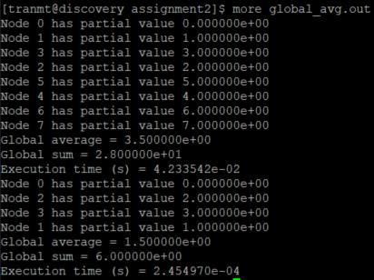

As observed, there are 8 nodes (corresponding to 8 processors in the first run) and 4 nodes (corresponding to 4 processors in the second run). The execution time of the 2nd run is 3 order of magnitudes less than the 1st run.

The message is only printed out for the master run (starting at node 0).

* Node 0 has partial value of 0 (starting point)
* Node 1 has partial value of 1 (id of node 1) (first pairwise exchange information in this master run is between node 0 and node 1 at level 0
* The global average = global sum/number of processors:
  + First run:
    - global sum = 0 + 1 + …+ 7 = **28**
    - number of processors: 8
    - global average = 28/8 = **3.5**
  + Second run:
    - global sum = 0 + 1 + …+ 3 = **6**
    - number of processors: 4
    - global average = 28/8 = **1.5**

