Minh Tran

Assignment 3 CSCI 596: Parallel Computation of Pi and Scalability Analysis

1. Programming

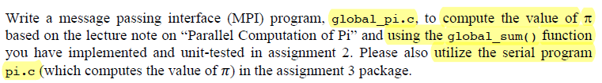

**Solution:**

Below is the image of the source code:

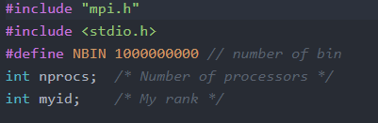

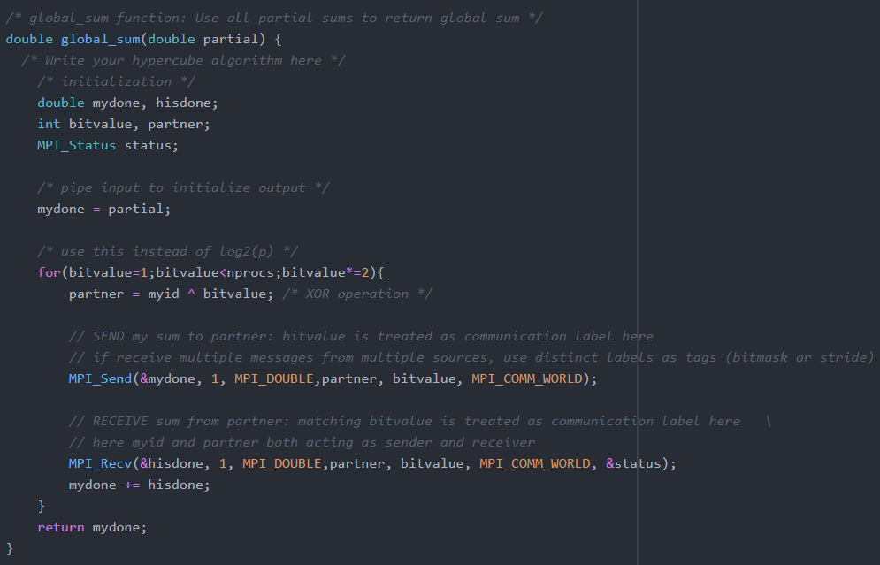

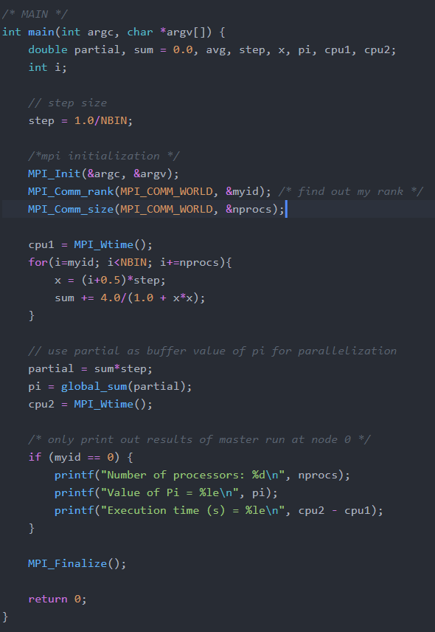

To compile this program, on discovery cluster node run:

**Mpicc -o global_pi global_pi.c**

To submit the job run: **sbatch global_pi.sl**

1. Scalability
2. Fixed problem-size scaling

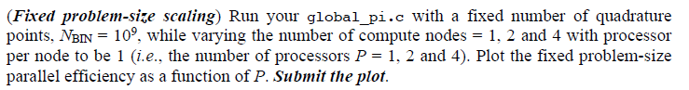

1. Isogranular scaling

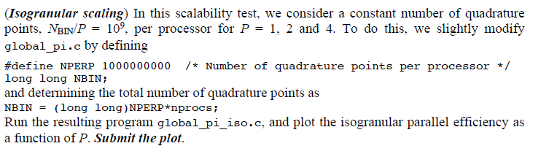

**Solution:**

Here is the printout of the output file.

