Minh Tran

Assignment 4 CSCI 596: Parallel Molecular Dynamics

1. Asynchronous Messages

The new program pmd_irecv.c is modifed from pmd.c by inserting proper asynchronous messaging lines of code. Note that nrc is number of atoms received while nsd is number of atoms sent. The MPI_Irecv requires adjustment from MPI_Recv by changing &status to &request and adding MPI_Wait. The changes are marked by //NEW CODE

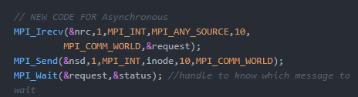

A similar adjustment is made for the buffer (note the commented out code as we do not need the deadlock-avoidance scheme anymore)

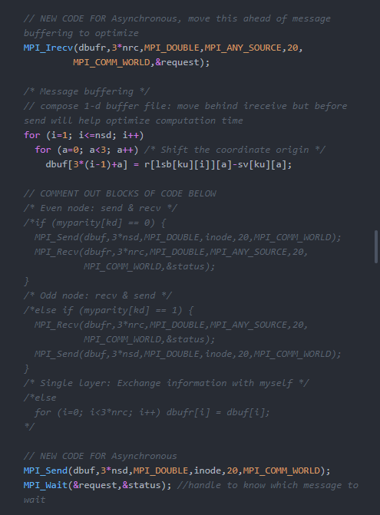

To complete this part, run the following on cluster:

* Compile the program by: (The input file pmd.in and header pmd.h are automatically read by the following scripts in both C programs: pmd.c and pmd_irecv.c)



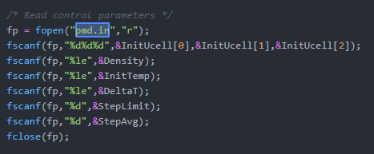

* + **Mpicc -o pmd pmd.c -lm**
  + **Mpicc -o pmd_irecv pmd_irecv.c -lm**
* Run sbatch:
  + **Sbatch pmd_irecv.sl**
  + This sbatch will get 4 computing nodes, each with 4 processors. The job consists of 3 runs, each run has two tasks: pmd_irecv and pmd. Then it will generate output pmd_recv.out.

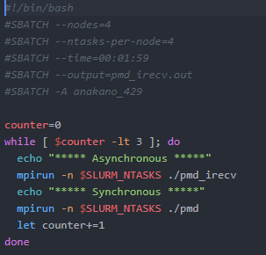

Below is the output pmd_irecv.out. Note that each run consits of one asynchronous part (in red shadow) and one synchronous part (in yellow shadow). The processing computational and the communication time is highlighted in green.

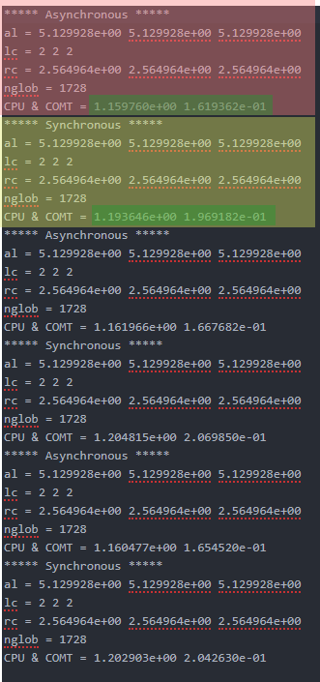

The results of computing time is shown below:



This part can be done interactively:

* **Run salloc –nodes=4 –ntasks-per-node=4 -t 30**

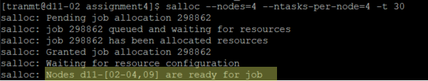

* In another terminal, run **ssh d11-02** and **top** to see the reserved nodes

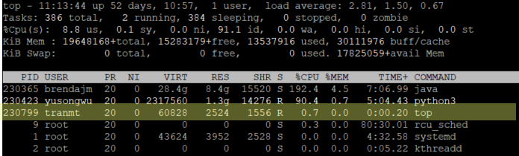

1. Communicators
2. Modified source code

The modifications are clearly marked with //NEW CODE, which are in several places:

* In the header file pmd_split.h, the variable definition is added from calc_pv() as well as the change in the number of processors

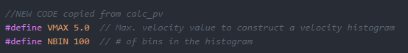



* In the input file pmd_split.in, I change the parameters to the following:

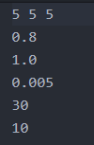

* In the program file pmd_split.c (the original copy is from pmd_irecv.c), the major changes are:
  + Change input file name



* + Add this following the initialization part

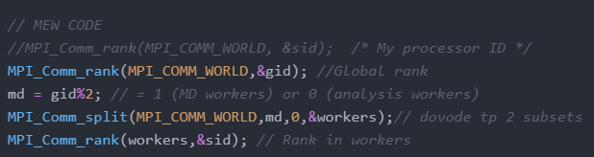

* + Modify to add rank-dependent task assignment

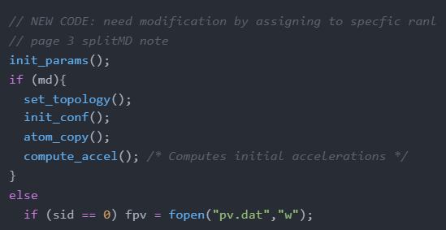

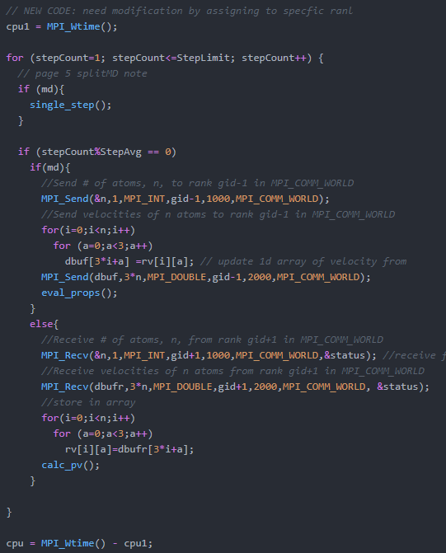

* + Add this to the finalization

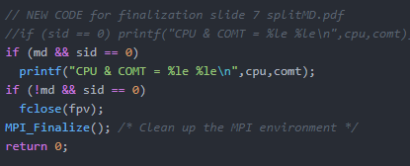

* + Change most MPI_COMM_WORLD to workers

1. Run the program

Compile it by **mpicc -o pmd_split pmd_split.c -lm**

Then run **sbatch pmd_split.sl** on the computing node

The first output is pmd_split.out, stating the computational time

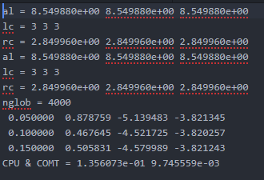

The second output is the pv.dat, which can be post-processed in excel by separating data of the three timesteps to plot the pdf:

