Minh Tran

Assignment 7 CSCI 596: OpenMP Target Offload and DPC++ Programming

1. OpenMP Target offload computation of Pi

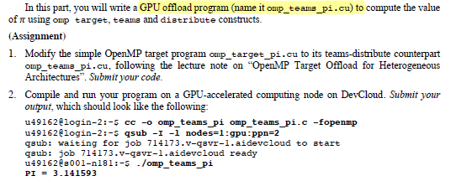

**Solution:**

#include <omp.h>

#include <stdio.h>

#define NBIN 1000000

#define NTRD 96

#define NTMS 12 // ### number of teams

int main() {

float step,sum=0.0,pi;

step = 1.0/(float)NBIN;

// data privatization among teams ###

float sum_teams[NTMS];

for (int j=0; j<NTMS; j++) sum_teams[j] = 0.0;

// copy variables step and sum

// #pragma omp target map(step,sum) ###

// ###

#pragma omp target teams map(step, sum_teams) num_teams(NTMS)

{

// ###

#pragma omp distribute // distribute the work between num_teams

// for each team, need to define index of thread

for (int j=0; j<NTMS;j++){

long long ibgn = NBIN/NTMS*j;

long long iend = NBIN/NTMS*(j+1);

if (j==NTMS-1) iend = NBIN;

// modified for offset and private accummulator

// thread reduction of sum; specify number of threads

# pragma omp parallel for reduction(+:sum_teams[j]) num_threads(NTRD)

for (long long i=ibgn;i<iend; i++) {

float x = (i+0.5)*step;

sum_teams[j] += 4.0/(1.0+x*x);

}

}

}

// ###

for (int j=0; j<NTMS;j++) sum+= sum_teams[j];

pi = sum*step;

printf("PI = %f\n",pi);

return 0;

}

To run on devcloud:

* Open local cygwin terminal to copy local files to cloud
* Run **scp -r csci596-as07 devcloud:home/u51841/project_mt/** -> copy all files to folder in cloud
* Open cygwin and run ssh devcloud
* Then go to the project folder on cloud and compile the program: **cc -o omp_target_pi_teams omp_target_pi_teams.c -fopenmp**
* Run interactive job on a GPU-accelerated computing node: **qsub -I -l nodes=1:gpu:ppn=2**
* Run the program: **./omp_target_pi_teams**

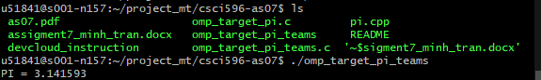

1. DPC++ Computation of Pi

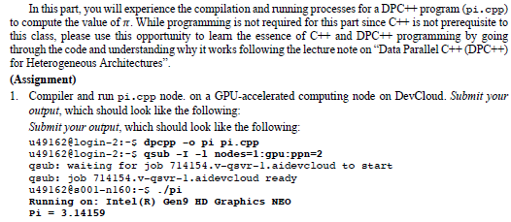

**Solution:**

