**CSCI-596 Homework 1**

Youzhi Qu

CSCI-596 homework1

Prof. Aiichiro Nakano

1-1.

|  |  |  |  |
| --- | --- | --- | --- |
| N | T | Log10(N) | Log10(T) |
| 4000 | 0.57101 | 3.602059991 | -0.243356286 |
| 13500 | 5.872 | 4.130333768 | 0.768786047 |
| 32000 | 32.122 | 4.505149978 | 1.506802578 |
| 62500 | 121.95 | 4.795880017 | 2.086181805 |

1-2.

3GHz*2(x+FMA)*4(SIMD)*4(quadcore)=96Gflop/s

2-1.

**global.c :**

#include "mpi.h"

#include <stdio.h>

int nprocs; /* Number of processors */

int myid; /* My rank */

double global_sum(double partial) {

/* Implement your own global summation here */

doubke mydone, hisdone;

int bitvalue , partner;

MPI_Status status;

mydone = partial;

for( bitvalue = 1 ; bitvalue < nprocs ; bitvalue *= 2){

partner = myid ^ bitvalue ;

MPI_Send(&mydone, 1, MPI_DOUBLE,partner,bitvalue,MPI_COMM_WORLD);

MPI_Recv(&hisdone, 1, MPI_DOUBLE,partner,bitvalue,MPI_COMM_WORLD,&status);

mydone += hisdone;

}

return mydone;

}

int main(int argc, char *argv[]) {

double partial, sum, avg;

MPI_Init(&argc, &argv);

MPI_Comm_rank(MPI_COMM_WORLD, &myid);

MPI_Comm_size(MPI_COMM_WORLD, &nprocs);

partial = (double) myid;

printf("Node %d has %le\n", myid, partial);

sum = global_sum(partial);

if (myid == 0) {

avg = sum/nprocs;

printf("Global average = %le\n", avg);

}

MPI_Finalize();

return 0;

}

**global.sl:**

#!/bin/bash  
#SBATCH --ntasks-per-node=4  
#SBATCH --nodes=2  
#SBATCH --time=00:00:59  
#SBATCH --output=global.out  
#SBATCH -A lc_an2  
WORK_HOME=/home/rcf-proj/an2/youzhiqu  
cd $WORK_HOME  
srun -n $SLURM_NTASKS --mpi=pmi2 ./global  
srun -n 4 --mpi=pmi2 ./global

**global.out:**

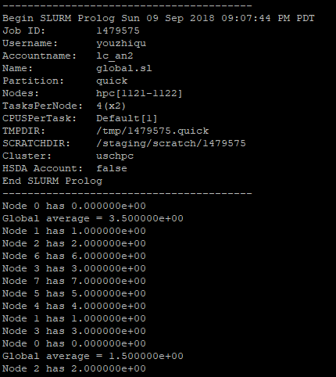

Begin SLURM Prolog Sun 09 Sep 2018 09:07:44 PM PDT

Job ID: 1479575

Username: youzhiqu

Accountname: lc_an2

Name: global.sl

Partition: quick

Nodes: hpc[1121-1122]

TasksPerNode: 4(x2)

CPUSPerTask: Default[1]

TMPDIR: /tmp/1479575.quick

SCRATCHDIR: /staging/scratch/1479575

Cluster: uschpc

HSDA Account: false

End SLURM Prolog

----------------------------------------

Node 0 has 0.000000e+00

Global average = 3.500000e+00

Node 1 has 1.000000e+00

Node 2 has 2.000000e+00

Node 6 has 6.000000e+00

Node 3 has 3.000000e+00

Node 7 has 7.000000e+00

Node 5 has 5.000000e+00

Node 4 has 4.000000e+00

Node 1 has 1.000000e+00

Node 3 has 3.000000e+00

Node 0 has 0.000000e+00

Global average = 1.500000e+00

Node 2 has 2.000000e+00