**GY-39 Weather Sensor Guide**

**Background**

GY-39 sensor board is a low cost, pressure, humidity, light intensity sensor with onboard microcontroller (MCU). GY-39 is a low power device which required supply voltage between 3 to 5 volts. The microcontroller is to gather data from ME280, and MAX44009 sensors, calculate, and generate output. It is also used for device configuration such as setting the UART baud rate, disable/enable outputs, and setting I2C address. Two communication modes are supported, either by serial UART (TTL voltage level), or by I2C. There is also an option to work with ME280, and MAX44009 sensors directly.

The default setting is using onboard MCU and serial communication with the UART configurate for 9600bps, N, 8, 1.

**Specification**

|  |  |
| --- | --- |
| **Reference Data** | **Reference Values** |
| Sensing Temperature | -40 ~ 85c |
| Sensing Humidity | 0 ~ 100% |
| Sensing Light Intensity | 0.025 ~ 188000lux |
| Sensing Barometric Pressure | 300 ~ 1100hpa |
| Data Acquisition Frequency | 10Hz |
| Supply Voltage | 3 ~ 5V |
| Current Draw | 5mA |
| Operating Temperature | -40 ~ 85c |
| Storage Temperature | -40 ~ 125c |
| Board Dimension | 24.3mm X 26.7mm |
| Onboard Sensor ICs | ME280 + MAX44009 |

**Pins Information**

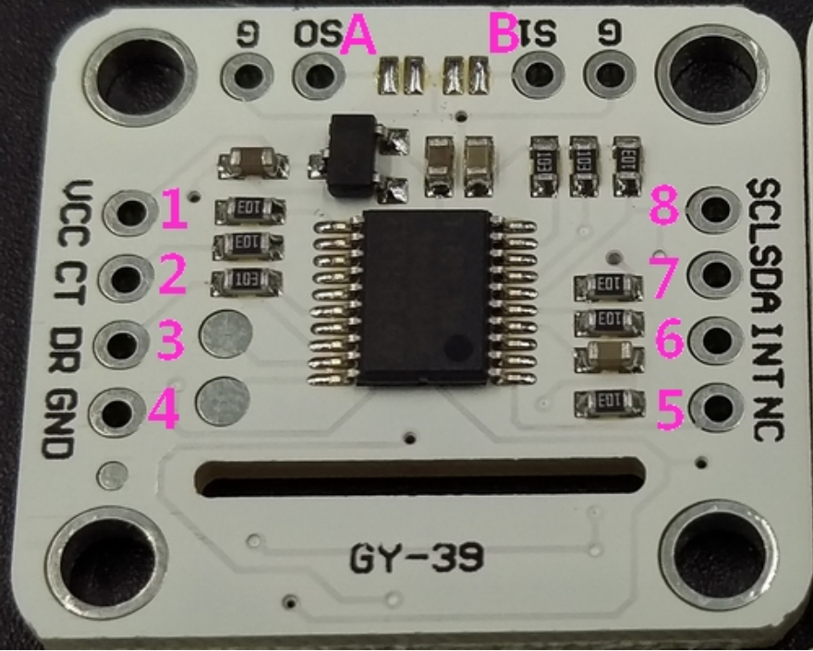

|  |  |  |
| --- | --- | --- |
| Pin1 | VCC | Supply Voltage (3V – 5V) |
| Pin2 | CT | MCU_UART_TX / MCU_I2C_SCL |
| Pin3 | DR | MCU_UART_RX / MCU_I2C_SDA |
| Pin4 | GND | Ground |
| Pin5 | NC | Reserved, don’t connect |
| Pin6 | INT | To Disable MAX44009 (No MCU mode) |
| Pin7 | SDA | SDA for ME280 and MAX44009 (No MCU mode) |
| Pin8 | SCL | SCL for ME280 and MAX44009 (No MCU mode) |
| PinA | S0 | MCU_UART by Default / MCU_I2C when S0 pull to ground |
| PinB | S1 | MCU mode by Default / No MCU mode when S1 pull to ground |

**Switches Information (1=VCC, 0=GND)**

|  |  |  |
| --- | --- | --- |
| **S0** | **S1** | **Mode** |
| 1 | 1 | MCU_UART (Default), Data and Control |
| 0 | 1 | MCU_I2C, Data |
| 1 | 0 | Not covered in this menu. Refer to ME280 and MAX44009 datasheets |
| 0 | 0 | Not covered in this menu. Unknown consequences. |

**Default MCU UART Mode Operation (S0=1, S1=1)**

In this mode, the weather board automatically output sensors’ data using the UART set to 9600bps baud rate. The output message is in bytes started with headers and ended with a checksum byte. The pattern of the message starts with two preamble bytes and ended with a lower byte for checksum.

For light intensity data (from MAX44009), assume the MCU have the following message (in Hex):

[5A,5A,15,04,00,00,00,B4,81]

Here are how we can consume the message:

[5A,5A] Two preamble bytes

[15] Light intensity data type from MAX44009

[04] Payload has 4 bytes

[00,00,00,B4] Light intensity measurement in big endian, for calculation:

(00 << 24) | (00 << 16) | (00 << 8) | B4 = B4

DEC(B6) = 182

Light intensity = 182 / 100 = 1.82 Lux

[81] Lower byte of the sum of all previous bytes in the message. To validate the data is not corrupted, compare the checksum with the running sum by this calculation:

(5A + 5A + 15 + 04 + 00 + 00 + 00 + B4) & 0xFF = 81

For weather data (from BME280), assume the MCU have the following message (in Hex):

[5A,5A,45,0A,09,88,00,95,33,47,10,39,01,2B,18]

Here are how we can consume the message:

[5A,5A] Two preamble bytes

[45] Weather data type from BME280

[0A] Payload has 10 bytes

[09,88] Temperature in big endian, for calculation:

(09 << 8) | 88 = 0908

DEC(0908) = 2440

Temperature = 2440 / 100 = 24.40 c

[00,95,33,47] Pressure in big endian, for calculation:

(00 << 24) | (95 << 16) | (33 << 8) | 47 = 953347

DEC(953347) = 9777991

Pressure = 9777991/ 100 = 97779.91 pa

[10,39] Humidity in big endian, for calculation:

(10 << 8) | 39= 0908

DEC(0908) = 1039

Humidity = 4153 / 100 = 41.53 %

[01,2B] Humidity in big endian, for calculation:

(01 << 8) | 2B = 012B

DEC(012B) = 299

Elevation = 299 m

[18] Lower byte of the sum of all previous bytes in the message. To validate the data is not corrupted, compare the checksum with the running sum by this calculation:

(5A + 5A + 45 +0A + 09 + 88 + 00 + 95 + 33 + 47 + 10 + 39 + 01 + 2B) & 0xFF = 18