How to install Perl and Debugger using the Internet
Adam Resnick

- Download & Install Perl
  - Open a web browser and go to http://www.activestate.com/activeperl
  - Click on the “Free Downloads” link
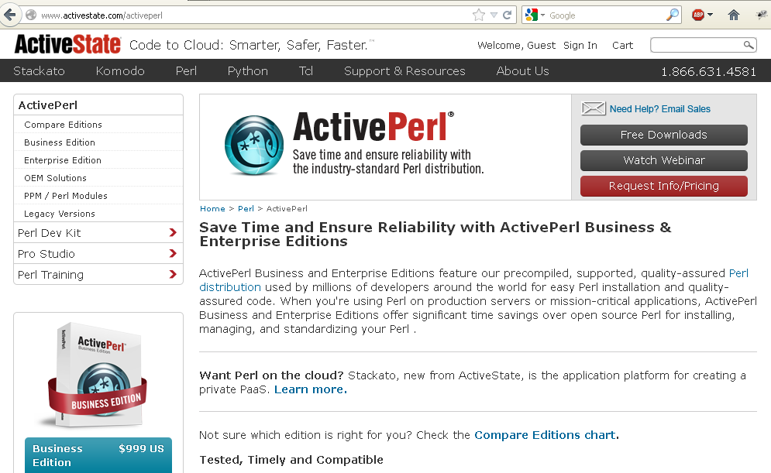

  - In the next screen, click on the X86 Windows Installer here.
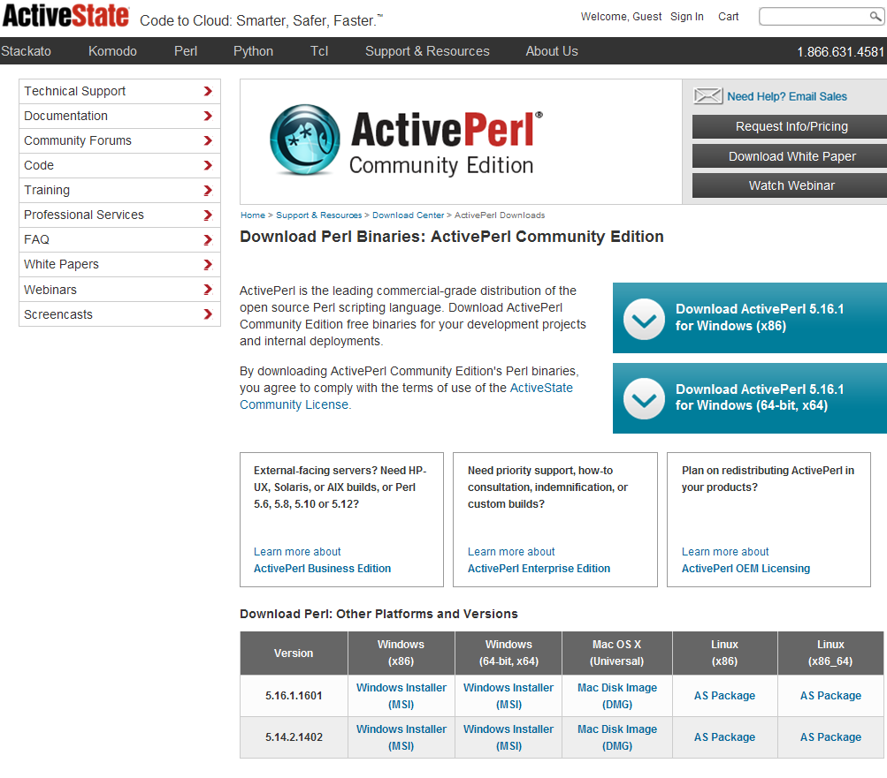
This will start the downloading of the Perl MSI file [it’s about 24 megabytes in size]
ActivePerl-5.14.2.1402-MSWin32-x86-295342.msi

  - Save this file to here: c:\vault\ActivePerl-5.14.2.1402-MSWin32-x86-295342.msi
- Install Perl 5.14.2.1402
  - Press <Start><Run> c:\vault
  - Double-click on the ActivePerl-5.14.2.1402-MSWin32-x86-295342.msi
  - Within the Perl Installer, follow these steps:
    - In this window, click “Next”
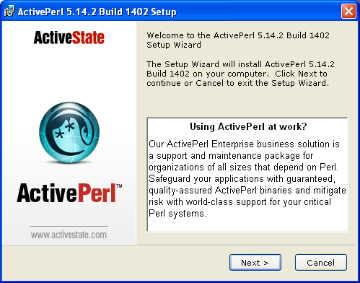
    - In the license agreement window, click “I accept…” and press “Next”
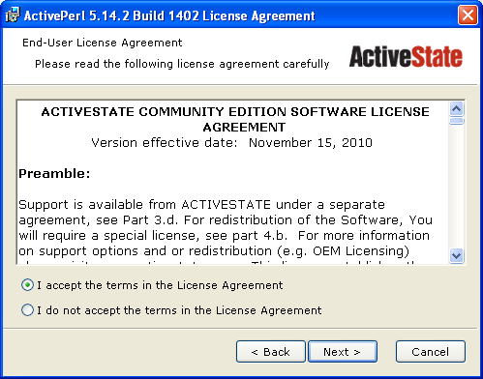
    - In this window, click “Next”
NOTE: This will install perl to the c:\perl\ directory which should be fine.
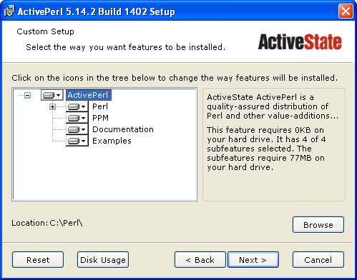
    - In this window, click “Next”
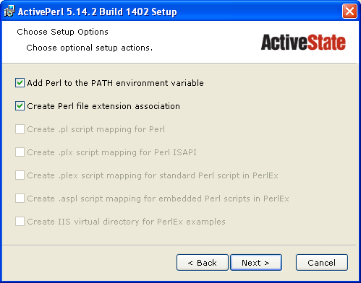
NOTE: You want these options so that you can run Perl from the command-line
    - In this window, click “Install”
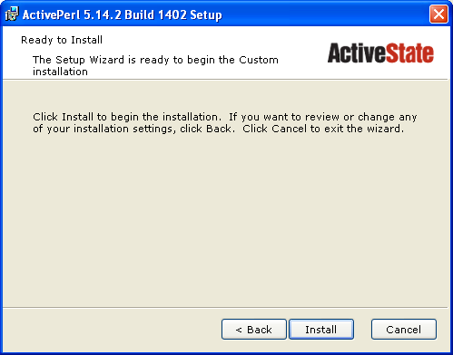

    - When the install is complete, you should see this window:
Uncheck, the checkbox and press Finish.
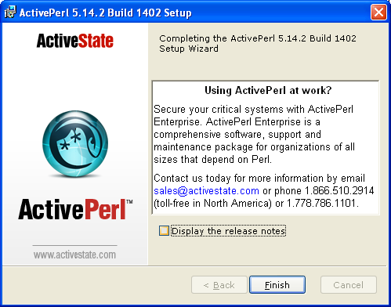
Now you have installed Perl on your Windows computer!

- Download & Install PadWalker PPM [using CPAN]
  - Open a dos window by pressing <Start><Run>cmd
  - Within the dos window, type-in these commands
    - DOS> Cd /d c:\
    - DOS> cpan
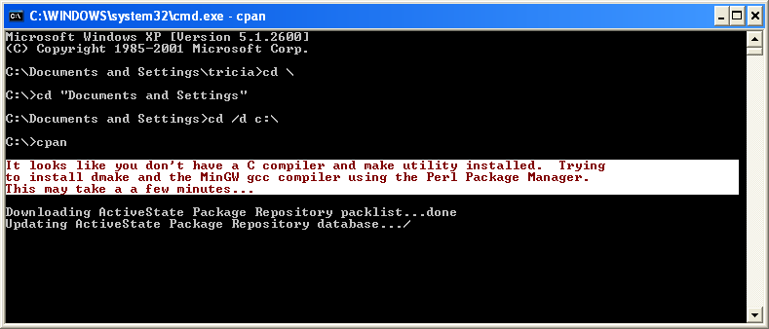
NOTE: CPAN will see that you do not have a C compiler and make utility and then proceeds to start downloading MinGW and dmake for you so that you have the tools you need to compile perl packages.
    - Next, you should see a cpan> prompt
Type-in this command at the cpan prompt:
cpan> install PadWalker
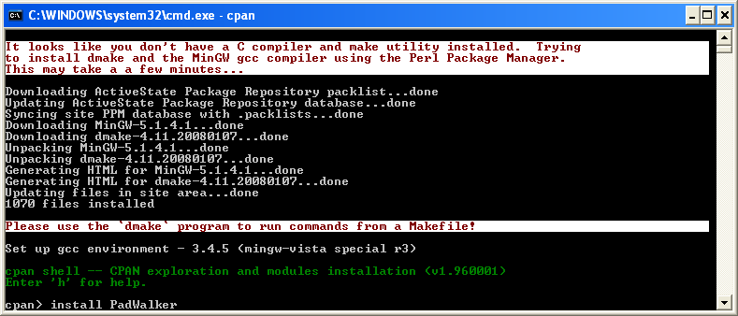
    - If things are working well, you should see this after a few minutes
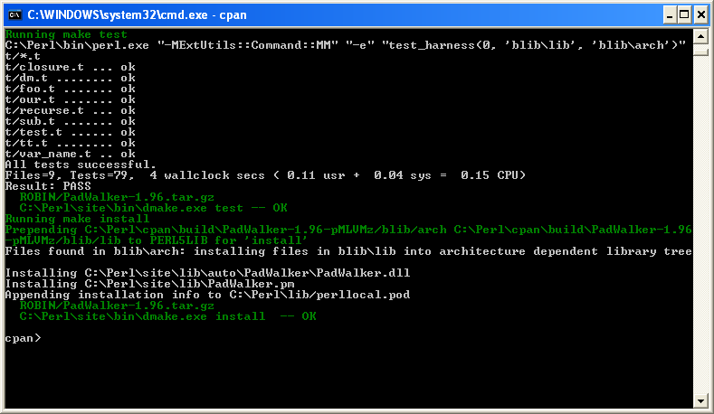
    - Finally, type-in quit at the cpan prompt and press enter
cpan> quit <enter>
    - To verify that PadWalker was installed, run this command in the dos window
DOS> ppm query *
This will generate a listing of every perl package that is installed.
You are looking for the PadWalker module in this listing.
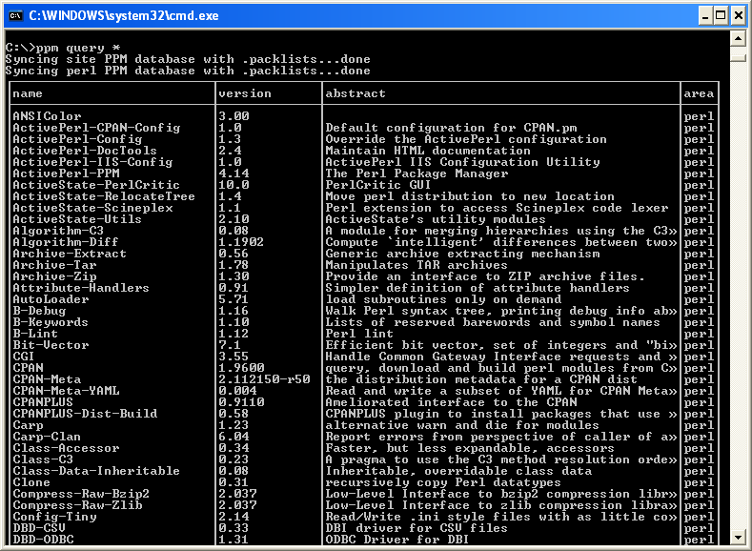
If you see PadWalker, then you have successfully installed the PadWalker module
- Download & Install Notepad++
  - Open a web browser and go to http://notepad-plus-plus.org/download/
  - In the web page, click the large “Download” button in the middle of the page.
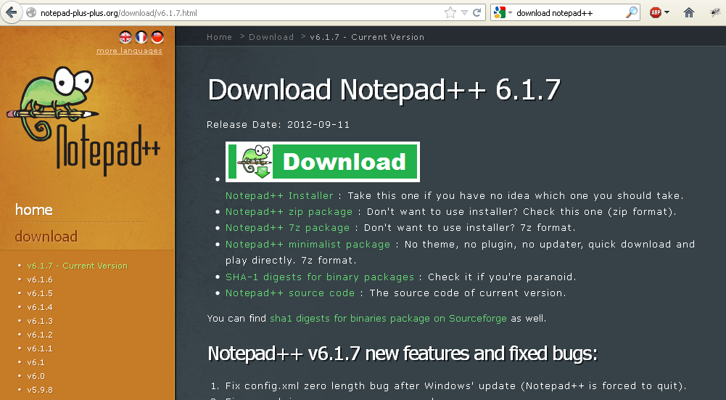
  - In the popup, click “Save File”
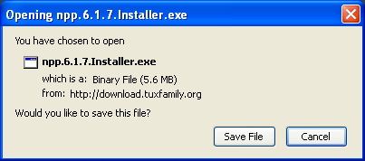
  - Save this Notepad++ installer to your c:\vault\ dirctory
  - Run the c:\vault\npp.6.1.7.Installer.exe
    - Press <start><run>c:\vault
    - Double-click on npp.6.1.7.Installer.exe
    - In this window, click “OK”
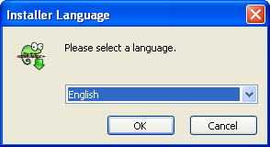
    - In the next window, click ”Next”
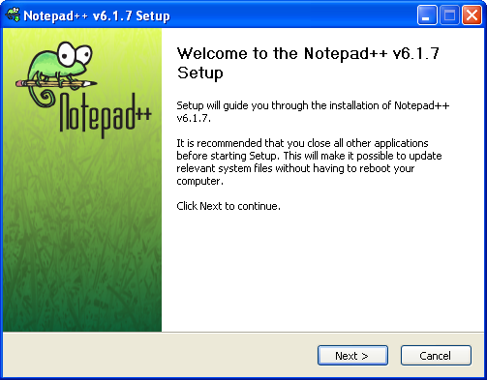
    - In this window, click “I Agree”
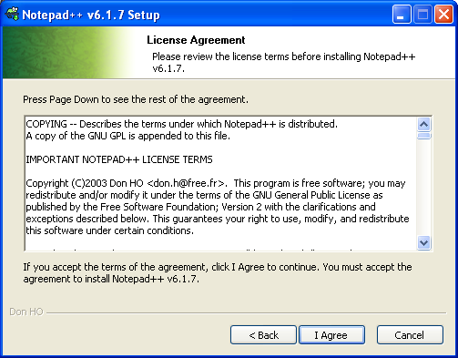
    - In this window, click “Next”
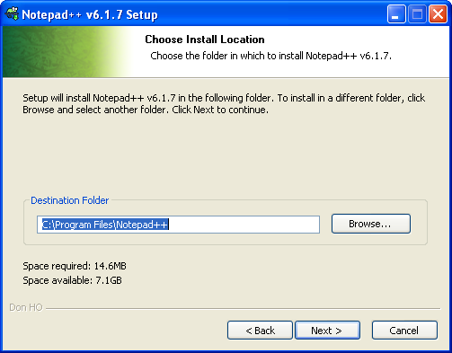
    - In this window, click “Next”
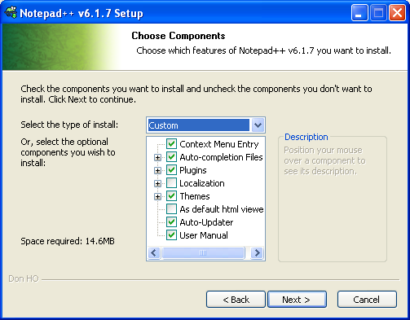
    - In this window, click “Install”
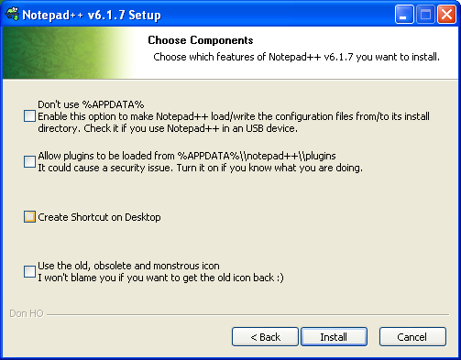
    - In this window, uncheck the checkbox and click “Finish”
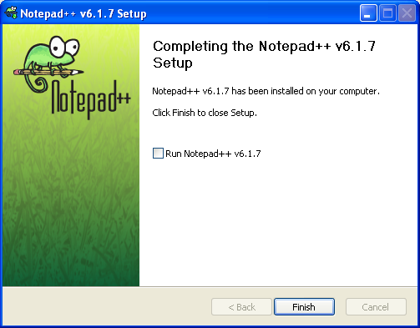

- Download & Install Java 1.6
  - Check to see if you already have Java 1.6 or later
    - Open a DOS window by pressing <Start><Run>Cmd
    - Within the DOS window, type-in this command:
DOS> java –version
If you already have java installed, you will see something like this:
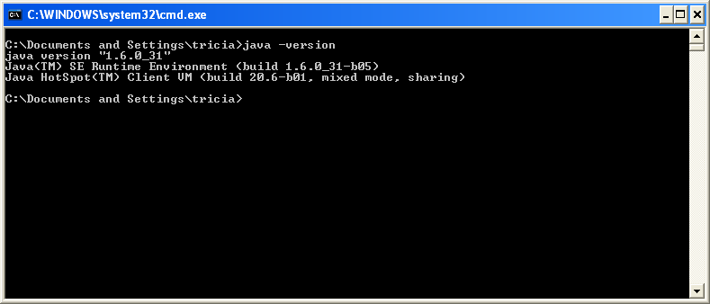This shows that this user already had Java 1.6 installed.
If you see Java 1.5, Java 1.4.2, or nothing at all, continue to download and install Java.
  - Open a web browser and go to http://www.oracle.com/technetwork/java/javase/downloads/index.html
  - In this web page, click on Java Platform JDK:
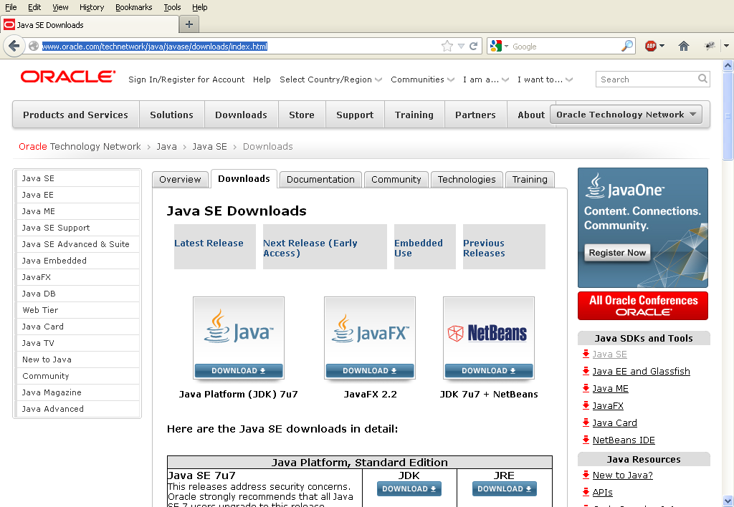
  - In this web page,
click “Accept License Agreement” and
click on jdk-7u7-windows-i586.exe
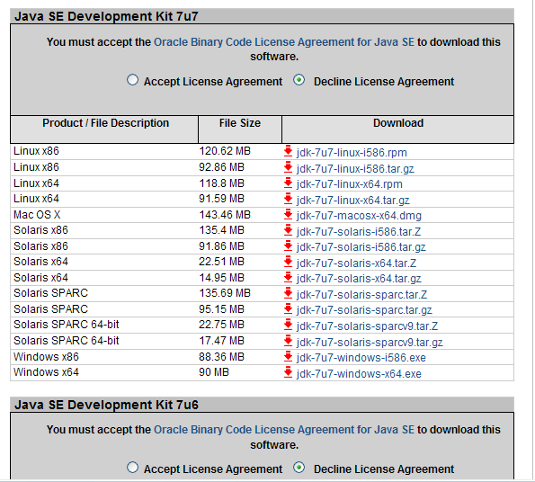

  - You will be prompted to save the file jdk-7u7-windows-i586.exe
Save the file to your c:\vault\ directory
NOTE: The version name may change, but it will probably end in windows-i586.exe
  - Run the Java JDK installer
    - Press <Start><Run>c:\vault
    - Double-click on jdk-7u7-windows-i586.exe
    - In this window, click “Next”
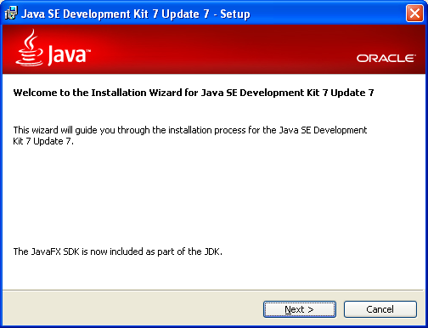
    - In this window, click “Next”
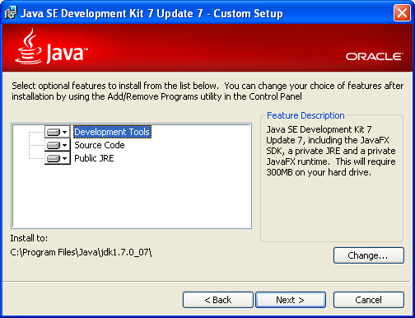
    - In this window, click “Next”
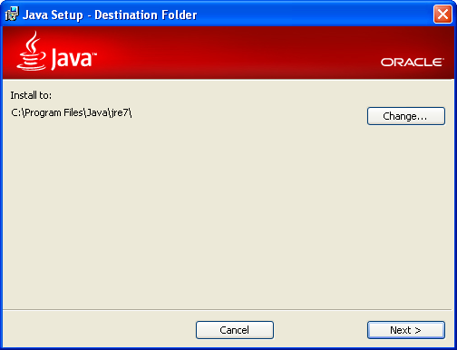
    - You should see this silly window next.
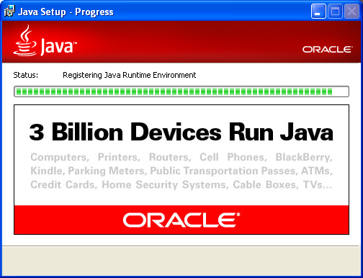
    - In this window, click “Close”
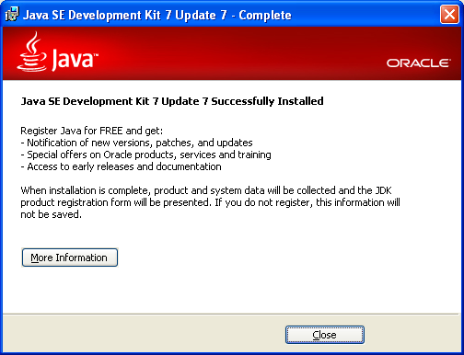
Now, you have successfully installed the Java JDK
    - If your web browser shows this, feel free to ignore it and close the page.
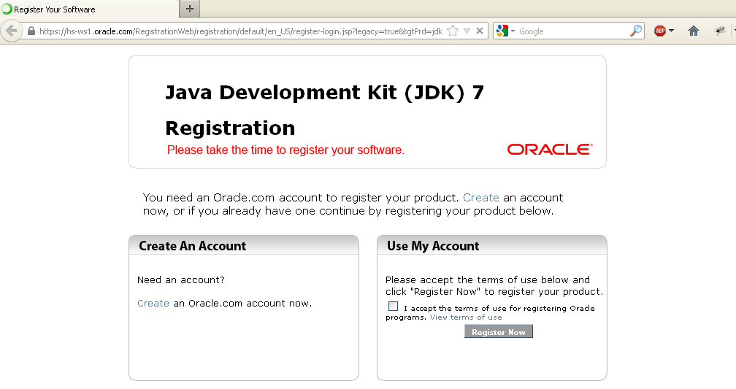
- Download & Install Eclipse
  - Open a web browser and go to http://www.eclipse.org/
  - In this window, click on Downloads
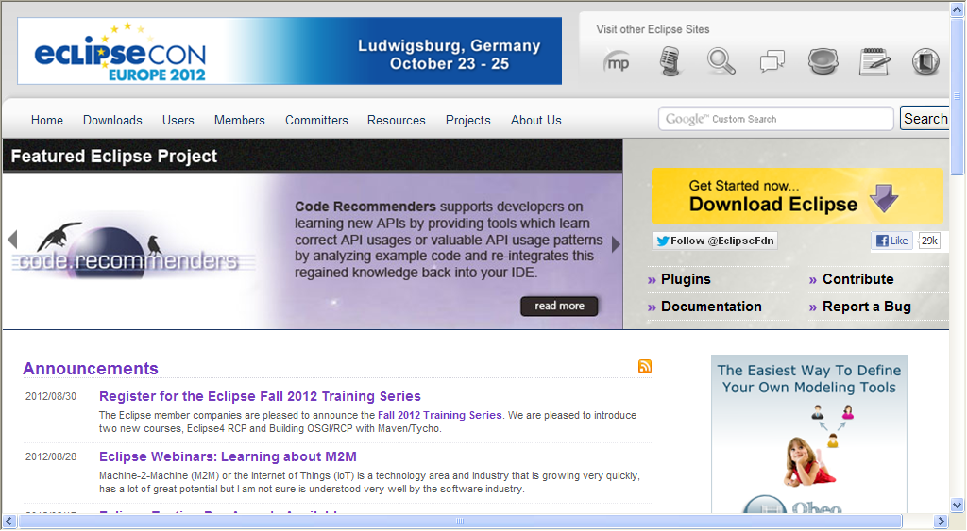
  - In this window, find the line that has “Eclipse IDE for Java EE Developers” and
click “Windows 32 bit”
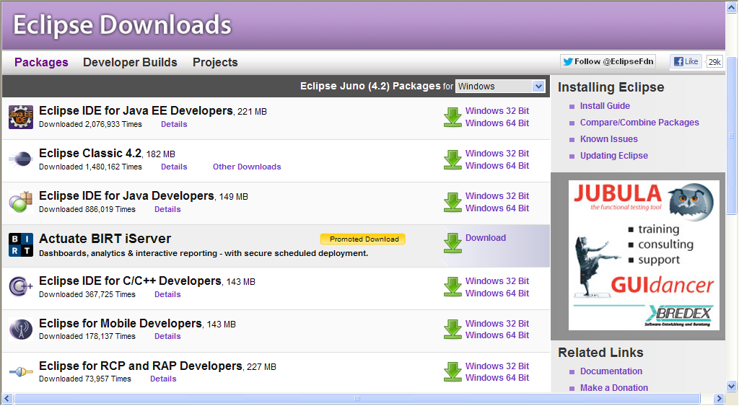
  - In this window, click on the big down arrow to begin downloading Eclipse.
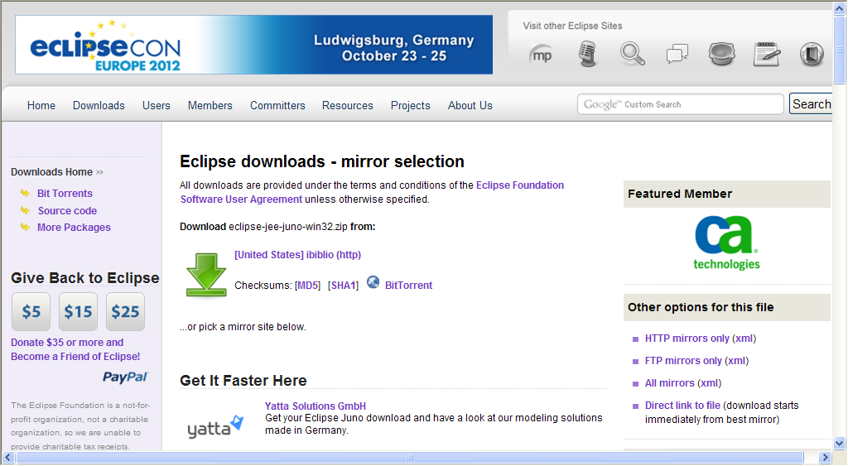
  - Save the eclipse-jee-juno-win32.zip file to your c:\vault directory
NOTE: This file will be approximately 220 megabytes in size.
  - Install Eclipse
    - Copy eclipse-jee-juno-win32.zip to your c:\tools\ directory
    - Unzip eclipse-jee-juno-win32.zip
      - Right-click on eclipse-jee-juno-win32.zip and select “Extract All…”
      - In this window, click “Next”
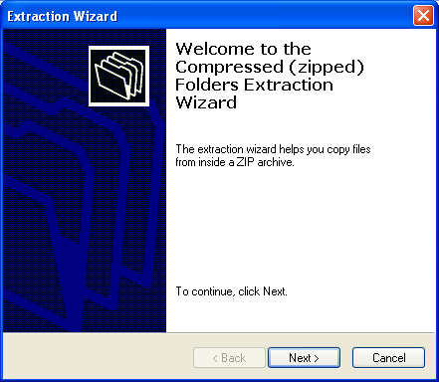
      - In this window, type-in c:\tools here and click “Next”
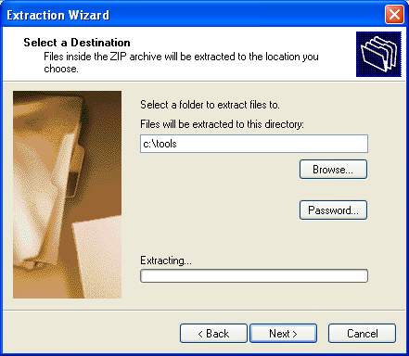
    - In this window, uncheck the checkbox and press “Finish”
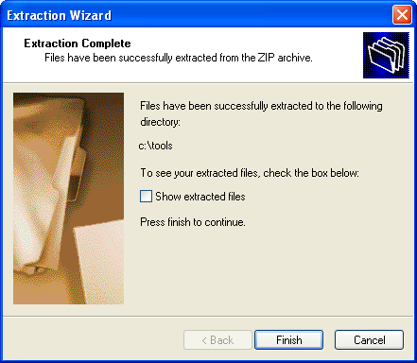
    - Look at the files in c:\tools\eclipse\ directory. You should see this:
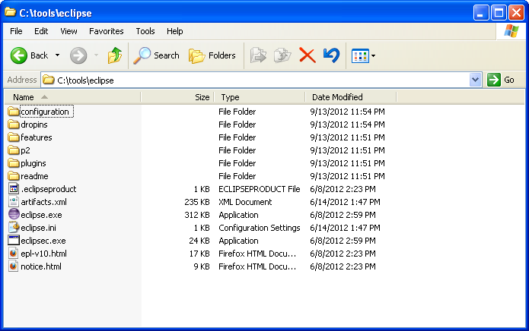
    - Create a workspace directory here:
      - Pull File / New / Folder
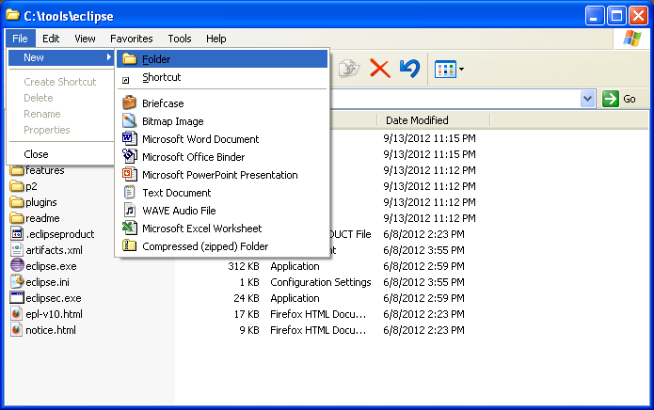
      - Type-in the name workspace
      - When you are done, you should see this in your c:\tools\eclipse\ directory:
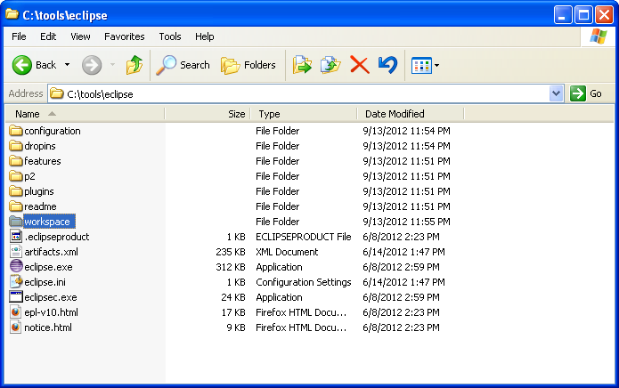
Now, you have installed Eclipse!

- Install Epic Plugin for Eclipse
  - Press <Start><Run> c:\tools\eclipse\eclipse.exe
  - In this window, type-in c:\tools\eclipse\workspace
And, check the checkbox on the bottom of the page and press “OK”
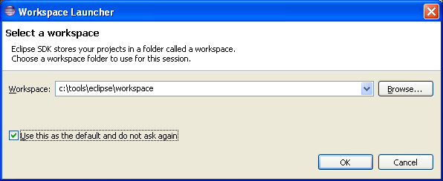
  - Pull Help / Install New Software…
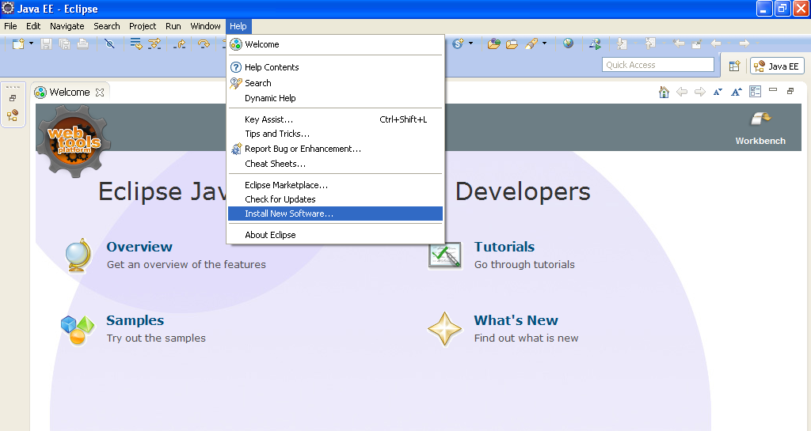
  - Press the "Add..." button
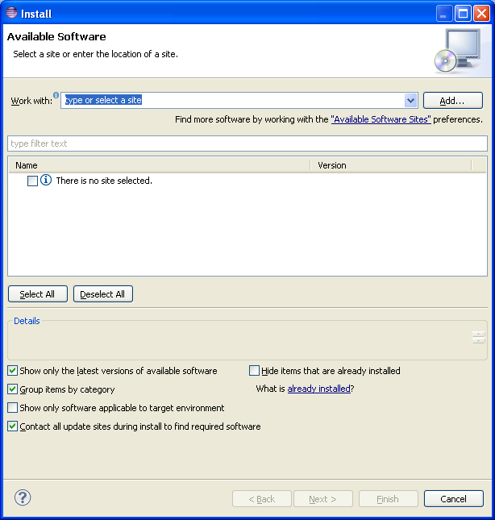
  - In this popup, type-in the location: http://e-p-i-c.sf.net/updates and press OK
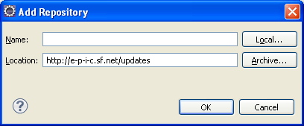
  - Check the checkbox next to "EPIC Main Components" and press “Next”
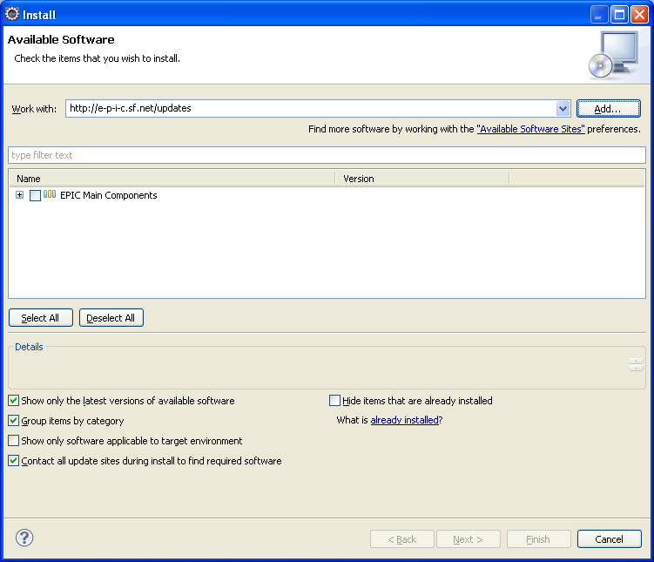
  - In this screen, click “Next”
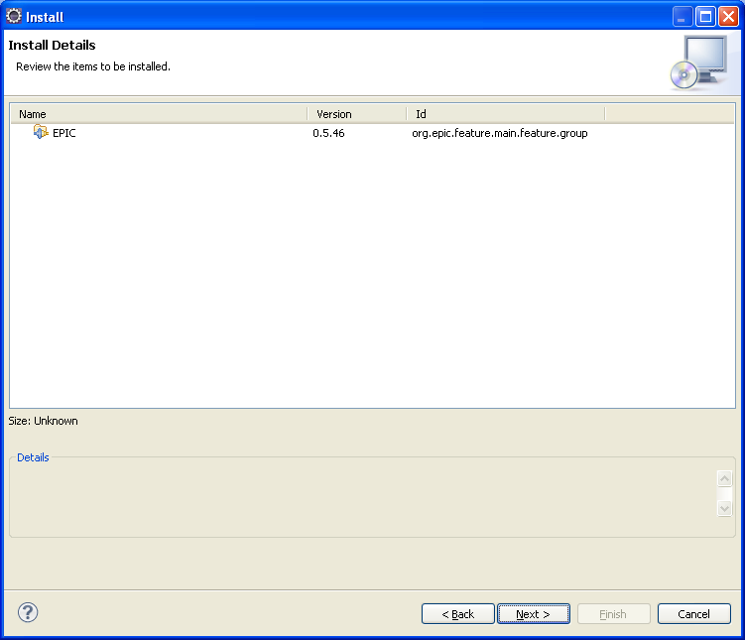
  - In this screen, check “I Accept the agreement…” and press “Finish”
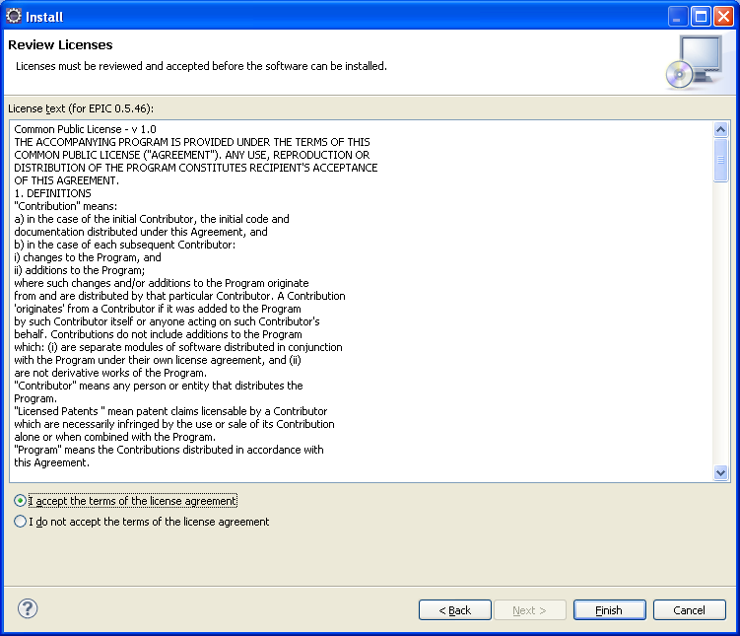
  - Next, you should see this screen
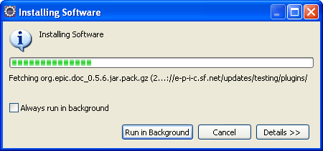

  - If you get the warning about an unsigned cabinet, click “OK”
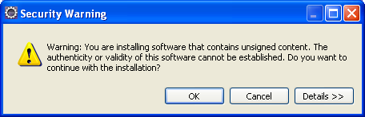
  - You will be prompted to restart Eclipse, click "Yes"
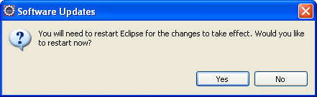
- Create a 1st project within Eclipse
  - If Eclipse is not running, start eclipse by running c:\tools\eclipse\eclipse.exe
  - Pull Window / Open Perspective / Other...
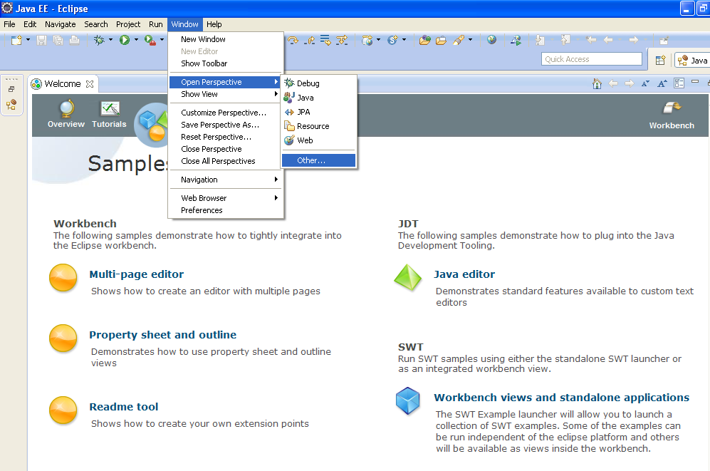
  - Select Perl and press OK
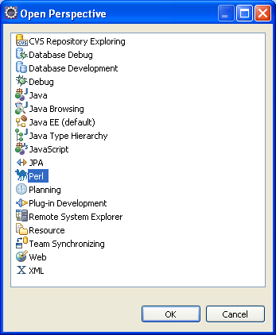
  - Pull File / New / Perl Project
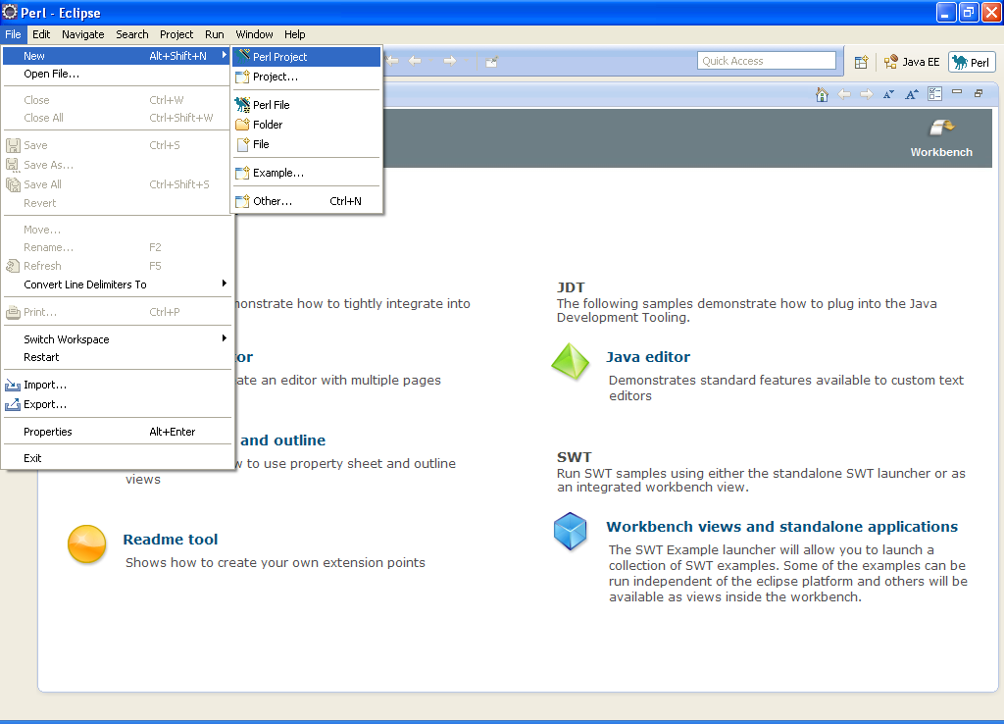
  - Type-in project1 and press “Finish”
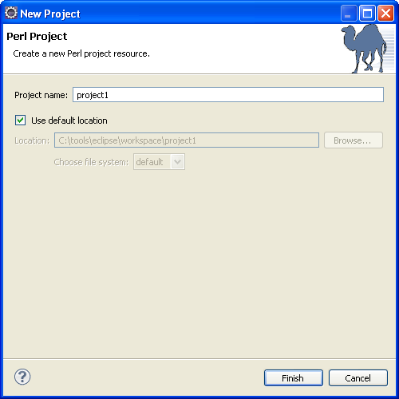
  - Close the “Welcome” window by clicking here
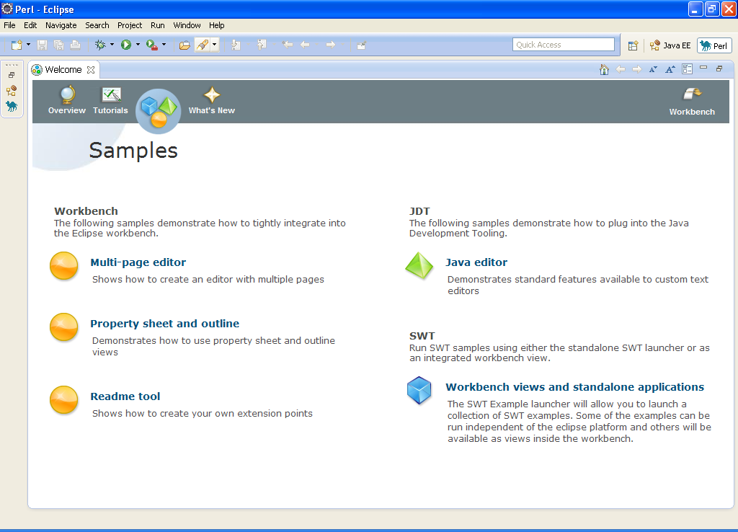
  - Now, you should see your project1
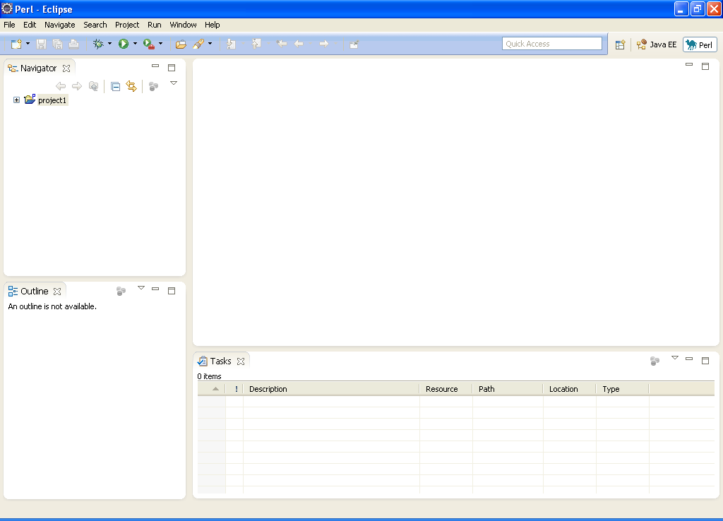
  - Right-click on project1 and pull New / Perl File
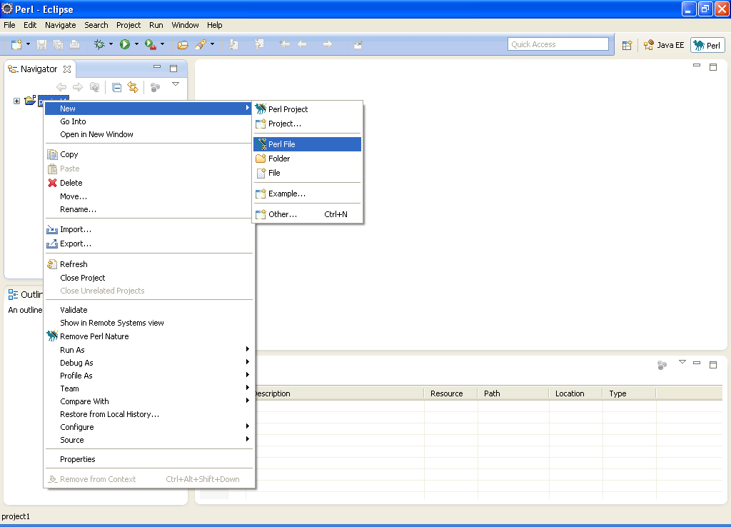
  - Type-in helloworld.pl and press “Finish”
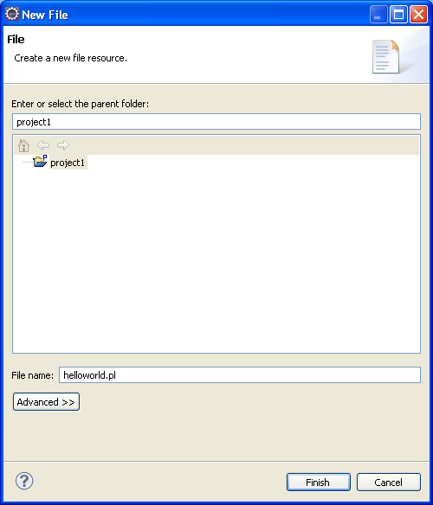
  - Type-in this code into helloworld.pl
use strict;
my $string = "Hi there";
my $number = 27;
print "string holds this $string\n";
exit 0;
  - Click on the line next to the print statement to set a breakpoint
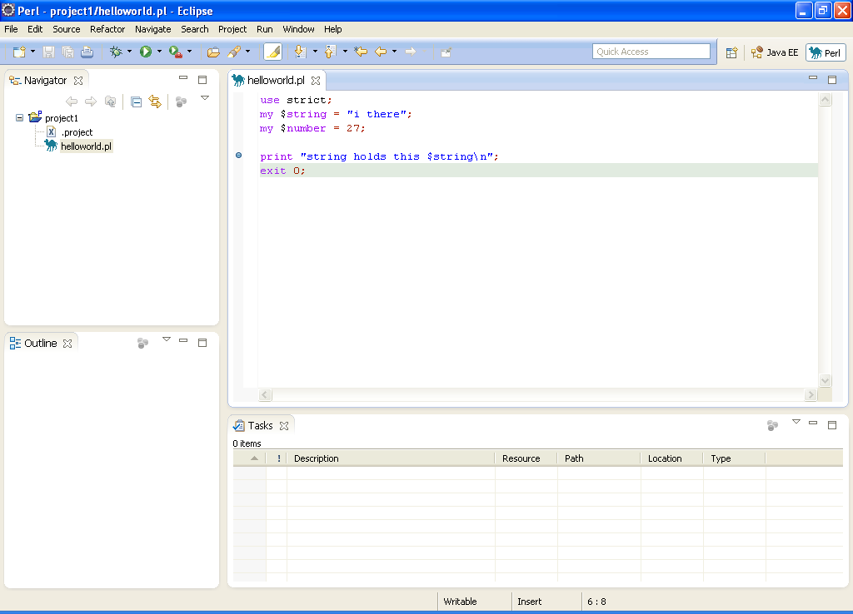
  - Now, run the Perl program and it should stop at the breakpoint
    - Pull Run / Debug to start debugging
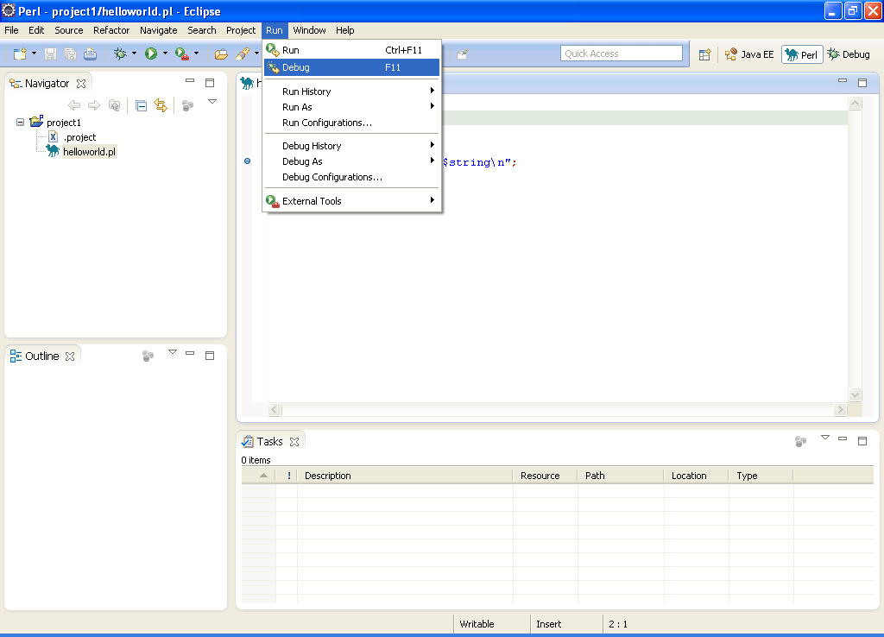
    - To stop the debugger, click the Red square here
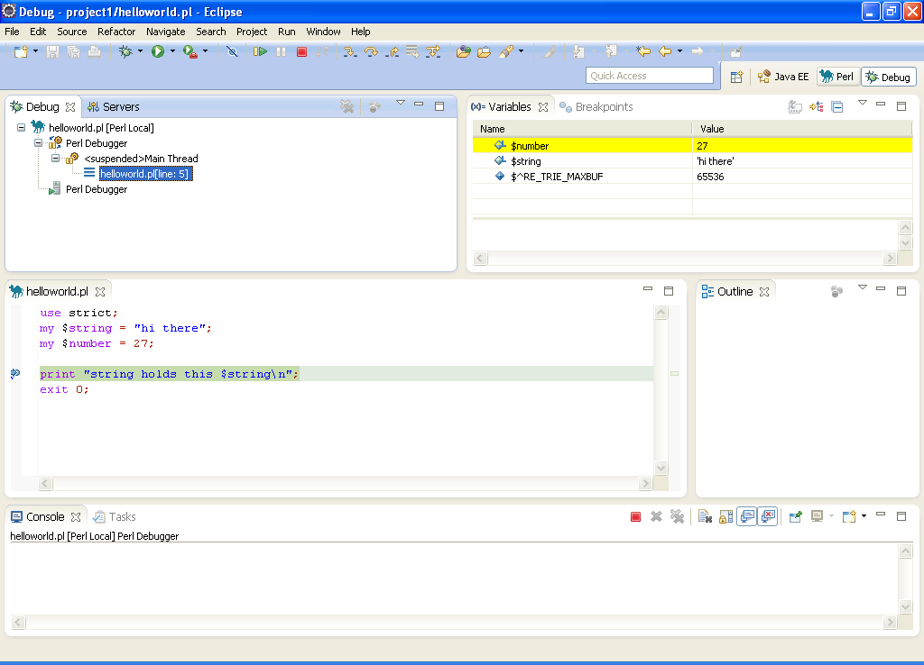
If you see the variables with values, then the debugger is working.
Press F6 to step over code

