ESCAP Structural Gravity Dashboard

User Instructions

**Table of Contents**

[1. Structural gravity model 2](#__RefHeading___Toc1457_3382665128)

[2. Model 3](#__RefHeading___Toc241_453758159)

[2.1. Years 3](#__RefHeading___Toc243_453758159)

[2.2. Countries 4](#__RefHeading___Toc245_453758159)

[2.3. Reference country 4](#__RefHeading___Toc257_453758159)

[2.4. Elasticity of substitution 4](#__RefHeading___Toc271_4537581591)

[3. References 4](#__RefHeading___Toc279_453758159)

# 1. **Structural gravity model**

The structural gravity model is an econometric framework used to analyze international trade flows. Based on the metaphor of Newton’s Law of Universal Gravitation, the gravity model of trade predicts that international trade (gravitational force) between two countries (objects) is directly proportional to the product of their sizes (masses) and inversely proportional to the trade frictions (the square of distance) between them (Yotov et al., 2016).

The structural gravity model has been widely used in international trade research to estimate the effects of various policy interventions, such as trade agreements and transportation infrastructure investments. One of the main advantages of the structural gravity model is that it delivers a tractable framework for trade policy analysis in a multi-country environment.

The difference between “naive gravity” and “structural gravity” relies on consistency with multilateral-resistance constraints, which are related to prices and market clearing conditions, and translate as output equals the sum of outward trade and expenditures equal the sum of inward trade (Shepherd, 2020). When the fitted values from an estimation are consistent with these constraints, then we are in presence of structural gravity.

Similar to the human circulatory system, the gravity system describes the links between the different parts (countries, sectors, and even firms) of the world economy. As such, the gravity system captures the possibility that markets (sectors, countries, etc.) are connected to each other and that trade policy changes in one market will trigger ripple effects in the rest of the world.

The structural gravity model of trade has the nice properties of CGE models, every equation in the model can be estimated, allowing to test for causal relationships, deliver key structural parameters and uncover new estimation opportunities. The gravity model is not only a CGE model, it is an Estimating CGE (E-CGE) model.

In the state-of-the-art literature model is typically expressed as a Generalized Linear Model, in particular as a Poisson Pseudo Maximum Likelihood especification (Shepherd, 2020), where data consists in a panel for exporter-importer-year dyads, the dependent variable is trade flows (goods or services) and the independent variables are:

* GDPs (or other variable to express the economies size).
* Distance (geographic distance or transportation costs).
* Common language, colonial ties, and/or trade agreements, to capture additional factors that may influence trade flows.
* Exporter-time and/or importer-time fixed effects, to capture sources of unobserved heterogeneity that are constant for a given exporter (Shepherd et al., 2019).

PPML estimation with fixed effects and imposing the sum of fitted trade to equal observed output and expenditures for each source and each destination is equivalente to structural gravity estimation (using observed output and expenditures).

# 2. Model

The starting point of [https://gravity.tiid.org](https://gravity.tiid.org/) is a short video that shows how to estimate a model. Here we’ll describe each to the available options. These instructions are based on Yotov et al. (2016).

The general view of the selectors is:

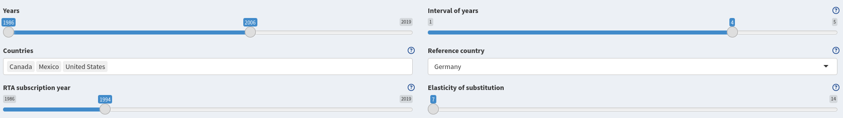These selectors estimate an structural gravity model, with an output visible in-browser like this:

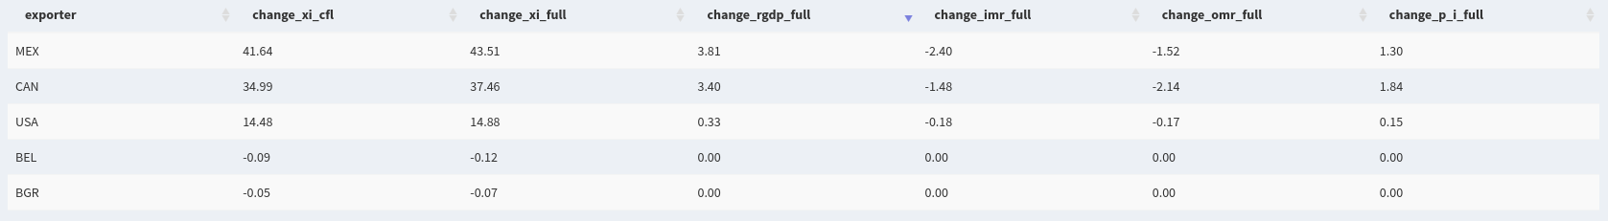From the download section you can also download the data used to estimate the model and also the estimated model (stored as a regression object to use it with R)



## 2.1. Years

We can adjust the year range and the interval of years at will. For example, and following gravity estimation recommendations of avoiding adding consecutive years, we can move the ‘years’ slider to filter data for a period such as 2010-2018. Then, if we want the sequence 2010-2014-2018, we need to move the ‘interval of years’ slider to 4. Yotov et al. (2016) suggest to use intervals of four years in gravity estimation.

## 2.2. Countries

You can select one or more countries. For example, to estimate effects for NAFTA, choose the US, Canada and Mexico.

## 2.3. Reference country

You can select one country. For example, Germany.

## 2.4. Elasticity of substitution

In this selector we define a parameter for the General Equilibrium simulation (Baier, et al 2019) to obtain predicted trade under a counterfactual scenario (i.e., drop NAFTA in the year 2010). Yotov et al. (2016) suggest to use a value of seven.

# 3. References

Baier, Scott L., Yoto V. Yotov, and Thomas Zylkin. [*On the widely differing effects of free trade agreements: Lessons from twenty years of trade integration*](https://www.sciencedirect.com/science/article/pii/S0022199618304367). Journal of International Economics 116 (2019): 206-226.

Berge, L. and McDermott, G. *[Fast Fixed-Effects Estimation: Short introduction](https://cran.r-project.org/web/packages/fixest/vignettes/fixest_walkthrough.html" \l "14_Other_estimation_functions)*. CRAN, 2022.

Shepherd, B., Doytchinova, H. S., and Kravchenko, A. [*The grav**ity model of international trade: a user guide [R version]*](https://www.unescap.org/resources/gravity-model-interna-%0Ational-trade-user-guide-r-version). United Nations ESCAP, 2019.

Shepherd, B. [*Structural Gravity, Panel Data and Policy Effects: Evidence from Trade in Services*](https://developing-trade.com/wp-content/uploads/2020/08/Working-Paper-DTC-2020-4.pdf). Developing Trade Consultants, 2020.

Yotov, Y. V., Piermartini, R., and Larch, M. [*An Advanced Guide to Trade Policy Analysis: The Structural Gravity Model*](https://www.wto.org/english/res_e/publications_e/advancedguide2016_e.htm). WTO iLibrary, 2016.