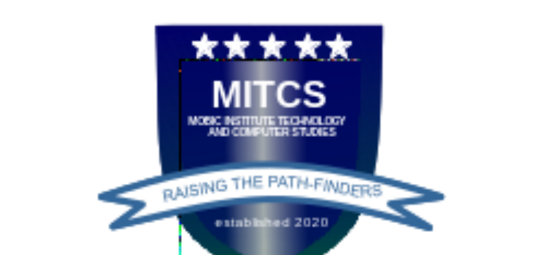
MOBIC INSTITUTE TECHNOLOGY
AND COMPUTER STUDIES
CERTIFICATE OF COMPLETION
This Certificate is Awarded to
Emmanuel Enebelu

General Computing / Coding

 | 
Director of Studies |  | Principal

