Simple

1. Upon launching the app the user should be redirected to Simple Opening Page

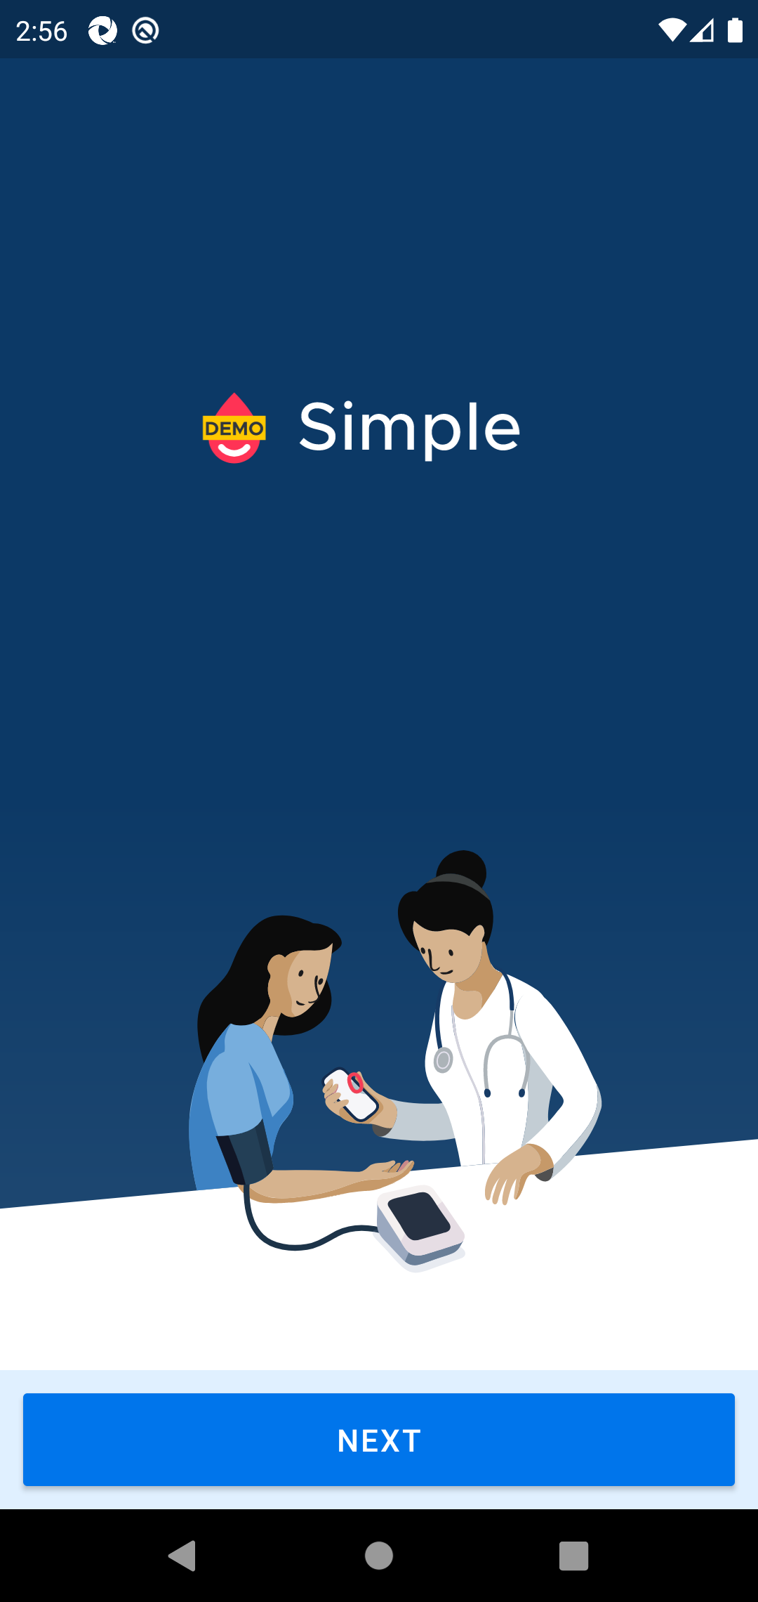

2. Click Next Button

