Simple

1. Click Medicine (+) button

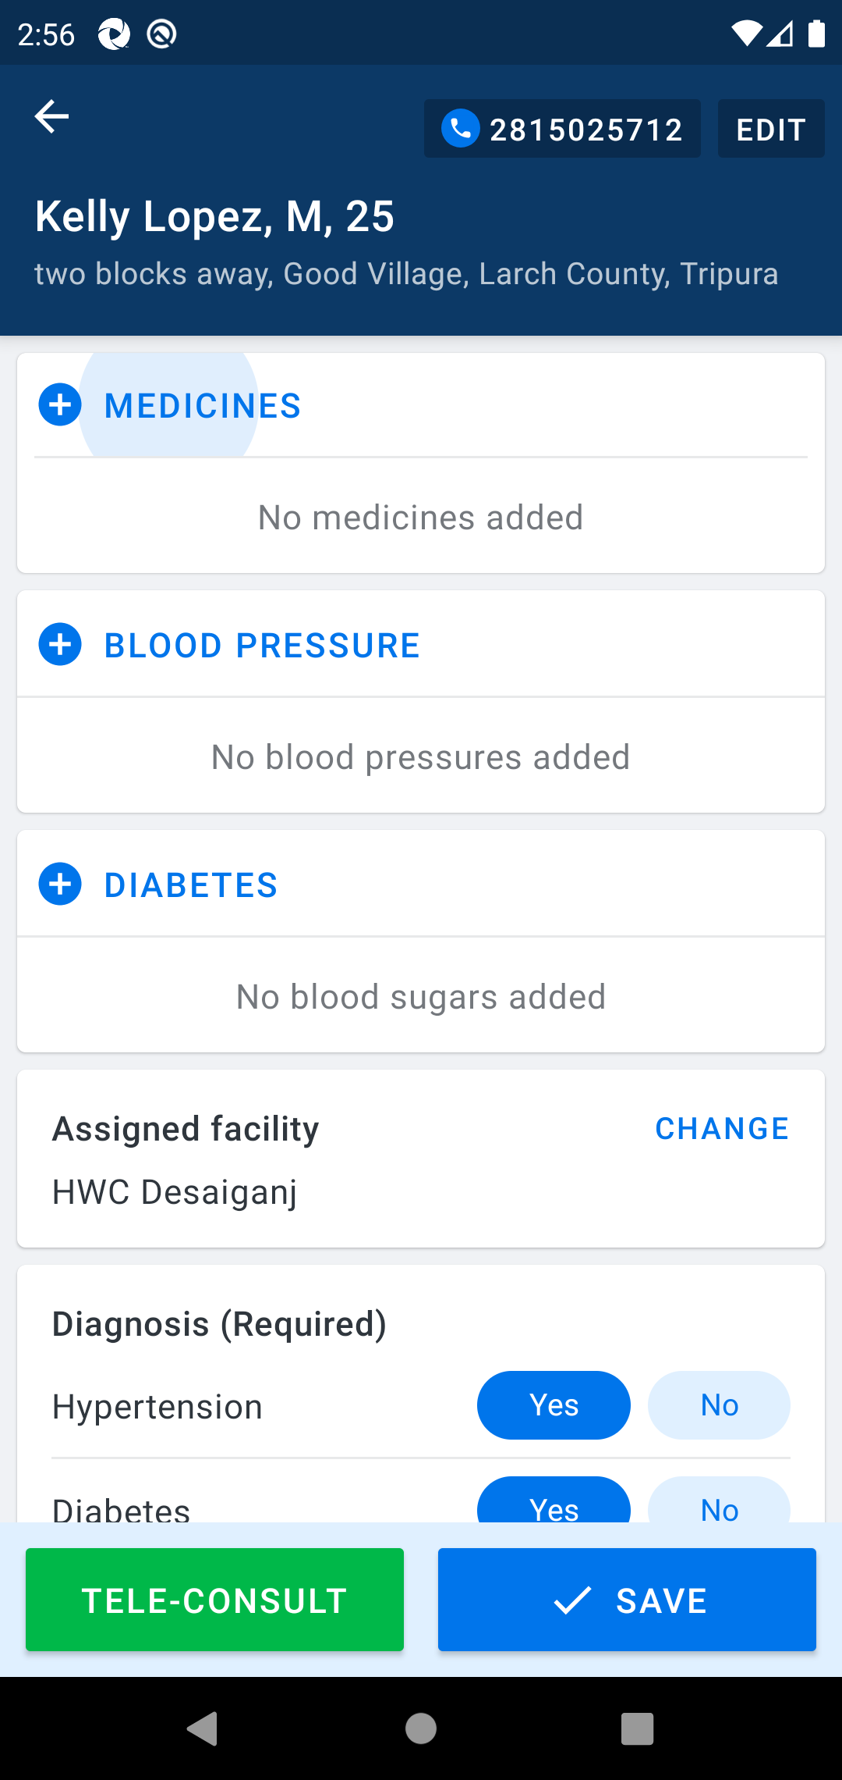

2. Select multiple kinds of existing medicines and their dosage

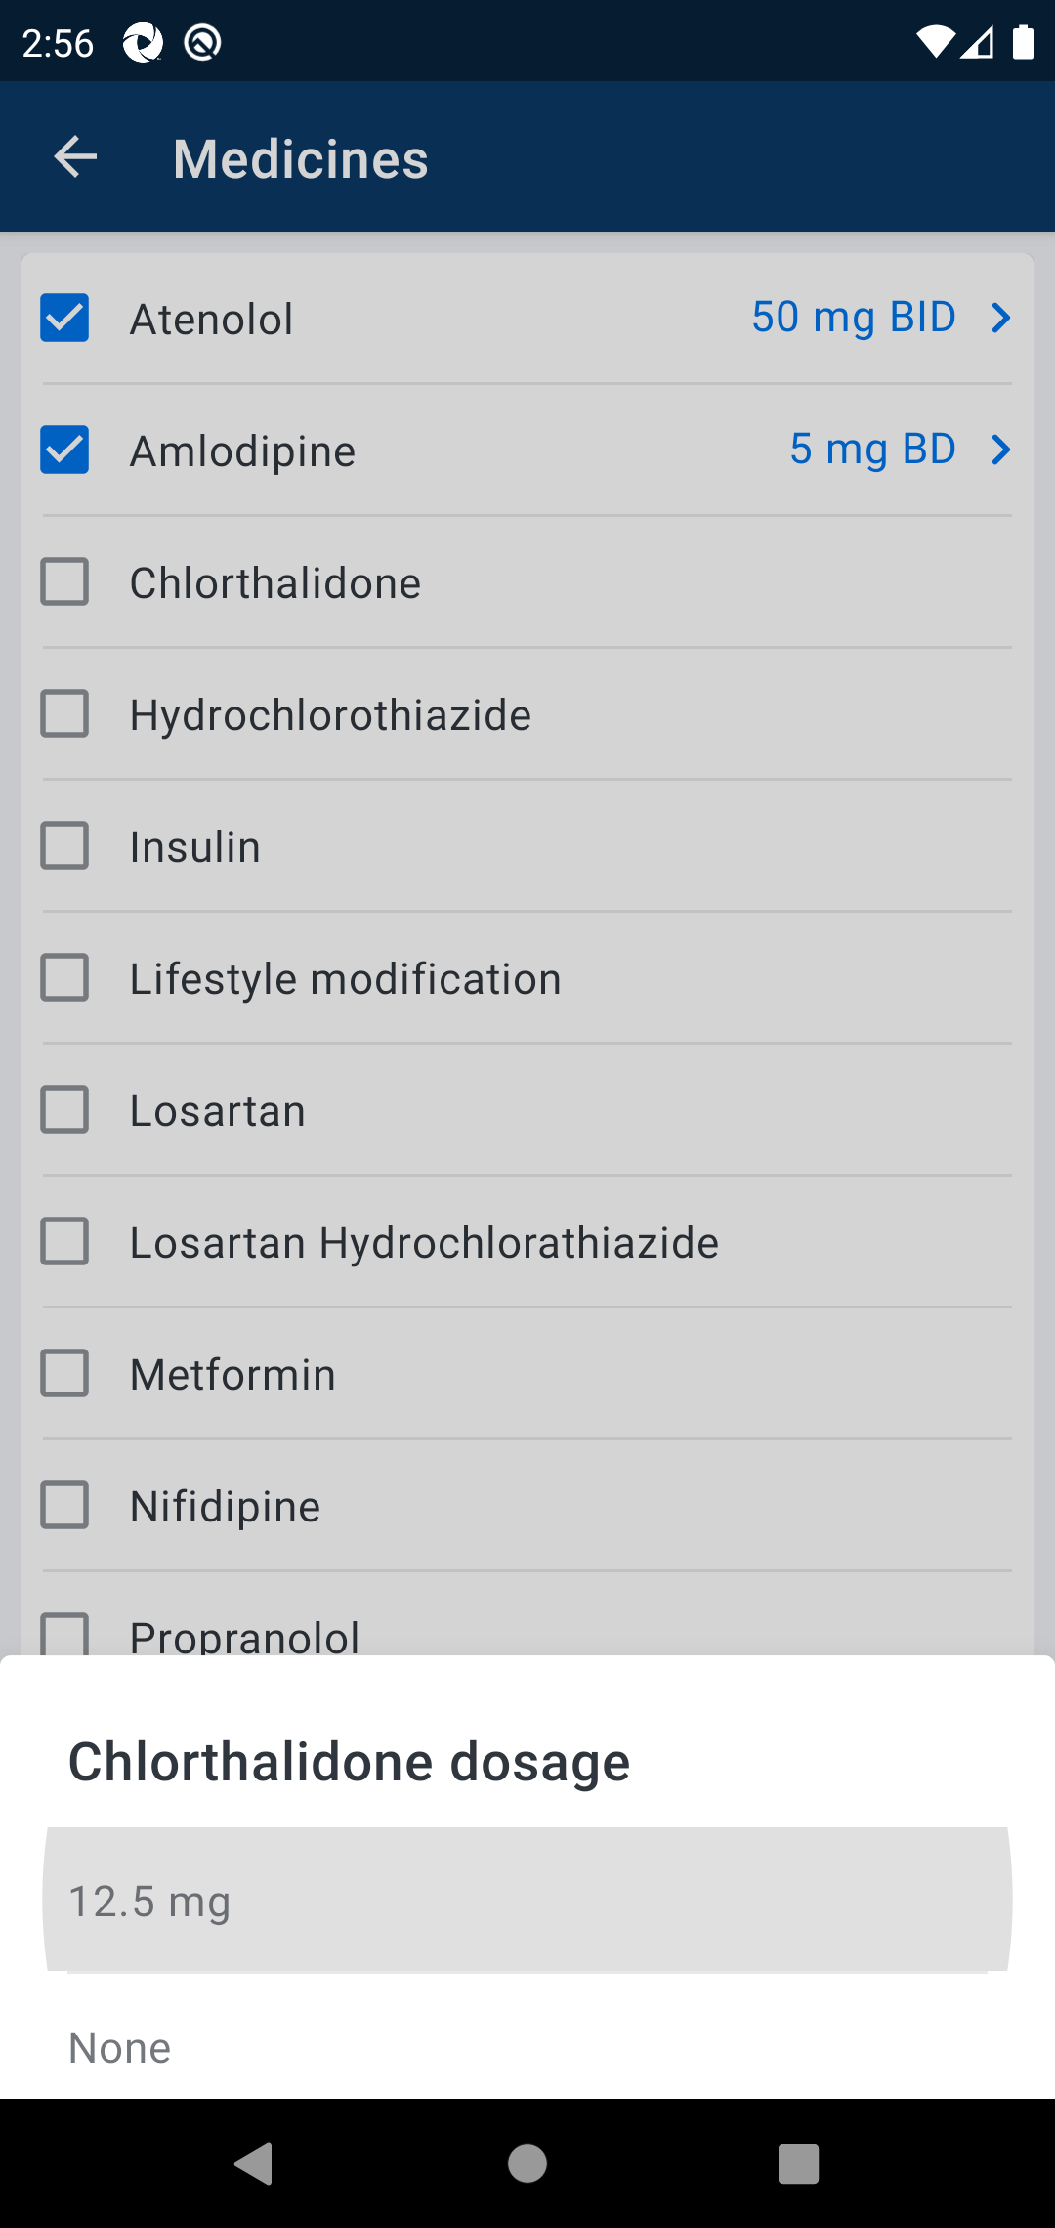

3. Click Save

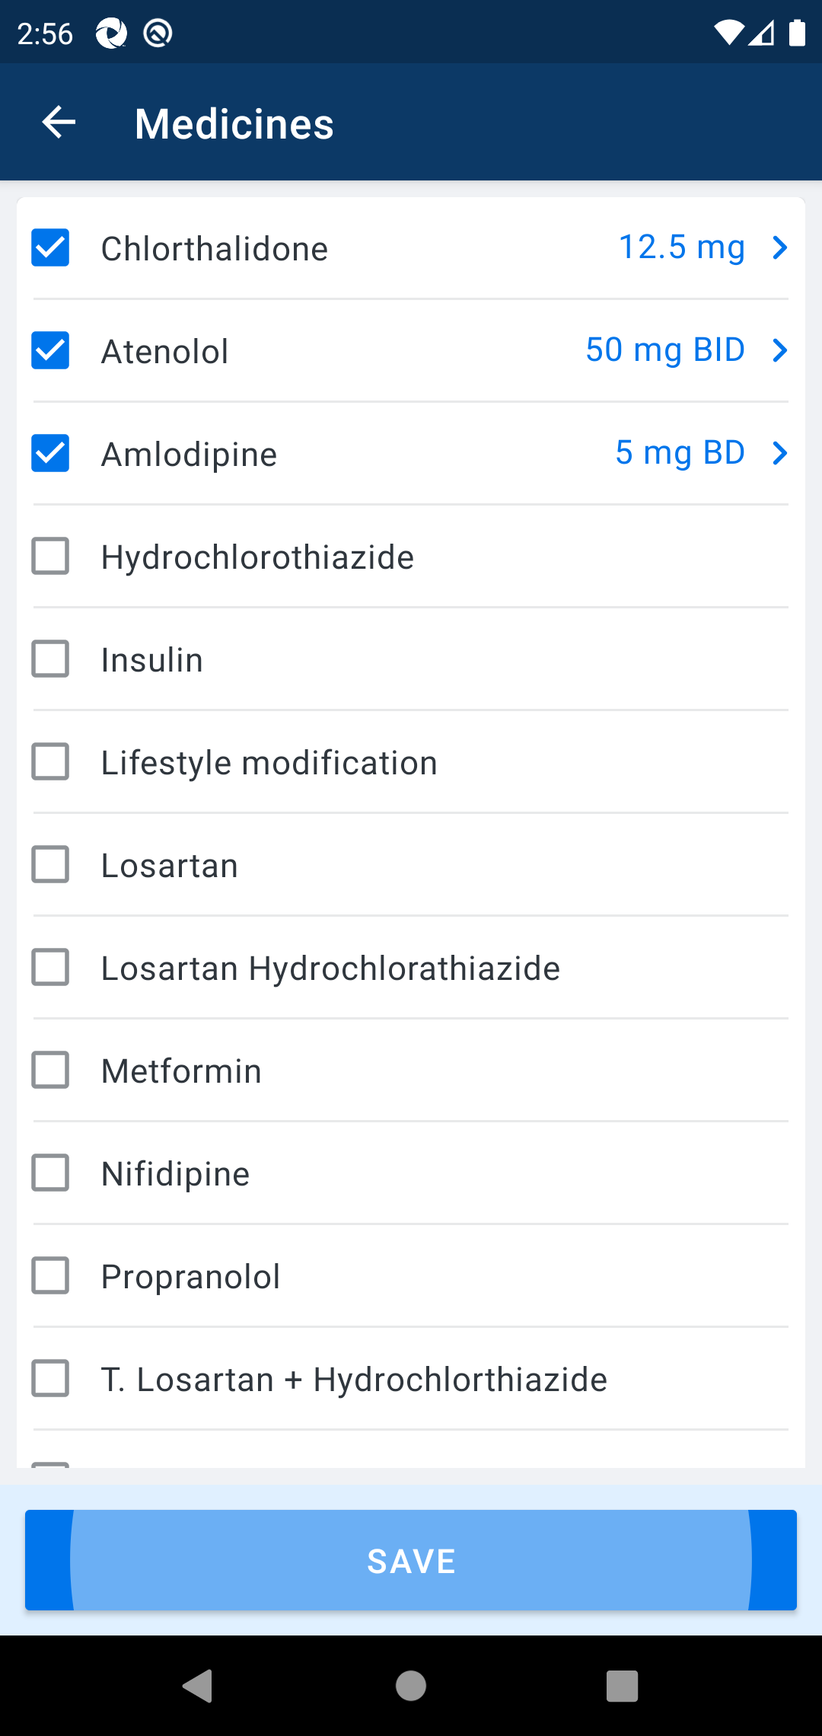

4. Validate if the selected medicines reflected in the medicine section

