1. 利用matlab读入一幅灰度图和一幅彩色图像，分析得到的数据；

I = imread('C:\Users\user\Downloads\Êý×ÖÍ¼Ïñ´¦Àímatlab°æÍ¼Æ¬×ÊÔ´\Fig0101.tif');

I2 = imread('C:\Users\user\Downloads\Êý×ÖÍ¼Ïñ´¦Àímatlab°æÍ¼Æ¬×ÊÔ´\Fig0612(a).tif');

1. 将读入的图像在绘图窗口中显示出来；

imshow(I);

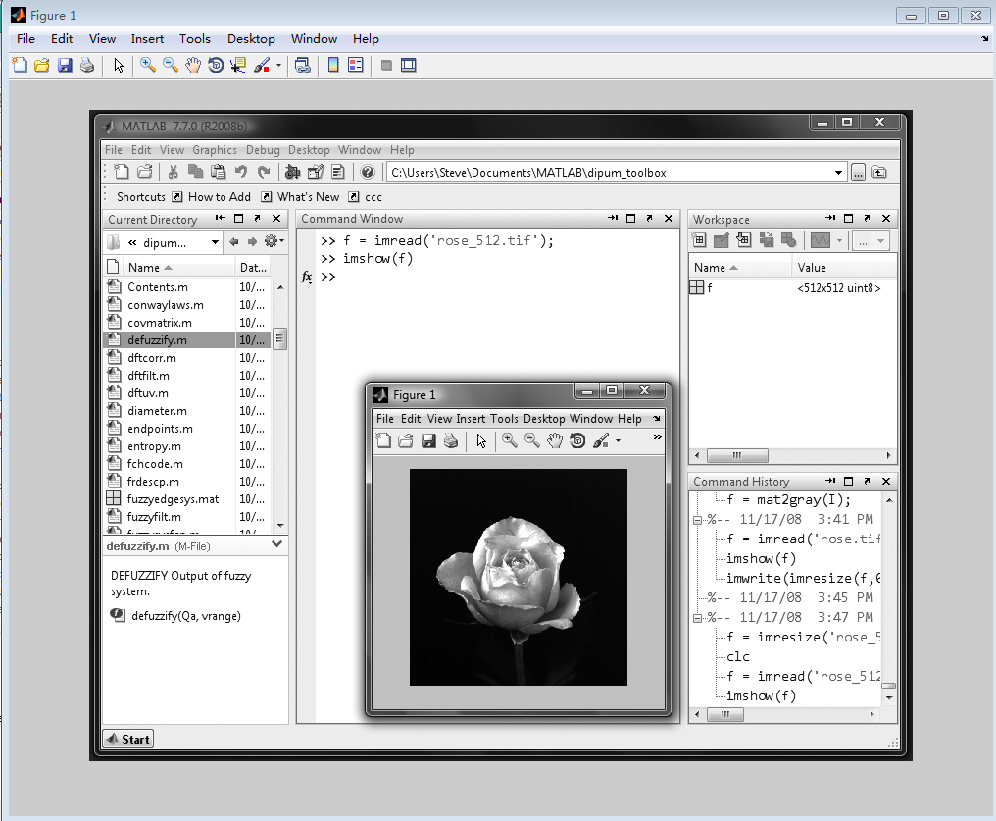

imshow(I2);

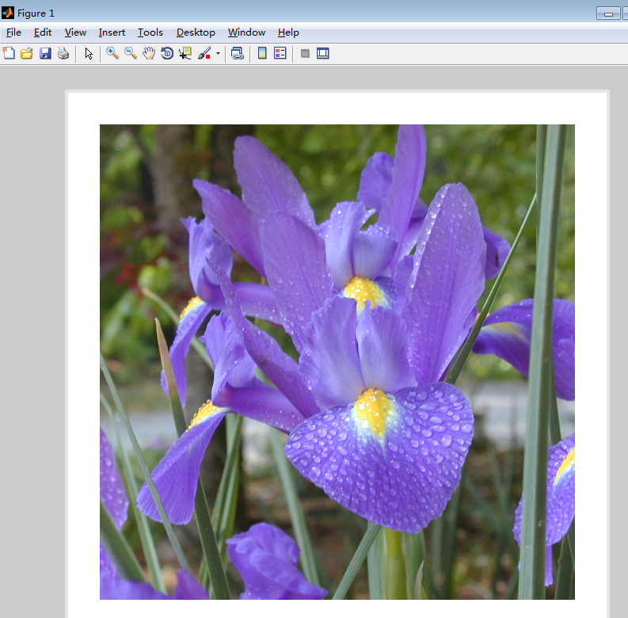

1. 读入一幅彩色图像，将得到的R、G、B三色分量分别在绘图窗口中显示出来；

I2 = imread('C:\Users\user\Downloads\数字图像处理matlab版图片资源\Fig0612(a).tif');

R = I2;

R(:,:,2)=0;

R(:,:,3)=0;

G = I2;

G(:,:,1)=0;

G(:,:,3)=0;

B = I2;

B(:,:,1)=0;

B(:,:,2)=0;

figure;

subplot(2, 2, 1);

imshow(R);

title('R');

subplot(2, 2, 2);

imshow(G);

title('G');

subplot(2, 2, 3);

imshow(B);

title('B');

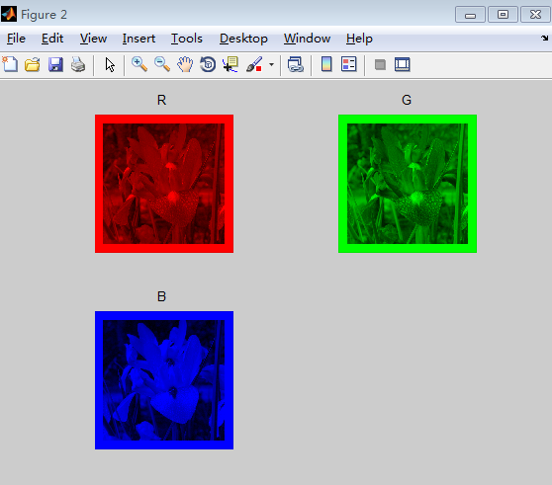

1. 分别读入一幅灰度图和一幅彩色图像，自己编程统计图像灰度信息，绘出直方图。（自己编写程序统计图像灰度信息，不可使用matlab提供的直方图函数）；

灰度图：

Fig0228(a)

I = imread('Fig0228(a).tif');

Grey = zeros(1,256);

[m,n]=size(I);

for i=1:m

for j=1:n

Grey(I(i,j)+1)=Grey(I(i,j)+1)+1;

end

end

bar(Grey);

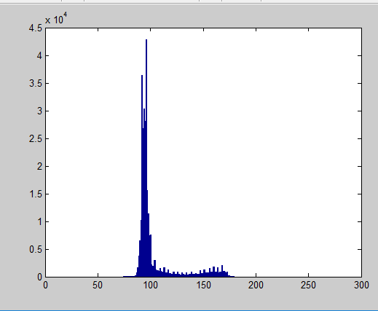

彩色图：

Fig0628(a)

I = imread('Fig0628(a).tif');

Grey = zeros(3,256);

[m,n,c]=size(I);

for k=1:c

for i=1:m

for j=1:n

Grey(k, I(i,j,k)+1)=Grey(k, I(i,j,k)+1)+1;

end

end

end

figure;

subplot(2,2,1);

bar(Grey(1,:));

title('R');

subplot(2,2,2);

bar(Grey(2,:));

title('G');

subplot(2,2,3);

bar(Grey(3,:));

title('B');

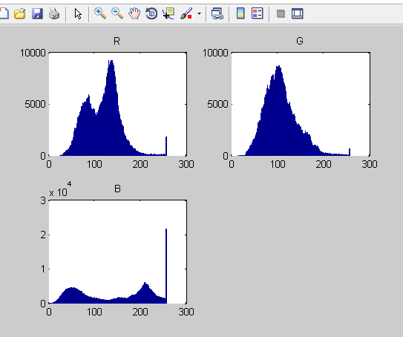

      (5)完成课本p20页第四题（2）“求图像f的直方图”；

f = [ 100, 76, 0, 132, 7, 7;

28, 7, 7, 7, 7, 243;

28, 243, 7, 100, 7, 28;

100, 7, 7, 0, 7, 100;

100, 0, 7, 7, 132, 0;

132, 132, 132, 100, 7, 100 ]

Grey = zeros(1,256);

[m,n]=size(f);

for i=1:m

for j=1:n

Grey(f(i,j)+1)=Grey(f(i,j)+1)+1;

end

end

bar(Grey);

