Kurukshetra Kart
Full-Vehicle Telemetry, Software & Digital Twin System
Hardware Plan · Software Architecture · Digital Twin Specification
Field | Detail
Prepared by | Arshad — Chassis & Design Subteam
Team | Kurukshetra Racing, SKCET
Category | EKVC Season 4 — Innovation Round
Scope | V1 core build + V2/V3 roadmap + Digital Twin architecture

1. Project Overview
This document defines the complete engineering plan for the Kurukshetra Kart telemetry and digital twin system: which sensors to install, how the embedded and pit software is structured, and how collected data becomes a validated simulation model. It is organized in three parts — Hardware, Software, and Digital Twin — so that the embedded team, the pit/dashboard team, and the analytics/simulation team can work from the same document without stepping on each other.
The guiding principle throughout: collect real measurements first, derive a calibrated model second, and only then use that model to make predictions. A simulator that hasn't been checked against real telemetry is a guess with graphics.

1.1 System Summary
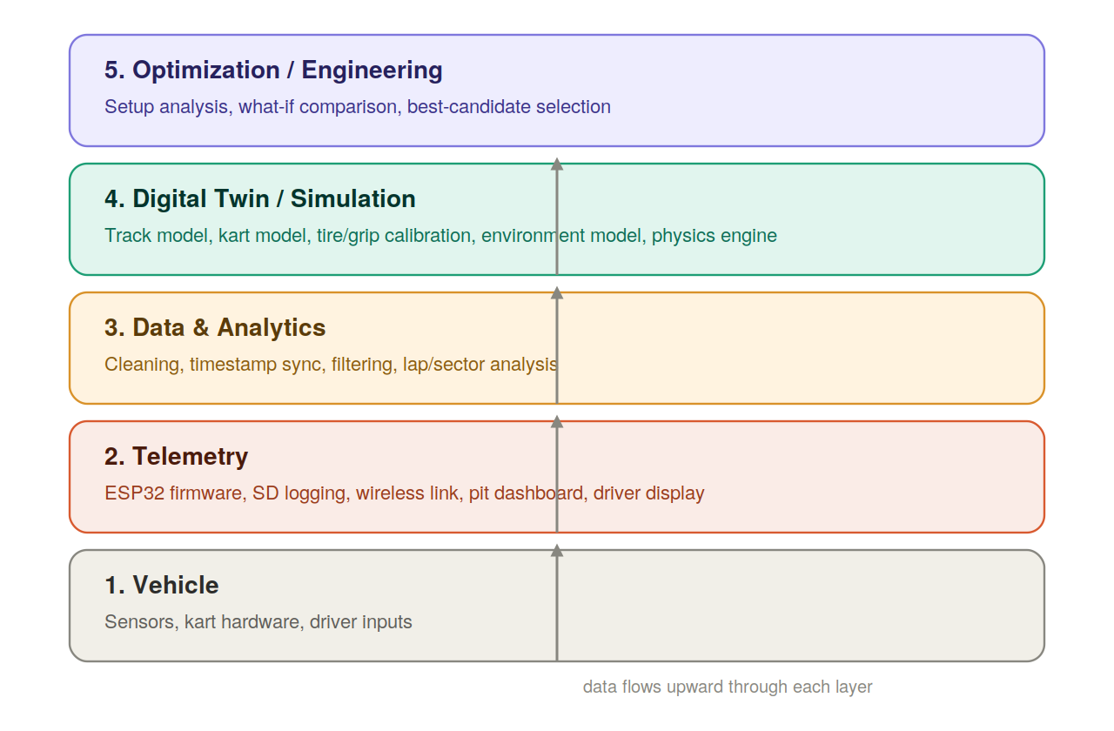
The system is organized into five layers. Data flows upward: raw vehicle signals become telemetry, telemetry becomes analytics, analytics feeds the digital twin, and the digital twin supports optimization.

2. Hardware & Sensor Architecture
Not every measurable quantity needs a dedicated sensor in V1. Some values are calculated from others; some are only useful once the basic system is working reliably. The sensor list below is staged across three versions so the team builds a working core system first.

2.1 Core Sensors — V1 (Essential)
# | Parameter | Sensor | Why it's needed | Priority
1 | Wheel speed | Hall-effect sensor + magnet | Vehicle speed, wheel behaviour, distance | Essential
2 | Engine RPM | Inductive pickup / tach sensor | Engine speed, gear analysis, powertrain model | Essential
3 | Engine temperature | DS18B20 / temperature probe | Engine thermal monitoring | Essential
4 | Steering angle | Rotary potentiometer / encoder | Steering input, corner analysis | Essential
5 | IMU / G-force | MPU6050 / better IMU | Acceleration, braking, cornering, yaw | Essential
6 | Obstruction distance | HC-SR04 (V1) / better ToF sensor (later) | Distance, closing speed, time-to-contact | Essential
7 | Throttle position | Potentiometer / Hall throttle sensor | Driver input, vehicle model | Strongly recommended
8 | Brake position/pressure | Brake pressure or position sensor | Braking analysis, driver model | Strongly recommended

2.2 Wheel-Speed Sensing — Sensor Count Options
Option | Sensors | What you get
A — Minimum | 1, on rear driven wheel | Basic vehicle speed — good enough for V1
B — Recommended | 2, left + right rear wheels | Detects difference between wheels; better cornering data
C — Full | 4, one per wheel | Individual wheel speed, slip estimation, differential behaviour, full cornering analysis
Do not make four-wheel sensing mandatory for V1 — start with Option A or B and expand later.

2.3 Engine RPM — Critical Safety Note
Important
Do not connect the ESP32 directly to a spark-plug ignition/high-voltage line. Use proper signal conditioning and isolation. The engine bay is electrically hostile — ignition noise and voltage spikes can destroy a microcontroller quickly without isolation components in between.

2.4 What to Buy First — V1 Parts List
Sensor | Qty | Purpose | Est. Cost (₹)
ESP32 Dev Board | 1 | Central controller | 400–600
Hall-effect wheel sensor | 1–2 | Wheel speed | 80–120 each
RPM pickup (inductive/Hall) | 1 | Engine RPM | 150–300
DS18B20 | 1 | Engine temperature | 80–120
Rotary potentiometer | 1 | Steering angle | 50–100
MPU6050 | 1 | G-force + gyro | 120–200
HC-SR04 | 1 | Obstruction / TTC | 80–150
Throttle position sensor | 1 | Driver input | 100–200
BME280 | 1 | Ambient temp / humidity / pressure | 150–250
MicroSD module + card | 1 | Full dataset logging | 150–250
OLED display (0.96″ I2C) | 1 | Driver display | 180–250
RF/Bluetooth module (nRF24L01 or similar) | 1 | Pit wireless link | 150–300
Voltage regulator + isolation components | 1 set | Clean, isolated power | 200–350
Wiring, connectors, shielding, mounts | — | Reliable install | 500–800
Estimated V1 total: approx. ₹2,300–4,000 — fits within a ₹6,000 budget with headroom.

2.5 Staged Expansion — V2 and V3

V2 additions
- Brake pressure sensor
- GPS / GNSS module
- Gear position sensor
- Second wheel-speed sensor (if starting from Option A)
- Higher-quality IMU (MPU6500 / ICM-42688)
- Better distance/obstruction sensor (ToF)

V3 — Digital Twin-grade additions
- Four-wheel speed sensing
- Tire temperature (IR sensors, per wheel)
- Tire pressure (per wheel)
- Suspension travel (linear potentiometer/encoder, per wheel)
- More accurate GNSS
- Additional drivetrain measurements
Suspension travel and tire sensing are genuinely complex to mount reliably — keep these out of V1 and V2 entirely.

2.6 The 10 Signals That Matter Most
If asked “what data actually matters?”, this is the answer — these ten give the foundation for understanding what the kart did; everything else helps explain why.
# | Signal
1 | Speed
2 | Engine RPM
3 | Throttle
4 | Brake
5 | Steering angle
6 | Longitudinal acceleration
7 | Lateral acceleration
8 | Yaw rate
9 | Engine temperature
10 | Track position

2.7 Hardware Data Flow
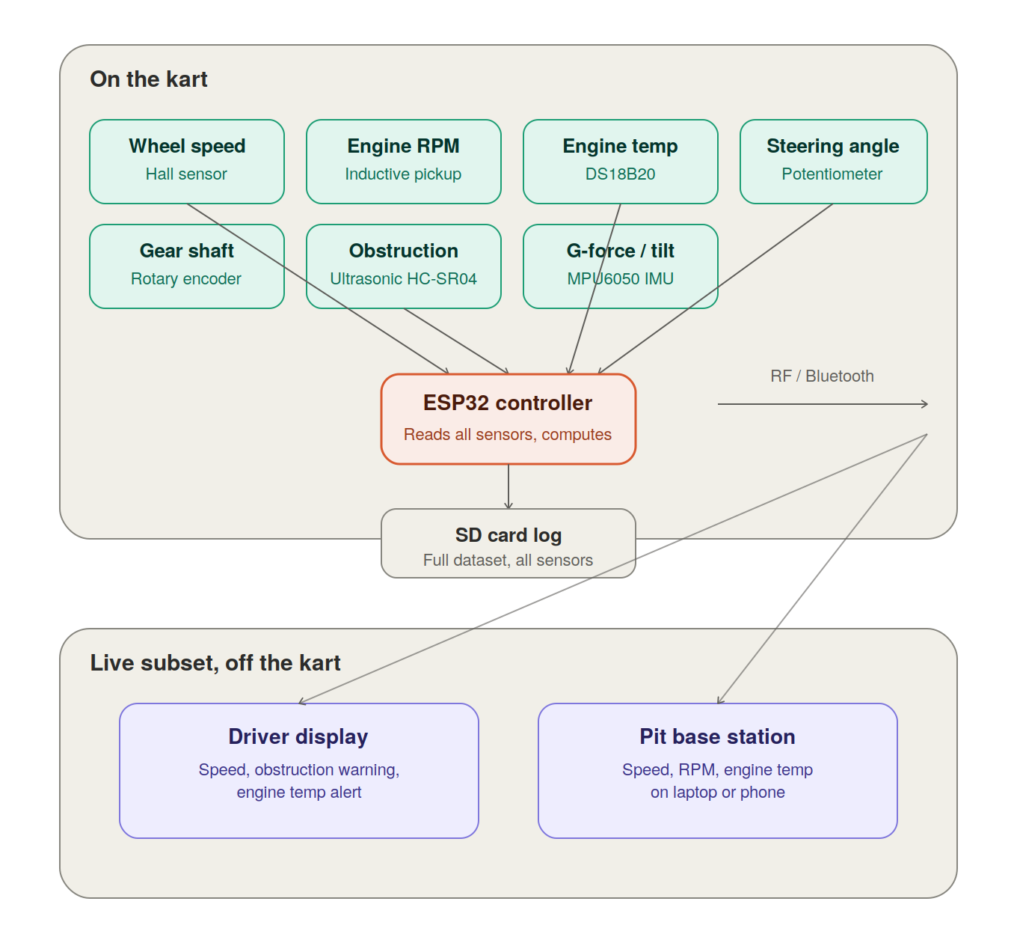
Sensors feed the ESP32 controller. The full dataset logs to SD card; a filtered live subset streams wirelessly to the driver display and pit base station.

3. Software Architecture
The software is organized into five layers, each with a distinct responsibility. This separation matters because it lets different subteams (embedded, pit/dashboard, analytics, simulation) build and test independently.

3.1 Embedded Firmware (Layer 1–2)
Runs directly on the ESP32. Responsibilities:
- Sensor acquisition
- Filtering
- Timestamping
- Derived calculations (e.g. speed from wheel pulses, time-to-contact from distance)
- Data logging to SD card
- Driving the steering-mounted display
- Sending wireless packets to the pit
- Fault detection

Firmware task structure
ESP32
|
+----------+-----------+
v v v
SENSOR TASK SENSOR TASK SENSOR TASK
| | |
+----------+-----------+
v
DATA PROCESSOR
|
+----------+-----------+
v v v
Filtering Derived Alerts
values
| | |
+----------+-----------+
v
DATA MANAGER
+-------+--------+
v v
SD CARD RADIO
| |
| v
| PIT
v
FULL DATASET
The wireless system must never control the primary logging system. If radio communication fails mid-run, sensors and SD logging continue — the run's data is never lost because of a wireless dropout.

Data record format
Every telemetry record carries a timestamp. Example structure (for reference — not stored as JSON on the ESP32 itself):
{
"timestamp": 12.450,
"speed": 58.3,
"rpm": 7120,
"gear": 4,
"steering": 13.4,
"throttle": 82,
"brake": 0,
"accel_x": 0.72,
"accel_y": 0.91,
"yaw_rate": 18.4,
"engine_temp": 81.5,
"distance": 14.2
}
On-device, use a compact binary or CSV-style record for high-frequency logging — convert to JSON/CSV/Parquet later during post-run analysis, not on the microcontroller itself.

Telemetry communication — what goes to the pit
The kart sends a small live packet, not the full dataset:
- timestamp
- speed
- RPM
- gear
- engine temperature
- steering
- G-force
- time-to-contact (TTC)
- warning flag
The complete dataset stays on the SD card for post-run Python analysis; the pit only ever receives the filtered live subset.

Driver display — keep it minimal
The driver needs actionable information only, not a full data dump:
+-----------------------+
| KURUKSHETRA |
| |
| 67 km/h |
| |
| RPM 7240 |
| GEAR 4 |
| |
| ENGINE 82C |
| |
| TTC 2.4s |
| CAUTION |
+-----------------------+

3.2 Pit Software
The pit receives the live telemetry packet and turns it into a dashboard.
Layer | Recommended technology
Kart firmware | C/C++ — ESP-IDF or Arduino framework
MCU | ESP32
Data logging | microSD
Wireless | ESP-NOW or suitable RF link
Driver display | OLED / TFT
Pit receiver | ESP32 or laptop
Backend | Python + FastAPI
Dashboard frontend | React (or Streamlit for fastest prototype)
Database | SQLite (V1) → PostgreSQL (later)
Analytics | Python + Pandas + NumPy
Scientific computing | SciPy
Visualization | Plotly
Track processing | GeoPandas / Shapely
Simulation V1 | Custom Python physics model
Simulation V2 | Project Chrono (stretch goal)
Version control | Git + GitHub

Pit dashboard layout — four areas
Area | Fields shown
Vehicle | Speed, RPM, gear, throttle %
Dynamics | Lateral G, longitudinal G, steering angle, yaw rate
Health | Engine temperature, system voltage, sensor status
Safety | Time-to-contact, obstruction detected, status (safe/caution/danger)

3.3 Data & Analytics Pipeline
Once SD-card data comes off the kart, it moves through a defined pipeline before any analysis happens:
RAW DATA
|
VALIDATION
|
CLEANING
|
TIMESTAMP SYNC
|
FILTERING
|
FEATURE EXTRACTION
|
ANALYSIS

Automatic lap and sector analysis
Rather than manually reading graphs, the pipeline should automatically identify start/finish, braking zones, corner entry, apex, corner exit, and acceleration zones — then compare laps and sectors directly:
 | Lap 1 | Lap 2 | Lap 3
Sector 1 | 31.2 | 30.9 | 30.5
Sector 2 | 29.8 | 29.4 | 28.9
Sector 3 | 31.4 | 30.5 | 30.6
This is far more useful than “lap 3 was faster” — it shows exactly where the improvement came from, which can then be cross-referenced against speed, brake, steering, and throttle data for that sector.

3.4 Database Structure
Store data as sessions, not one giant table:
DATABASE
|
+-- Drivers
+-- Vehicles
+-- Tracks
+-- Sessions
+-- Telemetry
+-- Weather
+-- Surface Conditions
+-- Simulation Results
Each session record carries its own metadata (track, date, driver, temperature, surface, kart setup) linked to its telemetry, weather, and results — this becomes valuable once dozens of sessions accumulate.

3.5 Recommended Build Order
Phase | Deliverable
1 | ESP32 + sensors + SD logging
2 | Steering display + obstruction warning
3 | Wireless telemetry + pit dashboard
4 | Python data analysis pipeline
5 | Track reconstruction + database
6 | Kart physics model
7 | Digital twin (see Section 4)
8 | Weather / surface simulation
9 | Optimization / what-if simulation
Do not build this simultaneously across all phases — each phase depends on the previous one producing real, validated data.

4. Digital Twin
The digital twin is the most technically demanding part of the project — and the strongest differentiator for the innovation round, provided it's built honestly. It combines four separate models into one simulator.

4.1 The Four Models
Model | Represents | Data source
Track model | Centerline, curvature, segment types, elevation | GPS + track-position telemetry from real laps
Kart model | Mass, wheelbase, CG, torque curve, gear ratios, tire grip, drag | Partly measured, partly spec sheet, partly calibrated against real telemetry
Environment model | Temperature, humidity, wind, surface grip | Weather API/dataset or live BME280 readings
Driver behaviour | Throttle/brake/steering patterns per corner | Extracted directly from telemetry logs

4.2 Honest Difficulty Assessment

Track model — achievable
GPS position, speed, and steering angle from real laps is enough to reconstruct a centerline and classify segments (straight / corner / braking zone). This is mostly geometry, buildable with GeoPandas/Shapely.

Kart model — the hard part
Mass, wheelbase, and gear ratios are simple measurements or spec lookups. But tire grip, rolling resistance, and drag coefficient cannot be looked up — they must be back-calculated by comparing simulated behaviour against real telemetry and iterating:
Guess tire grip value
|
Run simulation
|
Compare simulated corner speed vs real telemetry corner speed
|
Adjust grip value
|
Repeat until simulation matches reality within acceptable error
This calibration loop is the project's real differentiator
It is genuinely research-grade work condensed into a student project. This is the part to present explicitly to judges — it is the strongest evidence of engineering rigor, and skipping it while still calling the result a “digital twin” is the biggest credibility risk in the whole project.

Environment model — straightforward
Weather API or live BME280 readings feed in as parameters directly; no significant complexity.

Physics engine — scope-dependent
A basic point-mass model (F = ma, simple friction-circle tire model, no suspension dynamics) is realistic to build from scratch in Python within the project timeline. A full multi-body vehicle dynamics engine (e.g. Project Chrono) is a serious undertaking better suited as a stated V2/stretch direction, not a V1 deliverable.

4.3 Recommended V1 Digital Twin — Point-Mass Simulator
Rather than a full vehicle-dynamics engine, build a point-mass simulator:
- Track represented as a sequence of segments: straight, corner (with radius), braking zone
- Kart represented as: mass, max lateral G (from tire grip estimate), engine power curve, drag coefficient
- At each segment, compute max achievable speed given available grip and power, then integrate to get lap time
- Calibrate against 2–3 real laps; adjust tire grip and drag until predicted lap time is within roughly 5% of actual
This is honest, buildable in the available timeline, and supports a much stronger claim than “we built a simulator” — it supports “we validated our simulator against real telemetry.”

4.4 Digital Twin Data Flow
TRACK
|
WEATHER
|
v
+---------------+
| DIGITAL TWIN |
| |
| Track |
| Kart |
| Tires |
| Environment |
+-------+-------+
|
v
PHYSICS ENGINE
|
v
SIMULATOR
The simulator receives track, kart, driver, weather, and surface parameters, and produces speed, acceleration, G-force, lap time, and energy/fuel-use predictions.

4.5 What-If Simulation (Stretch)
Once the simulator is calibrated, individual variables can be swept to study their effect:
Variable | Example values
Speed | 45 / 50 / 55 / 60 / 65 km/h
Surface | Dry / damp / wet / low grip
Temperature | 25°C / 30°C / 35°C / 40°C / 45°C
Wind | 0 / 10 / 20 / 30 km/h
Optimization — comparing multiple full setups against each other to find the best predicted configuration — comes last, only after the core simulator is validated. Do not attempt optimization before validation.

5. Key Risks Across the Whole System

Data volume vs. wireless bandwidth
A kart has no Wi-Fi range or LTE on a typical track. Stream only a small live subset (speed, RPM, obstruction warning, engine temp); log everything else to SD card for post-session review.

Engine electrical noise and vibration
The most common failure point in student telemetry builds is wiring and electrical isolation near the engine, not code. Use shielded wiring, vibration-rated mounts, and isolate the ignition system from the microcontroller supply.

Processing load
Reading many sensors, computing derived values, driving a display, and handling wireless transmission all at once needs the headroom of an ESP32 (dual-core), not a basic Arduino Nano.

Scope creep
The single biggest risk is not technical — it's committing to the full V3 sensor and digital-twin scope before the V1 core system is working reliably. Lock the phased build order in Section 3.5 before Day 1, and treat later phases as stretch goals until each prior phase is validated.

Digital twin credibility
Presenting a simulator without validating it against real telemetry is the biggest credibility risk in the project. Always be able to show the calibration comparison — predicted vs. actual lap time or corner speed — rather than just the simulator output alone.

6. Innovation Round Pitch
One-line pitch
We don't just collect telemetry — we convert real vehicle data into a validated computational model, and use that model to test conditions that are expensive or impossible to reproduce physically.

Anticipated questions
Likely question | Answer
Why not stream everything live? | Bandwidth and reliability — explain the live-vs-logged split; even advanced reference builds use exactly this pattern
What's your actual data latency? | State the number measured during testing, not an estimate
How do you handle engine electrical noise? | Explain the shielding/isolation approach directly — shows understanding of the real engineering risk
Why wheel-based speed and not GPS? | GPS isn't accurate enough on tight kart-track turns; wheel-based sensing is standard at this track scale
How do you know your simulator is accurate? | Show the calibration comparison — predicted vs. actual lap time / corner speed from real runs
What happens if a sensor fails mid-run? | System continues logging other channels; driver display shows a fault indicator rather than failing silently

Kurukshetra Racing — EKVC Season 4 Innovation Round | Internal team planning document

