Modeling Phytoplankton Populations with Machine Learning
Luke Prasarttongosoth
University of Washington
August 1, 2026

Introduction
Phytoplankton are microscopic creatures that act as the bedrock of the ocean’s delicate ecosystem, serving a variety of vital roles, for example carbon fixation, oxygen production and the cycling of key nutrients as well as food web support. As their purpose is manifold and essential to oceanic life (and by proxy our own), they are worthy of being monitored and protected, a task that is growing ever more difficult with increases in phenomena such as climate-change driven marine heatwaves, oceanic acidification, and global warming, which threaten to damage the stability of the phytoplankton population.
Thus, a predictive tool to estimate phytoplankton populations in the future given current ocean conditions would prove useful for disaster forecasting and phytoplankton research as a whole. However, such an idea is difficult to achieve in practice. Current oceanographic models are limited in their efficacy. Mathematical models cannot encompass the ever-shifting complexity of the ocean and its physiochemical state, and manually capturing data from each and every point across the ocean is technologically and financially infeasible. To that end, this paper proposes to apply Machine Learning techniques to address this issue, leveraging computational power to address the mathematical and data driven deficiencies in current phytoplankton models. The question this paper seeks to ask and address is as such: “Given the chemical and physical state of the current ocean condition, to what extent and confidence can the population state of phytoplankton seven days from now be forecast?”

Procedure
The data used was the Japan Coastal Ocean Predictability Experiment (JCOPE-EC) ocean reanalysis, provided by the Japan Agency for Marine-Earth Science and Technology (JAMSTEC). The dataset spans 1993–2018 at daily temporal resolution and 1/12° (~9 km) spatial resolution, covering the upper 200 m of the water column across the northwest Pacific (10–40°N, 120–150°E). The variables drawn from this dataset were temperature, dissolved inorganic nitrogen, and phytoplankton concentration, sampled at the surface and at approximately 50 m depth.
In modeling the phytoplankton, the choice of machine learning model in particular was a point of contention. The importance of phytoplankton meant that it would be ill advised to use a model in which the results were not interpretable and understandable, as understanding the underlying factors as to why predicted changes are occurring is as important as the result itself. This, combined with the tabular format of the oceanographic datasets provided, left a Random Forest Model, a model in which large counts of decision trees have the majority taken, as the best possible choice for the situation. The model was then specifically trained to classify the state of the phytoplankton in a 9 km quadrant into bloom, collapse, or normal states, seven days ahead of the input observations. Notably, the model outputs probabilities rather than a discrete classification, as a single label discards the model’s confidence, which is precisely the information an early-warning tool needs. A probability allows the user to set their own warning threshold according to whether a missed collapse or a false alarm is more costly, and it can be checked for calibration; that is, whether events assigned a 30% chance genuinely occur about 30% of the time.
Because phytoplankton concentration is dominated by a strong seasonal cycle with a great deal of flux, all variables were converted to anomalies, defined as departures from a per-day-of-year climatology (historical average) computed with an ±5-day window at each grid cell, and then standardized to z-scores. This ensures the model predicts departures from what is normal for that place and time of year, rather than simply relearning the seasonal cycle and predicting the corresponding flux. The phytoplankton anomaly was then separated into three classes:
- Collapse: anomaly below −0.75σ of historical norm (unusually low for that location and season)
- Normal: anomaly between −0.75σ and +0.75σ
- Bloom: anomaly above +0.75σ
Validation of the model used year-blocked cross-validation (GroupKFold over calendar years), a process in which entire years are withheld from training. This is essential for oceanographic data: a random train/test split would place spatially and temporally adjacent cell-days, which are strongly autocorrelated, on both sides of the split, leaking information and inflating apparent skill. A leakage-safe blocked hold-out (withholding whole 2° tiles from every year) was also run as a check. Test accuracy (0.751) closely matched cross-validated accuracy (0.717), and blocked and naive splits produced nearly identical scores, indicating that the model is neither overfit nor benefiting from leakage. Evaluation was performed on approximately 1.2 million cell-day forecasts drawn from JAMSTEC.

Results
The model achieves 72.2% accuracy, but a trivial model always predicting “normal” achieves 69.3% simply because normal is the most common class. Accuracy is therefore a poor measure here, and the meaningful assessment is probabilistic. This is measured by the Brier score relative to two reference forecasts: climatology (the historical collapse rate for that season) and persistence (assuming conditions in seven days match conditions today). The model achieves a Brier Skill Score of +0.16 against climatology and +0.19 against persistence, a probabilistic error 16% and 19% lower than those baselines, with an overall log-loss of 0.634. Positive skill against both confirms a genuine forecast rather than a restatement of the historical average or of present conditions.
The model also separates the rare collapse class well. Given one true collapse and one non-collapse cell-day chosen at random, it assigns the higher collapse probability to the true collapse 84% of the time. Because collapse occurs on only about 15% of cell-days, this separation is roughly three times what random guessing would produce.
Because the model outputs probabilities rather than hard classifications, the trade-off between catching collapses and issuing false alarms is tunable by the warning threshold:
Threshold P(collapse) > | Collapses caught | Warnings correct | Cell-days flagged
0.2 | 79.6% | 34.0% | 35%
0.3 | 56.0% | 44.9% | 19%
0.4 | 29.8% | 57.4% | 8%
0.5 | 9.4% | 67.2% | 2%
Table 1. Early-warning trade-off at four candidate warning thresholds.
Lowering the threshold catches more collapses at the cost of more false alarms; the two balance near P ≈ 0.33. The appropriate operating point depends on the relative cost of a missed collapse versus a false alarm, and an early-warning application would favor the lower thresholds. Critically, these probabilities are trustworthy: reliability curves computed separately for each season lie close to the 1:1 diagonal, meaning predicted probabilities match observed collapse frequencies in every season rather than only on average.
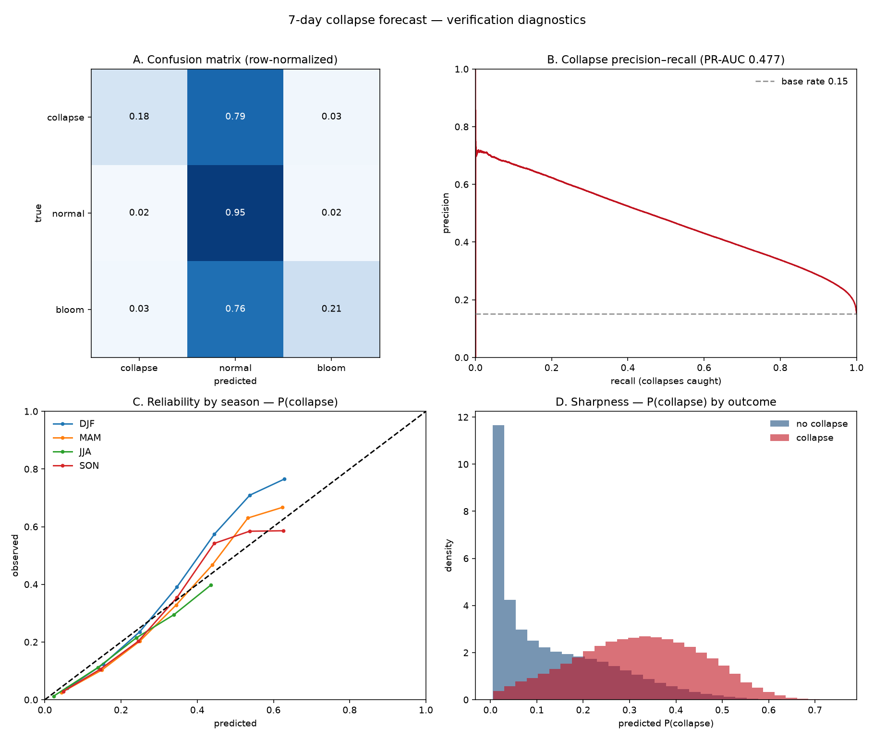
Figure 1. Verification of the seven-day collapse forecast. (A) Confusion matrix, row-normalized. (B) Precision–recall curve for collapse. (C) Reliability by season. (D) Distribution of predicted collapse probability, separated by outcome.
Lead time. Skill was evaluated at leads of 1, 3, 5, 7, and 10 days using identical features and validation.
Lead (days) | Accuracy | Skill vs. climatology | Skill vs. persistence
1 | 0.751 | +0.269 | −1.443
3 | 0.730 | +0.218 | −0.166
5 | 0.717 | +0.180 | +0.068
7 | 0.709 | +0.157 | +0.169
10 | 0.702 | +0.133 | +0.249
Table 2. Forecast skill as a function of lead time.
Two opposing trends emerge. Skill relative to climatology decays with lead time but remains positive through ten days. Skill relative to persistence increases with lead time and crosses zero near day five: at short leads the ocean changes so little that assuming no change is nearly unbeatable, whereas at longer leads persistence degrades rapidly and the model becomes substantially better. The seven-day horizon used throughout sits in the regime where the model outperforms both references simultaneously.
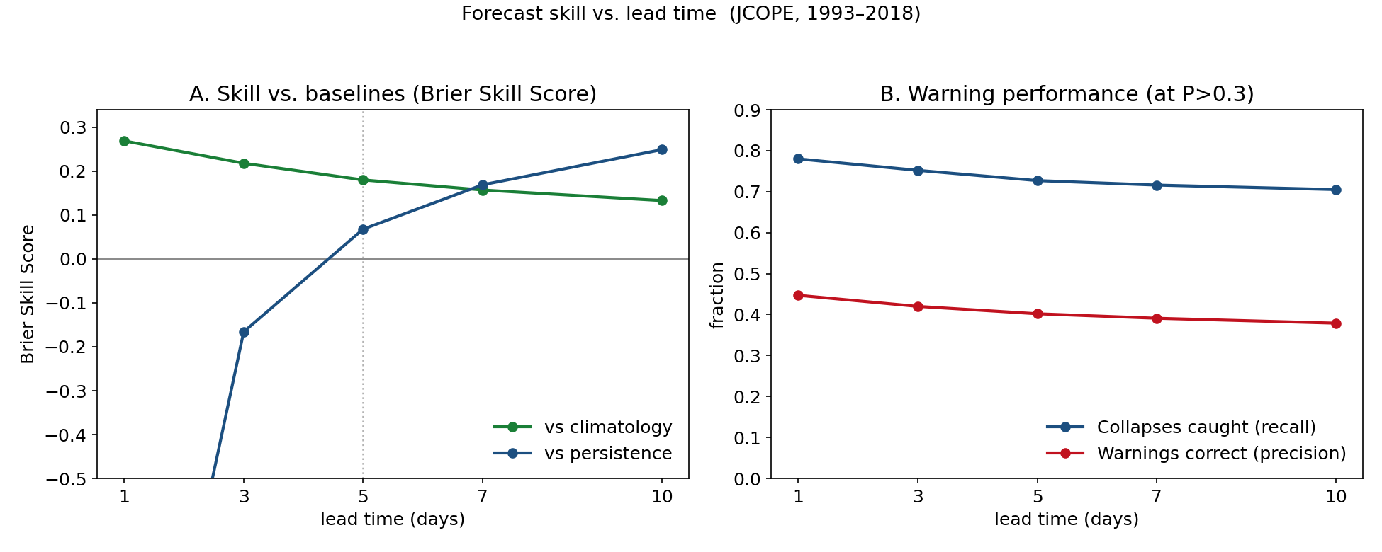
Figure 2. Forecast skill against lead time. (A) Skill against climatology decays but stays positive through ten days, while skill against persistence rises and crosses zero near day five. (B) Warning performance at P > 0.3 across lead times.
Marine heatwave response. Marine heatwaves were identified following Hobday et al. (2016), in which sea surface temperature exceeding the local seasonally varying 90th percentile for at least five consecutive days. Conditioning collapse rate on heatwave status shows a clear effect: observed collapse probability seven days after a non-heatwave day is 14.5%, rising to 20.4% after a heatwave day, a relative increase of roughly 40%. The calibrated model reproduces this structure, predicting approximately 15.5% and 21.5% respectively. Suppression varies seasonally, strongest in spring and autumn (≈ −0.53σ) and weakest in winter (−0.21σ); forecast skill follows a complementary pattern, highest in summer (log-loss 0.268, accuracy 0.928) and lowest in winter (0.897, 0.557).

Conclusion
The initial goal of creating a model to correctly forecast phytoplankton population states was met to an extent. As seen above, the model itself does perform adequately, producing calibrated seven-day probabilities that beat both climatological and persistence baselines, discriminate the rare collapse class well above chance, and reproduce the observed marine-heatwave signal. However, there are certain limitations that prevent it from being a ubiquitously usable tool.
Foremost is the limitation of the datasets. While JCOPE does provide impressive coverage, it is in itself an ocean reanalysis, not direct observation. Its physical fields are constrained by assimilated measurements, but its biological fields are model-derived and only weakly observationally constrained. Thus, there is the possibility of discrepancies between the phytoplankton variability represented in the reanalysis and that of the real ocean, and the forecast presented here should be understood as validated against a model rather than against nature. Independent verification against satellite ocean-color chlorophyll is the necessary next step, with the caveat that satellites observe only the near-surface layer and so may not capture the full depth structure of the response.
Several further limitations bear noting. The definition of collapse is relative rather than absolute, denoting an unusually low concentration for a given place and season rather than a specific biomass floor. The model treats total phytoplankton rather than distinguishing functional groups such as diatoms, whose ecological roles differ substantially. The domain is a single region over a historical period, so the results should not be read as a projection of future climate states. And the trade-off between collapses caught and warnings proven correct limits how aggressively the model can be operated.
Furthermore, the topic itself can be refined further. The most direct extensions are the incorporation of additional physical variables that were not captured, extension of the forecast horizon beyond ten days toward monthly and seasonal ranges, where short-term prediction gives way to genuinely anticipatory management; and expansion of the spatial domain beyond the northwest Pacific to test whether the relationships learned here generalize. Establishing that generality, alongside observational validation, would mark the transition from the demonstration presented here to a tool suitable for operational use.

References
Hobday, A. J., et al. (2016). A hierarchical approach to defining marine heatwaves. Progress in Oceanography, 141, 227–238.
Miyazawa, Y., et al. JCOPE ocean reanalysis. Japan Agency for Marine-Earth Science and Technology (JAMSTEC).

