Gas Plant SCADA Software Application

Traian Turc
“Petru Maior” University of Targu Mures
traian.turc@engineering.upm.ro

Adrian Gligor
“Petru Maior” University of Targu Mures
agligor@engineering.upm.ro

Abstract

The paper describes a SCADA software application based on MySQL database, implemented on gas pipeline plant. The main purpose of SCADA system is remote monitoring and controlling of gas plant. SCADA software application is based on database located in server. The Server is responsible for data acquisition and handling. Data gathered from gas plant are centralized and displayed at the station office headquarter and are sent to a large number of users using dynamic WEB pages. The main benefit of using SCADA is real-time displaying of gas plant state. The main contribution of the author consists in the SCADA server application, database architecture, and the monitoring system using dynamic WEB pages.

1. Introduction

As far as gas plants are concerned, safety is one of the most important issues. In order to increase safety level and achieve more reliability and robustness a SCADA system is implemented.
PC-based SCADA systems are widely accepted today by the oil and gas industry.
The SCADA systems are used to monitor and control gas plants and also for gathering and analyzing real-time data.
A huge amount of data gathered by the SCADA system is managed using a MySQL database. The database is the main part of SCADA system.
In order to share data with a large number of SCADA Clients a MySQL database, which can be accessed over the Internet, is used.
Using dynamic web pages, SCADA clients can display the gas plant state using any computer connected to the Internet, no matter what browser it is used.

2. Hardware architecture

In the following sections we describe the proposed SCADA-based system architecture. Scalability architecture allows the resizing of the SCADA architecture, without having to modify all the existing hardware or software systems. The scalar architecture of SCADA allows the architecture to grow with new requirements while still preserving the initial investment.
Figure 1 shows the hardware architecture for gas plant.
The SCADA servers communicate with devices in the field through the serial line RS 232. RTU (Remote Terminal Unit) and the Base Radio are connected to RS485 in multi drop system.
The RTU is installed at a remote location and collects data from actuators, acting as data concentrator.
On the SCADA server request, the TRU codes the data into transmittable format and sends data to the SCADA Server. The RTU also collects information from the SCADA server and implements processes that are directed by the SCADA Server. The RTU is equipped with input channels for sensing or metering, output channels for control, indication or alarms and a communications port.
The main purpose of the RTU is to interconnect the field devices (actuators) with the SCADA server through a MODBUS RTU interface card.
The TRU transfers all the information from the field to the higher level of the control system (SCADA sever). This function gives total control of the plant.
Data are transmitted through serial line RS485 using MODBUS RTU communication protocol.
Data transferred are relevant to the variables transmitted with each actuator and to the actuator physical sequence on MODBUS map.
The RTU is also capable of executing simple programs autonomously without involving the SCADA server to simplify deployment, and to provide redundancy for safety reasons.
The Base Radio collects data from wireless pressure sensors and transmits the data to the SCADA Server.
A serial RS232-RS485 data converter is used to connect the SCADA server to a RS485 serial line.
The SCADA servers are connected to the SCADA clients and the WEB server stations via an Ethernet LAN.

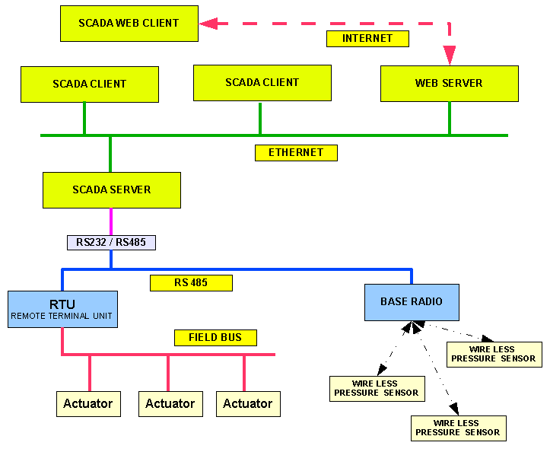

Figure 1. Hardware architecture for gas pipeline

3. SCADA software architecture

The SCADA application is developed according the software architecture shown in Figure 2, having two main components: SCADA server application and SCADA client application.
Figure 2 shows the software architecture for the gas pipeline plant.

The SCADA server application is multi-tasking and is based on MySQL database located in the SCADA server.
The SCADA servers are responsible for data acquisition and data storing in database.
The SCADA server application reads data from RS232 serial port using MBUS RTU protocol.

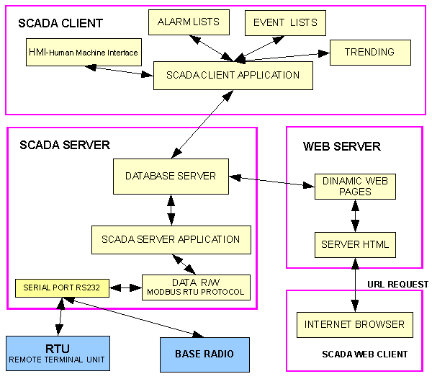

Figure 2. Software architecture for gas pipeline

Data transferred from RTU are stored in a MySQL database, called “cons_el”.
Data are stored using several tables. For instance, data from actuators are stored in tables called “actuators”. The structure of “actuator” table is shown in Figure 3.
The SCADA client application uses the database actualized by the server in order to realize HMI, which consist in gas plant mimics, events lists, warning lists, alarm lists, graphical parameters’ trending and measured parameters’ lists.
A web server is used for generating dynamic web pages, which are necessary to the SCADA web clients. In a similar way to the regular the SCADA clients, the web SCADA clients can be displayed the gas plant state, the parameters list, the events list and the alarm list no matter what browser they use.
The database is also used to keep a historical record of the temporal behavior of various variables in the system, such as pressure in different gas pipelines.

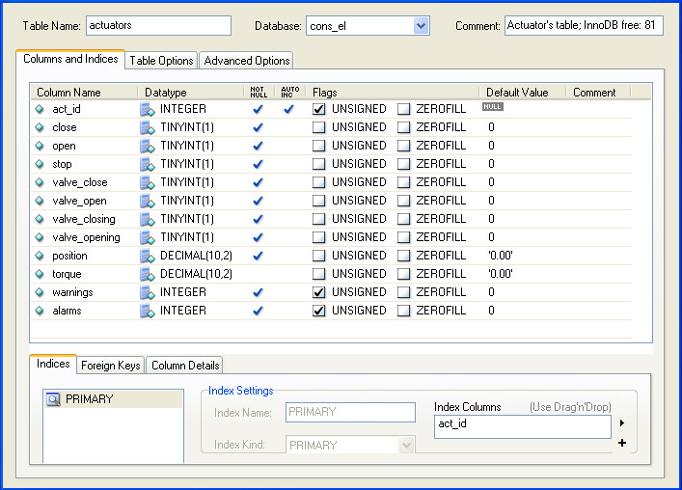

Figure 3. Table “actuators” structure

4. HMI-Human Machine Interface

The HMI (Human Machine Interface) presents the processed data to a human operator, and through this the human operator monitors and controls the process.
By providing information alerts, commands and other tools, an HMI connects the user with the process being controlled.
The HMI is a graphical user interface that includes controls where the operators can interface with the SCADA system.
The SCADA client application offers an intuitive and user-friendly HMI. As shown in Figure 5, HMI mimics gas plant and operators can see an electronic “mirror” of the gas plant.
The SCADA client application also offers support on multiple screens, which can contain combinations of synoptic diagrams and text in order to display event lists, alarm lists, trends.
The Human Machine Interface for gas pipeline plant is shown in Figure 4.

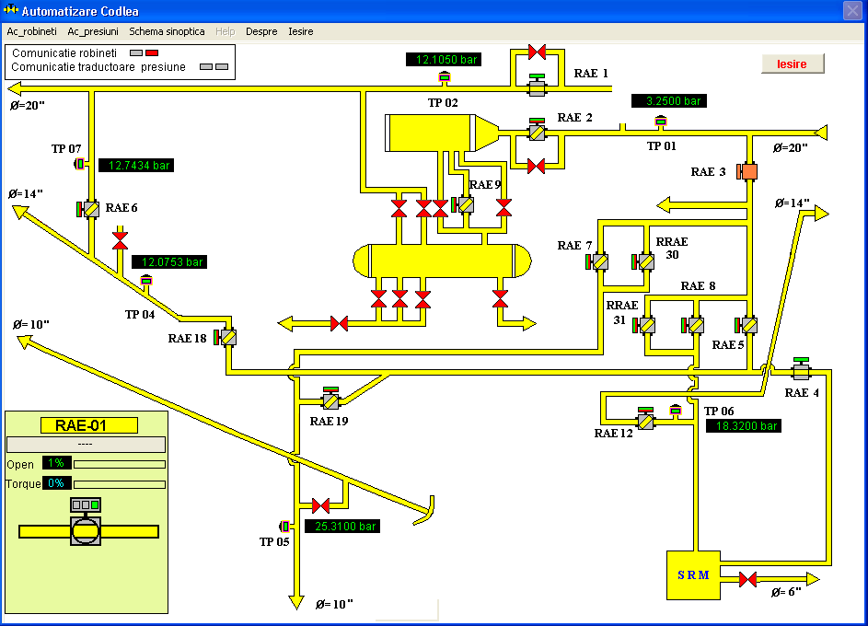

Figure 4. Human machine interface

5. Trending

The SCADA client application provides trending facilities (see Figure 5) having many capabilities, as follows:
- Selecting the parameters to be trended in a specific chart;
- A chart may contain up to 8 trended parameters;
- Historical trending is possible for any archived parameter;
- Zooming and scrolling functions provide the parameter values at the cursor position, simultaneously being displayed.

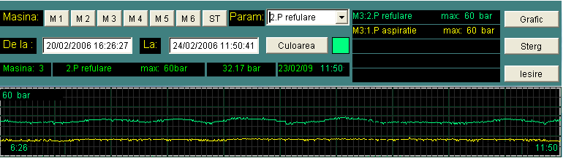

Figure 5. Pressure chart

6. Conclusion and future work

The paper significantly contributes to computer assisted controlling and monitoring of the gas plant.
The main contribution of the author consists in the SCADA software application, database architecture, and the monitoring system using dynamic WEB pages.
Using the SCADA system, the SCADA clients benefit from real-time displaying of gas plant state.
The SCADA clients permanently benefit the actualized scheme of the gas plants.
The SCADA system it is also an event manager.
All this events are stored in the database for ulterior analysis.
The SCADA clients are warned about the incidents and anomalies of the gas plants. As a result of the process of functioning parameters monitoring, a notification system was realized.
Using the SCADA system provides the following facilities:
- Archiving and production parameters analysis;
- After-crash analysis, which can be realized using the stored data (historical data) in order to determine the causes and find prevention measures;
- Product reports based on historical data stored on databases;
The behavior of the entire system can be analyzed due to parameters’ trending displayed in the graphic charts.
SCADA provides both a permanent awareness of the gas plant state, enabling the efficiency increase of the decisional processes and the reduction of fault detection time.
The solution that was proposed in this paper was implemented in two natural gas plants.
The next research includes the using of intelligent sensors and intelligent maintenance system based on neural networks.

7. References

[1] Gavril Toderean, Microprocesoare Univ. Tehnica Cluj, 1994

[2] Mircea Dulau, Automatizarea proceselor termice si chimice- Universitatea „Petru MaiorTargu Mures, 2002

[3] Traian Turc, Brevet de inventie nr:11863 “Sistem pentru automatizarea si monitorizarea proceselor industriale”, OSIM, 2003

[4] Munteanu,R., Tarnovan,I.G., Dragomir,N.D.,
Popovici,O, Electrotehnică şi convertoare energetice. Editura MEDIAMIRA, Cluj-Napoca, România, 1997.

[5] R. Hyde, AoA - The Art of Assembly language, webster.cs.ucr.edu/AoA/DOS/pdf/

[6] S. Nedevschi, Microprocesoare, Editura UTCN, 1994

[7] T. Leţia, A. Aştilean, Sisteme cu evenimente discrete, Editura albastră, 1998

[8] Riptech, Inc, Understanding SCADA System, 2001

[9] A. Daneels - What is SCADA -International Conference on Accelerator and Large Experimental Physics Control Systems, 1999, Trieste, Italy

[10] Schneider Electric Ltd SCADA’s Powerful System Architecture, 2009, Australia

[11] Pacific Northwest National Laboratory, U.S. Department of Energy, The Role of Authenticated Communications for Electric Power Distribution – Beyond SCADA, November 8-9, 2006

