SCADA Architecture for Natural Gas Plant

Traian Turc
“Petru Maior” University of Targu Mures traian.turc@engineering.upm.ro
Horatiu Grif
“Petru Maior” University of Targu Mures hgrif@engineering.upm.ro

Abstract

The paper describes the Natural Gas Plant SCADA architecture. The main purpose of SCADA system is remote monitoring and controlling of any industrial plant. The SCADA hardware architecture is based on multi-dropping system allowing connecting a large number of different field devices. The SCADA Server gathers data from gas plant and stores data to a MySQL database. The SCADA server is connected to other SCADA clients through Ethernet-LAN. The SCADA client application offers an intuitive and user-friendly HMI. The main benefit of using SCADA is real time displaying of gas plant state. The main contribution of the author consists in designing SCADA architecture based on multi-dropping system and Human Machine Interface.

1. Introduction

SCADA is an acronym that stands for Supervisory Control and Data Acquisition. It refers to a system that collects data from various sensors at a factory, plant or in other remote locations and then sends it to a central computer, which manages and controls the data.
A SCADA system includes signal hardware (input and output), controllers, networks, user interface (HMI), communications equipment and software.
The SCADA provides real-time control and optimizes exploitation management systems.
Figure 1 shows typical hardware architecture.

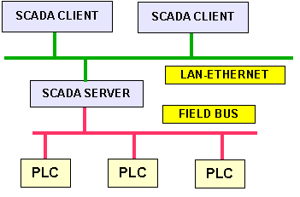
Figure 1. Typical SCADA hardware architecture

2. RTU (Remote Terminal Unit)

The RTU is installed at a remote location and collects data from PLCs, acting as data concentrator.

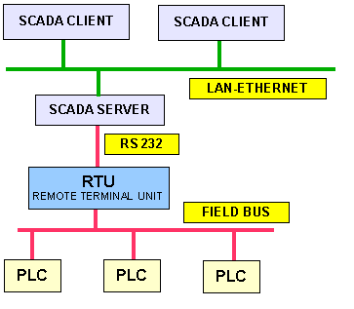
Figure 2. Typical SCADA hardware architecture, using RTU

The SCADA Server request data from the RTU, which codes the data into a format that is transmittable and then the RTU, transmits data to SCADA Server.
The RTU also collects information from the SCADA Server and implements processes that are directed by the SCADA Server.
The RTU is also equipped with input channels for sensing or metering, output channels for control, indication or alarms and a communications port.

3. Connecting multiple RTU

In order to connect multiple RTU or other instruments to the SCADA Server trough serial port, a new BUS is needed. A RS 485 serial line allows multiple devices connection.
The SCADA Server has only RS-232 interface, so a serial data converter RS-232/RS-485 is required.
Figure 3 shows a typical hardware architecture using multiple RTU.

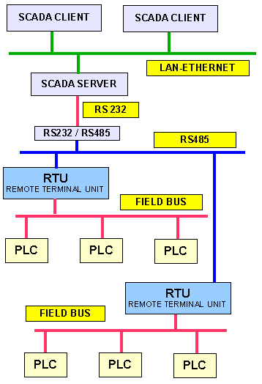

Figure 3. Typical SCADA hardware architecture, using multiple RTU

4. Redundancy

For increasing the integrity of the system, multiple servers are occasionally configured in hot-standby or dual-redundant formation, providing monitoring and continuous control during server failure. For increasing integrity of field bus, dual RTU in master slave configuration and redundant field bus is used.
If the plant processes are critical, or the downtime costs are high, redundancy must be incorporated into the system to eliminate failures caused by equipment failure.
Figure 4 shows a typical hardware architecture using dual redundant server and dual RTU in master slave configuration.

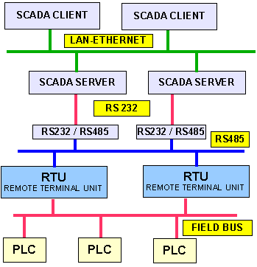

Figure 4. Typical SCADA hardware architecture, using dual RTU in master slave configuration

5. Multi dropping

In many cases, the RTU and other instruments are RS-232 interface equipped. In this case, each of them has to be connected through RS-232/RS-484 serial data converter in order to connect all devices in the same bus.
Finally, even the SCADA Server has to be connected through serial data converter R-S484/RS-232.
Instead of using many serial data converters, using a multi-dropping system is a better solution.

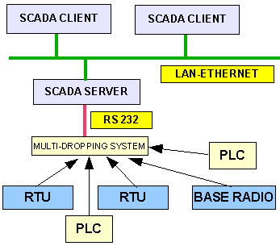
Figure 5. Multi-dropping system

The multi-dropping system allows more than one devices to share a RS-232 common serial (see Figure 5).
Figure 6 shows a multi-dropping system, based on the IC-232 serial interface circuit.
In a multi droppings system, all devices are slaves and can communicate through a serial line only when the master requests (SCADA Server). All devices can read the serial line but only the called device can answer. The SCADA Server scans all subsystems and collects data using MODBUS RTU protocol. Every data request includes the address of the slave. The slave “feels” its own address and answers to the master request. Every subsystem has its own address.
The multi-dropping system allows more than one instrument from different manufacturers to share a RS-232 common serial.
This approach allows a mixed assortment of instrumentation to share a common serial line.

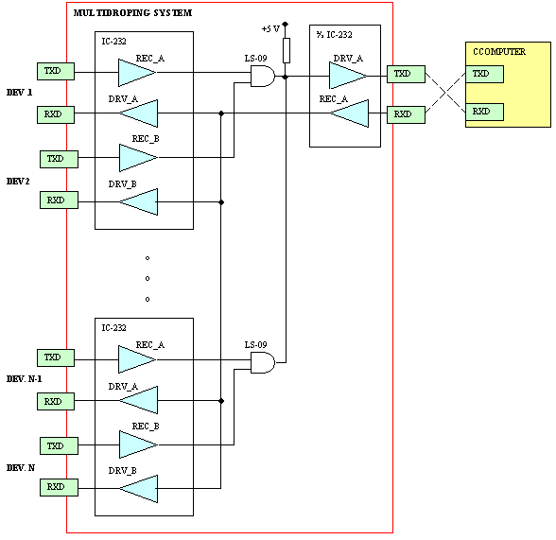

Figure 6. Multi-dropping system, based on IC-232

6. SCADA hardware architecture for Natural gas Industry

In the following sections a SCADA scalar architecture used in Natural Gas Industry is described.
Scalability architecture allows the resizing of SCADA architecture, without having to modify all the existing hardware or software systems. The Scalar architecture of SCADA allows the architecture to grow with new requirements while still preserving the initial investment.
Figure 7 shows the hardware architecture for gas plant.

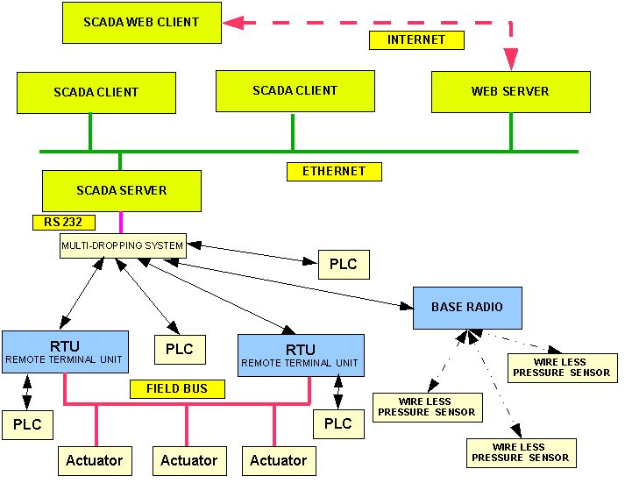

Figure 7. Gas plant SCADA hardware architecture

The SCADA servers communicate with devices in the field through the RS-232 serial line. The RTU (Remote Terminal Unit) and the Base Radio are connected to RS-485 in multi drop system.
The RTU is installed at a remote location and collects data from actuators, acting as data concentrator.
On the SCADA server request, the RTU codes the data into transmittable format and sends data to the SCADA Server. The RTU also collects information from the SCADA server and implements processes that are directed by the SCADA Server. RTU is equipped with input channels for sensing or metering, output channels for control, indication or alarms and a communications port.
The main purpose of RTU is to interconnect field devices (actuators) with the SCADA server through a MODBUS RTU interface card.
RTU transfers all the information from the field to the higher level of the control system (SCADA sever). This function gives total control of the plant.
Data are transmitted through RS-485serial line using MODBUS RTU communication protocol.
Data transferred are relevant to the variables transmitted with each actuator and to the actuator physical sequence on MODBUS map.
The RTU is also capable of executing simple programs autonomously without involving the SCADA server to simplify deployment, and to provide redundancy for safety reasons.
The Base Radio collects data from wireless pressure sensors and transmits the data to the SCADA Server.
An RS-232/RS-485 serial data converter is used to connect SCADA server to a R-S485 serial line.
The SCADA servers are connected to the SCADA clients and WEB server stations via an Ethernet LAN.

6. Software user interface-HMI

The HMI (Human Machine Interface) presents the processed data to a human operator, and through this the human operator monitors and controls the process.
The HMI is a graphical user interface that includes controls where the operators can interface with the SCADA system.

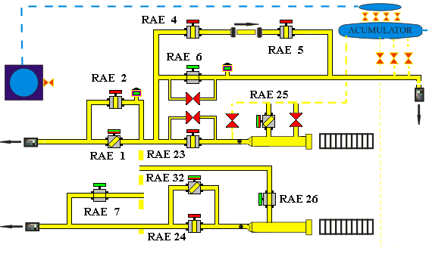

Figure 8. HMI-User interface and process mimics

By providing information alerts, commands and other tools, an HMI connects the user with the process being controlled.
The SCADA clients permanently benefit the actualized scheme of the gas plants.

7. Conclusion and future work

The paper significantly contributes to computer assisted controlling and monitoring of the gas plant.
Using a scalar architecture, the resizing of SCADA architecture can be done without having to modify all the existing hardware or software systems.
Adding new requirements while still preserving the initial investment.
The Multi-dropping system allows a mixed assortment of instrumentation to share a common serial line.
Using the SCADA system, the SCADA clients benefit from real time displaying of gas plant state.
The SCADA clients permanently benefit the actualized scheme of the gas plants.
The SCADA clients are warned about the incidents and anomalies of the gas plants.
As a result of the process of functioning parameters monitoring, a notification system was realized.
Using Internet connection, SCADA Web clients can display the gas plant state, the parameters list, the events list and the alarm list no matter what browser they use.
The solution that was proposed in this paper was implemented in two natural gas plants.
The next research includes the using of intelligent sensors and intelligent maintenance system based on neural networks.

8. References

[1] Gavril Toderean, Microprocesoare Univ. Tehnica Cluj, 1994

[2] Mircea Dulau, Automatizarea proceselor termice si chimice- Universitatea „Petru MaiorTargu Mures, 2002

[3] Traian Turc, Brevet de inventie nr:11863 “Sistem pentru automatizarea si monitorizarea proceselor industriale”, OSIM, 2003

[4] Munteanu,R., Tarnovan,I.G., Dragomir,N.D., Popovici,O, Electrotehnică şi convertoare energetice. Editura MEDIAMIRA, Cluj-Napoca, România, 1997.

[5] R. Hyde, AoA - The Art of Assembly language, webster.cs.ucr.edu/AoA/DOS/pdf/

[6] S. Nedevschi, Microprocesoare, Editura UTCN, 1994

[7] T. Leţia, A. Aştilean, Sisteme cu evenimente discrete, Editura albastră, 1998

[8] T. Leţia. Programarea avansată în Java. Editura Albastră (Microinformatica), 2002

[9] Riptech, Inc, Understanding SCADA System, 2001

[10] Schneider Electric Ltd SCADA’s Powerful System Architecture, 2009, Australia

[11] Pacific Northwest National Laboratory, U.S. Department of Energy, The Role of Authenticated Communications for Electric Power Distribution – Beyond SCADA, November 8-9, 2006

