Retro GUI IDE Quick Start User Guide:

Thanks for using the Retro GUI IDE (RGI) and code builder. This tool provides a window interface to building C and Apple IIe BASIC (with WeeGUI) text GUI programs. For more background see traidna.wordpress.com for the Retrochallenge documentation and examples.

To begin your setup you will need to place some supporting files on your system, the location is dependent on how you have installed the CC65 compiler and your emulators. Included are TUI library files which contain the C programs that support all of the TUI functionality like windows, buttons etc. The tuilib*.o files need to be placed in the same directory where you will be housing your source files. There are also tuilib*.h files and these should be placed in the included directory of your CC65 installation, usually in a c:/…/cc65/include where the … depends on where you installed CC65. You can place the RGI executable (tui_ide.exe) on the desktop, it really should work from anywhere.

Some usage notes:

1. When you compile your C program, the RGI creates a batch file to run the compiler, it has a built in pause so you can see the compiler output, at some point I will put in a setting to make this optional, but just know you will need to press a key once the program is compiled.
2. When the compiler, Ciderpress, emulators are run RGI cannot be accessed until they supporting programs are closed.
3. There are bound to be bugs in this beta released, please feel free to send any feedback to [traidna@gmail.com](mailto:traidna@gmail.com)
4. Settings show in this document are for VICE Commodore emulator, AppleWin for Apple IIe, Altirra for Atari and Ocutron for Oric Atmos.

Running Retro GUI

The RGI can be run by double clicking on the tui_ide.exe file or you can set up a shortcut on your windows desktop. When the program starts you can click the open project button and pick the sample64.rci file. (note all Retro GUI IDE project files have an .rci extension)

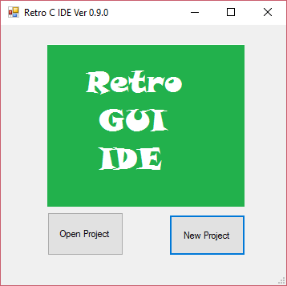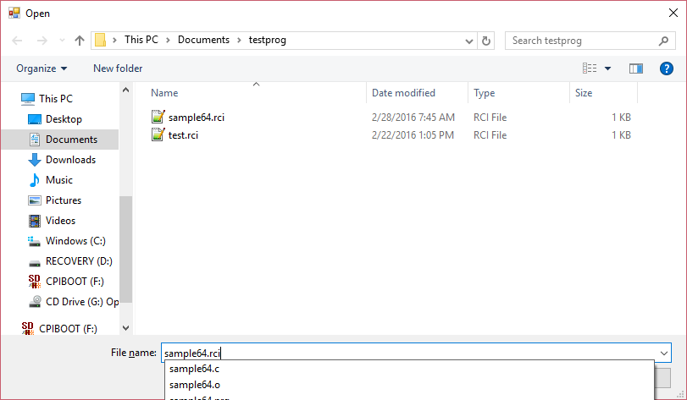

You will not be able to run it until you take care of creating your settings, see Settings below. You access the settings by clicking on the settings button on the RGI main screen toolbar.

Settings

Compiler Settings

CC65 button to set the location for the cl65.exe (the CC65 compiler/linker). Press the button and select the cl65.exe file using the file dialog

Include director – press the button to select the directory where the CC65 include files are located. This is typically in the cc65/include folder in your CC65 directory structure.

Source Directory – click the button to select where you will want to store the source and executable files that Retro GUI IDE should look for and save files.

Compiler switches – these are for CC65 type in the required switches based on the target system. Note Commodore 64 is the default for CC65, see the screen print below for typical settings.

Executable extensions – use PRG for Commodore systems, xex for Atari, tap for Atoms, none is needed for Apple as the executable will need to be added to a disk image before running in the emulator.

Emulator Settings

Click on the button to select the emulator executable for your system of interest, and use the file dialog to select the emulator program. Type any emulator parameters in the prefix (before the executable file name ) and suffix after the executable file name. In the screen shot below for commodore 64 the call to the emulator will be :

C:\Users\traid_000\Downloads\WinVICE-2.4-x64\WinVICE-2.4-x64\x64.exe –autostart myprog.prg

Where myprog.prg is the file name of the executable from my RGI project.

For the Apple settings the suffix tells the emulator which disk image to use in drive 1.

If you are using Ciderpress to add your programs to Apple IIe disk images use the Ciderpress button to select the Ciderpress executable and File button to provide a default disk image.

NOTE : RGI default settings is to create executables for DOS 3.3 binary files. When you add the executable to the disk image you will need to change the file type to BIN.

MAKE SURE TO CLICK SAVE BEFORE CLOSING THE WINDOW!!!!

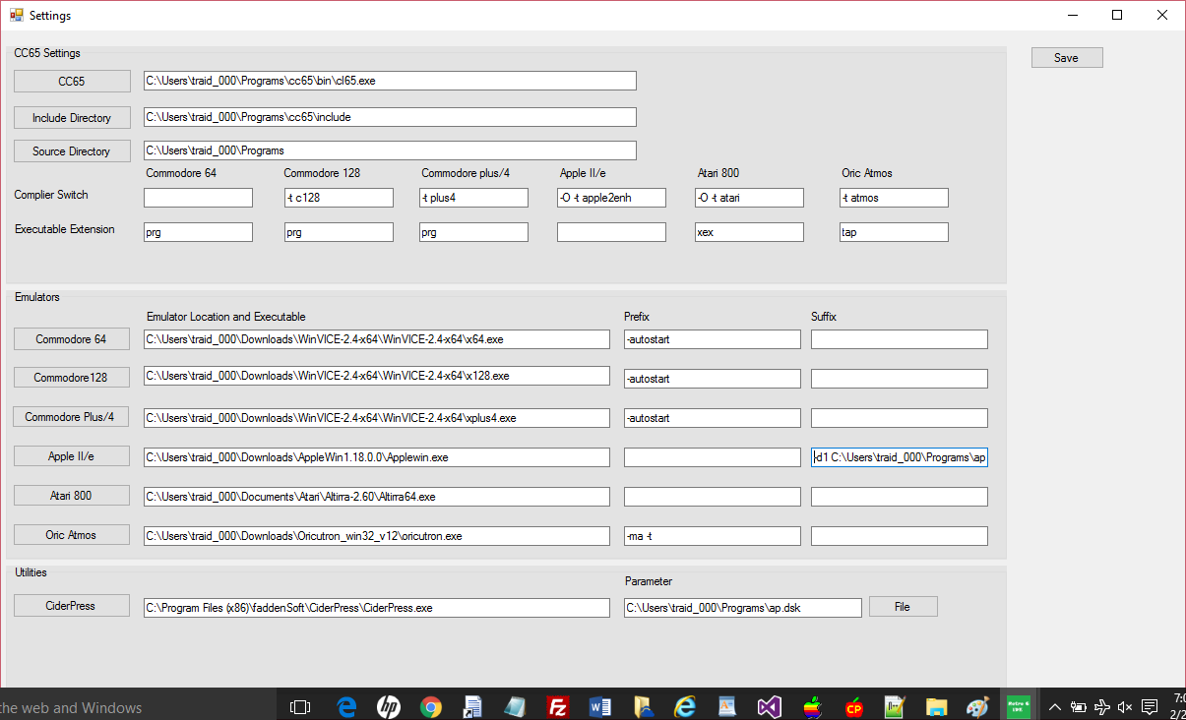

The sample Commodore 64 project is included in the distribution it is called sample64.rci and should be placed in your source directory. Once you have set up all of your settings and have the sample64.rci project loaded your main form will look like this:

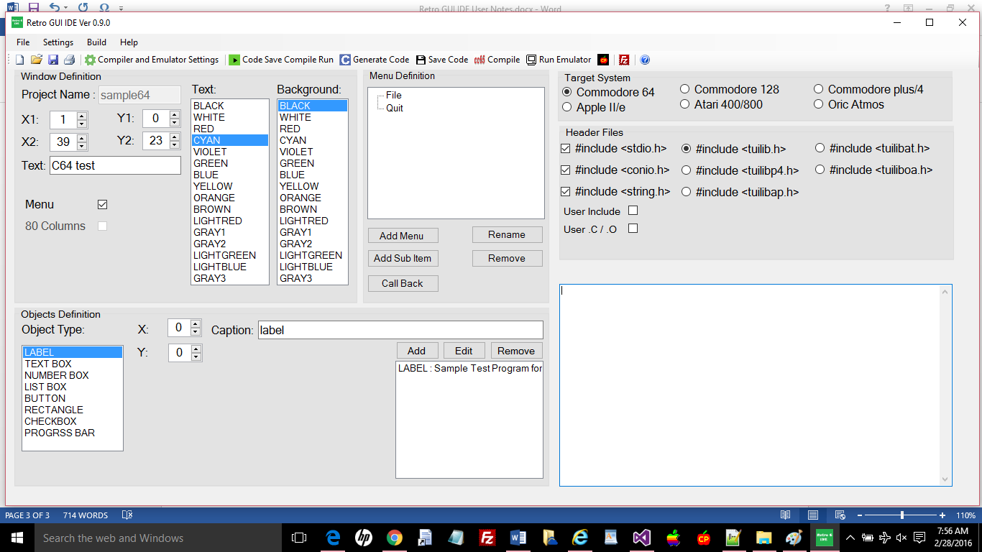

To try the sample64 program click on the Play button  and this will invoke code builder and create and save the sample64.C source file, run the compiler which will create the sample64.o and sample64.prg files. When the compiler finishes press a key to continue, which will start the Commodore 64 emulator (VICE) is used in this demo and you should see the following Commodore 64 program :

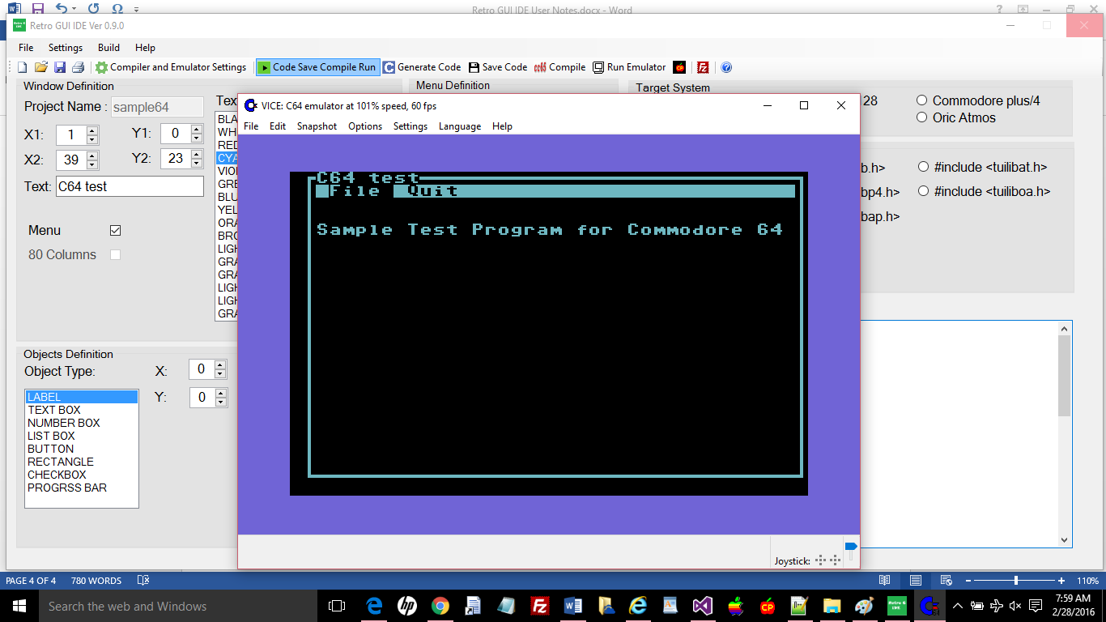

You can traverse the two menu items with the arrow keys, the File option does nothing in the sample and the Quit option will end the program (select a menu option with enter).

When the program ends you can close your emulator to return to RGI.