Setup Infrastructure

Prerequisites & Requirements

System Requirements
- Operating System: Linux (Ubuntu 20.04+ recommended) or macOS
- RAM: Minimum 4GB, recommended 8GB+
- Storage: At least 10GB free space
- Network: Stable internet connection

Knowledge Requirements
Don't worry if you're new to these technologies!
This guide explains everything step-by-step. You should be comfortable with:
- Using the command line/terminal
- Basic understanding of what applications and databases are
- Willingness to learn new concepts

Step 1: Install Docker

What is Docker?
Docker is like a shipping container for software. It packages your application with everything it needs to run, making it easy to move between different computers and environments.

Installation Commands
curl -fsSL https://get.docker.com -o get-docker.sh
sudo sh get-docker.sh

Verify Installation
docker –version
Docker version 27.5.0, build a187fa5

Add Your User to Docker Group (Linux only)
sudo usermod -aG docker $USER
# Log out and log back in for this to take effect

Step 2: Install kubectl

What is kubectl?
kubectl (pronounced "kube-control") is your command-line remote control for Kubernetes clusters. Think of it as the steering wheel for your container orchestration.

Installation Commands
curl -LO "https://dl.k8s.io/release/$(curl -L -s https://dl.k8s.io/release/stable.txt)/bin/linux/amd64/kubectl"
chmod +x kubectl
sudo mv kubectl /usr/local/bin/

Verify Installation
kubectl version –client
Client Version: v1.30.8+k3s1
Kustomize Version: v5.0.4-0.20230601165947-6ce0bf390ce3
Server Version: v1.30.8+k3s1

Step 3: Install Helm

What is Helm?
Helm is like an app store for Kubernetes. Instead of manually configuring complex applications, you can install pre-built packages (called "charts") with a single command.

Installation Commands
curl https://raw.githubusercontent.com/helm/helm/main/scripts/get-helm-3 | bash

Verify Installation
helm version
version.BuildInfo{Version:"v3.19.2", GitCommit:"8766e718a0119851f10ddbe4577593a45fadf544", GitTreeState:"clean", GoVersion:"go1.24.9"}

Step 4: Set Up Kubernetes Cluster

What is Kubernetes?
Kubernetes (K8s) is like a smart conductor for an orchestra of containers. It automatically manages, scales, and monitors your applications across multiple servers.
Choosing Your Setup:
For beginners, we recommend starting with K3S (lightweight Kubernetes) on your local machine. It's perfect for learning and testing.

Option A: Easy Local Setup with K3S (Recommended)
curl -sfL https://get.k3s.io | INSTALL_K3S_VERSION="v1.30.8+k3s1" sh -

Check if K3S is Running
sudo systemctl status k3s

Configure kubectl to Work with K3S
# Make kubectl easier to use
mkdir -p ~/.kube
sudo cp /etc/rancher/k3s/k3s.yaml ~/.kube/config
sudo chown $USER:$USER ~/.kube/config
# Create an alias for convenience
echo 'alias kubectl="k3s kubectl"' >> ~/.bashrc
source ~/.bashrc

Test Your Cluster
kubectl get nodes
NAME STATUS ROLES AGE VERSION
desktop-hehpqgl Ready control-plane,master 24h v1.30.8+k3s1

Option B: Cloud Provider Setup (Advanced)
For Production Use: Consider using managed Kubernetes services like:
- Amazon EKS (AWS)
- Google GKE (Google Cloud)
- Azure AKS (Microsoft Azure)

Step 5: Deploy PostgreSQL Database

Set Up Your Database

What is PostgreSQL?
PostgreSQL is a powerful, reliable database system. It's like a smart filing cabinet that can store and retrieve your application data very efficiently.

Add Bitnami Repository
helm repo add bitnami https://charts.bitnami.com/bitnami
helm repo update

Create PostgreSQL Configuration
Create postgresql-helm-values.yaml:
cd postgresql
Note: This folder already contains a postgresql-helm-values.yaml file
# postgresql-values.yaml
auth:
postgresPassword: "mySecurePassword123"
database: "myapp"

primary:
persistence:
enabled: true
size: 8Gi

metrics:
enabled: true # Enable monitoring

resources:
limits:
memory: 512Mi
cpu: 500m
requests:
memory: 256Mi
cpu: 250m

Install PostgreSQL
# Install PostgreSQL
helm upgrade --install postgresql bitnami/postgresql \
--namespace database \
--values postgresql-helm-values.yaml \
--create-namespace

Verify Database Installation
# Check if PostgreSQL is running
kubectl get pods -n database
NAME READY STATUS RESTARTS AGE
postgresql-0 2/2 Running 2 (2m51s ago) 22h
# Get connection information
kubectl get secret --namespace database postgresql -o jsonpath="{.data.postgres-password}" | base64 -d

Step 6: Deploy Your Applications
Project Structure Overview:
Your project contains three main applications with comprehensive monitoring setup:
- AI Chatbot: Python application with AI capabilities
- Backend API: .NET Core API server
- Frontend: React user interface

Understanding Your Project Structure
Before we deploy, let's understand what we're working with:
newrelic-ai-monitoring-demo/
├── application/
│ ├── dotnet/ # .NET Core Backend API
│ ├── python/ # Python AI Chatbot
│ ├── react-crud-app/ # React Frontend
│ └── script.sh # 🔧 Build & Push Script
├── deployment/
│ └── app/
│ ├── ai-app-deployment.yaml # AI App K8s config
│ ├── k8s-deployment-api.yaml # API K8s config
│ ├── k8s-deployment-node.yaml # Node.js K8s config
│ └── secrets/
│ └── secrets.yaml # Application secrets
├── k3s-setup/
│ └── setup-k3s.sh # K3s installation script
└── postgresql/
├── init-db.sql # 📊 Database initialization
└── postgresql-helm-values.yaml # PostgreSQL config

Step 6.1: Build and Push Application Images

Prepare Docker Images
Prerequisites:
Make sure you have:
- Docker registry access (Docker Hub, AWS ECR, etc.)
- Docker logged in: docker login
- Registry URL configured in script.sh

Navigate to Application Directory
cd application

Review and Configure the Build Script
Before running the script, check the configuration:
# View the script content
cat script.sh

# Make sure it's executable
chmod +x script.sh
What the Script Does:
The script.sh script will:
- Build Docker images for all three applications
- Tag images with proper versions
- Push images to your Docker registry

Run the Build Script
# Build and push all application images
./script.sh without-newrelic
Success Check: You should see output showing successful builds and pushes for dotnet, python, and react applications.

Step 6.2: Prepare Database

Initialize PostgreSQL Database

Navigate to PostgreSQL Directory
cd ../postgresql

Review Database Initialization Script
# Check the SQL initialization script
cat init-db.sql
What init-db.sql Contains:
This script typically includes:
- Database schema creation
- Initial table structures
- Sample data insertion
- User permissions setup

Initialize the Database
# Get PostgreSQL pod name
POSTGRES_POD=$(kubectl get pods -n database -l app.kubernetes.io/name=postgresql -o jsonpath='{.items[0].metadata.name}')

# Copy SQL script to the pod
kubectl cp init-db.sql database/$POSTGRES_POD:/tmp/init-db.sql

# Execute the initialization script
kubectl exec -n database $POSTGRES_POD -- psql -U postgres -d postgres -f /tmp/init-db.sql

Success Check: You should see SQL commands executing successfully without errors.

Step 6.3: Configure Application Settings

Database Connection & Configuration

Update Application Configuration
Your applications need to know how to connect to PostgreSQL:
Configuration Files:
- appsettings.test.json: Database connection strings
- secrets.yaml: Kubernetes secrets for sensitive data

Step 6.4: Deploy Applications to Kubernetes

Navigate to Deployment Directory
cd ../deployment
Before applying, let's understand what each file does:
# Review the .NET API deployment
cat app/k8s-deployment-api.yaml

# Review the AI chatbot deployment
cat app/ai-app-deployment.yaml

# Review the frontend deployment
cat app/k8s-deployment-node.yaml
What to Look For:
In each deployment file, verify you can see:
- Proper image references from your registry
- Resource limits and requests
- Health check configurations
# Create application secrets for OpenAI key
kubectl apply -f secrets/secrets.yaml

# Generate and apply application configuration secret
jq '.' appsettings.test.json > appsettings.json
export appSettingsBase64=$(cat "appsettings.json" | base64 -w 0)
envsubst < secret.yaml > app/secret-backend.yaml

kubectl apply -f app/secret-backend.yaml -n default

Deploy Applications
# Deploy AI Chatbot (Python)
kubectl apply -f app/ai-app-deployment.yaml

# Deploy Backend API (.NET Core)
kubectl apply -f app/k8s-deployment-api.yaml

# Deploy Frontend (Node.js/React)
kubectl apply -f app/k8s-deployment-node.yaml

Verify Deployments
# Check all application pods
kubectl get pods -n default
NAME READY STATUS RESTARTS AGE
ai-chatbot-79854c5967-vjf95 1/1 Running 1 (4m51s ago) 21h
backend-api-76f64b8b4-qjp2d 1/1 Running 1 (4m51s ago) 21h
frontend-66c6944597-jvwq6 1/1 Running 1 (4m51s ago) 21h
# Check services
kubectl get services
ai-chatbot-service ClusterIP 10.43.167.239 <none> 80/TCP 22h
backend-api NodePort 10.43.40.255 <none> 80:31080/TCP 22h
frontend ClusterIP 10.43.178.61 <none> 80/TCP 22h
kubernetes ClusterIP 10.43.0.1 <none> 443/TCP 24h
# Check deployment status
kubectl rollout status deployment/ai-chatbot
kubectl rollout status deployment/backend-api
kubectl rollout status deployment/frontend
Success Check:
All pods should show "Running" status:
- ai-chatbot-xxx
- backend-api-xxx
- frontend-xxx

Step 7: Verify Everything Works

Final Checks

Check All Pods
# Check all namespaces
kubectl get pods --all-namespaces

# Specifically check your applications
kubectl get pods -n default
NAME READY STATUS RESTARTS AGE
ai-chatbot-79854c5967-vjf95 1/1 Running 1 (5m38s ago) 21h
backend-api-76f64b8b4-qjp2d 1/1 Running 1 (5m38s ago) 21h
frontend-66c6944597-jvwq6 1/1 Running 1 (5m38s ago) 21h
kubectl get pods -n database
NAME READY STATUS RESTARTS AGE
postgresql-0 2/2 Running 2 (5m54s ago) 22h

Verify from UI (Frontend)
# Use Port-forward
kubectl port-forward svc/frontend 5000:80 -n default

# Open the web browser and navigate to http://localhost:5000

- Add New User
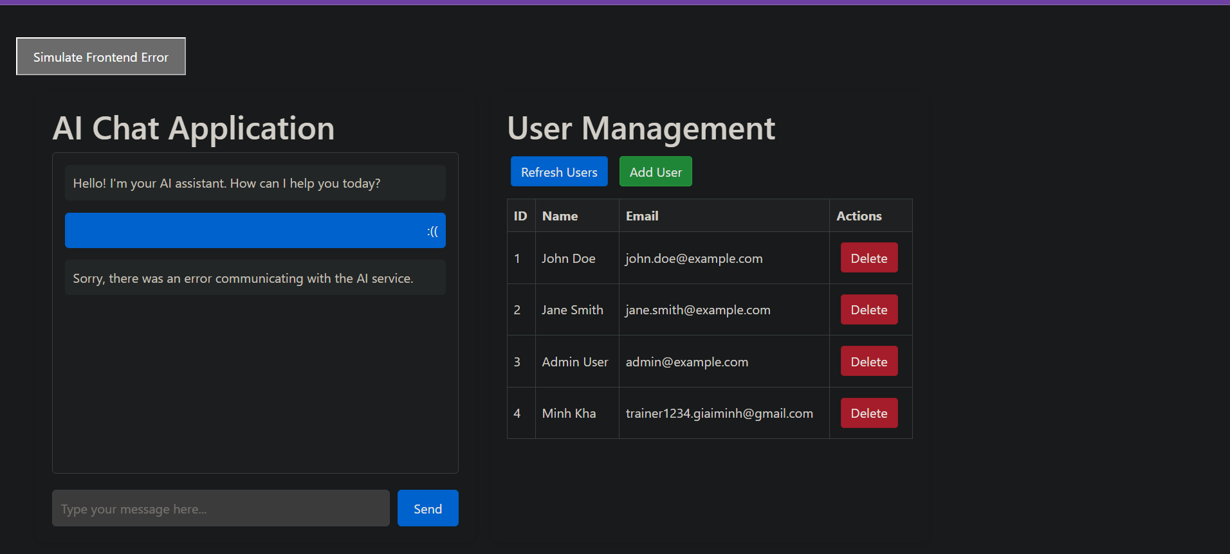

- Ask AI Chatbot

