1. Display the total commission of each salesman based on the orders.

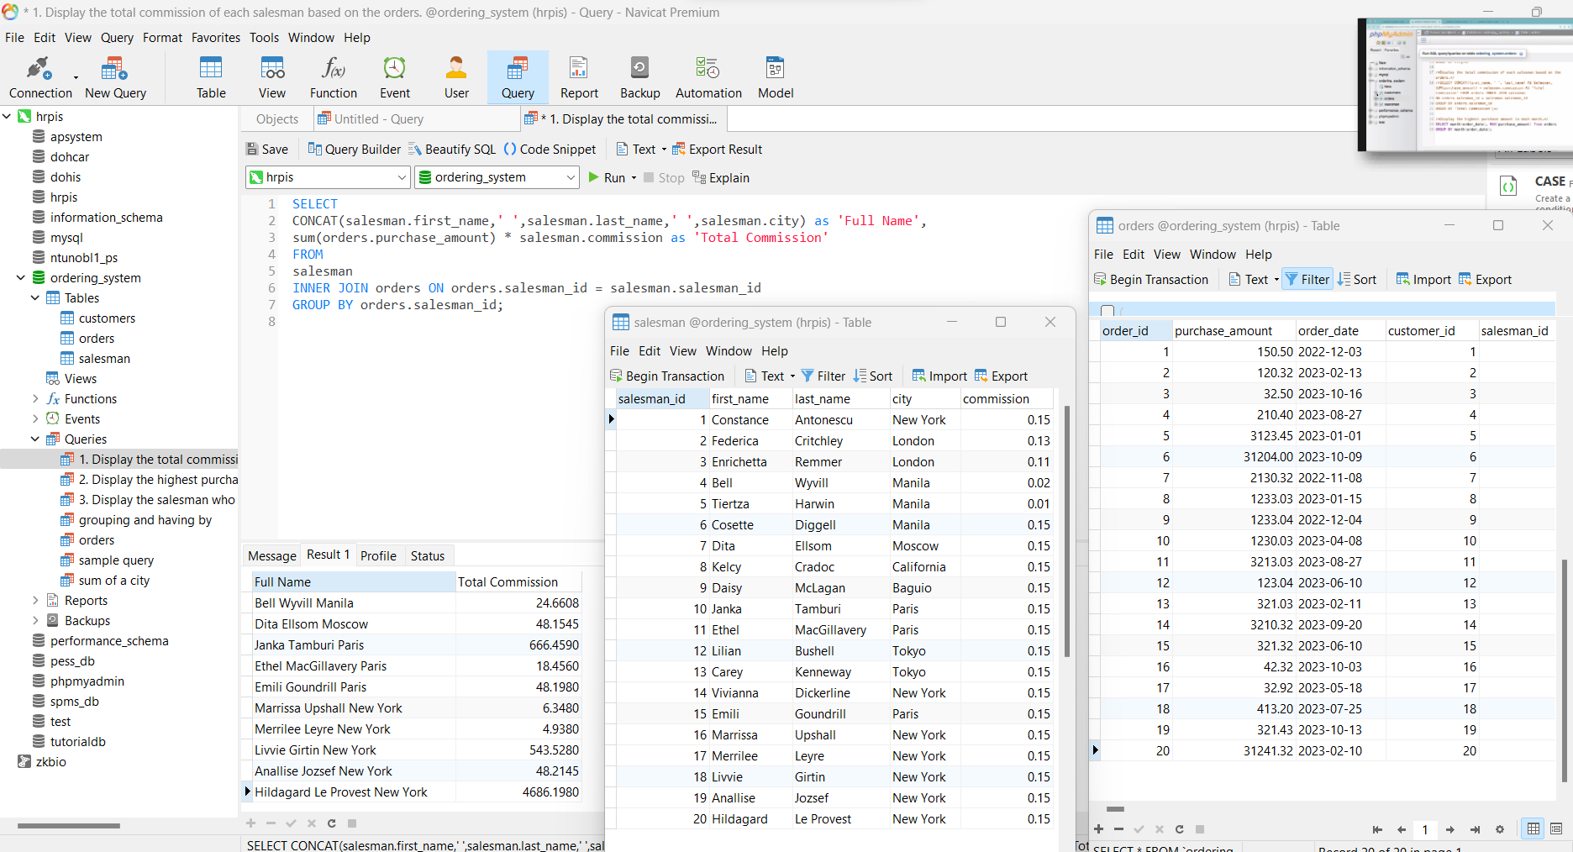

2. Display the highest purchase amount in each month.

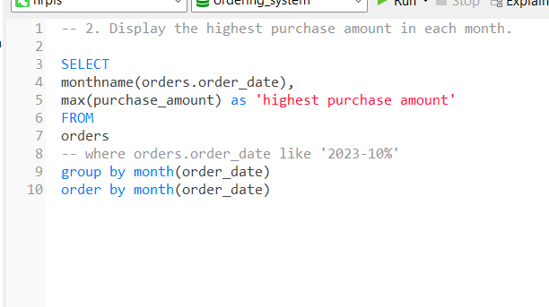

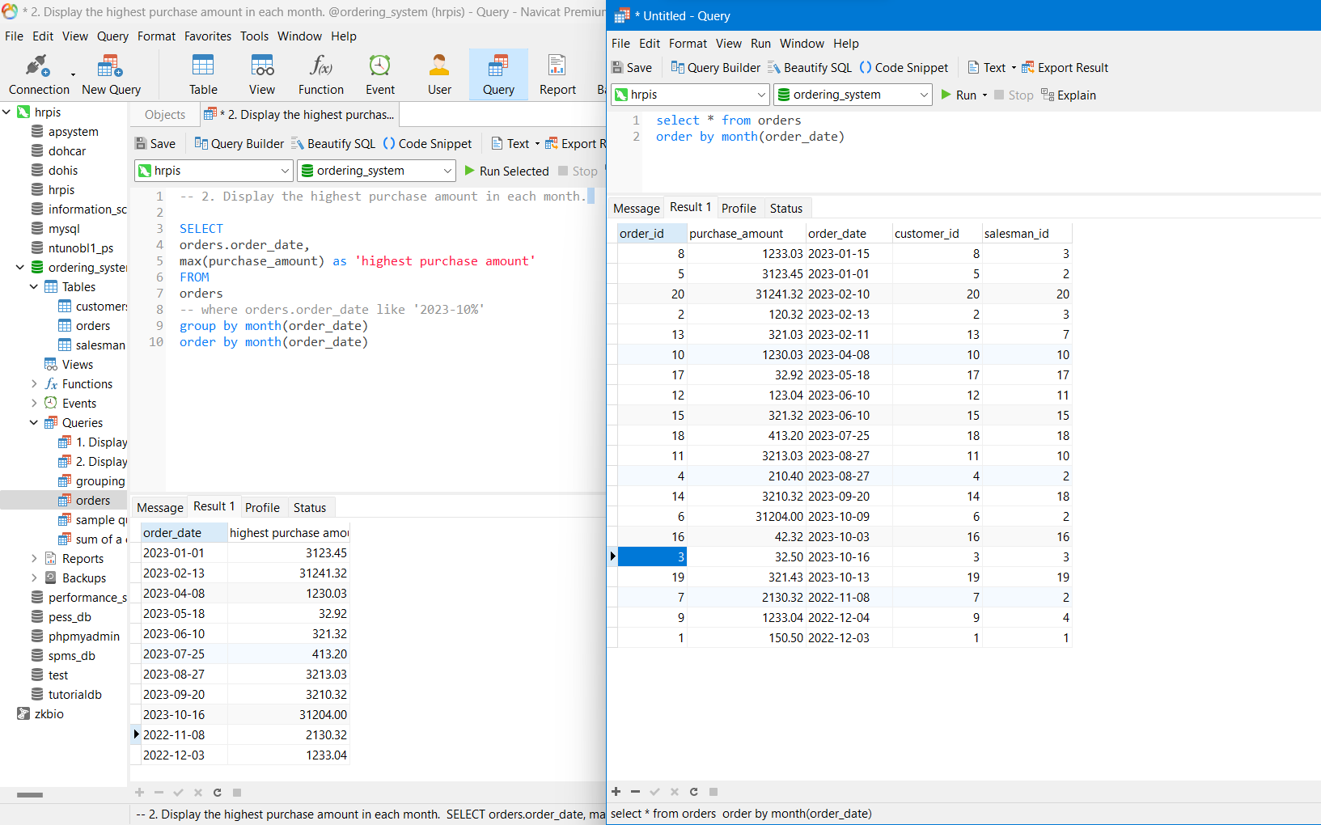

3. Display the salesman who have assisted more than one order

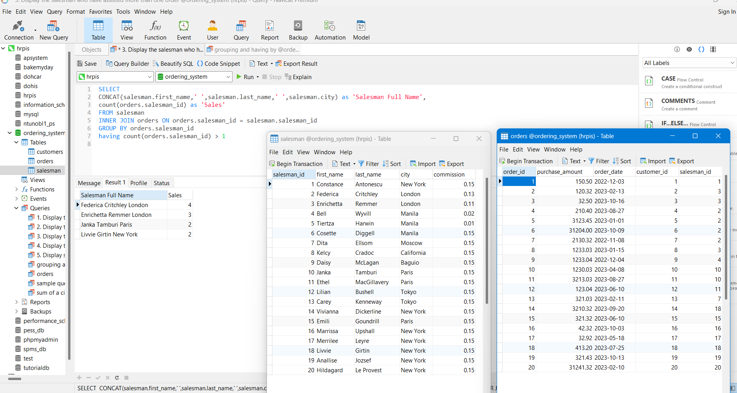

4. Display the name of the customers assisted by each of the salesman.

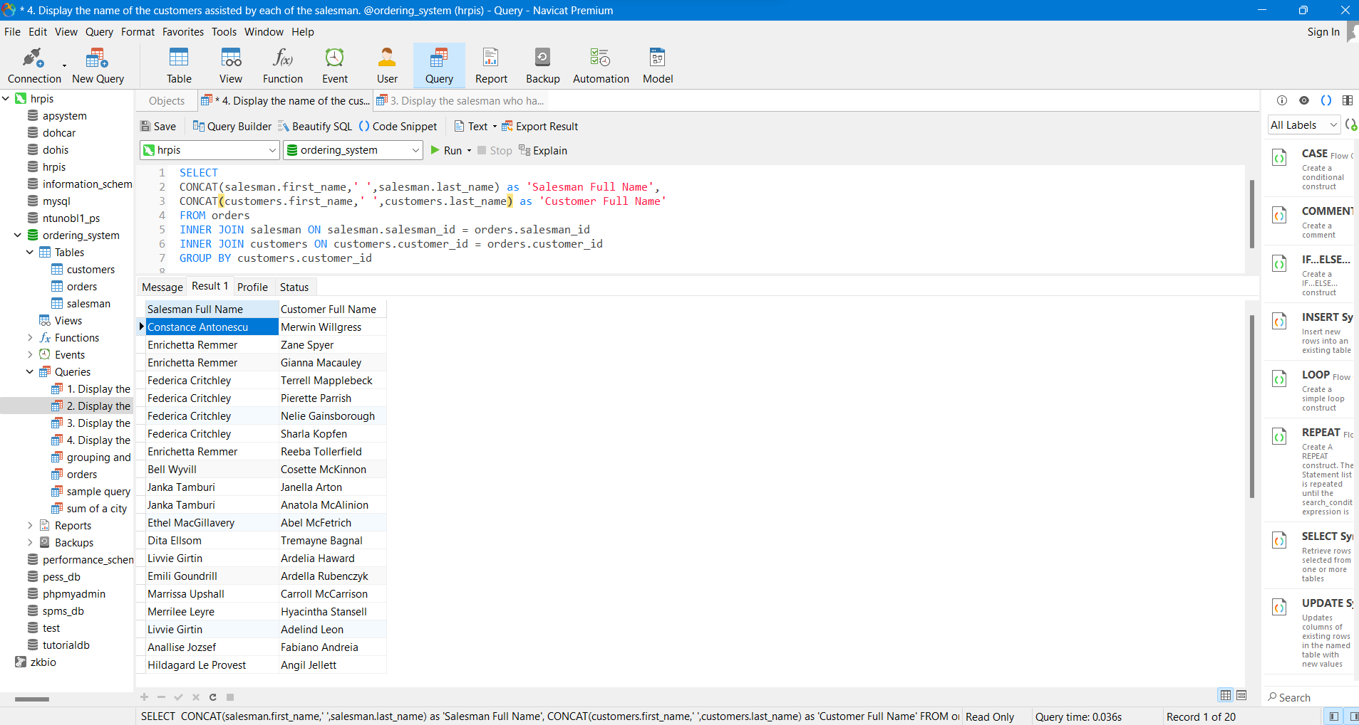

5. Display salesman who have the highest total commission based on the orders.

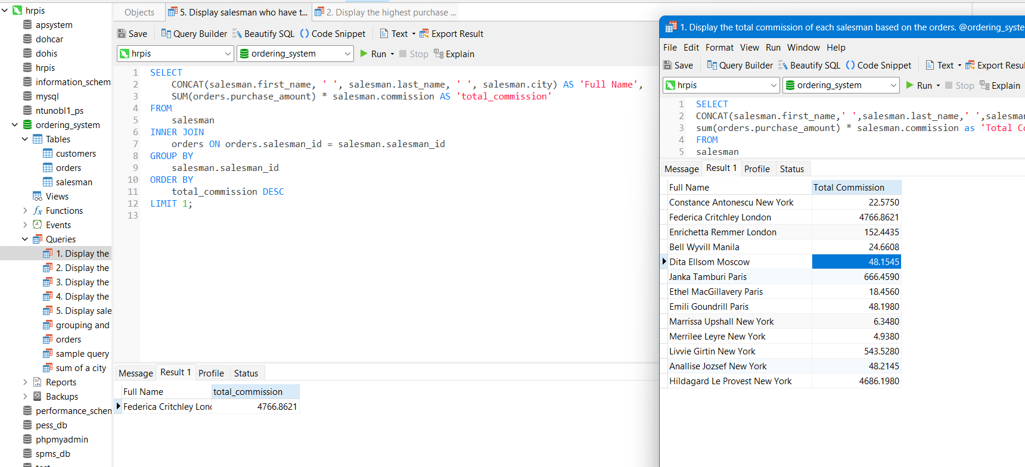

1. Display the total commission of each salesman based on the orders.  
2. Display the highest purchase amount in each month.  
3. Display the salesman who have assisted more than one order  
4. Display the name of the customers assisted by each of the salesman.  
5. Display salesman who have the highest total commission based on the orders.