1. 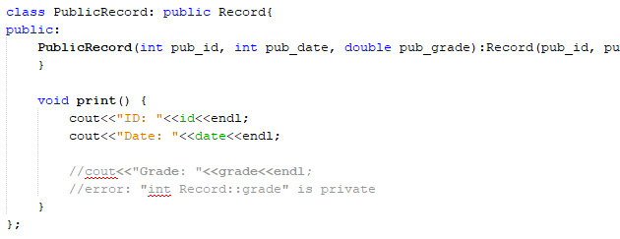

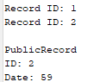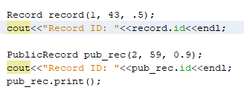

Public inheritance may be accessed by the base class as ‘record.id’ as well as by derived classes such as ‘PublicRecord’ in the ‘print()’ function.







Public inheritance protected data may be accessed by the base class as well as other functions from that class

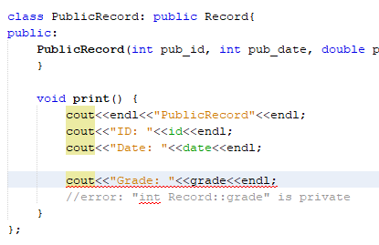

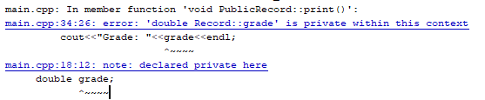

Private data cannot be accessed by derived classes

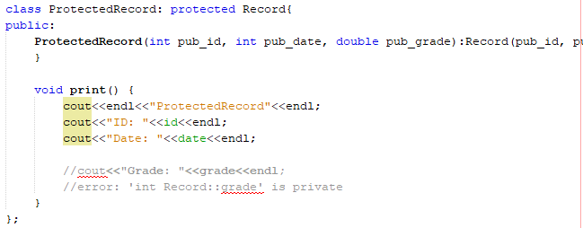



Protected inheritance for both public and protected data may be accessed by the base class as well as other derived functions, along with act like protected data

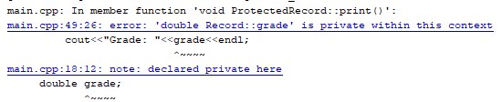

For protected inheritance private data cannot be accessed by derived functions

1. 

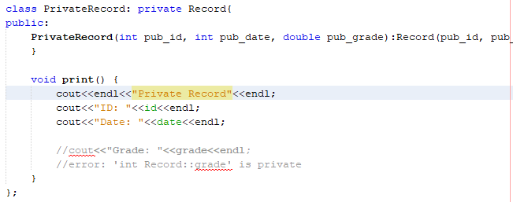

For private inheritance may be accessed by the derived class

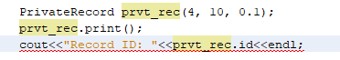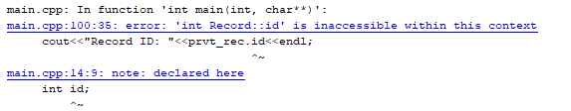

However, clients of derived class or further derived classes

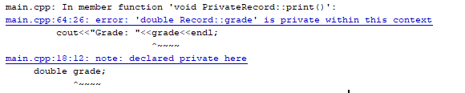

For private inheritance, private data cannot be accessed in the base class