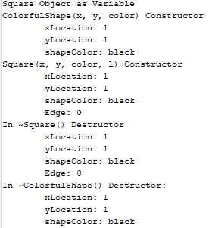A square object is initiated as a variable:

- A shape constructor is called first to create a ColorfulShape object for the square

- Square constructor is then called to create the square

- The variable is then deleted from outside in (Square deleted then ColorfulShape)

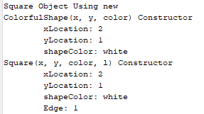

When a square object is initiated using new:

- ColorfulShape constructor is called to build the shape object for the square

- Square constructor is then called to build the square object

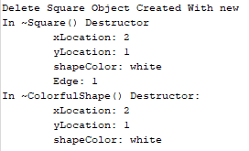

When The square object that was created using new is deleted:

- The square object is first deleted

- After the ColorfulShape object is deleted

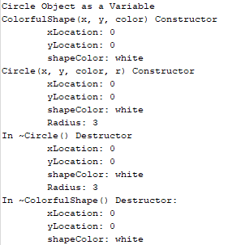 When Circle object is created as a variable:

- ColorfulShape constructor is called to make object for circle

- Circle constructor is called to create the object

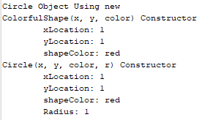 - Object is then deleted starting with the circle object and then the ColorfulShape object

When Circle object is created using new:

- ColorfulShape constructor is called to create shape object for the circle

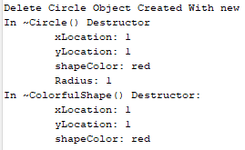 - Circle constructor is called to create the circle object

When Delete is called on the Circle object that was created using new:

- Circle destructor is called first deleting the Circle object

- ColorfulShape destructor is called last to delete the shape class of the Circle objects