**Application Notification.**

1. **WebSocket-style messaging.**

The WebSocket protocol enables interaction between a web client (such as a browser) and a web server with lower overheads, facilitating real-time data transfer from and to the server. This is made possible by providing a standardized way for the server to send content to the client without being first requested by the client, and allowing messages to be passed back and forth while keeping the connection open

WebSocket application may use a single URL only for the initial HTTP handshake. All messages thereafter share and flow on the same TCP connection. These points to an entirely different, asynchronous, event-driven, messaging architecture.

WebSocket RFC defines the use of [sub-protocols](https://tools.ietf.org/html/rfc6455#section-1.9). During the handshake.

The Spring Framework provides support for using [STOMP](https://stomp.github.io/stomp-specification-1.2.html#Abstract) (Streaming text oriented messaging protocol) — a simple, messaging protocol

[STOMP](https://en.wikipedia.org/wiki/Streaming_Text_Oriented_Messaging_Protocol) messaging with Spring.

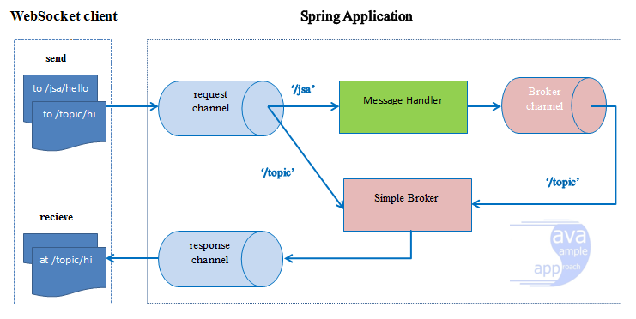

1. **Message broker server**

**ActiveMQ.**

Apache ActiveMQ is an [open source](https://en.wikipedia.org/wiki/Open_source) [message broker](https://en.wikipedia.org/wiki/Message_broker) written in Java together with a full [Java Message Service](https://en.wikipedia.org/wiki/Java_Message_Service) (JMS) client. It provides "Enterprise Features" which in this case means fostering the communication from more than one client or server. Supported clients include Java via JMS 1.1 as well as several other "cross language" clients. The communication is managed with features such as [computer clustering](https://en.wikipedia.org/wiki/Computer_clustering) and ability to use any [database](https://en.wikipedia.org/wiki/Database) as a JMS [persistence](https://en.wikipedia.org/wiki/Persistence_(computer_science)) provider besides [virtual memory](https://en.wikipedia.org/wiki/Virtual_memory), [cache](https://en.wikipedia.org/wiki/Cache_(computing)), and [journal](https://en.wikipedia.org/wiki/Journal_(computing)) persistency.

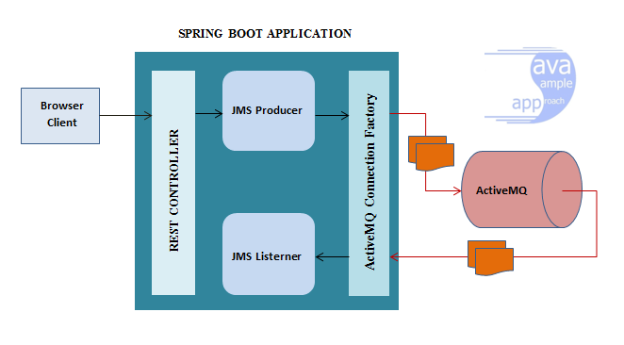

1. **References.**

* <https://spring.io/guides/gs/messaging-stomp-websocket/>
* <http://javasampleapproach.com/spring-framework/spring-websocket/create-spring-websocket-application-springboot-sockjs-stomp>
* <https://docs.spring.io/spring/docs/5.0.0.BUILD-SNAPSHOT/spring-framework-reference/html/websocket.html>