**Spring**

* Spring makes use of the Dependency Injection concept
* Here we can add annotation (@Autowired) to the classes and let spring know we want to create these objects
* Spring will create instance of quick sort algorithm and instance of complex algorithm using the instance of quick sort algot
* The process in which spring identifies:
  + The beans
  + The dependencies
  + Populates dependencies into beans

Is called dependency injection

**Important Terms**

* **Dependency Injection or Inversion of Control** – It is a process in which the objects define their dependencies. The Spring container then creates and injects those dependencies when it creates beans.
* **Beans** – A bean is an object that is instantiated and managed by Spring IoC container
* **Spring Container** – A spring container creates, configures and assembles beans. It gets instructions on how to do that using configuration metadata. Configuration metadata could be in form of XML, annotations or Java code.

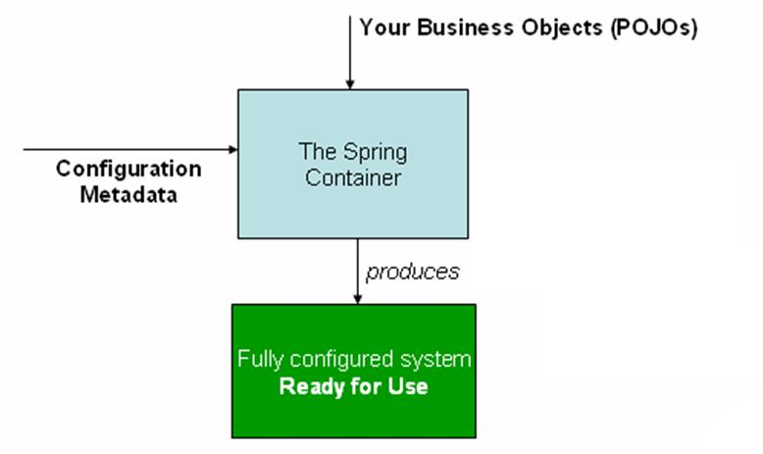

* **BeanFactory** – Provides the configuration framework and basic spring functionality
* **ApplicationContext** – Child interface of BeanFactory. Provides more enterprise specific functionality