Demo 6 – Bedrock Flows

Prompt Management
Create a prompt in Prompt Management and name it stats-classifier, use the below User message
You are a component of a tutor bot for high school students, which is especially skilled in statistics. Your task is to serve as a classifier component, and classify the student's questions into one of two categories.

The categories are as follows: <Statistics>'Statistics' for high school questions related to high school level statistics</Statistics> and <Other>'Other' for questions related to any other topics</Other>.

The question is the following: <Question>{{Question}}</Question>.

Please classify the question into one of the two categories above. Only answer with the category word.

Building Prompt Flows

To implement this, we'll use a knowledge base with Amazon Bedrock Knowledge Bases . This will use a managed Retrieval-Augmented Generation (RAG) technique for indexing the learning materials on Statistics. When students have questions about statistics, you want the chatbot to respond based on the content in this Knowledge Base. However, for questions on other subjects, you don't want the chatbot to simply refuse answers. Instead, in those cases, you want it to rely on the Large Language Model's (LLM) parametric memory to provide a response.

The solution involves classifying each student's question with your previously designed prompt, to determine if it relates to the available learning content e.g. the book on statistics. If it does, the question is routed to the Knowledge Base for an answer based on pre-indexed material. If not, the question is directed to the LLM - either the same one used for classification or a different one - to generate a response using its parametric memory.
Here is an example of the flow we'll follow to implement the solution:

Architecture Diagram

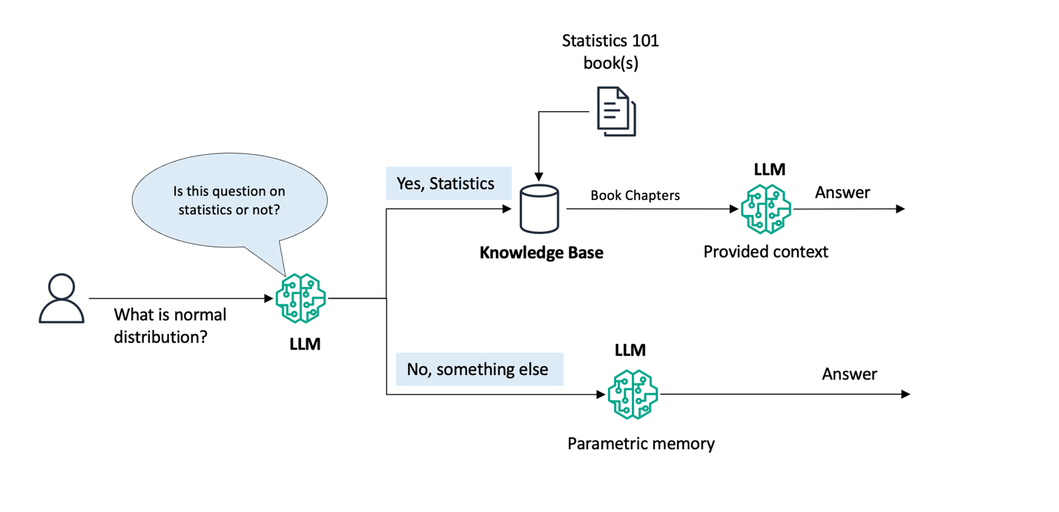
Prepare the Knowledge Base
Before we begin building the Flow, we need to create a Knowledge Base which will hold our educational content, in this case - study materials on statistics. In this demo, we'll use a book called "Statistics" from the OpenStax and upload it on S3 Bucket.

Create a Knowledge Base with "Statistics.pdf" file, use Amazon Titan Embeddings G1 - Text v1.2 FM. Don't forget to sync the KB once created successfully.

Flow
Let’s name our first workflow “workshop-flow-1”, choose “Create and use a new service role” and select “Create”:

You will automatically land into the Flow designer

Classifier
We will begin by creating the LLM classifier node. First, select the line connecting the Input and Output nodes and delete it (hit Backspace or Delete in your keyboard).

Next, select the "Nodes" tab on the left panel, pick the "Prompts" node and drag it onto the builder canvas. This will be our Classification node:

Select the new Prompt node by clicking on it, observe the explorer pane on the left and switch to the "Configure" tab. Name this node “Classifier”, and from the dropdown select the prompt that we've created earlier called "stats-classifier" (latest version of it):

Finally, let's define the input for the classifier. Connect the "Flow input" node to the "Classifer" node using the dots in the visual builder:

Condition

In this step, we will define conditional workflow split. If our Classifier outputs "Statistics" we will execute a Knowledge Base query; otherwise we will allow the LLM to answer the question directly.

Let's go back to the Nodes catalog in the flow builder explorer pane, pick the "Condition" node, and bring it over onto the canvas. Connect the "Classifier" prompt output to the "conditionInput" and populate the condition field as shown below:

Knowledge Base vs LLM output:
Finally, let's define the rest of the flow with the two different paths in our Condition node. For this, write a "Condition" expression as: "(conditionInput == "Statistics")" in the Condition node.

Now, let’s bring in few more Nodes:

- Add a "Knowledge base" node and then connect the “Go to node” output of the Condition block to it.
- Add another "Prompt" node and connect the “If all conditions are false” output of the Condition to it. Rename this prompt node as: "LLM".
- Connect the "LLM" output to the "Flow output" node, and rename this "Flow output" node as: "LLM_output"
- Bring in one more "Flow output" node and connect the "Knowledge base" output node to it. Rename this "Flow output" node as: "KB output"

Next, let's configure the "Knowledge Base" node. Click on it, and in the Configuration parameters on the left:

Choose the "bedrock-sample-knowledge-base-..." from the drop down.
Choose “Generate responses based on retrieved results” and pick "Anthropic Claude Haiku 3" as the model.

Next, select "LLM" prompt node in the canvas and:

- Choose “Define in node” and enter the "Message" as shown in the picture
- Choose “Select model” and pick "Anthropic Claude 3 Haiku"
- Populate Message (below the "Claude 3 Haiku") with the prompt as shown

By now, we have defined the control plane for our flow, i.e. what needs to be executed and when. Now we also have to provide the data flow, i.e. both the knowledge base and the LLM will need the actual question that came in. Here is how we accomplish that:

Connect the "Flow input" node to the "retrievalQuery" input of the Knowledge base node.
Make another connection from the "Flow input" node to the "LLM" node.
Hit Save at the top and we’re ready to test our flow:

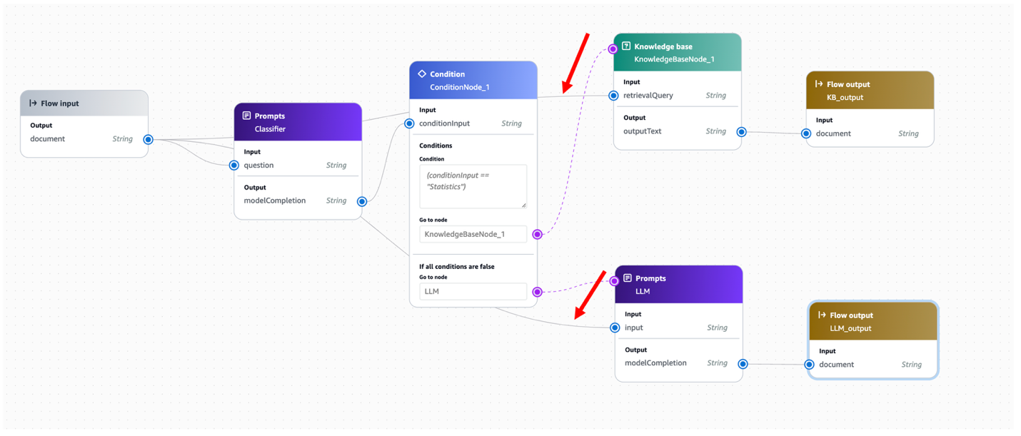

Testing Prompt Flows

Test the flow from the Bedrock Console

Now that our OctankTutor application's flow is ready, we can test it by simply submitting a question from the "Test" panel on the right hand side.

We can try with in example: "What is normal distribution?", or anything else on the topic of statistics. Note, the answer should come from the "KB output" which is part of the Knowledge Base branch of our flow.

Next, we can try non-statistics related question, for example: "Tell me about process of photosynthesis". Note the answer now should come from the "LLM output", which is the output node in the other LLM branch of our flow, meaning the answer came from the LLM's parametric memory.

