Methods and Results
Table of contents

0.1 Abstract
Background & Aims: Marine omega-3 fatty acids are inversely associated with the metabolic syndrome, and randomized trials have confirmed benefits on triglycerides and blood pressure, but not on glucose regulation. Whether they add to the benefits of resistance training is largely untested, and no trial has raised omega-3 status prior to the initiation of training. We investigated whether krill oil improves glucose tolerance, alone and combined with resistance training, and secondarily whether it affects the metabolic syndrome.
Methods: In this double-blind trial, 148 sedentary adults aged 23–60 years (BMI 18.4–52.1 kg/m²) were randomized to krill oil (4 g/day; 508 mg EPA and 300 mg DHA; n=74) or placebo (n=74) for 20 weeks: 7 weeks of supplementation alone, then 13 weeks combined with supervised resistance training. The primary outcome was the change in glucose tolerance (oral glucose tolerance test, OGTT) from week 7 to 20. Secondary outcomes included glucose tolerance from week 0 to 7, fasting glucose, HOMA2-IR, HbA1c, adiponectin, LDL cholesterol and the metabolic syndrome (five components, a composite burden score and prevalence). Treatment effects were estimated using Bayesian models with integrated missing-data imputation. Models were developed and validated following a simulation-based Bayesian workflow. Treatment effects were classified as beneficial, negligible or harmful using thresholds of 0.1 × the between-participant SD, estimated at baseline or from population-based cohorts.
Results: Ninety-five participants completed the trial, attrition being mainly due to the COVID-19 pandemic. Krill oil raised the Omega-3 Index from 6 % to 8 % (2.1 and 2.3 percentage points above placebo at weeks 7 and 20). For the primary outcome, krill oil did not improve glucose tolerance during the combined period, and the estimates instead favoured placebo (difference in within-group change across the OGTT, weeks 7–20, 0.18 mmol L⁻¹ (95% CrI: −0.15, 0.51; P(benefit/negligible/harm) 3/39/58 %)). During supplementation alone, glucose tolerance probably improved with krill oil (weeks 0–7, −0.28 mmol L⁻¹ (95% CrI: −0.65, 0.09; P(benefit/negligible/harm) 77/22/1 %)), but this was not maintained (weeks 0–20, −0.10 mmol L⁻¹ (95% CrI: −0.47, 0.26; P(benefit/negligible/harm) 40/50/10 %)). Fasting glucose was probably lower with krill oil at week 7 (−0.08 mmol L⁻¹ (95% CrI: −0.23, 0.06; P(benefit/negligible/harm) 66/31/3 %)), with a less certain difference at week 20 (−0.06 mmol L⁻¹ (95% CrI: −0.21, 0.09; P(benefit/negligible/harm) 54/39/7 %)). HbA1c was probably higher with krill oil at week 7 (+2 % (95% CrI: 0, 5; P(benefit/negligible/harm) <1/37/63 %)) but not at week 20 (+1 % (95% CrI: −2, 3; P(benefit/negligible/harm) 3/74/23 %)). Effects on HOMA2-IR, adiponectin, LDL cholesterol, BMI and relative fat mass were most probably negligible. Krill oil probably lowered the metabolic syndrome burden score during supplementation alone (−0.08 SD; 95 % CrI −0.17, 0.01; P(benefit/negligible/harm) 71/29/<1 %) and during the combined period (−0.08 SD; −0.17, 0.02; 68/32/<1 %), with harm unlikely in both periods. The largest component effects were lower systolic blood pressure at week 7 (−3.7 mmHg; 90/10/<1 %) and higher HDL cholesterol at week 20 (+0.05 mmol/L; 60/40/<1 %). The prevalence of the syndrome was not reliably reduced.
Conclusions: Krill oil did not improve glucose tolerance when combined with resistance training after a supplementation-only period. A probable early improvement during supplementation alone was not maintained. Krill oil probably lowered the combined burden of the metabolic syndrome, with harm being unlikely, through small effects distributed across several risk factors, most clearly systolic blood pressure and HDL cholesterol, without reducing the prevalence of the syndrome. Registered at ClinicalTrials.gov (NCT04279951).

0.2 Data analysis and statistics
Descriptive data are presented as mean (standard deviation, SD) for baseline characteristics and as mean (95 % confidence interval, CI) for dietary intake, and categorical data as n (%). For inferential statistics, a general Bayesian workflow was adopted where models were incrementally built and tested for validity through simulations. First, implications of prior distributions were evaluated using prior-predictive simulations. Priors were selected to constrain model predictions and parameter values to a priori plausible ranges. This approach encourages the use of weakly informative priors on model parameters, which regularize models and shrink estimates and predictions without distorting the influence of the data on inference (1–3). In relevant cases, synthetic data were used to confirm that model inferences were not biased by model misspecification. Samples from the joint posterior distribution were used to create posterior predictive simulations, in which model implications are simulated and compared with characteristics of the observed data (3,4). Selected models were also, in relevant cases, assessed for inferential capabilities using synthetic data simulations where parameter values are known. The sensitivity of model specifications to inference was assessed by comparing predictions across different models.
Missing values were imputed in all models used for inference allowing for the use of all available data while incorporating the uncertainty associated with loss of data due to drop-out (see Fig. 1) into the posterior probability distribution. Data imputation was done by treating missing values as parameters estimated conditionally on available data and priors (3). Missing data parameters were given a weakly informative prior ($Normal(0,2)$) on the standardized scale (mean centered and scaled by the standard deviation of each variable).
Bayesian models were constructed using the Stan probabilistic programming language (5) and fitted using the cmdstanr interface (6) in R (7). All sampling from prior and posterior distributions was done using the Hamiltonian Monte Carlo (HMC) no-U-turn sampler (8). Performance of the HMC algorithm was assessed using chain convergence statistics (R-hat) and by visually inspecting convergence and stationary sampling across multiple HMC chains.
Whole-blood fatty acid composition and the omega-3 index were modeled for each target ($k=1,…,K$; $K=12$; 11 fatty acids and the omega-3 index) using a Gaussian likelihood after log-transformation and standardization of the outcome variables ($y_{i}∼Normal(μ_{i},σ_{\text{FA}[i],\text{TX}[i]})$, where $\text{FA}[i]∈\{1,…,K\}$, $\text{TI}[i]$, and $\text{TX}[i]$ index the target, follow-up time-point and treatment of observation $i$). The linear predictor included a target-, treatment- and time-point-specific intercept and a target-specific coefficient for the association with pre-intervention values ($μ_{i}=α_{\text{FA}[i],\text{TI}[i],\text{TX}[i]}+β_{\text{FA}[i]}×{\text{Pre}}_{i}$, where ${\text{Pre}}_{i}$ is the standardized pre-intervention value of the same target and participant). Priors were common to all targets ($α∼Normal(0,1)$, $β∼Normal(1,1)$, and $σ∼Exponential(1)$). Treatment effects were assessed by calculating the contrast between treatments at each follow-up time-point.
Blood glucose measured during the oral glucose tolerance test (OGTT) was modeled using a Gaussian likelihood after standardization ($y_{i}∼Normal(μ_{i},σ)$). Glucose curves were represented by a cubic B-spline basis with $J=5$ basis functions (5 degrees of freedom, no intercept column; bs() from the splines package), where $B_{j,i}$ is the $j$-th basis function evaluated at the sampling time (min) of observation $i$. A population-level curve was estimated for each combination of treatment ($\text{TX}[i]$) and time-point ($\text{TP}[i]∈\{1,2,3\}$; baseline, after the supplementation-only period, and after the intervention), with participant-level deviations from the population-level curve: $μ_{i}=α_{\text{TX}[i],\text{TP}[i]}+\sum_{j=1}^{J}{β_{j,\text{TX}[i],\text{TP}[i]}}B_{j,i}+a_{\text{ID}[i]}+δ_{\text{TP}[i],\text{ID}[i]}+\sum_{j=1}^{J}{b_{j,\text{TP}[i],\text{ID}[i]}}B_{j,i}$, where $α$ and $β$ are treatment- and time-point-specific intercepts and spline parameters, $a$ is a participant-specific intercept, $δ$ are participant- and time-point-specific deviations from that intercept, and $b$ are participant- and time-point-specific spline deviations ($\text{ID}[i]$ indexes the participant of observation $i$). The participant-specific intercept and spline deviations ($1+3J$ effects per participant) were drawn from a multivariate normal distribution ($MVNormal(0,SRS)$, $S=diag(σ_{\text{ID}})$), with an $\text{LKJ}(1)$ prior on the correlation matrix $R$ (non-centered parameterization via its Cholesky factor). Time-point-specific intercept deviations were modeled as independent, $δ_{t,\text{ID}}∼Normal(0,τ_{δ})$, with $τ_{δ}∼Exponential(2)$ regularizing the model towards a common participant intercept across time-points. Remaining priors were $α,β∼Normal(0,2)$ and $σ,σ_{\text{ID}}∼Exponential(1)$, and missing OGTT values were imputed as described above. Treatment effects were assessed as between-group differences in the change from baseline of posterior predicted population-level curves, evaluated across the sampling time. For the main outcome analysis, the first follow-up time-point (week 7) was used as the baseline. We used the observed baseline SD, pooled within sampling minute, as the scale for a threshold for negligible treatment effects at single time-points of the OGTT (δ = 0.1 × SD; SD = 1.66 mmol L⁻¹). For treatment effects averaged across the OGTT (0–120 min), the threshold was based on the between-participant SD of the average blood glucose across the test at baseline (SD = 1.43 mmol L⁻¹). We found our data to indicate a slightly larger variation than reported from a comparable published cohort (9), consistent with this cohort having fewer samples across the OGTT procedure. We therefore concluded that our observed baseline data was more relevant for the purpose of deciding on a threshold for negligible effects.
Metabolic syndrome criteria (10) (waist circumference, systolic and diastolic blood pressure, fasting glucose, high-density lipoprotein cholesterol (HDL) and triglycerides (TG)) and related measures of metabolic health (relative fat mass, body mass index (BMI), HOMA2-IR, adiponectin, glycated haemoglobin (HbA1c) and low-density lipoprotein cholesterol (LDL)) were jointly modeled in a multivariate model ($K=12$ outcomes). The reason for choosing this model over several univariate models was twofold: first, we wanted to improve the accuracy of imputed outcome values by sharing information across outcomes, allowing for more realistic estimation of the metabolic syndrome diagnostic criteria; second, we wanted to combine information from several outcome variables into a continuous composite score (11,12) while accounting for their correlations. Triglycerides, HOMA2-IR and HbA1c were log-transformed, and all outcomes were standardized. The linear predictor for observation $i$ was $μ_{i}=α_{\text{OC}[i],\text{TI}[i],\text{TX}[i]}+β_{\text{OC}[i],\text{TI}[i]}×{\text{Pre}}_{i}+γ_{\text{OC}[i],\text{TI}[i]}×{\text{Sex}}_{i}$, where $\text{OC}[i]∈\{1,…,K\}$, $\text{TI}[i]$ and $\text{TX}[i]$ index the outcome, follow-up time-point and treatment of observation $i$, ${\text{Pre}}_{i}$ is the standardized pre-intervention value of the same outcome and participant, and ${\text{Sex}}_{i}$ was coded as $−0.5$ (male) and $0.5$ (female). For each participant ($p$), observations and linear predictors of all outcomes at both follow-up time-points were stacked in vectors $y_{p}$ and $μ_{p}$ of length $2K$, modeled using a multivariate Student’s t-distribution, $y_{p}∼MVT(ν,μ_{p},Σ)$, with the degrees of freedom fixed at $ν=4$ to reduce the influence of extreme observations. The variance-covariance matrix was parameterized as $Σ=diag(σ) Ω diag(σ)$, with outcome- and time-point-specific scales ($σ$) and a $2K×2K$ correlation matrix ($Ω$) capturing correlations between outcomes and between time-points. Missing pre-intervention values were imputed using a multivariate normal model of pre-intervention values ($MVNormal(μ_{\text{pre}},Σ_{\text{pre}})$). Priors were $α∼Normal(0,1)$, $β∼Normal(1,0.4)$, $γ∼Normal(0,0.5)$, $σ,σ_{\text{pre}}∼Exponential(1)$, $μ_{\text{pre}}∼Normal(0,1)$, $Ω∼LKJ(4)$ and $Ω_{\text{pre}}∼LKJ(2)$. Comparing the multivariate model to a univariate version of the same model (shared mean and variance structure but without the between-outcomes correlation structure) indicated that the multivariate model had a better out-of-sample predictive performance (difference in expected log pointwise predictive density, ΔELPD, −167.6 (SE 26.5); leave-one-out cross-validation (13) on the level of participant for 73 complete cases). This difference between the two models indicates that the correlation structure carries information that benefits prediction. Assuming that missing values are missing at random, the multivariate model is expected to provide more realistic imputation estimates.
Treatment effects on each outcome ($k$) were assessed as the contrast between treatments ($α_{k,t,\text{Krill-oil}}−α_{k,t,\text{Placebo}}$) at each follow-up time-point ($t$). Thresholds for a potentially meaningful effect were set to δ = 0.1 × SD. For most outcomes, we used SDs pooled from Nordic population-based studies (9,14–16) (HDL, 0.47 mmol L⁻¹; TG, 0.54 [log scale]; waist circumference, 13.2 cm; systolic and diastolic blood pressure, 18.5 and 10.2 mmHg; BMI, 4.8 kg m⁻²; LDL, 1.0 mmol L⁻¹; HbA1c, 0.17 [log scale]). When no comparable population-based estimate was available, we used the between-participant SD at baseline in our own data (fasting glucose, 0.54 mmol L⁻¹; relative fat mass, 7.8 %; HOMA2-IR, 0.37 [log scale]; adiponectin, 6.0 mg L⁻¹). For fasting glucose, population-based estimates were available but included participants with diabetes or non-fasting samples, and were therefore not considered comparable.
A composite metabolic syndrome burden score was calculated as the average contrast across the five diagnostic criteria (blood pressure as the average of systolic and diastolic pressure, and HDL with reversed sign), such that positive values indicate a less favorable metabolic profile in the krill-oil group. To avoid the relative weights of the components depending on the variability in our sample, each component contrast was expressed in units of sex-specific SDs from the population-based studies described above (fasting glucose, our own sex-specific baseline SD), averaged over participants. The threshold for a negligible effect on the burden score was set to 0.1 × the between-participant SD of the burden score at baseline, calculated on the same scale (δ = 0.055 SD units). Metabolic syndrome diagnosis was determined for each participant and time-point in every posterior draw (including imputed values), defined according to the harmonized criteria as the presence of at least three of five components (waist circumference ≥ 94 cm in men and ≥ 80 cm in women; triglycerides ≥ 1.7 mmol L⁻¹; HDL cholesterol < 1.0 mmol L⁻¹ in men and < 1.3 mmol L⁻¹ in women; systolic ≥ 130 and/or diastolic ≥ 85 mmHg; fasting glucose ≥ 5.6 mmol L⁻¹) (10). However, we did not include drug treatment for elevated blood pressure or glucose to count as meeting the respective criterion. Treatment effects on diagnosis were estimated by fitting logistic mixed-effects models (time × treatment interaction, participant-specific intercepts) to 500 posterior draws using glmmTMB (17), with weakly regularizing Normal(0, 3) priors on the fixed effects to stabilize estimation, and pooling estimates using Rubin’s rules (18). These effects are therefore reported as odds ratios (OR) with 95 % confidence intervals (CI) rather than posterior percentile intervals.
To assess whether treatment effects depended on participants’ characteristics at baseline, the multivariate model was extended in four ways. First, the treatment effect on each outcome was allowed to depend on the baseline value of the same outcome by adding $δ_{\text{OC}[i],\text{TI}[i]}×{\text{KO}}_{i}×{\text{Pre}}_{i}$ to the linear predictor, where ${\text{KO}}_{i}$ is 1 for krill oil and 0 for placebo. Second, the treatment effect on all outcomes was allowed to depend on a baseline metabolic syndrome burden score by adding $γ_{\text{OC}[i],\text{TI}[i]}×{\text{KO}}_{i}×{\tilde{b}}_{\text{ID}[i]}$, where $\tilde{b}$ is the mean-centered average of the standardized baseline values of the five diagnostic criteria (HDL with reversed sign, and blood pressure as the average of systolic and diastolic pressure), calculated from observed and imputed baseline values. Third, the shared moderator was baseline relative fat mass, taken from the partly imputed baseline values and standardized within each posterior draw (mean 0, SD 1). Fourth, the shared moderator was the baseline omega-3 index (19), calculated from whole-blood fatty acids, standardized over participants with an observed value; missing baseline values were imputed with a standard normal prior so that all randomized participants were kept. In the third and fourth models, the interaction ($γ_{\text{OC}[i],\text{TI}[i]}×{\text{KO}}_{i}×m_{\text{ID}[i]}$, where $m$ is the standardized moderator) had the same hierarchical prior as in the second model. Interaction parameters were given hierarchical priors that shrink them towards zero unless supported by the data ($δ=τ_{δ}z$, $z∼Normal(0,1)$, $τ_{δ}∼Half-Normal(0,0.25)$, and correspondingly for $γ$). Predictive performance of the extended models was compared with the main model using leave-one-participant-out cross-validation (PSIS-LOO).
Posterior distributions are presented as posterior densities in visualizations, and summarized using the median with 50 and 95 % (visualizations) or 95 % (text) percentile intervals; in the text, 95 % percentile intervals are reported as credible intervals (CrI). Statements about the probability of beneficial, negligible and harmful effects of krill oil supplementation were made using the region of practical equivalence (ROPE; 0 ± δ, defined for each outcome, see above) as the region indicating negligible effects. Beneficial and harmful effects were defined as effects beyond δ (< −δ or > δ) in the beneficial or harmful direction. We also quantified the probability of any benefit, P(any benefit), as the probability of an effect < 0 for outcomes where lower values are favorable and of an effect > 0 for HDL and adiponectin, irrespective of its size. The HDI+ROPE decision rule (20) was used to make inferential decisions about the null hypothesis that the effect is practically equivalent to zero. When the 95 % highest density interval (HDI) was situated entirely inside the ROPE, the null hypothesis was accepted; when the HDI was entirely outside the ROPE, the null hypothesis was rejected; and when the HDI was partly inside the ROPE, the decision was undecided.

0.3 Results
Table 1: Treatment effects (krill oil − placebo) after supplementation alone (week 7) and after combined supplementation and resistance training (week 20). Estimates are posterior medians with 95 % highest density intervals (HDI). OGTT, difference in change in the mean blood glucose across the test (0–120 min) from week 0 to week 7 (week 7 column) and from week 7 to week 20 (week 20 column; primary outcome); other outcomes, differences adjusted for the week 0 value, with triglycerides, HOMA2-IR and HbA1c as % differences. P(any benefit), posterior probability of a difference in the beneficial direction (lower values, or higher values for HDL cholesterol and adiponectin), irrespective of size. ROPE, region of practical equivalence (±δ, δ = 0.1 × SD). Decisions: Accept, the 95 % HDI is entirely inside the ROPE; Reject, the 95 % HDI is entirely outside the ROPE (direction of the effect in parentheses); Undecided, otherwise.
 | ROPE | Week 7, estimate (95 % HDI) | Week 7, P(any benefit) (%) | Week 7, decision | Week 20, estimate (95 % HDI) | Week 20, P(any benefit) (%) | Week 20, decision
Oral glucose tolerance test
Mean blood glucose (mmol L⁻¹) | ±0.143 | −0.28 (−0.65, 0.09) | 93 | Undecided | 0.18 (−0.15, 0.51) | 15 | Undecided
Metabolic syndrome
Waist circumference (cm) | ±1.32 | −0.7 (−1.8, 0.4) | 89 | Undecided | −0.1 (−1.5, 1.3) | 56 | Undecided
Triglycerides (%) | −5.28, 5.58 | −0.6 (−11.6, 11.6) | 54 | Undecided | −0.6 (−13.6, 13.5) | 54 | Undecided
HDL cholesterol (mmol L⁻¹) | ±0.047 | −0.01 (−0.06, 0.04) | 37 | Undecided | 0.05 (0.00, 0.11) | 98 | Undecided
Systolic blood pressure (mmHg) | ±1.85 | −3.7 (−6.9, −0.9) | >99 | Undecided | −2.5 (−6.3, 1.3) | 90 | Undecided
Diastolic blood pressure (mmHg) | ±1.02 | −1.8 (−3.8, 0.1) | 96 | Undecided | −1.2 (−3.4, 1.0) | 86 | Undecided
Fasting glucose (mmol L⁻¹) | ±0.054 | −0.08 (−0.23, 0.06) | 88 | Undecided | −0.06 (−0.21, 0.10) | 78 | Undecided
Burden score (SD units) | ±0.055 | −0.08 (−0.17, 0.00) | 96 | Undecided | −0.08 (−0.18, 0.02) | 94 | Undecided
Related metabolic health markers
Body mass index (kg m⁻²) | ±0.478 | 0.05 (−0.11, 0.22) | 29 | Accept | 0.09 (−0.24, 0.38) | 29 | Accept
Relative fat mass (percentage points) | ±0.78 | 0.2 (−0.2, 0.6) | 12 | Accept | 0.3 (−0.4, 0.9) | 22 | Undecided
HOMA2-IR (%) | −3.66, 3.80 | −2.4 (−9.0, 4.5) | 75 | Undecided | 1.6 (−6.9, 10.5) | 36 | Undecided
HbA1c (%) | −1.71, 1.74 | 2.1 (−0.1, 4.6) | 4 | Undecided | 0.8 (−1.7, 3.4) | 27 | Undecided
Adiponectin (mg L⁻¹) | ±0.596 | −0.11 (−1.01, 0.77) | 40 | Undecided | −0.18 (−1.10, 0.72) | 35 | Undecided
LDL cholesterol (mmol L⁻¹) | ±0.100 | −0.04 (−0.20, 0.11) | 71 | Undecided | 0.05 (−0.13, 0.23) | 30 | Undecided

0.3.1 Participant flow and baseline characteristics
Table 2: Baseline characteristics of participants. Data are mean (SD) or n (%).
 | n | Placebo (n = 74) | Krill oil (n = 74) | Total (n = 148)
Female, n (%) | 148 | 38 (51%) | 42 (57%) | 80 (54%)
Age (years) | 148 | 47.5 (7.8) | 45.7 (8.0) | 46.6 (7.9)
Height (cm) | 148 | 174.1 (9.2) | 173.9 (9.0) | 174.0 (9.1)
Body mass (kg) | 148 | 88.3 (18.2) | 88.8 (17.7) | 88.5 (17.9)
Body mass index (kg m⁻²) | 148 | 29.1 (5.4) | 29.4 (5.5) | 29.2 (5.4)
Obesity (BMI ≥ 30), n (%) | 148 | 30 (41%) | 28 (38%) | 58 (39%)
Relative fat mass (%) | 148 | 35.8 (7.4) | 37.2 (8.1) | 36.5 (7.8)
Waist circumference (cm) | 146 | 99.2 (15.1) | 100.0 (12.9) | 99.6 (14.0)
Systolic blood pressure (mmHg) | 147 | 132.4 (16.1) | 132.4 (15.0) | 132.4 (15.5)
Diastolic blood pressure (mmHg) | 147 | 83.2 (10.1) | 82.9 (11.0) | 83.1 (10.5)
Fasting glucose (mmol L⁻¹) | 147 | 4.4 (0.6) | 4.4 (0.5) | 4.4 (0.5)
HDL cholesterol (mmol L⁻¹) | 143 | 1.3 (0.3) | 1.4 (0.3) | 1.3 (0.3)
LDL cholesterol (mmol L⁻¹) | 143 | 3.5 (0.8) | 3.4 (0.9) | 3.4 (0.9)
Triglycerides (mmol L⁻¹) | 143 | 1.3 (0.7) | 1.2 (0.5) | 1.2 (0.6)
HOMA2-IR | 93 | 1.8 (1.0) | 1.8 (0.9) | 1.8 (0.9)
Adiponectin (mg L⁻¹) | 94 | 12.7 (6.2) | 14.6 (5.7) | 13.7 (6.0)
Omega-3 index (%) | 144 | 6.1 (1.5) | 6.0 (1.2) | 6.0 (1.4)
Metabolic syndrome, n (%) | 141 | 20 (28%) | 19 (27%) | 39 (28%)

Of the 148 randomized participants (placebo, n = 74; krill oil, n = 74), 95 completed the intervention (placebo, n = 44; krill oil, n = 51). Discontinuation was mainly related to the COVID-19 pandemic ([TODO: n discontinued due to COVID-19; the text said 45 of 56] of 53 participants), and all randomized participants were included in the analyses (Fig. 1). At baseline, participant characteristics were similar between arms (Table 1). At baseline, 35 % of participants used medication regularly or as needed (placebo, 28 %; krill oil, 42 %), the most common being analgesics, respiratory and cardiovascular medication (Supplementary Table S1; [TODO: n, draft 7] used antihypertensive, [TODO: n, draft 5] used lipid-lowering and [TODO: n, draft 2] used glucose-lowering medication). BMI ranged from 18.4 to 52.1 kg m⁻², and 39 % of participants had obesity (BMI ≥ 30 kg m⁻²; placebo, 41 %; krill oil, 38 %). Of 141 participants with all diagnostic criteria measured at baseline, 28 % met the harmonized criteria for the metabolic syndrome (placebo, 28 %; krill oil, 27 %). Energy and macronutrient intakes were similar between arms and did not change meaningfully during the intervention (Table 2).

0.3.2 Intervention efficacy
Krill oil substantially raised whole-blood n-3 PUFAs compared with placebo from week 0 to week 7 (supplementation alone), and the increase was sustained to week 20 (combined supplementation and resistance training; Figs. 3 and 4). EPA more than doubled (+105 % (95% CrI: 83, 129) at week 7 and +109 % (95% CrI: 83, 138) at week 20), and DHA increased by +24 % (95% CrI: 18, 32) and +32 % (95% CrI: 24, 41), respectively (Fig. 3). This was accompanied by reductions in the n-6 PUFAs arachidonic acid (−7 % (95% CrI: −9, −4) and −8 % (95% CrI: −11, −5)) and dihomo-γ-linolenic acid (−13 % (95% CrI: −17, −8) and −15 % (95% CrI: −20, −9)). Consequently, the Omega-3 Index increased from baseline to 7.9 % and 8.2 % at weeks 7 and 20 in the krill oil group, whereas it remained at a level comparable to baseline values in the placebo group (5.8 % and 5.9 %; difference, 2.1 (95% CrI: 1.8, 2.4) and 2.3 (95% CrI: 2.0, 2.7) percentage points; Fig. 4). Krill oil supplementation thus effectively increased n-3 PUFA status, with observed changes in line with or above those expected for this dose of EPA and DHA [TODO: citation, Walker 2019 (EndNote #1476); add to bibliography.bib] and consistent with a previous trial of the same krill oil product [TODO: citation, Rundblad 2018 (EndNote #114); add to bibliography.bib].
Both groups completed the resistance training as intended. Participants completing the training intervention attended 97 % of the scheduled training sessions (placebo, 98 %; krill oil, 96 %), and training volume increased progressively during the training period, reaching 45 % above session 1 at session 20, Fig. 2. This progression is consistent with that reported for the same protocol in older adults [TODO: citation, draft “ref 36”; add to bibliography.bib].
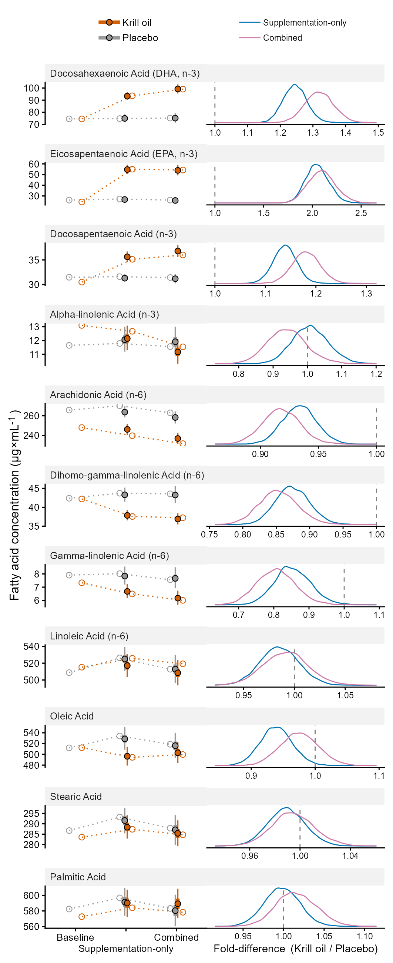
Figure 1: Whole-blood fatty acid concentrations in the krill oil and placebo groups at week 0 (baseline), week 7 (after supplementation-only) and week 20 (after combined supplementation and resistance training). Left: observed group means (open circles) and model-estimated medians with 50 and 95 % percentile intervals (filled circles). Right: posterior distributions of the fold difference between groups (krill oil / placebo) at week 7 (blue) and week 20 (pink). The dashed line indicates no difference.
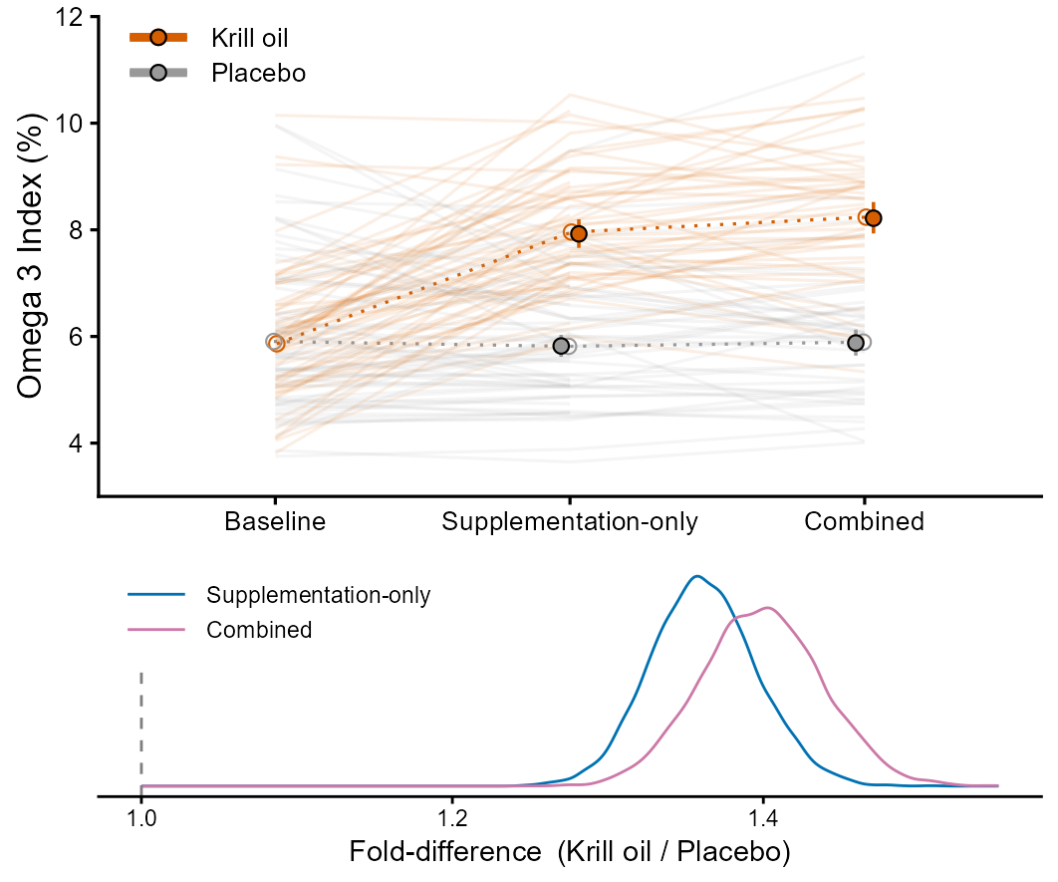
Figure 2: Omega-3 Index in the krill oil and placebo groups at week 0 (baseline), week 7 (after supplementation alone) and week 20 (after combined supplementation and resistance training). Upper panel: individual participant values (thin lines), observed group means (open circles) and model-estimated medians (filled circles) with 95 % (thin bars) and 50 % (thick bars) percentile intervals. Lower panel: posterior distributions of the fold difference between groups (krill oil / placebo) at week 7 (blue) and week 20 (pink). The dashed line indicates no difference between treatments.

0.3.3 Glucose regulation
Krill oil did not improve the primary outcome, the change in glucose tolerance during the combined period (from week 7 to week 20; Fig. 5A), compared with placebo. Instead, blood glucose during the OGTT tended to decrease more with placebo than with krill oil from week 7 to week 20 (average difference in change across the OGTT, 0.18 mmol L⁻¹ (95% CrI: −0.15, 0.51; P(benefit/negligible/harm) 3/39/58 %); Fig. 5A, right panels; HDI+ROPE decision: undecided; Table 3), most clearly in the later part of the curve (from 80 to 110 min, 0.43 mmol L⁻¹ (95% CrI: −0.08, 0.95; P(benefit/negligible/harm) 1/13/86 %)). During supplementation alone (week 0 to week 7), glucose tolerance probably improved with krill oil, mainly during 25 to 100 min (Fig. 5A, left panels; across the OGTT, −0.28 mmol L⁻¹ (95% CrI: −0.65, 0.09; P(benefit/negligible/harm) 77/22/1 %); Table 3). Over the whole intervention (week 0 to week 20), blood glucose during the OGTT decreased in both groups (average change across the OGTT; placebo, −0.34 mmol L⁻¹ (95% CrI: −0.60, −0.08); krill oil, −0.44 mmol L⁻¹ (95% CrI: −0.69, −0.19)), and the difference between groups was most likely negligible (−0.10 mmol L⁻¹ (95% CrI: −0.47, 0.26; P(benefit/negligible/harm) 40/50/10 %)), although the HDI+ROPE decision was undecided.
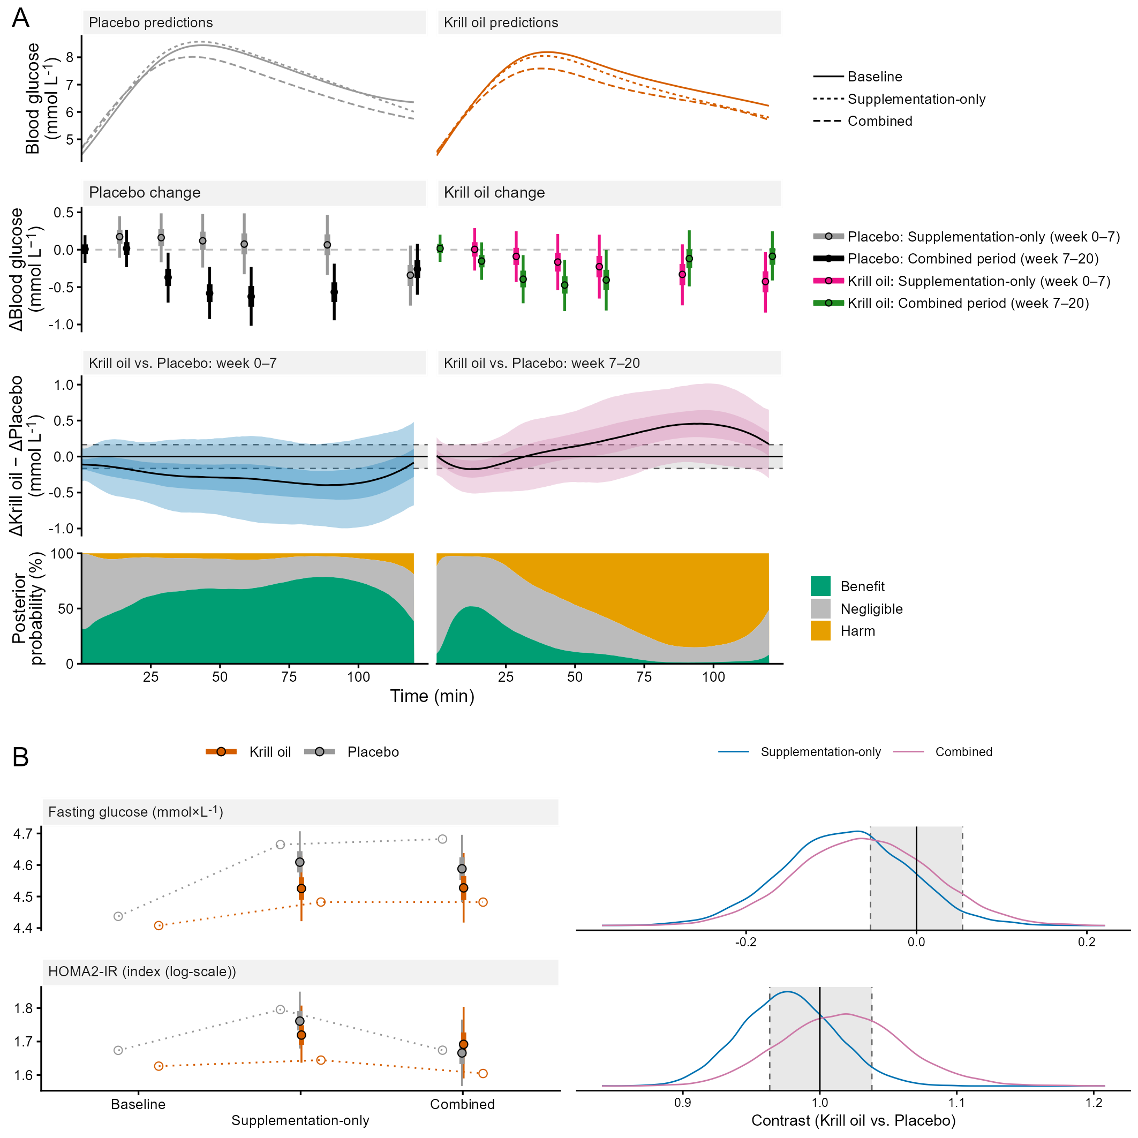
Figure 3: Glucose regulation. (A) Blood glucose during the oral glucose tolerance test. First row: model-predicted median glucose curves per group at week 0 (baseline), week 7 (supplementation-only) and week 20 (combined). Second row: within-group change during supplementation alone (week 0 to 7) and during the combined period (week 7 to 20) at the sampling times. Third row: between-group differences in change (krill oil − placebo) for the same periods (left, week 0 to 7; right, week 7 to 20, primary outcome); gray areas indicate ±δ, the region of negligible effects. Fourth row: posterior probabilities of benefit (lower glucose with krill oil), a negligible effect and harm at each minute of the test. Estimates are posterior medians with 50 and 95 % percentile intervals. (B) Fasting glucose and HOMA2-IR at each time point (left panels; observed group means, open circles; model-estimated medians, filled circles with 50 and 95 % percentile intervals), and posterior distributions of the between-group contrasts at week 7 and week 20 (right panels; HOMA2-IR as fold difference). Gray areas in the right panels indicate ±δ, the region of negligible effects.
Krill oil supplementation was associated with, on average, lower fasting glucose at weeks 7 and 20 (week 7, −0.08 mmol L⁻¹ (95% CrI: −0.23, 0.06; P(benefit/negligible/harm) 66/31/3 %); week 20, −0.06 mmol L⁻¹ (95% CrI: −0.21, 0.09; P(benefit/negligible/harm) 54/39/7 %)), but this difference was uncertain and reflected a smaller increase rather than a decrease, as fasting glucose increased numerically in both groups (Fig. 5B). Krill oil did not affect HOMA2-IR (week 7, −2 % (95% CrI: −9, 5); week 20, +2 % (95% CrI: −7, 11); Fig. 5B), or adiponectin (week 7, −0.11 mg L⁻¹ (95% CrI: −1.01, 0.78); week 20, −0.18 mg L⁻¹ (95% CrI: −1.08, 0.75); Table 3) but was associated with an increased HbA1c at week 7, resulting in higher probability of harm (+2 % (95% CrI: 0, 5; P(benefit/negligible/harm) <1/37/63 %)). Differences in HbA1c between treatments were most likely negligible at week 20 (+1 % (95% CrI: −2, 3; P(benefit/negligible/harm) 3/74/23 %)).

0.3.4 Metabolic syndrome
Krill oil lowered the combined burden of metabolic syndrome components compared with placebo, reflecting small and mostly favorable changes across the individual components, most clearly, besides fasting glucose, systolic blood pressure and HDL cholesterol. Among the components, krill oil probably lowered systolic blood pressure during supplementation alone, resulting in a mostly beneficial effect (−3.7 mmHg (95% CrI: −6.7, −0.8; P(benefit/negligible/harm) 90/10/<1 %)), whereas the reduction during the combined period was smaller and less certain (−2.5 mmHg (95% CrI: −6.2, 1.4; P(benefit/negligible/harm) 63/35/2 %)). Krill oil did not affect HDL cholesterol during supplementation alone (−0.01 mmol L⁻¹ (95% CrI: −0.06, 0.04; P(benefit/negligible/harm) 2/92/6 %)) but increased it during the combined period (0.05 mmol L⁻¹ (95% CrI: 0.00, 0.11; P(benefit/negligible/harm) 60/40/<1 %)). Krill oil resulted in slightly lower diastolic blood pressure in both periods (−1.8 mmHg (95% CrI: −3.8, 0.2; P(benefit/negligible/harm) 78/22/<1 %) and −1.2 mmHg (95% CrI: −3.4, 1.0; P(benefit/negligible/harm) 56/41/2 %)), but these differences were uncertain. Krill oil did not affect waist circumference (week 7, −0.7 cm (95% CrI: −1.8, 0.4; P(benefit/negligible/harm) 13/87/<1 %); week 20, −0.1 cm (95% CrI: −1.5, 1.3; P(benefit/negligible/harm) 4/94/2 %)) or triglycerides (week 7, −1 % (95% CrI: −12, 12; P(benefit/negligible/harm) 21/65/15 %); week 20, −1 % (95% CrI: −13, 14; P(benefit/negligible/harm) 25/56/19 %); Fig. 6A).
When the five components were combined for each participant, krill oil probably reduced the burden score during supplementation alone (−0.08 SD (95% CrI: −0.17, 0.01)) and during the combined period (−0.08 SD (95% CrI: −0.17, 0.02); Fig. 6B; Table 3), with probabilities of any benefit of 96 % and 94 %, respectively. The effect of krill oil was consistent across both periods, however, at week 7, a decreased average blood pressure was most likely the largest contributor to the lower burden score (55 % probability of being the main contributing factor), followed by fasting glucose (39 %), with other factors (waist circumference, HDL and TG) having < 5 % probability of being the main contributor. At week 20, probabilities of being the main contributing factor were spread across fasting glucose (33 %), blood pressure (32 %), and HDL (25 %), with no single dominant contributor (TG, 9 %; Waist circumference, 1 % ). The treatment effect did not depend on the burden score at week 0: the reduction was of similar size regardless of baseline metabolic burden (difference in treatment effect when the burden score at baseline increases by 1 SD, week 7, 0.00 SD (95% CrI: −0.01, 0.02); week 20, 0.00 SD (95% CrI: −0.01, 0.02)). Similarly, effects on the individual components did not depend on their own baseline values, the baseline omega-3 index or the baseline relative fat mass (Supplementary Figure 7.4 [TODO: check the figure number after rendering the book; it is fig-moderation-pred in 07-metsyn-inference.qmd]) and none of the extended models clearly improved predictive performance compared with the main model (ΔELPD, positive values favouring the extended model, −2.0 (SE 1.6), −0.1 (SE 2.1), 2.7 (SE 2.5) and −0.5 (SE 1.2) for interactions with own baseline values, the baseline burden score, baseline relative fat mass and the baseline omega-3 index, respectively).
Despite the lower burden score, krill oil did not credibly reduce the prevalence of the metabolic syndrome. The odds of meeting the criteria were lower with krill oil in both periods, but the uncertainty was large (week 7, OR 0.26 (95% CI: 0.04, 1.58); week 20, OR 0.56 (95% CI: 0.10, 2.99); Fig. 6C–D).
Krill oil did not affect other secondary outcomes, including body mass index (week 7, 0.05 kg m⁻² (95% CrI: −0.12, 0.22); week 20, 0.09 kg m⁻² (95% CrI: −0.22, 0.40)) and LDL cholesterol (week 7, −0.04 mmol L⁻¹ (95% CrI: −0.20, 0.12); week 20, 0.05 mmol L⁻¹ (95% CrI: −0.13, 0.23)) with body mass index and relative fat mass showing high probability of equivalence between groups at week 7 and 20, and week 7, respectively (ROPE: accepted; Table 3).
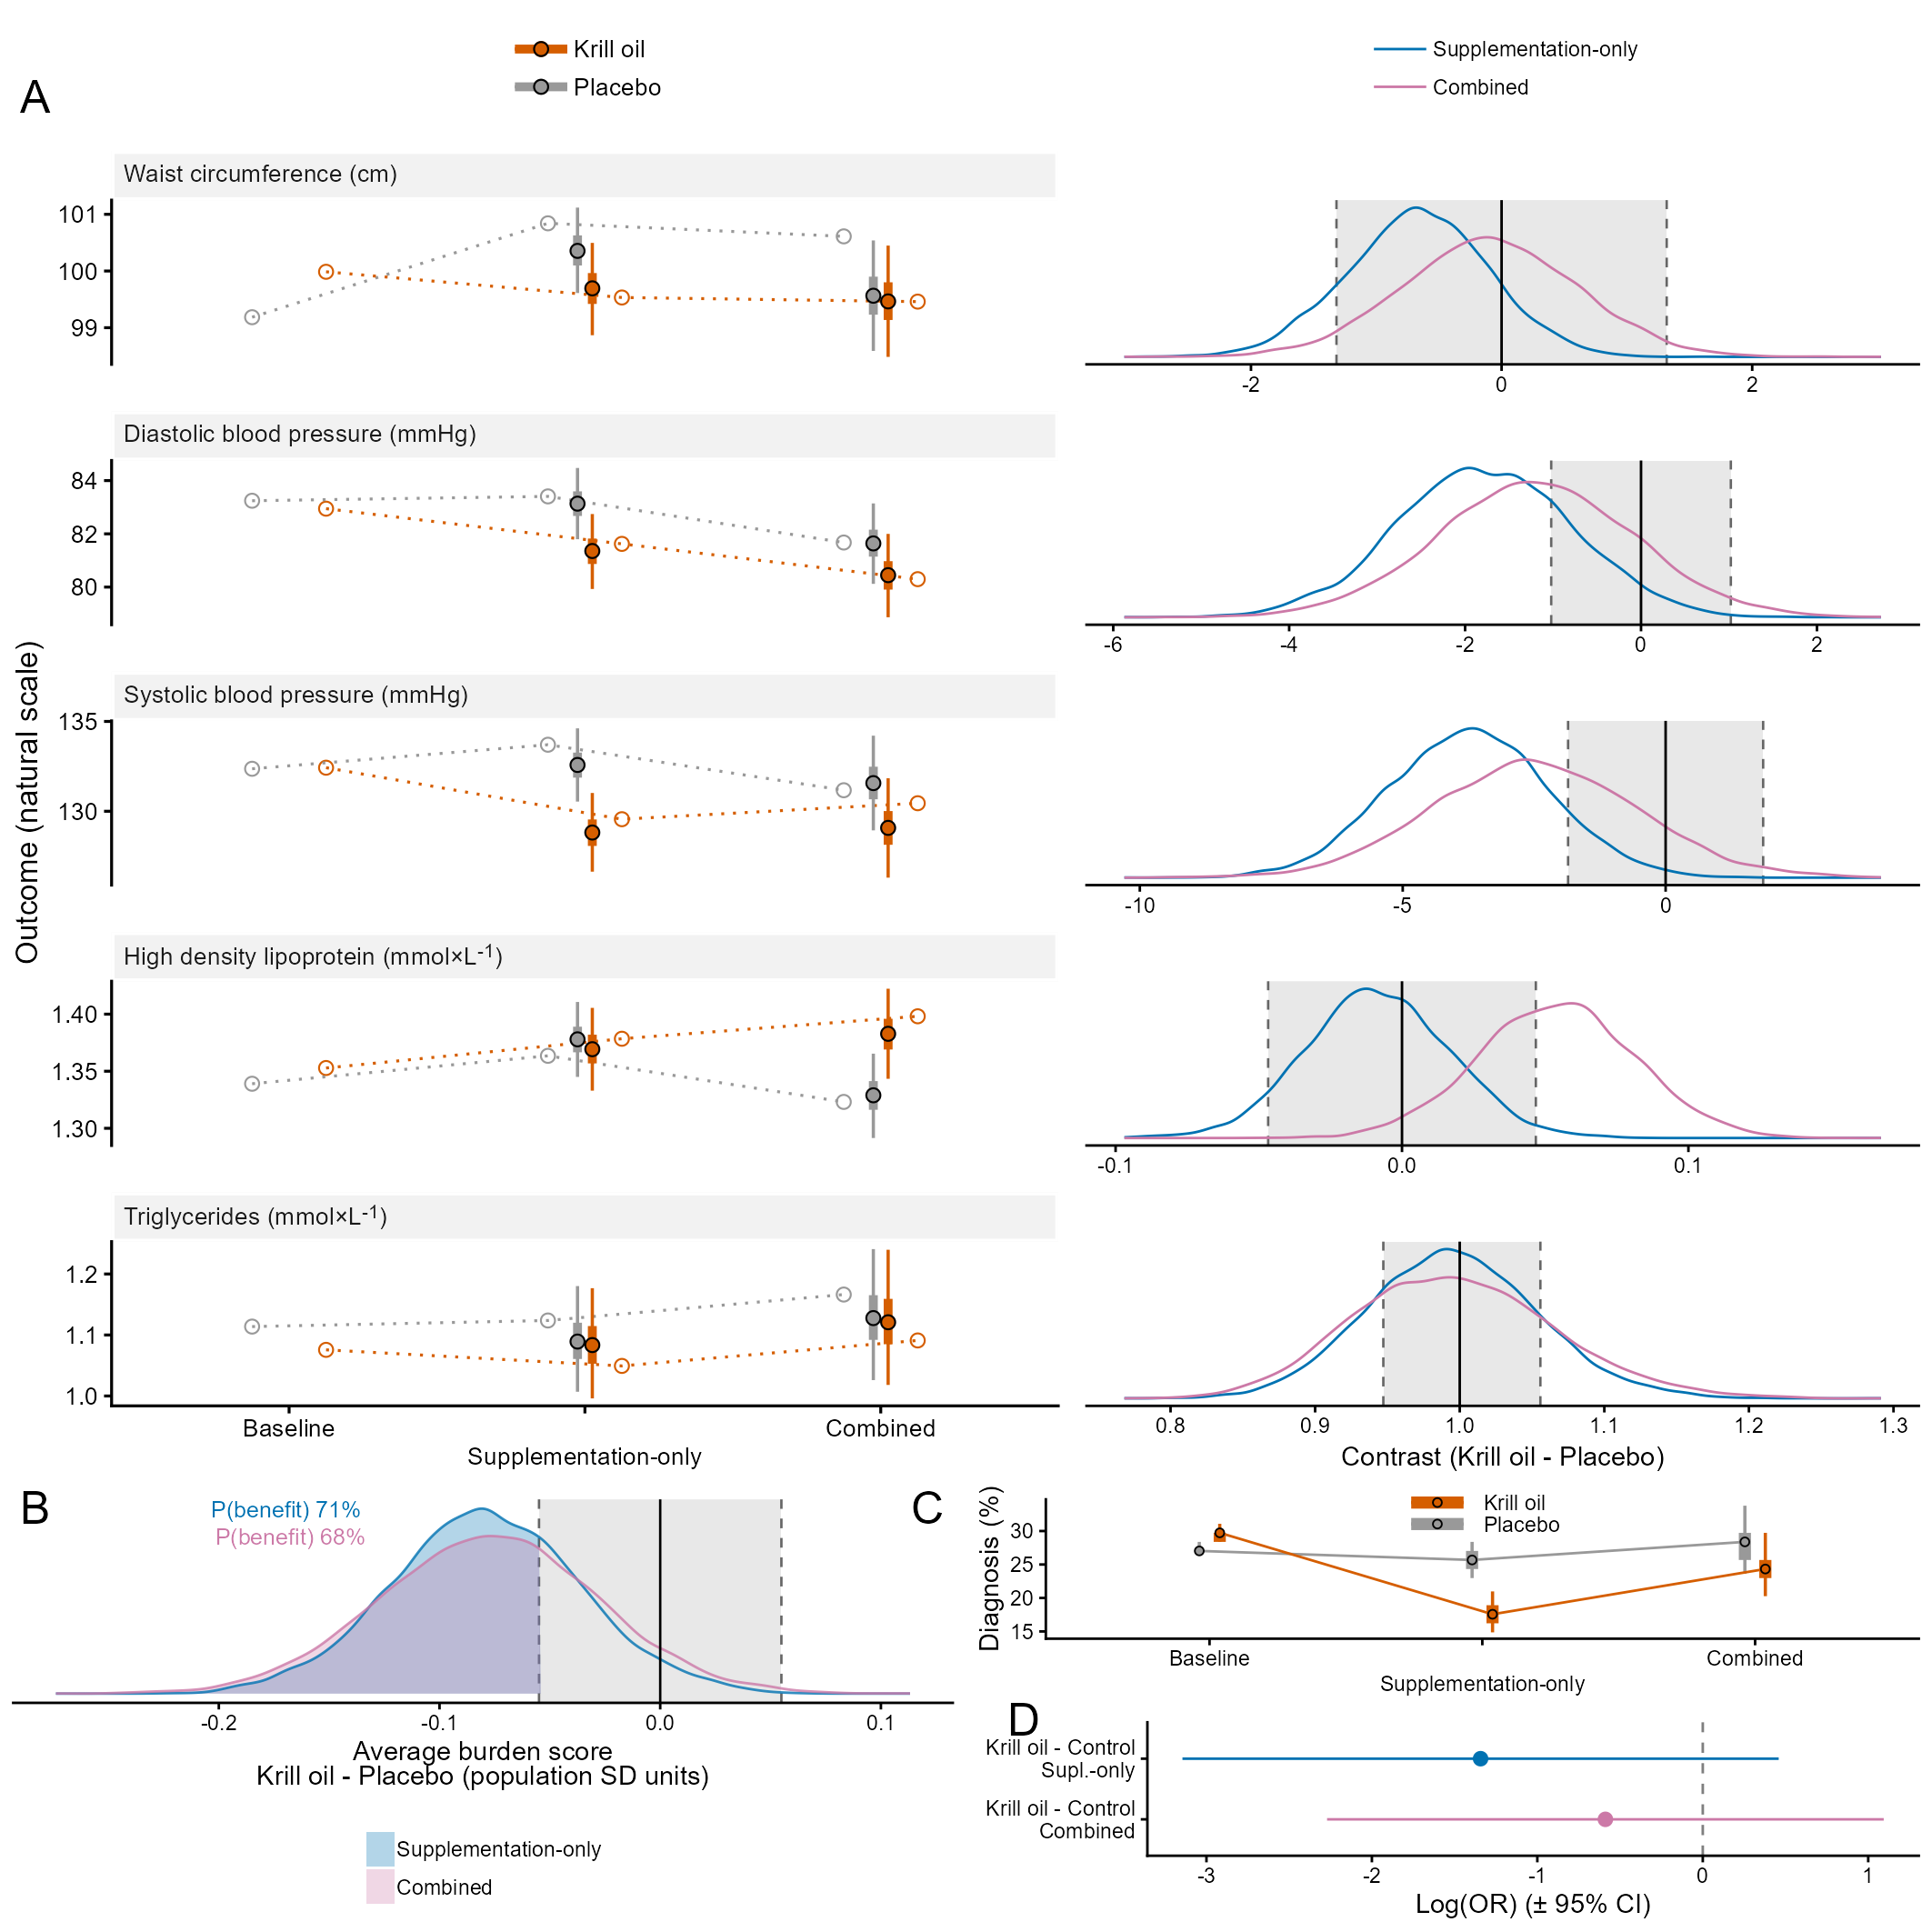
Figure 4: Metabolic syndrome outcomes in the krill oil and placebo groups at week 0, week 7 (supplementation-only) and week 20 (combined supplementation and resistance training). (A) Metabolic syndrome components. Left: observed means (open circles) and model estimates (filled points) with 50 and 95 % percentile intervals. Right: posterior distributions of the between-group differences (krill oil − placebo). (B) Difference between krill oil and placebo in burden score (sum of the five standardized components; negative values favor krill oil), shown as posterior distributions with the probability of a benefit. (C) Prevalence of the metabolic syndrome (Albertini 2009). (D) Between-group log odds ratios for the metabolic syndrome, with 95 % confidence intervals. Dark and light shades denote week 7 and week 20. Dashed lines mark no difference.
1. Lemoine NP. Moving beyond noninformative priors: Why and how to choose weakly informative priors in Bayesian analyses. Oikos. 2019 Jul;128(7):912–28. doi:10.1111/oik.05985
2. McElreath R. Statistical rethinking: A Bayesian course with examples in R and Stan. Second edition. Boca Raton: CRC Press; 2020. (Chapman & Hall/CRC texts in statistical science series).
3. Gelman A, Carlin JB, Stern HS, Dunson DB, Vehtari A, Rubin DB. Bayesian data analysis. Third edition. Boca Raton: CRC Press; 2014.
4. Gelman A, Vehtari A, McElreath R, Simpson D, Margossian CC, Yao Y, et al. Bayesian workflow. First edition. Boca Raton, FL ; Abingdon, Oxon: CRC Press; 2026.
5. Carpenter B, Gelman A, Hoffman MD, Lee D, Goodrich B, Betancourt M, et al. Stan: A probabilistic programming language. Journal of Statistical Software. 2017;76(1):1–32. doi:10.18637/jss.v076.i01
6. Gabry J, Cesnovar R, Johnson A, Bronder S. Cmdstanr: R interface to ’CmdStan’ [Internet]. 2025. Available from: https://mc-stan.org/cmdstanr/
7. R Core Team. R: A language and environment for statistical computing [Internet]. Vienna, Austria: R Foundation for Statistical Computing; 2025. Available from: https://www.R-project.org/
8. Stan Development Team. Stan reference manual, version 2.40 [Internet]. 2026. Available from: https://mc-stan.org/docs/2_40/reference-manual/
9. Holmkvist J, Banasik K, Andersen G, Unoki H, Jensen TS, Pisinger C, et al. The Type 2 Diabetes Associated Minor Allele of Rs2237895 KCNQ1 Associates with Reduced Insulin Release Following an Oral Glucose Load, editorMaedler K. PLoS ONE. 2009 Jun;4(6):e5872. doi:10.1371/journal.pone.0005872
10. Alberti KGMM, Eckel RH, Grundy SM, Zimmet PZ, Cleeman JI, Donato KA, et al. Harmonizing the metabolic syndrome: A joint interim statement of the International Diabetes Federation Task Force on Epidemiology and Prevention; National Heart, Lung, and Blood Institute; American Heart Association; World Heart Federation; International Atherosclerosis Society; and International Association for the Study of Obesity. Circulation. 2009;120(16):1640–5. doi:10.1161/CIRCULATIONAHA.109.192644
11. DeBoer MD, Gurka MJ. Clinical utility of metabolic syndrome severity scores: Considerations for practitioners. Diabetes, Metabolic Syndrome and Obesity: Targets and Therapy. 2017 Feb;Volume 10:65–72. doi:10.2147/DMSO.S101624
12. Guseman EH, Eisenmann JC, Laurson KR, Cook SR, Stratbucker W. Calculating a Continuous Metabolic Syndrome Score Using Nationally Representative Reference Values. Academic Pediatrics. 2018 Jul;18(5):589–92. doi:10.1016/j.acap.2018.02.011
13. Vehtari A, Gelman A, Gabry J. Practical Bayesian model evaluation using leave-one-out cross-validation and WAIC. Statistics and Computing. 2017 Sep;27(5):1413–32. doi:10.1007/s11222-016-9696-4
14. Nilsen A, Hanssen TA, Lappegård KT, Eggen AE, Løchen ML, Selmer RM, et al. Change in cardiovascular risk assessment tool and updated Norwegian guidelines for cardiovascular disease in primary prevention increase the population proportion at risk: The Tromsø Study 2015–2016. Open Heart. 2021 Aug;8(2):e001777. doi:10.1136/openhrt-2021-001777
15. Haverinen E, Paalanen L, Palmieri L, Padron-Monedero A, Noguer-Zambrano I, Sarmiento Suárez R, et al. Comparison of metabolic syndrome prevalence using four different definitions - a population-based study in Finland. Archives of Public Health = Archives Belges De Sante Publique. 2021 Dec;79(1):231. doi:10.1186/s13690-021-00749-3 PubMed PMID: 34949223; PubMed Central PMCID: PMC8697452.
16. Michalsen VL, Kvaløy K, Svartberg J, Siri SRA, Melhus M, Broderstad AR. Change in prevalence and severity of metabolic syndrome in the Sami and non-Sami population in rural Northern Norway using a repeated cross-sectional population-based study design: The SAMINOR Study. BMJ Open. 2019 Jun;9(6):e027791. doi:10.1136/bmjopen-2018-027791
17. Brooks M, Kristensen K, Benthem KJ van, Magnússon Á, Berg CW, Nielsen A, et al. glmmTMB Balances Speed and Flexibility Among Packages for Zero-inflated Generalized Linear Mixed Modeling. R J. 2017;9:378.
18. Rubin DB. Multiple Imputation for Nonresponse in Surveys [Internet]. 1st ed. Wiley; 1987 [cited 2026 Oct 16]. (Wiley Series in Probability and Statistics). Available from: https://onlinelibrary.wiley.com/doi/book/10.1002/9780470316696 doi:10.1002/9780470316696
19. Harris WS, Von Schacky C. The Omega-3 Index: A new risk factor for death from coronary heart disease? Preventive Medicine. 2004 Jul;39(1):212–20. doi:10.1016/j.ypmed.2004.02.030
20. Kruschke JK. Rejecting or Accepting Parameter Values in Bayesian Estimation. Advances in Methods and Practices in Psychological Science. 2018 Jun;1(2):270–80. doi:10.1177/2515245918771304

