Contents

Presetation 1 1

Paper 1 1

Presetation 2 4

Paper 2 4

Presetation 3 6

Paper 3 6

Overall impression 7

## Presetation 1

1. Title: Geometry-Driven Detection, Tracking and Visual Analysis of Viscous and Gravitational Fingers

Presentation link: <https://virtual.ieeevis.org/session_f-papers-topo-scalar-field.html>

1. What do I learn:

The paper focuses on how to detect, track, and visual analyze viscous and gravitational fingers. The most exciting part of this paper is that instead of the previous density thresholding method, which provides limited geometric information of the fingers, it talks about a technique that considers the data's geometric structure.

For in-situ simulation, sometimes we need to store only the features instead of storing raw simulation results. Currently, my idea is adaptive sampling by a cut on the octree. However, one of my idea's limitation is that it does not consider data's geometric property. This paper's idea may help me develop an adaptive sampling method based on geometry, and my InSituNet work would benefit from it.

1. Comment on the presentation:

I think overall, Jiayi did an excellent job. His presentation is clear, covering the application background, his algorithm for detecting the finger, the visualization system design, and case studies. One suggestion is that maybe he can use some time to illustrate the overall pipeline, as Fig 1 in the paper. But it is understandable since the time constrain.

1. One question I would like to ask:

This paper’s finger detection is a feature extraction method. As as I mentioned before, would this approach help the “InSituNet” idea for in-situ simulation?

## Paper 1

1. Title: Geometry-Driven Detection, Tracking and Visual Analysis of Viscous and Gravitational Fingers

Authors: Xu, Jiayi; Dutta, Soumya; He, Wenbin; Moortgat, Joachim; Shen, Han-Wei

Affiliations: The Ohio State University

URL:

1. Summarize the paper
   1. The reason why I choose this paper:

First, I am interested in visualization applications in geographic data. Second, this paper’s feature extraction method may enlighten me on a new adaptive sampling method on ensemble data for in-situ visualization.

* 1. The problem this paper tackcles:

How to efficiently detect and visualization fingers?

* 1. The techniques the paper proposes to solve the problem:
     1. Voxel-based ridge detection to guide the extraction of finger cores on 3D scalar fields & a spanning tree based heuristic algorithm for the construction of finger branches from finger skeletons.
     2. an interactive visual analytics system for exploration of fingers over space and time. The system incorporates a novel geometric-glyph augmented tracking graph that reveal fingers’ temporal evolution.
  2. Visualization system:

What:

The finger cores, the complete finger volume, the finger skeleton.

Why:

* + - 1. **Spatial Exploration**: Domain experts want to address how hundreds of distributed fingers grow vertically and spread horizontally with minimal occlusion.
      2. **Temporal Exploration**: The earth scientist is interested to know how the fingers shield and merge at certain timesteps and predominantly split into new smaller fingers at other timesteps geometrically.

How:

**Spatial Visualizations of Fingers**

1. **Depth selection and density field slicing:** the system allows users to drag a slider to select a depth of interest (Fig. 1a); the density field slice at the selected depth is then extracted and shown as a 2D heatmap in Fig. 1b.
2. **Spatial Projection of Fingers:** the authors project critical points of finger skeletons onto the x-y plane and then draw a convex hull to enclose the projection of the critical points of each finger (Fig. 1c).

The authors also use the Voronoi treemap to represent each finger branch by a Voronoi cell. (Fig. 2f)

1. **3D Spatial Visualizations of a Selected Finger:** volume rendering image of an individual finger (Fig. 1d) and visual display of finger skeletons using orthogonal projection.

**Geometric-Glyph Augmented Tracking Graph:**

This tracking graph visualize the evolution of fingers to facilitate temporal exploration of fingers (Fig1. f). Each row of the tracking graph displays the fingers at one timestep.

1. **Linear Glyph for Finger Side View:** The authors draw finger branchs and their connections in a plane (Fig1. f).
2. **Rectangular Glyph for Finger Top View:** The authors draw the top view of fingers to display quantitative geometric attributes and relative positions of finger branchs by using treemap based rectangular glyphs (Fig3).

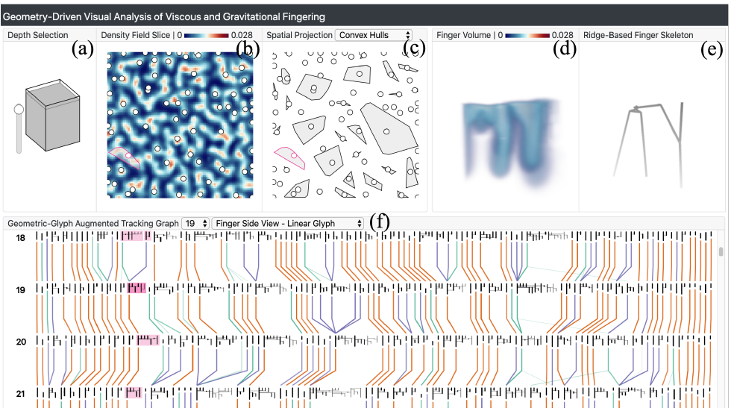

Fig. 1

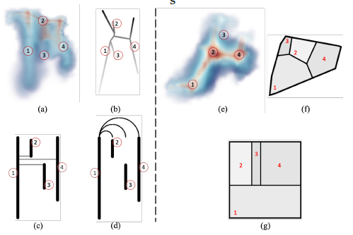

Fig. 2

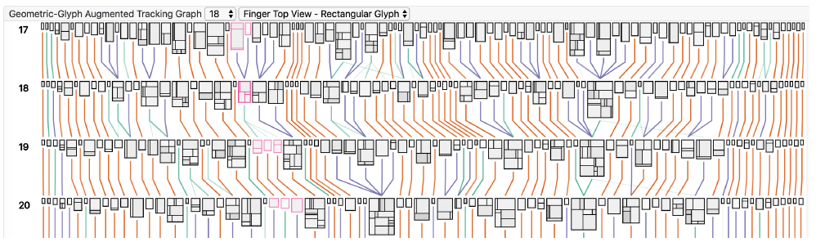

Fig. 3

* 1. The main contribution of the paper:
     1. The voxel-based ridge detection method can guide the extraction of finger cores on 3D scalar fields, which outperformes previous density thresholding-based methods.
     2. The authors offer an interactive visual analytics system that allows efficient and effective exploration of fingers over space and time with minimized occlusion. Before this paper, domain scientists use software such as ParaView to do the visual analysis, but the techniques they use are not ideal because they do not support tracking and quantifying the 3D geometry of these ramified structures in both space and time.

## Presetation 2

1. Title: Data-Driven Space-Filling Curves

Presentation link: <https://virtual.ieeevis.org/session_f-papers-multidim-data.html>

1. What do I learn:

Before I know this paper, we have come up with a “data-driven space-filling curve” idea. So when I watched the presentation, I mainly focus on achieving their goal, and I am comparing their algorithm with mine. They regard the space-filling curve generation problem as a Hamiltonian path generation problem and get the path by replacing a minimum spanning tree for regular grids. This is different from my idea, and we may talk about it in the future.

1. Comment on the presentation:

Overall, the presenter did a good job. He first talked about the space-filling curves at a high level, then discussed their applications in the visualization domain. After that, he started to mention the limitation of current space-filling curves and proposed this paper’s contribution. Next, he gave the formal problem formulation and explained the algorithm. I think he gave concrete examples when explained the algorithm, and overall, I got the intuition of their techniques.

One suggestion is when he explained the algorithm, it would be better to talk about the time complexity of his algorithm. From the experiment, the algorithm is not efficient enough. So, I wonder maybe the author can give a theoretical analysis of that.

1. One question I would like to ask:
   1. What is the time complexity of your algorithm?
   2. I think your algorithm will not preserve the position locality very well. In other words, is there any possibility your algorithm degrades to scanline when you don’t consider feature similarity?

## Paper 2

1. Title: Data-Driven Space-Filling Curves

Authors: L. Zhou; C. R. Johnson; D. Weiskopf

Affiliations: Peking University; University of Utah; University of Stuttgart

1. Summarize the paper
   1. The reason why I choose this paper:

I have one idea about space-filling curves on unstructured grids by arranging these unstructured grids to a graph and coming up with a graph filling curve. During the SciVis subgroup meeting, we discussed whether our space filing curve could adapt to the data feature. Then we found this paper. The authors’ idea is pretty similar to what we want to do. It seems reasonable to read this paper and know the details.

* 1. The problem this paper tackcles:

Previously, some space-filling curves such as Hilbert curve have good locality and, therefore, are popular in visualization. However, these space-filling curves ignore a dataset's content, which means they are likely to break one feature into multiple 1D pieces. The authors thus want to propose a new data-driven space-filling curve approach that is more feature-oriented.

* 1. The techniques the paper proposes to solve the problem:

Their approach compromises two variants of techniques: one for 2D and 3D regular grids, and another for 2D and 3D multiscale data. For regular grids, their method generates Hamiltonian cycles by replacing a mimimum spanning tree using an objective function and combines locality and position terms; for multscale data – quadtrees, and octrees – their method find adaptive Hamiltonian paths across data scales in a greedy fashion.

* 1. Visualization system:

what: line chart visualization linearized by space filling curve, volume rendering result

why: The authors want to use position to encode ensemble members’ intensity since human is more sensitive to positions than colors. By using the line chart, it is easier for scientists to compare different ensemble members.

How:

* + 1. Use space-filling curves to linearize 3D volume data, use positions to encode intensities.
    2. Use volume rendering to visualize the row volume, and support brush-and-link.

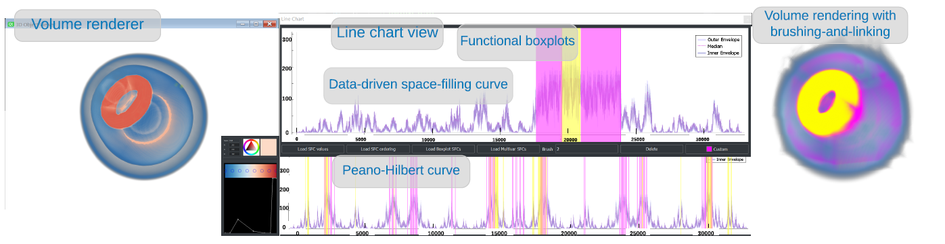

Fig. 4

* 1. The main contribution of the paper:

The most significant contribution of this paper is that their space-filling curves better preserve features in space than existing algorithms without sacrificing position locality too much.

## Presetation 3

1. Title: VC-Net: Deep Volume-Composition Networks for Segmentation and Visualization of Highly Sparse and Noisy Image Data

Presentation link: <https://virtual.ieeevis.org/session_f-papers-deep-learn-spatial.html>

1. What do I learn:

This paper’s main contribution is using MIP projection to get some 2D features, which can help improve the 3D segmentation results.

1. Comment on the presentation:

Actually, I don’t pretty enjoy the presetation.

In the QA session, I don’t think the presenter answered Hanqi’s question very well. Especially for the second one, Hanqi asked how they came up with using MIP to help training. However, the presenter answers that since MIP is a famous algorithm in the domain, we use it. The answer is not so convincing for me. Besides, I think their paper aims to get good 3D segmentation results, but all their qualitative results are 2D images from the same viewpoint. I believe their 3D segmentation result should support scientists to visualize the results from different viewpoints.

1. One question I would like to ask:

As I said before, the effect of 3D segmentation is to support multi-view visualization. By applying their method, they constrain the viewpoint to the axial plane, which confuses me.

## Paper 3

1. Title: VC-Net: Deep Volume-Composition Networks for Segmentation and Visualization of Highly Sparse and Noisy Image Data

Authors: Wang, Yifan; Yan, Guoli; Zhu, Haikuan; Buch, Sagar; Wang, Ying; Haacke, Ewart Mark; Hua, Jing; Zhong, Zichun

Affiliations: Wayne State University

1. Summarize the paper
   1. The reason why I choose this paper:

Deep learning for scientific visualization is something I want to do in my current research. So, reading deep learning for spatial data paper should help.

* 1. The problem this paper tackcles:

A 3D segmentation problem on the cerebrovasculature data which has high sparseness and noisiness as well as highly complex geometry and topology variations of microvessels.

* 1. The techniques the paper proposes to solve the problem:

It leverages the volume visualization technique (e.g., MIP – a volume rendering scheme for 3D volume images) to enhance the 3D data exploration at the deep learning level.

* 1. Visualization system:

None

* 1. The main contribution of the paper:
     1. It proposes an end-to-end 3D deep learning method to segment and visualization the 3D sparse microvascular data.
     2. A multi-stream CNN framework is designed to effectively learn the feature vectors of 3D raw volume and multislice composited 2D MIP (volume rendering). And it tries to construct a joint space from the 2D projection and 3D volume.

I don’t think this a pioneering work. Their main contribution is using some tricks to improve the segmentation result. For me, the accuracy improvement is not a lot, and they are not having a fair comparison since their new model has more parameters than the baseline. Besides, they only show their qualitative results from the same viewpoint as in the training stage.

## Overall impression

Besides the three papers I choose, I mainly focus on papers on deep learning for scientific visualization. During the SciVis subgroup meeting, we have read and discussed all the DL4SciVis papers. Overall, DL4SciVis papers this year are not so exciting. Some papers’ result is hard to validate if the authors do not release the source code. I think our community also faces the question of whether deep learning papers’ authors should release their source code or not.