14.2

a. To store the address of the caller’s first local variable.

b. To store the address of the caller.

c. To store the value that returned by the function.

14.4

a. caller

b. callee

c. callee

d. callee

14.15

|  |
| --- |
|  |
| 16(int x1) |
| Frame pointer |
| x3103(the return address of main) |
| 0(return value) |
| 5(the third argument of f) |
| 5(the second argument of f) |
| 6(the first argument of f) |
| 6(int c) |
| 5(int b) |
| 4(int a) |

17.5

a.(1) 0

(2)2

(3)0

b. floor(logba)

c.

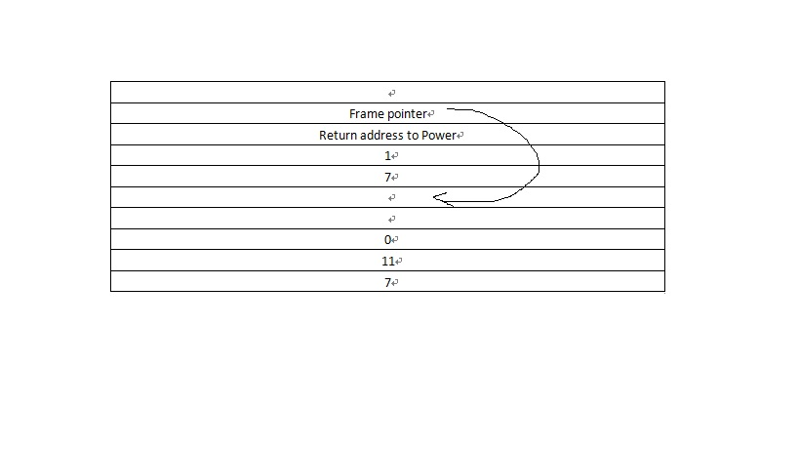

17.7

a. 2047. The activation record for SevenUp occupies 8 bytes and the stack can occupy up to 16KB of memory. And the integer a in the main function occupies 2 bytes.

b. 511. The reason is similar.