2.34

a.0111

b.0111

c.1101

d.0110

2.37 ((n AND m AND NOT(s)) OR (NOT(n) AND NOT(m) AND s)) AND 1000

2.54

|  |  |  |  |  |
| --- | --- | --- | --- | --- |
| X | Y | Z | Q1 | Q2 |
| 0 | 0 | 0 | 0 | 1 |
| 0 | 0 | 1 | 0 | 1 |
| 0 | 1 | 0 | 0 | 1 |
| 0 | 1 | 1 | 0 | 1 |
| 1 | 0 | 0 | 1 | 1 |
| 1 | 0 | 1 | 1 | 1 |
| 1 | 1 | 0 | 1 | 1 |
| 1 | 1 | 1 | 0 | 0 |

2.56 xE5=(11100101)2=-1.101*2^5=-52

3.3 16

3.5

|  |  |  |  |
| --- | --- | --- | --- |
| A | B | C | OUT |
| 0 | 0 | 0 | 1 |
| 0 | 0 | 1 | 0 |
| 0 | 1 | 0 | 1 |
| 0 | 1 | 1 | 0 |
| 1 | 0 | 0 | 1 |
| 1 | 0 | 1 | 0 |
| 1 | 1 | 0 | 0 |
| 1 | 1 | 1 | 0 |

3.16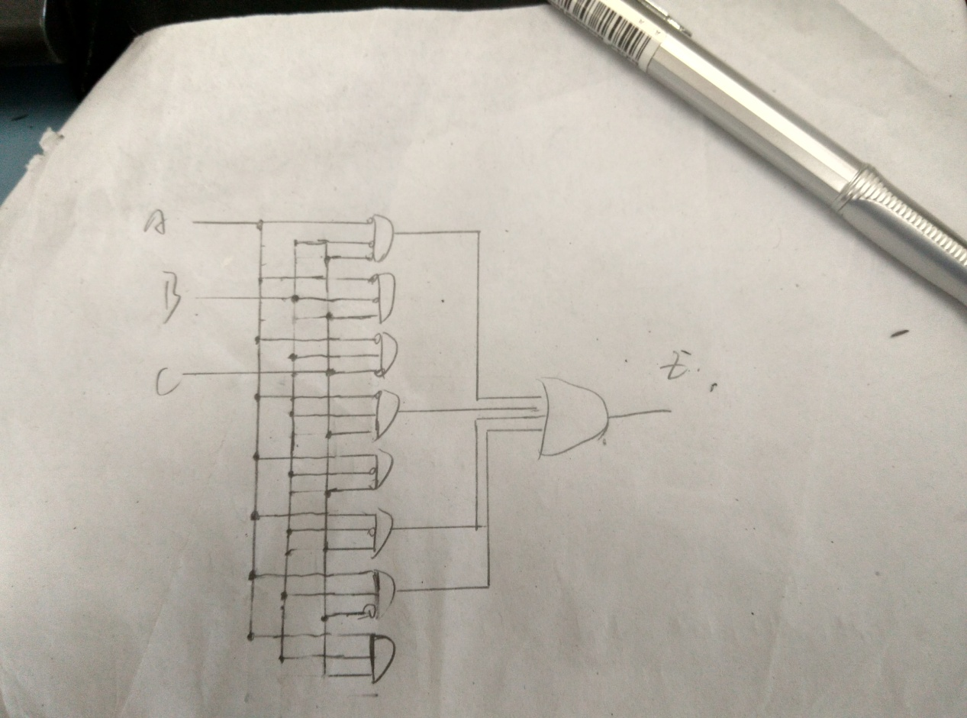

3.23

|  |  |  |  |
| --- | --- | --- | --- |
| A | B | C | Z |
| 0 | 0 | 0 | 0 |
| 0 | 0 | 1 | 0 |
| 0 | 1 | 0 | 0 |
| 0 | 1 | 1 | 0 |
| 1 | 0 | 0 | 0 |
| 1 | 0 | 1 | 0 |
| 1 | 1 | 0 | 0 |
| 1 | 1 | 1 | 0 |

3.27

a. Z=A

b. Z retains its previous value

c. Yes.

3.29

No.