# The Report of Experiment-1

First, I want to introduce my train of thought. I use the number 1000 0000 0000 0000 to and the input data in order to tell whether the highest digit of the input is 0 or 1. If the result is not 0, then I can add 1 in the counter. After that operation, I will left shift the operand to change the highest digit. After several repeats until the operand is 0, I can solve the problem.

Here is the flow diagram of how I solve the problem:

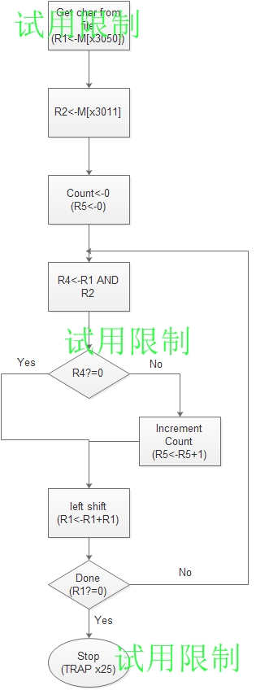

### Here is my machine code:

(0000) 0011 0000 0000 0000 ;in order to make my instruction start at x3000

(3000) 0010 001 00100 1111 ;load the input to R1

(3001) 0010 010 00000 1001 ;load the data which will be ANDed later to R2

(3002) 0101 101 101 100000 ;clear R5

(3003) 0110 011 010 000000 ;loop1 It has no meaning.

(3004) 0101 100 001 000 010 ;R1 AND R2 in order to tell whether the highest digit is 0 or 1, and store the result in R4

(3005) 0000 010 00000 0001 ;if the last result is 0, then move to x3007, else move to the next instruction

(3006) 0001 101 101 1 00001 ;add 1 in R5(counter).

(3007) 0001 001 001 000 001 ;left shift the operand to change the highest number.

(3008) 0000 101 11111 1010 ;If the last result is not 0 ,then move to loop1 to repeat, else move to the next instruction.

(3009) 0011 101 00100 0111 ;store the answer in R5 to x3051

(3010) 1111000000100101 ;halt

(3011) 1000 0000 0000 0000 ;the data that needed to be ANDed.

In fact, the 3003 instruction is useless.

During the communication with the TA, I know that we can also use the CC to tell that whether the highest digit of the operand is 0 or 1. If the highest digit of the operand is 1, then the operand is a negative number. In my opinion, it is a much more convenient way to solve the problem.

### And here is some data that I use to test my program and its result:

