# The Report of Experiment-2

First, I want to show the diagram of how I solved the problem and the diagram is stored in diagram.pdf.

Second, I want to show my code:

.ORIG x3000

;output "Type a room number and press Enter:"

LEA R0,inst

TRAP x22

;input

LD R3,address

loop1 TRAP x20

TRAP x21

ADD R1,R0,#-10;tell the current input is 'entry' or not

BRz match

STR R0,R3,#0;store the input to memory

ADD R3,R3,#1

BRnzp loop1

;match

match AND R0,R0,#0

STR R0,R3,#0

LD R2,stp;x3300

LDR R2,R2,#0;R2<-pointer of the linked list

LDR R4,R2,#1;R4<-pointer of the room

LDR R5,R4,#0;R5<-one digit of the room

LDR R0,R2,#2;R0<-pointer of the name

LD R3,address;R3<-input address

LDR R1,R3,#0;R1<-one digit of the input

loop2 NOT R1,R1

ADD R1,R1,#1

ADD R1,R1,R5;to tell whether the current digit of the input is equal to the current digit of the room number in the linked list

BRnp Reg2;if these two are not equal,then prepare to compare with the next one in the linked list

AND R5,R5,R5

BRz success;if the digit is the sentinel x0000,then prepare to do the success output

ADD R4,R4,#1

LDR R5,R4,#0;change to the next digit

ADD R3,R3,#1

LDR R1,R3,#0;change to the next digit

BRnzp loop2

;prepare to compare with the next one in the linked list

Reg2 LDR R2,R2,#0;to the next node

BRz fail;if the pointer in the linked list is 0 which means there is no room in the linked list, do the fail output

LDR R4,R2,#1

LDR R5,R4,#0

LDR R0,R2,#2

LD R3,address

LDR R1,R3,#0

BRnzp loop2

;output

success TRAP x22

BRnzp stop

fail LEA R0,outstr

TRAP x22

;stop

stop TRAP x25

address .BLKW #15

stp .FILL x3300

inst .STRINGZ "Type a room number and press Enter:\n"

outstr .STRINGZ "No Entry"

.END

And then, I want to show the result after excution:

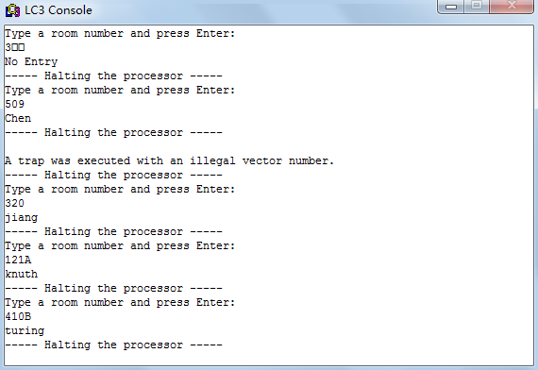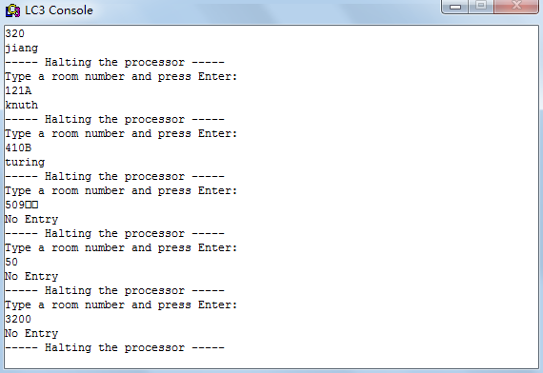

At last,I want to do some analysis towards my program:

1. The program may have mistake when the input data is “3200” or “50”. To avoid this situation. I first compare the two current digit to see whether they are equal or not. If these two are equal, I will judge whether the digit is x0000 which indiates it is the end of the number or not. If the digit is x0000, the I finish the matching work.
2. The pseudo-op .BLKW is necessary. At first, I use .FILL x3500 to store the input in the memory starting at address x3500. But in fact it’s a bad idea if there are many programs running in the simulator. The useful data may be covered by other data.