Grant helpdesk permissions to a user
IT Process Documentation · PRC-2026-2D0FAE · Version 1.1 · Published

1. Process Information
Process title | Grant helpdesk permissions to a user
Process ID | PRC-2026-2D0FAE
Version | 1.1
Creation date | 2026-11-07
Last updated | 2026-11-07
Process owner | –
Responsible department | –
Category | –
Author | IT Admin
Reviewer / approver | IT Admin
Status | Published

2. Purpose
Gives service desk staff the minimum admin rights they need to support users.

3. Scope
Included
- assigning helpdesk roles to internal staff
Excluded
- global administrator assignments

4. Prerequisites
Required permissions
- User administrator role in the admin portal
Required access
To be confirmed.
Applications and systems
- Contoso Admin Portal
Required information
To be confirmed.
Dependencies
To be confirmed.

5. Roles and Responsibilities
Role | Responsibilities
Service desk lead | performs the change
IT security | approves privileged roles

6. Process Execution – Step by Step

Step 1 – Search Active users and open the entry
Performed in Contoso Admin Portal on the "Active users" screen.
1. Open the "Active users" page (localhost:44085/portal).
2. Enter the required value in the "Search users" field and press Enter.
3. Select the relevant entry in the list.
Application / system | Contoso Admin Portal
Required input | Search users
Expected result | The "John Doe" screen is shown.
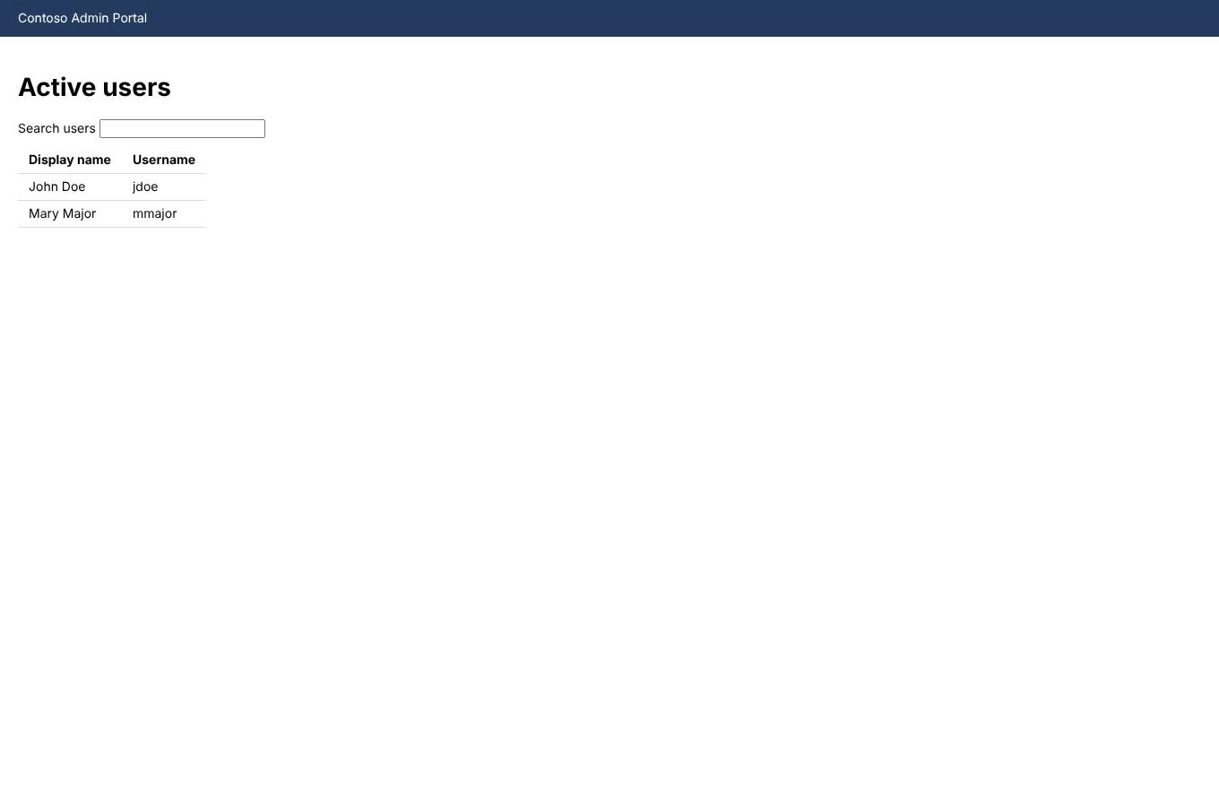
Figure: Step 1 – Search Active users and open the entry

Step 2 – Save in John Doe
Performed in Contoso Admin Portal on the "John Doe" screen.
1. Open the "Security" tab.
2. Select "Helpdesk administrator" in "Permission level".
3. Select the "Require phishing-resistant MFA" checkbox.
4. Enter the Temporary password (sensitive value - not recorded).
5. Click "Save".
6. Select the "View permission summary" link.
Application / system | Contoso Admin Portal
Required input | Permission level, Require phishing-resistant MFA, Temporary password
Expected result | The confirmation "Changes saved successfully" is displayed. The "Permission summary" screen is shown.
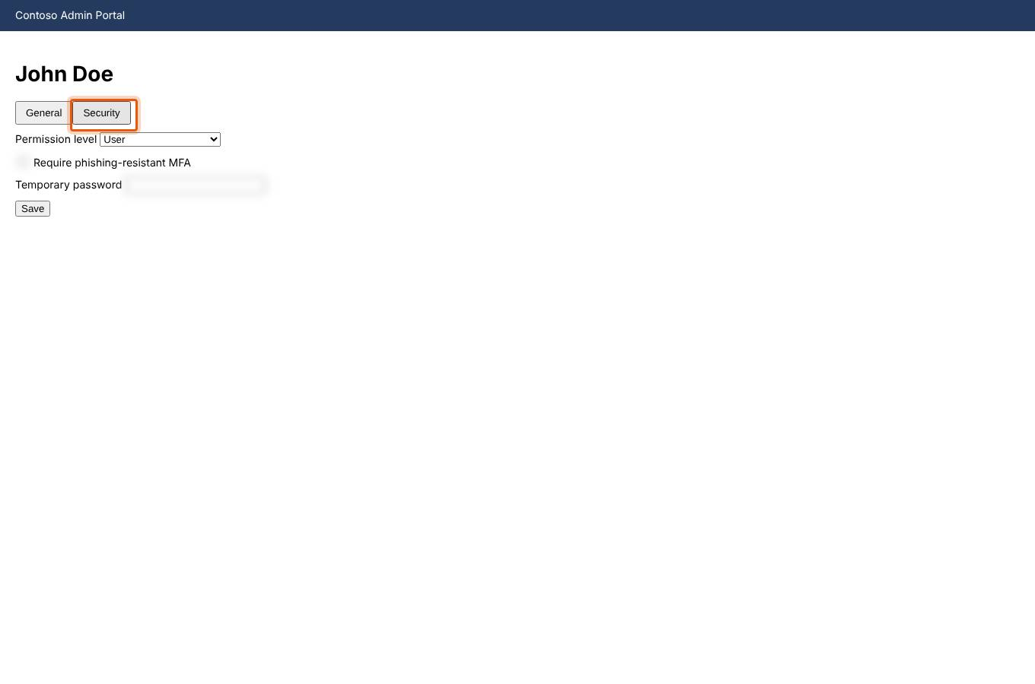
Figure: Step 2 – Save in John Doe

7. Decision Points and Exceptions
No decision points recorded.

8. Expected Outcome
The process is complete when: The confirmation "Changes saved successfully" is displayed.

9. Troubleshooting
No known issues recorded.

10. Related Documentation
None.

11. Change History
Version | Date | Author | Approver | Summary
1.0 | 2026-11-07 | IT Admin | IT Admin | Initial version created from a recorded execution.
1.1 | 2026-11-07 | IT Admin | IT Admin | Updated from a new recorded execution: 1 step(s) modified.

