**Running Head:** Plant trait responses to climate change

**Title:** Time travelling seeds reveal that plant regeneration and growth traits are responding to climate change

**Authors:** Susan E. Everingham1,2, Catherine A. Offord2, Manon E. B. Sabot3,4 and Angela T. Moles1.

**Author affiliations:**

1Evolution and Ecology Research Centre, School of Biological Earth and Environmental Sciences, UNSW, 2052, Australia.

2The Australian PlantBank, Royal Botanic Gardens and Domain Trust, Australian Botanic Garden Mount Annan, New South Wales 2567, Australia.

3Climate Change Research Centre, UNSW, Sydney, NSW 2052, Australia.

4Australian Research Council Centre of Excellence for Climate Extremes, UNSW, Sydney, NSW 2052, Australia.

**Corresponding author:** Susan Everingham ([susan.everingham@unsw.edu.au](mailto:susan.everingham@unsw.edu.au)), ORCID iD: <https://orcid.org/0000-0002-4780-2700>

**Abstract**

Studies assessing the biological impacts of climate change typically rely on long-term, historic data to measure trait responses to climate through time. Here, we overcame the problem of absent historical data by using resurrected seeds to capture historic plant trait data for a number of plant regeneration and growth traits. We collected seed and seedling trait measurements from resurrected historic seeds and compared these with modern seed and seedling traits collected from the same species in the same geographic location. The modern/historic seed pairs for each species were selected from a range of regions that have undergone different amounts of climate change across a range of temperature, precipitation and extreme measures of climate. There was a correlation between the amount of change in climate variables, and the amount of change in plant traits. Statistical model predictors of regeneration and growth trait changes (except stem density) combined at least two measures of climate change, indicating that these changes are correlated with climate change and that compounded changes, rather than change in a single climate metric, lead to plant regeneration and growth trait responses. Changes in extreme measures of climate such as heatwave duration and changes in climate variability were more strongly related to changes in regeneration and growth traits. Across our species, for every 0.05° C increase in temperature variability, there was a three-fold increase in the probability of seed viability and seed germination success. An increase of one day in the maximum duration of dry spells through time lead to a one-and-a-half-fold decrease in seed viability and a one third increase in seed dimension variance (seeds became flatter/thinner). Regions where the maximum heatwave duration had increased by ten days saw a 1.35 cm decrease in seedling height and a 1.04 g decrease in seedling biomass. Plant traits are responding to changes in climate and this is positive news for the future of plants, hinting at their ability to respond relatively swiftly as the climate continues to change.

**Keywords:** Biomass, climate change, dormancy, germination, plant traits, root to shoot ratio, seeds, stem density.

**Introduction**

Understanding how plant and animal species are responding to climate change is one of the major challenges of our time and is imperative to ensuring the protection of biodiversity and the survival of ecosystems (Scheffers et al. 2016). Unlike animals, plant survival may rely on *in situ* responses to the novel conditions presented by a rapidly changing climate because plants may not have the ability to migrate fast enough to keep up with the current pace of climate change (Jump and Penuelas 2005, Renton et al. 2013, Corlett and Westcott 2013). Most of our understanding of plant responses to climate change is based on species distribution models (Cramer et al. 2001, Bush et al. 2016) and analyses of historic records (Gallagher et al. 2009, Rumpff et al. 2010). However, models can be difficult to ground-truth and they have a level of uncertainty (Beale and Lennon 2012, Sánchez-Mercado et al. 2017), and many parts of the world do not have sufficient historic records to allow researchers to determine how much plant traits have changed through time. In this paper, we introduce a method that makes use of both resurrection ecology (i.e. the use of seeds that were collected decades ago and stored in seed banks; Franks et al. 2017, Weider et al. 2017) and spatial variation in climate change to ask whether changes in plant traits through the last few decades have been associated with changes in climate variables.

We began by asking whether 43 species from Australia have changed in a range of regeneration traits (including seed size, seed shape, germination success, dormancy, seed viability) and growth traits (plant size, root to shoot ratio, stem density) over the last few decades. We approached this question by comparing the traits of plants from seeds that were collected decades ago and stored in seed banks with the traits of plants grown from matching modern seed collections. This “resurrection ecology” method (Weider et al. 2017) allows us to not only quantify changes in traits for which we have historic data (Gallagher et al. 2009, Guerin et al. 2012), but also to measure ecological and physiological traits that were not recorded in the past, and to quantify change through time in species from regions in which there is little/no historic data. Our old and modern seeds differ in age by only a few decades. However, previous resurrection ecology studies have revealed that plants have been able to change in their physiological, phenological and morphological traits much more quickly than was previously thought possible (Nevo et al. 2012, Sultan et al. 2012, Thomann et al. 2015). Similarly, studies of rapid evolution have shown that plants often undergo significant trait changes within a few decades of introduction to a new country or region (Maron et al. 2004, Buswell et al. 2010, Brandenburger et al. 2019). Finally, changes in flowering phenology in response to climate change have been documented in many systems (Fitter and Fitter 2002, Parmesan and Yohe 2003). Thus, even though our study species are relatively long-lived (Appendix 1, Table S1), we predicted that some of them would demonstrate significant shifts in traits through time.

Next, we asked whether there are predictable trends in the type of species that have changed the most over the last few decades. Our first hypothesis was that herbs and shrubs would show larger changes in traits over time than trees would, due to their shorter generation times (Smith and Donoghue 2008, Salguero-Gómez et al. 2016). Second, trait responses in plants have been shown to have a strong phylogenetic signal in a range of contexts including plant-pollinator interactions (Sargent and Ackerly 2008), wood density (Swenson and Enquist 2007) and phenological responses to climate change (Cavender-Bares et al. 2009, Davies et al. 2013). We therefore predicted that more closely related species would show similar levels of trait change. By determining the which types of species have changed the most over the last few decades, we hope to contribute valuable knowledge to the conservation of the most “at-risk” species in future climate change scenarios.

Asking whether species have changed through time is an important and valuable starting point. However, viability loss and non-random mortality during long-term storage might generate differences between our modern and historic seeds and seedlings that are not due to climate change. To circumvent these issues, we introduce a novel method that makes use of the fact that climate change is not uniform across space (e.g. the Australian Continent; Fig. 1a,b; Australian Bureau of Meteorology, 2019). Specifically, we asked whether there is a correlation between the amount of change in plant traits (calculated as the log ratio of the mean trait values from historic vs modern seeds), and the amount of change in climate variables over the same time period. We hypothesised that we would observe greater plant trait changes in regions that have undergone larger climatic changes (Fig 1c).

Next, we asked which aspects of climate have the greatest effect on plant traits. Many studies have quantified changes in mean temperature on plants (Franks et al. 2007, but see Nevo et al. 2012 which has two species, Sultan et al. 2012). However, very few have quantified the effects of extremes (Siegmund et al. 2016, Yue et al. 2018). It has often been suggested that climate extremes or climate seasonality may have a greater impact on species responses than the means (Katz and Brown 1992, Reyer et al. 2012, Renton et al. 2014). We hypothesised that climate extremes (e.g. temperature range, precipitation range, heatwave duration, meteorological drought duration) and seasonality in climate that would see the highest plant trait responses compared to changes in mean annual temperature and precipitation. Quantifying plant trait responses to multiple climatic variables, particularly understudied extremes and variability in climate, would be valuable in future modelling studies to determine which climate parameters may have the most impact on species survival or distribution. Finally, we made some directional predictions about the biology of the change (see Appendix 2, Tables S1-S6 for a full list of predictions). Knowledge from biogeographic studies (e.g. Moles 2018), within-species relationships (e.g. Hovenden et al. 2008) and theory (e.g. Thompson et al. 1993, Drew et al. 2013) can inform predictions of species trait changes in response to climate change. For example, with an increase in mean temperature increase, we predicted that species would produce larger seeds. Small increases in mean temperature can result in species allocating more resources to offspring and the production of larger seeds (Moles 2018). Likewise, with a decrease in mean precipitation we predicted that species would tend to increase their stem density to reduce cavitation risk (Cornwell and Ackerly 2009, Drew et al. 2013). In regions where there have been significant increases in drought duration, we predicted that species would invest more in their root biomass to increase root surface area for maximum ground water acquisition, thus increasing their root to shoot ratio (Liu and Stützel 2004, Puritty et al. 2019). We also predicted that increasing temperature variability would be correlated with decreases in seed germination success, as more variable temperatures may results in seeds “hedging their bets” and prolonging germination until more favourable and stable environmental conditions occur (Ooi et al. 2009, Satyanti et al. 2018). Responses of plant traits to different climate metrics is key information for the selection of species in translocation experiments to more climatically suitable habitats.

In summary, we asked: 1) are plant traits changing through time?; 2) what types of species are undergoing the largest trait changes?; and 3) which climate change variables are associated with the largest changes in plant traits?

**Methods**

To determine if plant traits have changed within a species over time, we compared historic and modern accessions of seeds of 43 native Australian plant species from regions in south-eastern Australia which have experience differing levels of climatic change (Fig. 1). Many plant species have large geographic ranges, and plant traits often vary according to factors such as biotic interactions, altitude, latitude, soil fertility, and climate (Pakeman et al. 2008, Gong et al. 2020). Rather than spanning the full suite of variation within each species, our replicates are comparisons of tightly matched historic and modern population of plants. The level of within-population sampling (around 50 species) is substantially higher than the minimum (2-10 individuals) or preferred (5-25 individuals) number of replicates generally recommended for across-species studies of plant traits (Cornelissen et al. 2003). Paired modern and historic seeds were all collected from species that occurred in low elevation, non-alpine/mountainous sites to avoid confounding changes in elevation (elevation differences were always minimal, <100 m) with changes in traits over time.

Historic seeds were a random sample of *ex situ* stored seeds obtained from long-term collections at two Australian seed banks (PlantBank, The Australian Botanic Gardens Mount Annan; and The Australian National Botanic Gardens seed bank). Following the typical protocol of historic seed collections (Langkamp 1987), we assumed that historic seeds were collected from multiple individual plants (at least five, however, usually more than 50). At the time of their collection, historic seeds were typically dried out to 15 % relative humidity (RH) and kept in various storage conditions including cold rooms (-20° C) cool rooms (4° C) and drying rooms (ambient temperature). Our selection criteria were that the species were at least 30 years old (our range was 32 years to 46 years old); had at least five viable seeds in the collection; had accurate collection data; and were collected from wild populations.

We aimed to minimise differences between collection and processing of modern and historic seeds. To minimise geographic bias, we collected modern seeds as close as possible, typically at the same location or within 1 km (however for five species, the seeds were collected within a larger radius) of the recorded historic seed collection and from 50 individual plants. These modern seeds either originated from modern collections at the Australian Botanic Garden, Mt Annan, were supplied by Nindethana© and Eyre Native Seeds©, South Australia, or collected in the wild by author S.E.E. All modern seeds were collected when they were ripe, and before being shed from the mother plant. Modern seeds were then dried for two weeks at 15°C and 15% relative humidity and stored in the corresponding conditions of the historic seeds for one month to reduce the effect of storage environment. To minimise effects of seasonality, modern seeds were collected as close as possible to the same time of year as their historic counterparts. For 26 of the 43 species, collections were made within a month of the historic collection date and for another four species collections were made within 38 days. For the remaining 13 species, logistical limitations meant that we were unable to closely match the collection dates (> 38 days). However, the timing of collection had no effect on the changes in traits between the species (p > 0.05 for every trait, see Appendix 3, Table S1) and is disregarded from further analysis.

For each species, we measured the oven dry mass of up to 50 historic and 50 modern seeds using a microbalance (Mettler Toledo© AG204, 1 x 10-4 g accuracy). We measured length, width and height (mm) of the same 100 seeds using an electronic calliper (PES©, 1 x 10-2 accuracy). Seed dimension measurements did not include dispersal structures; only the seed coat, embryo and endosperm. Extremely small seeds (< 0.1 mg) were weighed in groups of five or ten, and their dimensions were not measured. Seed shape was calculated as the variance of seed dimensions by transforming width and height so as to normalise the length of the seed to one and calculate the variance of the values (Thompson et al. 1993). Only filled historic and modern seeds were measured in our study.

Where enough seeds were available, we germinated 100 historic and 100 modern seeds of each species on agar in incubators, for two weeks or until the cotyledon had appeared in at least 90 % of the germinated seeds. Most species (35 out of 43) were germinated on water agar (7 % weight per volume) at 20°C at constant humidity and alternating 12-hour light/dark conditions. However, eight species required specific germination regimes and these treatments were kept constant within each species, between historic and modern accessions (details in Appendix 3, Table S2). Every two days, the number of germinated seeds was recorded. A cut test with subsequent microscopic analysis were carried out to determine seed viability and seed dormancy at the end of the germination tests. Seed germination success was measured as the percent of seeds that germinated after the incubation period and was corrected excluding non-germinated, empty seeds. Seed viability was recorded as a binary trait (viable/non-viable) recorded for each individual seed at the end of the incubation period. For nine species all seeds of modern and/or historic accessions were 100 % non-viable and data for these species is limited to seed mass and seed shape.

A random sample of 50 germinated historic and 50 germinated modern seeds were transferred onto soil in 24-celled 4 cm by 2 cm2 trays with plastic dome lids to reduce moisture loss. After two weeks of growth seedlings were transferred to individual 1.9 L pots. All historic and modern seedlings were grown under the same conditions arranged in randomised blocks and re-randomised at monthly intervals to minimise possible positional effects during growth. Potting soil comprised 33% Australian Native Landscape supply of “Organic Garden Mix”, 33% washed river sand and 33% Cocopeat. Throughout growth we added a general, slow release fertiliser containing nitrogen and phosphorus applied at c. 200 mL of fertiliser per 75 L of soil. All plants were grown with adequate water supplied by overhead sprinklers and ambient light conditions in a glasshouse at UNSW, Sydney.

After six months, we followed standard protocols to quantify plant height, biomass, root to shoot ratio (root:shoot) and stem density (Pérez-Harguindeguy et al., (2013). We measured plant height from the top of the soil to the tip of the tallest apical meristem on each plant. All shoot tissue was harvested at the level of the soil and all plant roots were individually harvested and washed using distilled water. Roots and shoots were separated, dried at 60°C for 72 hr, and weighed. Masses were used to calculate total plant biomass and root:shoot. We took a fresh stem sample of 2 cm length at an equal distance of 1 cm from the soil on each plant. Fresh volume of the stem was calculated using the water displacement method (Pérez-Harguindeguy et al. 2013). Stem sections were dried at 60°C for 72 hr in a drying oven and weighed. Specific stem density was calculated as the ratio of oven dry stem mass (g) to the fresh volume of the stem (mL). To determine if growth form affected the amount of trait change, we categorised all species based on their growth forms (herb, shrub, shrub-tree, tree; see Appendix 3, Table S3 for classifications).

*Climate data*

Climate data originated from the Australian Gridded Climate Data (AGCD; Jones et al. 2009) at 5 km2 resolution and the processing code is freely available from <https://github.com/SEveringham/ClimateData>.

To strike a balance between long-term studies of climatic change that typically focus on decadal windows and the shorter-term studies of climate change impacts on plants in the year, months or weeks leading up to the collection date, we selected climate metrics from a period of five years prior to the dates of seed collection. Metrics of climate included the change in mean monthly temperature (calculated using the daily median temperatures, i.e. between the daily minimum and maximum temperatures, within the month prior to collection and averaged across the previous five years before each seed collection was made) and the change in mean monthly precipitation (averaged from the month prior to collection over the previous five years). Change in the range of temperatures and range of precipitations was calculated as the difference between the maximum yearly and minimum yearly temperature (Tmax - Tmin) or precipitation (Pmax – Pmin) averaged across the five years prior to seed collection. Temperature variability and precipitation variability were calculated as the standard deviation divided by the mean temperature or precipitation of the month prior to collection averaged across the five years preceding seed collection. Maximum precipitation of the season and minimum precipitation of the season of collection were calculated in a similar way (maximum or minimum precipitation across all five years prior to collection, only during the season – approximately four months prior and bounded by dry or wet season in the subtropics; or autumn, winter, spring or summer in the mid-latitude – prior to collection). Vapour pressure deficit (VPD) is the difference in how much moisture is held in the air compared to how much moisture can be held at saturation, and provides a measure of change in atmospheric aridity (calculated as the change in average VPD across the five years prior to collection.

Metrics for climate change extreme events include the change in maximum heatwave duration (calculated as the longest heatwave across all seasons in the five years prior to collection – with heatwaves defined following the relative extreme heat index metric based on anomalously high air temperatures proposed by Nairn, Fawcett & Ray (2009) – where the extreme heat index had to be positive for at least three days to signal a heatwave), the change in maximum dry spell duration (calculated as the longest dry spell in the five years prior to collection – with dry spells defined in an analogous way to heatwaves, by replacing the extreme heat index by an “extreme dryness index” using VPD instead of air temperature) and the change in maximum meteorological drought duration (the longest period of no rain in the five years prior to collection).

Change in all precipitation metrics (mean, variability, range, drought duration, dry spell duration) and heatwave duration was calculated as the log-transformed (i.e. ln) ratio of means ($\log\left(\frac{modern climate metric}{historic climate metric}\right)$). This scaling was due to the fact that our explanatory variables have different units and a change in one or a few degrees in temperature has higher biological significance compared to change in one or a few millimetres of precipitation. Change in all temperature metrics (except heatwave duration) was calculated as $modern climate metric-historic climate metric$.

Our analyses compare changes in plant traits and climate using multiple variables simultaneously. Because climate variables tend to be correlated with each other (Trenberth and Shea 2005, Braunisch et al. 2013), we used a correlation matrix to quantify correlation coefficients between our 12 climate metrics. Correlation coefficients never exceeded 0.6 (Appendix 3, Table S3), so we did not discard any climate metric.

*Data analysis*

All the following analyses were conducted in R studio (R Core Team 2018) and analysis code is freely available from <https://github.com/SEveringham/regeneration-and-growth-plant-trait-responses-to-climate-change>.

To test the hypothesis that species will show changes in their traits over time, we ran linear models comparing modern and historic plants within each species for each trait. We used the *lm* function in the stats package in base R (R Core Team 2018), with historic versus modern seeds or seedlings as the binary explanatory variable and trait measurements as the response variable. Seed mass, plant height, and total biomass were all log-transformed before analysis due to their non-normal distribution.

For all remaining analyses, the amount of trait change was calculated using either the log-transformed ratio of means ($\log\left(\frac{mean modern trait}{mean historic trait}\right)$) for continuous variables (seed mass, seed shape, germination success, plant height, biomass, stem density, and root:shoot), or as the log-transformed ratio of odds ($\log\left(\frac{proportion of binary modern trait}{proportion of binary historic trait}\right)$) for binary variables (i.e. seed viability and dormancy) using the *escalc* function in *metafor* (Viechtbauer, 2010).

To test for phylogenetic conservatism of the change in each trait, we used a phylogenetic generalised least squares (PGLS) framework using an estimate of the covariance across species measured in our study. The covariance matrix was obtained from the relationships and branch lengths of our species when pruned from the Qian & Jin (2016) tree, using the *S.phylomaker* function in the *phytools* package (Revell 2012) in R (see Appendix 6, Figure S1). Species in our study that were missing from the Qian & Jin (2016) tree were added as polytomies within their parental taxa and were assigned branch lengths using a branch length adjuster method (BLADJ). Species’ branch lengths were obtained using the *compute.brlen* function in the *ape* package (Paradis and Schliep 2018). We then used the calculated covariance matrix of branch lengths to compute phylogenetic signal of the changes in traits (each trait in separate analyses), using the *phylsig* function in the *phytools* package (Revell 2012) which computes phylogenetic signal via two methods (i.e. Pagel’s lambda (λ) or Blomberg’s K (K); Münkemüller et al. 2012).

The amount of trait change was averaged across all regeneration and growth traits within each species. This average was calculated as the mean of the absolute values of trait change (either log transformed means ratio for continuous data or log transformed odds ratio for binary data). Both negative and positive trait changes are taken into account, allowing us to assess the magnitude of change within each species irrespective of the direction of trait change. We then assessed whether growth-form was related to trait change, by using the species’ mean trait change value as the response variable in a linear regression (using the lmer function in the lme4 package; Bates et al. 2015) and their growth-form as a categorical, dependent variable. Mean trait change was log-transformed due to non-normal distribution of the data.

Although our study did not allow for the correction of maternal effects (due to the longevity and timing to reproduction for many of the species; see Appendix 1, Table S1), we used a method coupling change in long-term climate with change in traits. This allowed us to find relationships that were statistically strong correlations between climate change and trait change, accounting for maternal effects. To determine whether a relationship between change in the climate metrics and changes in the plant traits existed, we used the corrected Akaike Information Criterion (AICc) for stepwise statistical model selection for low sample size in a meta-analytic framework. This was done using the *glmulti* (Calcagno and de Mazancourt 2010) and *rma.uni* (Viechtbauer 2010) functions in R. A term for sample variance (*vi*) was added to the model selection framework due to the unequal sampling between modern and historic plants and between species (i.e. due to unviability of historic collections or unequal numbers of historic and modern seeds available/sampled). An effect for growth form (herb, shrub, shrub-tree, tree) was included in our statistical models. The results from the AICc stepwise statistical model selection also informed us of the climate metrics that had the strongest relationships with trait changes.

Finally, we quantified the direction of change for each trait as a function of the change in each climate metric. We used multi-model inference across all possible models from the AICc model selection meta-analytic framework using the *coef* function in the *glmulti* R package (Calcagno and de Mazancourt 2010). This allowed us to make statistical inferences about the various climate change predictors and their relationship with trait changes in the context of all possible models, taking each model’s relative weight into consideration (Burnham and Anderson 2002).

*Data considerations – variations in atmospheric carbon dioxide*

Across the regions in our study, the spatial variation in the amount of atmospheric CO2 under which the species grew would be considered to be minor. However, as historic seeds were collected from multiple decades spanning 15 years (1971-1986), there may be differences in the change between historical and modern atmospheric CO2 content between species. Although the majority of the modern seeds were collected in 2016-2018, two species’ modern seeds were collected in 2008 and 2009 respectively, also leading to differences in the amount of atmospheric CO2 increase between species. Previous research has shown that changes in atmospheric CO2 have impacted plant growth (Manderscheid and Weigel 1997, Franzaring et al. 2013). Therefore, we determined whether the extent of changes in CO2 over time impacted the change in traits. We used the NOAA ESRL mean monthly atmospheric CO2 data originating from the Mauna Loa Observatory, Hawaii (Tans and Keeling 2017), as a proxy for atmospheric CO2 levels free from anthropogenic or vegetation interferences at our collection sites. We performed separate linear regressions (using the lm function in base R; R Core Team 2018) with each trait change as the response variable and change in CO2 level as the predictor variable. We also included a term for change in CO2 in our meta-analytic model selection framework. There were no significant relationships between trait change and change in CO2 for any of the traits and none of the “best” models that explained most of the trait change included CO2 increase (see Appendix 5). This could be due to the fact that the rate of increase in atmospheric CO2 has been relatively constant since c. 1950 and so, evaluating CO2 impacts might require contrasting a pre-1950 period from a post-1950 period (which our trait data is not set to do). Due to these considerations, we excluded CO2 change from further analyses/results.

**Results**

There were substantial differences between modern and historic plants (Fig. 2). Two-thirds of species showed significant differences between modern and historic seed sizes (Fig. 2). In around half of the species, there were significant differences between modern and historic populations in seed shape, germination success and plant height (Fig. 2). One-third of species showed significant changes in seed viability and plant biomass, and the rest of our traits showed between 12-38 % of species changing significantly over time. There were more significant differences between modern and historic seed traits (43 % of species, Fig. 2) than seedling traits (28 % of species, Fig. 2), which could be due to lower sample sizes for seedling traits as some species did not germinate and/or survive until trait measurements were taken. Across all regeneration and growth traits, we performed a total of 303 comparative (modern against historic) tests across all 43 species and nine traits (Appendix 4, Table S2) Out of these 303 tests we found 114 significant differences between historic and modern populations for each trait (Fig. 2, see Appendix 4, Table S2). Although we performed a large number of comparisons, a binomial test indicated that the proportion of significant test outcomes is far greater than expected by chance when alpha is 0.05 (p<0.001).

Neither phylogenetic relatedness nor growth form was significantly associated with plant trait changes. We found no significant phylogenetic conservatism in any trait (Pagel’s λ and Blomberg’s K, p >0.05; Appendix 6, Table S1), so we did not include a term for phylogeny in further analysis. Although absolute average trait change was two times higher in herbs than trees (Fig. 3), growth form was not significantly related to absolute average trait change across the species (R2 = 0.044, p = 0.196, Fig. 3). Growth form was only selected in the best model for two trait changes: change in seed mass and seed dormancy. Its importance as a variable across all possible models for the two traits was low (47 % and 62 %, respectively).

At least two climate change metrics were included in the best model for each plant trait, except stem density (Table 1). However, changes in mean temperature and mean precipitation were not the strongest correlates of trait change. Mean temperature was not selected in the best model for any trait, and mean precipitation was only selected in three models (for change in seed mass, seed shape and root:shoot). Other climate change metrics were selected in the best models including changes in variability in temperature and precipitation, change in the range of precipitation and change in maximum seasonal precipitation. Maximum dry spell duration and maximum seasonal precipitation were both selected twice in the “best” models to explain trait changes and these metrics are representative of extreme measures of climate (Table 1).

Although the “best” models for all traits (except stem density) included terms for climate change metrics, the majority of individual relationships with climate change metrics did not yield significant changes in traits (Table 1, Fig. 4). This indicates that different climate metrics may impact trait responses in combination rather than individually.

There were four significant and two marginally significant pairwise relationships between change in plant traits and change in climate metric. These relationships were almost certainly not due to chance as they were significant after multi-model, meta-analytic variable inference which is not based on singular pairwise tests (lowering the false discovery rate). For every 0.05° C increase in temperature variability, there was a three-fold increase in the probability of seed viability and a three-fold increase in the probability of seed germination success (seeds were three times as likely to be viable and to germinate through time in regions where temperature became more variable; Table 1, Fig. 4a and 4d, p < 0.05). Post-hoc analyses have shown that germination success and seed viability are highly correlated (R2 = 0.86, p<0.001) which may have resulted in similar relationships between these trait changes and temperature variability. An increase of one day in the maximum duration of dry spells through time would lead to a one-and-a-half-fold decrease in seed viability (Table 1, Fig. 4b, 0.05 <p < 0.1) and a one-third increase in seed dimension variance (seeds becoming flatter and thinner; Table 1, Fig. 4e, p < 0.05). Regions where maximum heatwave duration had increased by ten days would see a 1.35 cm decrease in seedling height (Table 1, Fig. 4c, p < 0.05) and a 1.04 g decrease in seedling biomass (Table 1, Fig. 4f, 0.05 < p < 0.1).

Change in atmospheric carbon dioxide through time was not significantly related to any changes in plant traits (p > 0.05; Appendix 4, Table S1), nor was it selected for in any of the “best models” that explained the highest amount of plant trait changes.

**Discussion**

Many native Australian plant species have undergone changes in a wide range of regeneration and growth traits over the last 30-40 years (Fig. 2). These changes were sometimes substantial and were detected in at least one trait for 93 % of the species in our study. Crucially, we found some significant correlations between these trait changes and changes in the local climate (Table 1, Fig. 4), showing that many plants have already responded to climate change in seed and seedling traits. However, the climatic changes observed over the past 30-40 years tend to be smaller than those projected for the next century (Collins et al. 2013). Thus, while the fact that our species have shown substantial changes already is heartening, it is not clear whether Australian plants will be able to respond fast enough to persist in their current geographical range in the face of future climate change.

Our study indicates that species do have the ability to respond in some regeneration and growth traits to changes in climate. Climate change is an important factor to consider in species’ future distributions and extinction risk modelling as well as species’ conservation, as it presents a selective force that causes species to change and evolve (Thuiller et al. 2011, Pio et al. 2014). This is important information, which would be nicely complemented by future studies that determine the mechanisms by which the traits are responding. For example, future work could ask what extent changes in plant regeneration and growth traits results from direct responses of the plants to climate factors, and to what extent species’ responses are mediated by other factors such as changing interactions with soil microbes or herbivores. Future work could also ask whether changes most often result from phenotypic plasticity or rapid evolution. Addressing this question would involve growing the plants through to a second generation. This is unachievable in our system due to the long lifespans of the species, but could be done relatively simply in ecosystems characterised by shorter-lived species. Finally, future studies could grow plants under historic and modern conditions to determine whether species’ changes are adaptive.

We were initially concerned that storage effects and other sources of noise might affect our estimates of change through time (Fig. 1c). However, we found that when there is no change in climate (i.e. 0 on the x axis in figure 4), most traits displayed surprisingly little change (Fig. 4a,d,e,f; intercept not significantly different from 0, p > 0.05). Even when there was a change in traits in the absence of a change in climate (intercept significantly different from 0), the magnitude of the change was very small. For example, there was only a small increase in germination success (1.49%) and seed viability (1.82%) over time (Fig. 4b,c). That is, viability loss and storage biases don't seem to be having a major impact on trait changes in our study.

There is little consistency in how species changed their traits through time (Fig. 2). This idiosyncrasy in response is consistent with the findings of studies that have used herbarium specimens to track change through time (e.g. Buswell et al.,2010, Dalrymple,Buswell & Moles, 2014). We can think of at least four explanations for the lack of consistent responses. First, the species grow in different parts of the country, and have been exposed to different directions and amounts of climate change through time (Australian Bureau of Meteorology, 2019). Second, differences in the environmental conditions under which the species initially grew might result in differences in how they respond to the same change in climate. For instance, a plant in a cool moist climate (such as that found in much of Tasmania) that experiences an increase in temperature might respond with traits allowing it to grow more rapidly, or by increasing its seed size. Meanwhile, the same amount of increase in temperature in a plant growing in a hot, arid environment (such as western NSW), might respond with decreases in seed size, and shifts to a more conservative growth strategy. Third, differences in species’ traits might affect their responses. For instance, species with that produces larger seeds might be more affected by an increase in maximum temperatures than is a species that produces small seeds. Finally, different species might experience different changes in biotic interactions such as herbivory, competition, or belowground interactions through time. Beginning to understand which circumstances lead to different types of response is an important direction for the future. For now, the lack of a consistent direction of change across our species, and the fact that plant trait responses to climate change were not necessarily in the direction we had hypothesised based on theory, bio-geographical studies and experimental evidence (Tables S1-S6) serves as a useful reminder that predicting ecosystem responses to future climate change is a non-trivial challenge.

While previous studies have provided data on changes in gross morphology and the timing of biological events in rapid evolution and herbarium studies (Rawal et al. 2014, Brandenburger et al. 2019), our study shows that it is possible to reveal how plants are changing in response to climate change in traits that have not been historically measured (e.g. seed viability and root:shoot). This may be particularly achievable where historic seeds may have been collected and stored in museums or botanic gardens, (e.g. Millennium Seed Bank, Kew Botanic Gardens; Smith et al. 2010). This is important, as unlike Northern America and Europe where there is a long history of ecological data collection (Fitter and Fitter 2002, Primack et al. 2004), many areas of the globe have been under-studied in the past, particularly in regions in the southern hemisphere, such as South Africa, Indonesia, and the Pacific Islands.

Ecological responses to climate change have typically been quantified using mean climatic metrics (Merilä and Hendry 2014), such as mean annual temperature and precipitation (Cramer et al. 2001, Matthews and Mazer 2015). However, these metrics may be inadequate in comparison to metrics of climate variability and climate extremes (De Boeck et al. 2010, Merilä and Hendry 2014), as shown in our results where mean temperature was not a major predictor of change for any of our traits. The climate metric that was selected for in the largest number of our models was the change in the maximum duration of dry spells (selected in the best model in five out of nine plant traits); an indication that extreme dry events, which involve a combination of high atmospheric temperature and low atmospheric humidity, elicit strong trait responses in plants (Engelbrecht et al. 2006). This may be because vapour-pressure deficit is one of the main drivers of plant transpiration (Rawson and Begg 1977, Jones 1998). One possible reason why climate extremes may have stronger effects on plants than climate means is that changes in climate means might be relatively small (i.e. dramatic changes in average temperatures and precipitation are unlikely to have occurred across both space and time), making subsequent small changes in plant traits difficult to identify (De Boeck et al. 2010). Additionally, mean metrics may not pick up on nuances of climate like seasonality or extremes (Katz and Brown 1992). For example, our drought metric was not selected in any of the best models related to plant trait change. This may be due to drought being defined according to its meteorological sense and this metric does not guarantee that plants actually experienced drought stress as their water use strategies could have buffered that stress for them (Choat et al. 2007, Blackman et al. 2011, Moreno Gutiérrez et al. 2012). Overall, no single measure of climate explained all the measured trait changes. In future work, studying multiple climate metrics as well as their interactive effects will help to gauge the compound impacts of climate change on our natural ecosystems.

We found some significant trait changes through time for the critical seed, germination and seedling establishment stages, and these may have flow-on effects later in the plant life cycle (Moles and Leishman, 2008). Our results showed decreases in seedling height and biomass occurred where there were large increases in maximum heatwave duration (Fig. 4). Increases in heat stress have been linked with increases in the soil water content threshold of plants (Centritto et al. 2011). This leads to water-stressed plants which may select for species with lower photosynthetic rates and therefore decreased growth rates, biomass and plant heights (Haworth et al.,2018). Seed viability and germination success increased in regions where temperature variability increase and this was not what we had previously predicted (Fig. 4). However, species may be investing more in increased seed viability and germination success in more variable environments to ensure seedling survival

(McGinley et al. 1987). Seed viability and seed germination success were two different measurements, however, they are highly correlated and this explains their similar relationship with temperature variability (Fig. 4a,d). Increases in dry spell duration led to species traits changing as well, including decreases in seed viability which could be an indication that dry spells are having a longer term negative impact on reproductive output (Fig. 4). Longer dry spells also lead to a significant (p < 0.05) increase in seed dimension variance meaning that seeds were becoming flatter and thinner. Seed shape responses may be due to selection of species that are buried deeper in soil seed banks (Thompson et al.,1993) and also has implications for future seed storage in the soil for our species, particularly in regions where dry spells increase.

It may be surprisingly difficult to predict which species are going to change in response to climate change. In our study, phylogeny was not a useful predictor of plant trait response to climate change - all clades were equally likely to respond or not respond to climate change (Appendix 6, Table S1). The unpredictability of which species/genera/families are more likely to respond to climate change may leave us unable to predict which species will face the highest threats due to climate change in any given region. This highlights the importance of conserving whole ecosystems rather than specific species (Heller and Zavaleta 2009). Growth form was also not a good predictor of plant trait responses to climate change (Fig. 3, Table 1). This result may reflect the small number of herbs sampled (n = 6) due to a lack of historical seeds from herbaceous growth forms in Australia. Alternatively, there might be no difference in the rate of change of long-lived versus short-lived species and with some evidence showing that long-lived organisms may be able to adapt in the absence of recombination through somatic mutation (Dalrymple et al. 2014, Schmid-Siegert et al. 2017). Testing this hypothesis would require quantifications of the relationship between plant growth form and species’ response to climate change in ecosystems with a higher proportion of herbaceous species.

Our results indicate that plants have the ability to respond to climate change in their morphological traits - a glimmer of hope amongst a multitude of research that typically focuses on negative outcomes (e.g. mortality, invasion of introduced species) in natural ecosystems due to increasing alterations in climate (Hughes 2000, Parmesan 2006, Bellard et al. 2012). As the world moves into an era of unprecedented levels of atmospheric greenhouse gases as well as changes in temperature, precipitation and extreme weather (Collins et al. 2013), we need to determine if and how our natural ecosystems will respond. Moreover, we need to identify if ecosystems have the potential to respond fast enough to keep pace with current and predicted rates of climate change. Our study provides a key method to help address this challenging question.

**Acknowledgements**

This research was supported by the Australian Government through the Australian Research Council Discovery Projects funding scheme to ATM (project DP180103611). Author SEE was also supported by funding through the Australian Government’s Research Training Program (RTP) and the Ecological Society of Australia’s Holsworth Wildlife Research Endowment. Support was also received from the Australian Research Council Centre of Excellence for Climate Extremes (CE170100023) and from the UNSW Scientia PhD Scholarship Scheme to MEBS. We thank the Australian Botanic Gardens, Mount Annan as well as Tom North from the Australian National Botanic Garden; and Mole River Native Nursery for providing access to historic and/or modern seeds. We acknowledge the following governing bodies where fieldwork was undertaken: New South Wales National Parks and Wildlife Service (permit SL100569), the Forestry Corporation of New South Wales (permit HF54076), Tasmanian Department of Primary Industries, Parks, Water and Environment (permit FL 17203), South Australia Department of Environment, Water and Natural Resources (permit A26716-1) and the Victorian Department of Environment, Land, Water and Planning (permit 10008541). Finally, we thank Jason Evans (UNSW) and the Bureau of Meteorology for providing the AGCD data.

**Literature Cited**

Australian Bureau of Meteorology. 2019. Australian climate variability & change - Trend maps. http://www.bom.gov.au/climate/change/index.shtml#tabs=Tracker&tracker=trend-maps.

Bates, D., M. Mächler, B. Bolker, and S. Walker. 2015. Fitting linear mixed-effects models using lme4. Journal of Statistical Software 67:1–48.

Beale C., M. and J. J. Lennon JJ. 2012. Incorporating uncertainty in predictive species distribution modelling. Philosophical Transactions of the Royal Society B367:247–258

Bellard, C., C. Bertelsmeier, P. Leadley, W. Thuiller, and F. Courchamp. 2012. Impacts of climate change on the future of biodiversity. Ecology Letters 15:365–377.

Blackman, C. J., T. J. Brodribb, and G. J. Jordan. 2011. Leaf hydraulic vulnerability influences species’ bioclimatic limits in a diverse group of woody angiosperms. Oecologia 168:1–10.

Brandenburger, C. R., W. B. Sherwin, S. M. Creer, R. Buitenwerf, A. G. B. Poore, R. Frankham, P. B. Finnerty, and A. T. Moles. 2019. Rapid reshaping: the evolution of morphological changes in an introduced beach daisy. Proceedings of the Royal Society B: Biological Sciences 286:20181713–9.

Braunisch, V., J. Coppes, R. Arlettaz, R. Suchant, H. Schmid, and K. Bollmann. 2013. Selecting from correlated climate variables: a major source of uncertainty for predicting species distributions under climate change. Ecography 36:971–983.

Burnham, K. P., and D. R. Anderson. 2002. Model selection and multimodel inference: a practical information-theoretic approach. Springer-Verlag, New York, USA.

Bush, E. R., K. A. Abernethy, K. Jeffery, C. Tutin, L. White, E. Dimoto, J.-T. Dikangadissi, A. S. Jump, and N. Bunnefeld. 2016. Fourier analysis to detect phenological cycles using long-term tropical field data and simulations. Methods in Ecology and Evolution 8:530–540.

Buswell, J. M., A. T. Moles, and S. Hartley. 2010. Is rapid evolution common in introduced plant species? Journal of Ecology 99:214–224.

Calcagno, V., and C. de Mazancourt. 2010. glmulti: An R Package for Easy Automated Model Selection with (Generalized) Linear Models. Journal of Statistical Software 34:1–29

Cavender-Bares, J., K. H. Kozak, P. V. A. Fine, and S. W. Kembel. 2009. The merging of community ecology and phylogenetic biology. Ecology Letters 12:693–715.

Centritto, M., F. Brilli, R. Fodale, and F. Loreto. 2011. Different sensitivity of isoprene emission, respiration and photosynthesis to high growth temperature coupled with drought stress in black poplar (*Populus nigra*) saplings. Tree Physiology 31:275–286.

Choat, B., L. Sack, and N. M. Holbrook. 2007. Diversity of hydraulic traits in nine *Cordia* species growing in tropical forests with contrasting precipitation. New Phytologist 175:686–698.

Collins, M., R. Knutti, J. Arblaster, J. L. Dufresne, T. Fichefet, P. Friedlingstein, X. Gao, W. J. Gutowski, T. Johns, G. Krinner, M. Shongwe, C. Tebaldi, A. J. Weaver, and M. Wehner. 2013. Long-term Climate Change: Projections, Commitments and Irreversibility. Pages 1029–1106 in Climate Change The Physical Science Basis. Contribution of Working Group I to the Fifth Assessment Report of the Intergovernmental Panel on Climate Change. Cambridge, United Kingdom and New York, USA.

Corlett, R. T., and D. A. Westcott. 2013. Will plant movements keep up with climate change? Trends in Ecology and Evolution 28:482–488.

Cornelissen, J. H. C., S. Lavorel, E. Garnier, S. Diaz, N. Buchmann, D. E. Gurvich, P. B. Reich, H. T. Steege, H. D. Morgan, M. G. A. V. D. Heijden, J. G. Pausas, and H. Poorter. 2003. A handbook of protocols for standardised and easy measurement of plant functional traits worldwide. Australian Journal of Botany 51:335–47.

Cornwell, W. K., and D. D. Ackerly. 2009. Community assembly and shifts in plant trait distributions across an environmental gradient in coastal California. Ecological Monographs 79:109–126.

Cramer, W., A. Bondeau, F. I. Woodward, I. C. Prentice, R. A. Betts, V. Brovkin, P. M. Cox, V. Fisher, J. A. Foley, A. D. Friend, C. Kucharik, M. R. Lomas, N. Ramankutty, S. Sitch, B. Smith, A. White, and C. Young-Molling. 2001. Global response of terrestrial ecosystem structure and function to CO2 and climate change: results from six dynamic global vegetation models. Global Change Biology 7:357–373.

Dalrymple, R. L., J. M. Buswell, and A. T. Moles. 2014. Asexual plants change just as often and just as fast as do sexual plants when introduced to a new range. OIKOS 124:196–205.

Davies, T. J., E. M. Wolkovich, N. J. B. Kraft, N. Salamin, J. M. Allen, T. R. Ault, J. L. Betancourt, K. Bolmgren, E. E. Cleland, B. I. Cook, T. M. Crimmins, S. J. Mazer, G. J. McCabe, S. Pau, J. Regetz, M. D. Schwartz, and S. E. Travers. 2013. Phylogenetic conservatism in plant phenology. Journal of Ecology 101:1520–1530.

De Boeck, H. J., F. E. Dreesen, I. A. Janssens, and I. Nijs. 2010. Whole-system responses of experimental plant communities to climate extremes imposed in different seasons. New Phytologist 189:806–817.

Drew, D. M., K. Allen, G. M. Downes, R. Evans, M. Battaglia, and P. Baker. 2013. Wood properties in a long-lived conifer reveal strong climate signals where ring-width series do not. Tree Physiology 33:37–47.

Engelbrecht, B. M. J., J. W. Dalling, T. R. H. Pearson, R. L. Wolf, D. A. Gálvez, T. Koehler, M. T. Tyree, and T. A. Kursar. 2006. Short dry spells in the wet season increase mortality of tropical pioneer seedlings. Oecologia 148:258–269.

Fitter, A. H., and S. R. Fitter. 2002. Rapid Changes in Flowering Time in British Plants. Science 296:1689–1691.

Franks, S. J., E. Hamann, and A. E. Weis. 2017. Using the resurrection approach to understand contemporary evolution in changing environments. Evolutionary Applications 11:17–28.

Franks, S. J., S. Sim, and A. E. Weis. 2007. Rapid evolution of flowering time by an annual plant in response to a climate fluctuation. Proceedings of the National Academy of Sciences 104:1278–1282.

Franzaring, J., I. Holz, and A. Fangmeier. 2013. Responses of old and modern cereals to CO2-fertilisation. Crop and Pasture Science 64:943–14.

Gallagher, R. V., L. Hughes, and M. R. Leishman. 2009. Phenological trends among Australian alpine species: using herbarium records to identify climate-change indicators. Australian Journal of Botany 57:1–9.

Gong, H., Q. Cui, and J. Gao. 2020. Latitudinal, soil and climate effects on key leaf traits in northeastern China. Global Ecology and Conservation 22:e00904.

Guerin, G. R., H. Wen, and A. J. Lowe. 2012. Leaf morphology shift linked to climate change. Biology Letters 8:882–886.

Heller, N. E., and E. S. Zavaleta. 2009. Biodiversity management in the face of climate change: A review of 22 years of recommendations. Biological Conservation 142:14–32.

Hovenden, M. J., K. E. Wills, R. E. Chaplin, J. K. vander Schoor, A. L. Williams, W. Osanai, and P. C. D. Newton. 2008. Warming and elevated CO2 affect the relationship between seed mass, germinability and seedling growth in Austrodanthonia caespitosa, a dominant Australian grass. Global Change Biology 14:1633–1641.

Hughes, L. 2000. Biological consequences of global warming: is the signal already. Trends in Ecology and Evolution 15:56–61.

Jones, D. A., W. Wang, and R. Fawcett. 2009. High-quality spatial climate data-sets for Australia. Australian Meteorological and Oceanographic Journal 58:233.

Jones, H. 1998. Stomatal control of photosynthesis and transpiration. Journal of Experimental Botany 49:387–398.

Jump, A. S., and J. Penuelas. 2005. Running to stand still: adaptation and the response of plants to rapid climate change. Ecology Letters 8:1010–1020.

Katz, R. W., and B. G. Brown. 1992. Extreme events in a changing climate: variability is more important than averages. Climatic Change 21:289–302.

Langkamp, P. 1987. Germination of Australian native plant seed.

Liu, F., and H. Stützel. 2004. Biomass partitioning, specific leaf area, and water use efficiency of vegetable amaranth (*Amaranthus* spp*.*) in response to drought stress. Scientia Horticulturae 102:15–27.

Manderscheid, R., and H. J. Weigel. 1997. Photosynthetic and growth responses of old and modern spring wheat cultivars to atmospheric CO2 enrichment. Agriculture, Ecosystems & Environment 64:65–73.

Maron, J. L., M. Vila, R. Bommarco, S. Elmendorf, and P. Beardsley. 2004. Rapid evolution of an invasive plant. Ecological Monographs 74:261–280.

Matthews, E. R., and S. J. Mazer. 2015. Historical changes in flowering phenology are governed by temperature x precipitation interactions in a widespread perennial herb in western North America. New Phytologist 210:157–167.

McGinley, M. A., D. H. Temme, and M. A. Geber. 1987. Parental investment in offspring in variable environments: theoretical and empirical considerations. Journal of the American Society of Horticultural Science 130:370–398.

Merilä, J., and A. P. Hendry. 2014. Climate change, adaptation, and phenotypic plasticity: the problem and the evidence. Evolutionary Applications 7:1–14.

Moles, A. T. 2018. Being John Harper: Using evolutionary ideas to improve understanding of global patterns in plant traits. Journal of Ecology 106:1–18.

Moles, A. T., and M. Leishman. 2008. The seedling as part of a plant’s life history strategy. In: *Seedling Ecology and Evolution*, pp. 215–235. Cambridge UK: Cambridge University Press.

Moreno Gutiérrez, C., T. E. Dawson, E. Nicolás, and J. I. Querejeta. 2012. Isotopes reveal contrasting water use strategies among coexisting plant species in a Mediterranean ecosystem. New Phytologist 196:489–496.

Münkemüller, T., S. Lavergne, B. Bzeznik, S. Dray, T. Jombart, K. Schiffers, and W. Thuiller. 2012. How to measure and test phylogenetic signal. Methods in Ecology and Evolution 3:743–756.

Nairn, J., R. Fawcett, and D. Ray. 2009. Defining and predicting Excessive Heat events, a National system. Pages 83–86 in. Extended Abstracts, Modelling and Understanding High Impact Weather, Third CAWCR Modelling Workshop. Centre for Australian Weather and Climate Research. CAWCR Technical Report.

Nevo, E., Y.-B. Fu, T. Pavlicek, S. Khalifa, M. Tavasi, and A. Beiles. 2012. Evolution of wild cereals during 28 years of global warming in Israel. Proceedings of the National Academy of Science 109:3412–3415.

Ooi, M. K. J., T. D. Auld, and A. J. Denham. 2009. Climate change and bet-hedging: interactions between increased soil temperatures and seed bank persistence. Global Change Biology 15:2375–2386.

Pakeman, R. J., E. Garnier, S. Lavorel, P. Ansquer, H. Castro, P. Cruz, J. Doležal, O. Eriksson, H. Freitas, C. Golodets, J. and Kigel. 2008. Impact of abundance weighting on the response of seed traits to climate and land use. Journal of Ecology, 96:355–366.

Paradis, E., and K. Schliep. 2018. ape 5.0: an environment for modern phylogenetics and evolutionary analyses in R. Bioinformatics 35:526–528.

Parmesan, C. 2006. Ecological and Evolutionary Responses to Recent Climate Change. Annual Review of Ecology, Evolution and Systematics 37:637–669.

Parmesan, C., and G. Yohe. 2003. A globally coherent fingerprint of climate change impacts across natural systems. Nature 421:37–42.

Pérez-Harguindeguy, N., S. Diaz, E. Garnier, S. Lavorel, H. Poorter, P. Jaureguiberry, M. S. Bret-Harte, W. K. Cornwell, J. M. Craine, D. E. Gurvich, C. Urcelay, E. J. Veneklaas, P. B. Reich, L. Poorter, I. J. Wright, P. Ray, L. Enrico, J. G. Pausas, A. C. de Vos, N. Buchmann, G. Funes, F. Quétier, J. G. Hodgson, K. Thompson, H. D. Morgan, H. ter Steege, L. Sack, B. Blonder, P. Poschlod, M. V. Vaieretti, G. Conti, A. C. Staver, S. Aquino, and J. H. C. Cornelissen. 2013. New handbook for standardised measurement of plant functional traits worldwide. Australian Journal of Botany 61:167–70.

Pio, D. V., R. Engler, H. P. Linder, A. Monadjem, F. P. D. Cotterill, P. J. Taylor, M. C. Schoeman, B. W. Price, M. H. Villet, G. Eick, N. Salamin, and A. Guisan. 2014. Climate change effects on animal and plant phylogenetic diversity in southern Africa. Global Change Biology 20:1538–1549.

Primack, D., C. Imbres, R. B. Primack, A. J. Miller-Rushing, and P. Del Tredici. 2004. Herbarium specimens demonstrate earlier flowering times in response to warming in Boston. American Journal of Botany 91:1260–1264.

Puritty, C. E., E. H. Esch, S. P. Castro, E. M. Ryan, D. A. Lipson, and E. E. Cleland. 2019. Drought in Southern California coastal sage scrub reduces herbaceous biomass of exotic species more than native species, but exotic growth recovers quickly when drought ends. Plant Ecology 220:151–169.

Qian, H., and Y. Jin. 2016. An updated megaphylogeny of plants, a tool for generating plant phylogenies and an analysis of phylogenetic community structure. Journal of Plant Ecology 9:233–239.

R Core Team. 2018. R: A language and environment for statistical computing. Vienna, Austria.

Rawal, D. S., S. Kasel, M. R. Keatley, and C. R. Nitschke. 2014. Herbarium records identify sensitivity of flowering phenology of eucalypts to climate: Implications for species response to climate change. Austral Ecology 40:117–125.

Rawson, H. M., and J. E. Begg. 1977. The effect of atmospheric humidity on photosynthesis, transpiration and water use efficiency of leaves of several plant species. Planta 134:5–10.

Renton, M., N. Shackelford, and R. Standish. 2014. How will climate variability interact with long-term climate change to affect the persistence of plant species in fragmented landscapes? Environmental Conservation 41:110–121.

Renton, M., S. Childs, R. Standish, and N. Shackelford. 2013. Plant migration and persistence under climate change in fragmented landscapes: Does it depend on the key point of vulnerability within the lifecycle? Ecological Modelling 249:50–58.

Revell, L. J. 2012. phytools: An R package for phylogenetic comparative biology (and other things). Methods in Ecology and Evolution 3:217–223.

Reyer, C. P. O., S. Leuzinger, A. Rammig, A. Wolf, R. P. Bartholomeus, A. Bonfante, F. de Lorenzi, M. Dury, P. Gloning, R. Abou Jaoudé, T. Klein, T. M. Kuster, M. Martins, G. Niedrist, M. Riccardi, G. Wohlfahrt, P. de Angelis, G. de Dato, L. François, A. Menzel, and M. Pereira. 2012. A plant's perspective of extremes: terrestrial plant responses to changing climatic variability. Global Change Biology 19:75–89.

Rumpff, L., F. Coates, and J. W. Morgan. 2010. Biological indicators of climate change: evidence from long-term flowering records of plants along the Victorian coast, Australia. Australian Journal of Botany 58:428–12.

Salguero-Gómez, R., O. R. Jones, E. Jongejans, S. P. Blomberg, D. Hodgson, C. Mbeau-Ache, P. A. Zuidema, H. de Kroon, and Y. M. Buckley. 2016. Fast–slow continuum and reproductive strategies structure plant life-history variation worldwide. Proceedings of the National Academy of Sciences 113:230–235.

Sargent, R. D., and D. D. Ackerly. 2008. Plant–pollinator interactions and the assembly of plant communities. Trends in Ecology and Evolution 23:123–130.

Satyanti, A., L. K. Guja, and A. B. Nicotra. 2018. Temperature variability drives within-species variation in germination strategy and establishment characteristics of an alpine herb. Oecologia 189:407–419.

Sánchez-Mercado, A., K. M. Rodríguez-Clark, J. Miranda, J. R. Ferrer-Paris, B. Coyle, S. Toro, A. Cardozo-Urdaneta, and M. J. Braun. 2017. How to deal with ground truthing affected by human-induced habitat change?: Identifying high-quality habitats for the Critically Endangered Red Siskin. Ecology and Evolution 8:841–851.

Scheffers, B. R., L. De Meester, T. C. L. Bridge, A. A. Hoffmann, J. M. Pandolfi, R. T. Corlett, S. H. M. Butchart, P. Pearce-Kelly, K. M. Kovacs, D. Dudgeon, M. Pacifici, C. Rondinini, W. B. Foden, T. G. Martin, C. Mora, D. Bickford, and J. E. M. Watson. 2016. The broad footprint of climate change from genes to biomes to people. Science 354:aaf7671.

Schmid-Siegert, E., N. Sarkar, C. Iseli, S. Calderon, C. Gouhier-Darimont, J. Chrast, Pietro Cattaneo, F. Schütz, L. Farinelli, M. Pagni, M. Schneider, J. Voumard, M. Jaboyedoff, C. Fankhauser, C. S. Hardtke, L. Keller, J. R. Pannell, A. Reymond, M. Robinson-Rechavi, I. Xenarios, and P. Reymond. 2017. Low number of fixed somatic mutations in a long-lived oak tree. Nature Plants 3:926–929.

Siegmund, J. F., M. Wiedermann, J. F. Donges, and R. V. Donner. 2016. Impact of temperature and precipitation extremes on the flowering dates of four German wildlife shrub species. Biogeosciences 13:5541–5555.

Smith, P., J. Dickie, S. Linington, R. Probert, and M. Way. 2010. Making the case for plant diversity. Seed Science Research 21:1–4.

Smith, S. A., and M. J. Donoghue. 2008. Rates of Molecular Evolution Are Linked to Life History in Flowering Plants. Science 322:86–89.

Sultan, S. E., T. Horgan-Kobelski, L. M. Nichols, C. E. Riggs, and R. K. Waples. 2012. A resurrection study reveals rapid adaptive evolution within populations of an invasive plant. Evolutionary Applications 6:266–278.

Swenson, N. G., and B. J. Enquist. 2007. Ecological and evolutionary determinants of a key plant functional trait: wood density and its community-wide variation across latitude and elevation. American Journal of Botany 94:451–459.

Tans, P., and R. Keeling. 2017. Monthly mean atmospheric carbon dioxide at Mauna Loa Observatory, Hawaii. <https://www.esrl.noaa.gov/gmd/ccgg/trends/data.html>.

Thomann, M., E. Imbert, R. C. Engstrand, and P. O. Cheptou. 2015. Contemporary evolution of plant reproductive strategies under global change is revealed by stored seeds. Journal of Evolutionary Biology 28:766–778.

Thompson, K., S. R. Band, and J. G. Hodgson. 1993. Seed size and shape predict persistence in soil. Functional Ecology 7:236–241.

Thuiller, W., S. Lavergne, C. Roquet, I. Boulangeat, B. Lafourcade, and M. B. ARAÚJO. 2011. Consequences of climate change on the tree of life in Europe 470:531–534.

Trenberth, K. E., and D. J. Shea. 2005. Relationships between precipitation and surface temperature. Geophysical Research Letters 32:1–4.

Viechtbauer, W. 2010. Conducting meta-analyses in R with the metafor package. Journal of Statistical Software 36:1–48.

Weider, L. J., P. D. Jeyasingh, and D. Frisch. 2017. Evolutionary aspects of resurrection ecology: Progress, scope, and applications-An overview. Evolutionary Applications 11:3–10.

Yue, X., X. Zuo, Q. Yu, C. Xu, P. Lv, J. Zhang, A. K. Knapp, and M. D. Smith. 2018. Response of plant functional traits of *Leymus chinensis* to extreme drought in Inner Mongolia grasslands. Plant Ecology 220:141–149.

**Tables**

**Table 1.** Results from analysis of trait changes in relation to changes in climate metrics. The top row of the table presents overall results from the “best” model selected by AICc selection in a meta-analytic framework. Cells shaded in dark orange represent climate metrics selected in the “best” models using AICc stepwise model selection. Cells shaded light orange were not selected. Each orange coloured cell indicates the importance of the various measures of climate in explaining the amount of seed and plant trait changes. The number featured in each of these cells is the proportion of each metric contributing to the trait change model that was calculated across all possible models in AICc model selection, using an average weighted value for each model. Overall model R2 values are marginal R2. Cells with asterisks denote significant (p < 0.05) relationships from multi-model variable inference. Significance for best models and pairwise relationships are denoted in cells by asterisks(“****” for p < 0.0001, “***” for p < 0.001, “**” for p < 0.01, “*” for p < 0.05) and strong relationships are denoted by periods (“.” for 0.05 < p < 0.1).

|  |  |  |  |  |  |  |  |  |  |  |  |
| --- | --- | --- | --- | --- | --- | --- | --- | --- | --- | --- | --- |
|  |  | | Seed mass | Seed shape | Seed viability | Seed dorma-ncy | Germi-nation  success | Plant height | Total biomass | Stem  density | Root:  shoot |
| *“Best” model results* | | | AICc=  37.58  R2=  47.73%  **** | AICc=  -19.36  R2=  37.31%  ** | AICc=  164.23  R2=  43.06%  **** | AICc=  164.23  R2=  43.06%  **** | AICc=  161.21  R2=  46.37%  **** | AICc=  38.26  R2=  37.21%  ** | AICc=  74.48  R2=  28.85%  ** | AICc=  -36.71  R2= NA | AICc= 15.40  R2= 64.09%  *** |
| *Mean* | | Temperature | 0.28 | 0.18 | 0.28 | 0.23 | 0.30 | 0.31 | 0.21 | 0.19 | 0.19 |
| Precipitation | 0.64 | 0.38 | 0.34 | 0.22 | 0.46 | 0.19 | 0.17 | 0.21 | 0.44 |
| *Variability* | | Temperature | 0.37 | 0.18 | 0.92  * | 0.30 | 0.99  * | 0.18 | 0.20 | 0.30 | 0.20 |
| Precipitation | 0.81 | 0.17 | 0.38 | 0.19 | 0.22 | 0.21 | 0.31 | 0.15 | 0.76 |
| *Range* | | Temperature | 0.29 | 0.43 | 0.19 | 0.24 | 0.20 | 0.16 | 0.21 | 0.20 | 0.20 |
| Precipitation | 0.30 | 0.36 | 0.21 | 0.22 | 0.21 | 0.53 | 0.24 | 0.16 | 0.32 |
| *Seasonal precipitation* | | Max precip of season | 0.34 | 0.17 | 0.19 | 0.46 | 0.20 | 0.18 | 0.43 | 0.20 | 0.80 |
| Min precip of season | 0.21 | 0.30 | 0.35 | 0.23 | 0.27 | 0.21 | 0.21 | 0.18 | 0.20 |
| *Aridity* | | VPD | 0.33 | 0.21 | 0.37 | 0.23 | 0.24 | 0.19 | 0.19 | 0.17 | 0.20 |
| *Climate extremes* | | Max drought duration | 0.22 | 0.15 | 0.33 | 0.26 | 0.30 | 0.28 | 0.21 | 0.24 | 0.24 |
| Max heatwave duration | 0.23 | 0.15 | 0.23 | 0.76 | 0.21 | 0.89  * | 0.85  . | 0.16 | 0.19 |
| Max dry spell duration | 0.78 | 0.89  * | 0.87  . | 0.27 | 0.75 | 0.18 | 0.23 | 0.17 | 0.61 |

**Figure legends**

**Figure 1.** (a) and (b) depictclimate change maps adapted from the Australian Bureau of Meteorology (2019) with species location data overlaid (black points). Change in (a) mean temperature and (b) total rainfall across Australia from 1970-2018, showing heterogenous changes across the continent. Selecting species from a range of regions with differing amounts of climate change allows a test if there is a relationship between trait change and climate change. (c) We hypothesised that in regions where the climate has changed more, species traits will also have changed more (solid line) and where there may be losses in viability due to seed storage (dashed line), this could increase the elevation of the regression but unless there is a relationship between the effect of storage on a species’ seeds and the amount of climate change that occurred since the historic seeds were collected (which seems unlikely), storage effects should have no effect on the slope of the relationship.

**Figure 2.** Change between the historic and modern populations, calculated as log-transformed ratios [$\log\left(\frac{modern trait}{historic trait}\right)$] for each trait. Error bars are standard errors. Significance (p < 0.05) was determined using linear regression models (green = significant; orange = non-significant).

**Figure 3.** Mean trait change, calculated as the average of absolute trait change across all traits measured for each species (|) across growth forms. Violin plots show the distribution of data with mean and standard deviation as points and error bars, respectively. Letter (a) above plots denotes no significant relationship between each growth form as factors.

**Figure 4.** Pairwise relationships between trait changes and change in climate metric. Relationships plotted are those that were selected as significant p<0.05 ((**a**), (**c**), (**d**), (**e**)) or marginally significant 0.05<p<0.1; (**b**), (**f**)) in AICc stepwise regression analyses from all models considered. Each point is the amount of change in one species between historic and modern plants. The relative size of the data points represents the confidence of the amount of trait change based on sampling variance (the larger the points, the higher the sample confidence). Trait changes of zero mean that the modern traits did not differ from the historic traits within a species. Regression relationships between variables (orange lines) are obtained from the meta-analytic models.

**Figures**

Figure 1

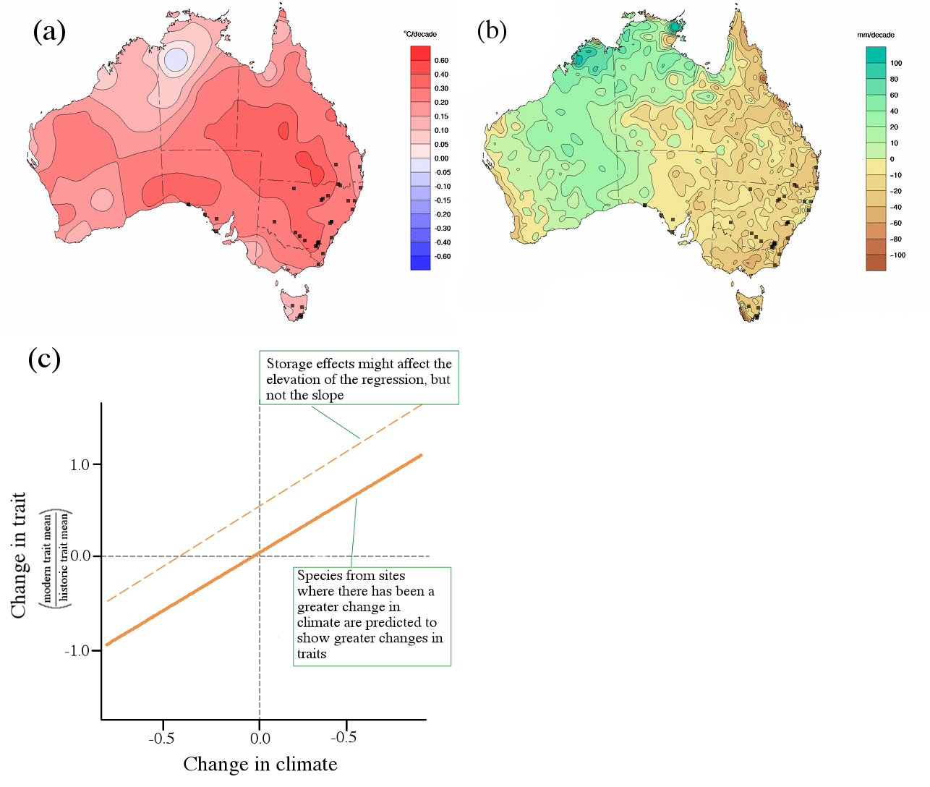

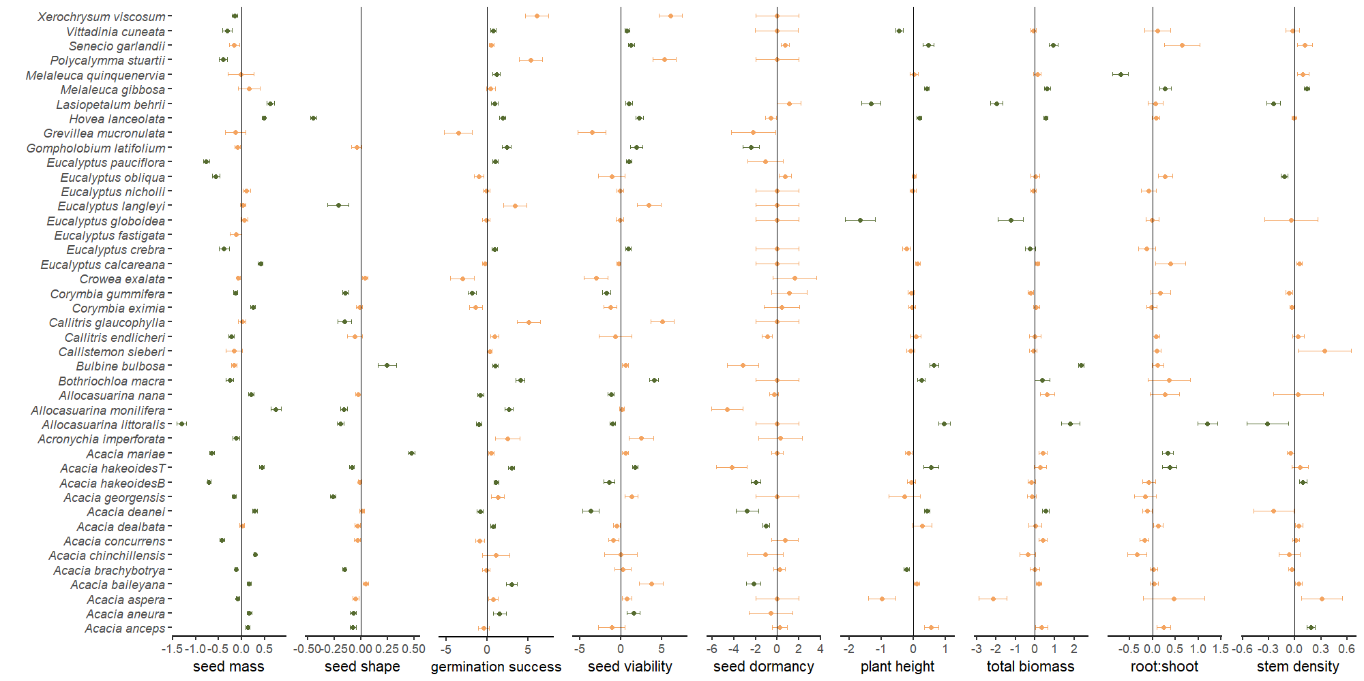Figure 2

Figure 3

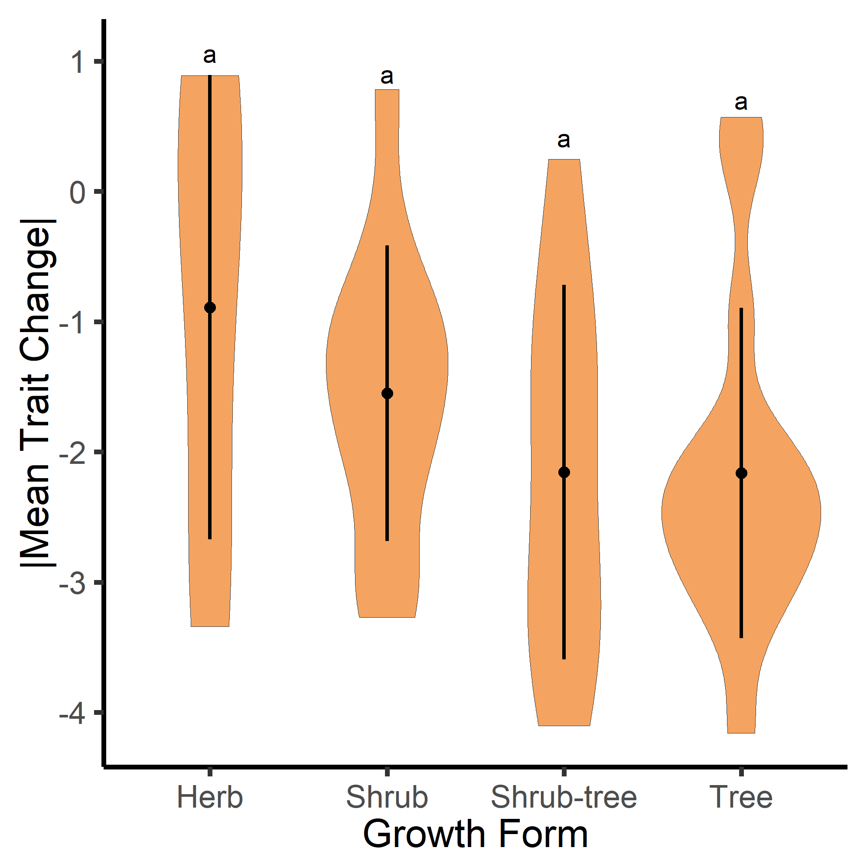

Figure 4

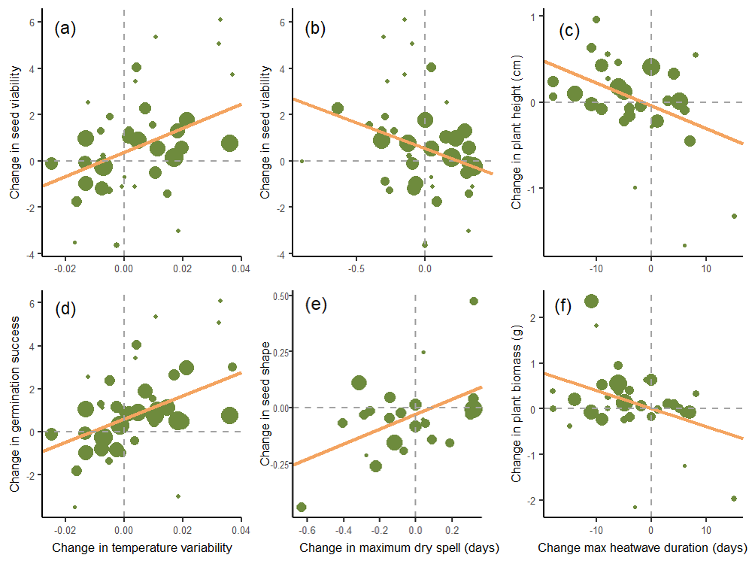

**Supporting Information**

*Appendix 1: selected species used in study and their longevities*

*Appendix 2: pairwise directional relationships hypothesised for all seed and seedling trait changes against all climate change variables.*

*Appendix 3: additional methods information*

*Appendix 4: additional results information*

*Appendix 5:* *additional information of methods and results of the relationship between change in carbon dioxide and change in traits*

*Appendix 6:* *supporting information of phylogenetic analysis of trait change across species used in study*