**A conceptual model of vegetation dynamics for the unique obligate-seeder eucalypt woodlands of south-western Australia**

*Austral Ecology*

Carl R. Gosper, Colin J. Yates, Garry D. Cook, Judith M. Harvey, Adam C. Liedloff, W. L. McCaw, Kevin R. Thiele, and Suzanne M. Prober

**SUPPORTING INFORMATION**

**Appendix S1.** Eucalypt species that form south-western Australian obligate-seeder and resprouter temperate woodlands

Note that these taxa may also occur in other vegetation structural formations. Order and higher-level classification follows Nicolle (2015), with current species and subspecies classification from WAH (2016). Taxa that form temperate woodlands were delineated on the basis of occurrence in the vegetation associations listed in Fig. 1a (authors’ personal observations) and having a tree (or tree and mallee) growth form. Obligate-seeder woodland eucalypts lack the capacity to resprout after crown-destroying disturbances, lacking both a lignotuber and well-protected epicormic buds on stems and branches. A few species that are marginally able to resprout from epicormic buds on stems after fire† (but lack lignotubers; e.g. *E. salmonophloia*, Nicolle 2006) are included in our definition of obligate-seeder woodlands, as their vegetation dynamics are primarily driven by stand replacement, with post-fire stands dominated numerically and functionally by recruiting individuals rather than resprouting ones (Yates *et al.* 1994a,b). Some other species we include as obligate-seeder eucalypts have limited ability to resprout from stems (above the tree base) after canopy loss due to wind-throw that does not uproot individuals, or coppice after logging (Kealley 1991). The resprouting response of *E. brockwayi* (Dundas mahogany) and *E. kumarlensis* are not known, but as they are non-lignotuberous (Nicolle 2006) we speculate that their vegetation dynamics will be represented by the obligate-seeder woodlands model (Fig. 2).There is discrepancy over the lignotuber state of *E. kondininensis* (Kondinin blackbutt) (Nicolle 2006; French 2012), so we do not classify this species. Obligate-seeder eucalypts that typically form scrubs and thickets (<~10 m in height, intersecting crowns), which are a prominent feature of the southern wheatbelt and southern coast of Western Australia (moorts and maaloks e.g. *E. alipes, E. platypus, E. forrestiana*; Yates *et al.* 2017), are excluded as they typically do not form woodlands. However, we hypothesise that they are likely to have similar post-fire vegetation dynamics to the obligate-seeder woodlands discussed here.

|  |  |
| --- | --- |
| Obligate-seeder woodlands | Resprouter woodlands |
| **Subg. *Corymbia*, sect. *Calophyllae*** | |
|  | *Corymbia calophylla* (marri) |
| **Subg*. Symphyomyrtus*, sect. *Bolites*** | |
|  | *E. gomphocephala* (tuart) |
| **Subg*. Symphyomyrtus*, sect. *‘Glandulosae’*** | |
| *E. salubris* (gimlet) | *E. accedens* (powderbark wandoo) |
| *E. ravida* (silver-topped gimlet) | *E. loxophleba* subsp. *loxophleba* (York gum) |
| *E. jimberlanica* (Norseman gimlet) | *E. l.* subsp. *supralaevis* (blackbutt York gum) |
| *E. campaspe* (silver gimlet) | *E. l.* subsp. *lissophloia* (smooth-barked York gum) |
| *E. tortilis* | *E. occidentalis* (swamp yate) |
| *E. terebra* (Balladonia gum) | *E. wandoo* subsp. *wandoo* (wandoo) |
| *E. diptera* (two-winged gimlet) | *E. w.* subsp. *pulverea* |
| *E. creta* (large-fruited gimlet) | *E. capillosa* (wheatbelt wandoo) |
| *E. stricklandii* (Strickland’s gum) | *E. subangusta* subsp. *pusilla* (ember mallee) |
| *E. spathulata* subsp. *spathulata* (swamp mallet) | *E. flavida* (yellow-flowered mallee) |
| *E. s.* subsp. *salina* (salt river mallet) |  |
| *E. steedmanii* (Steedman’s mallet) |  |
| *E. sargentii* subsp. *sargentii* (salt river gum) |  |
| *E. astringens* subsp. *astringens* (brown mallet) |  |
| *E. a.* subsp. *redacta* (brown mallet) |  |
| *E. protensa* |  |
| *E. extensa* (yellow mallet) |  |
| *E. arachnaea* subsp*. arrecta* (black-stemmed mallet) |  |
| *E. melanophitra* |  |
| *E. clivicola* (green mallet) |  |
| *E. gardneri* subsp. *gardneri* (blue mallet) |  |
| *E. g.* subsp. *ravensthorpensis* (Ravensthorpe blue mallet) |  |
| *E. densa* subsp. *densa* (narrow-leaved blue mallet) |  |
| *E. dundasii* (Dundas blackbutt) |  |
| **Subg*. Symphyomyrtus*, sect. *Bisectae*** | |
| *E. salmonophloia* (salmon gum)† | *E. delicata* |
| *E. recta* (Wongan hills silver mallet) | *E. longicornis* (red morrel) |
| *E. rugulata* (Ironcaps silver mallet) | *E. oleosa subsp. ampliata* (coastal red mallee) |
| *E. ornata* (silver mallet) | *E. o.* subsp. *corvina* (Ravensthorpe stocking mallee) |
| *E. falcata* (silver mallet) | *E. o. subsp. oleosa* (red mallee) |
| *E. purpurata* (purple-crowned silver mallet) | *E. flocktoniae* subsp. *flocktoniae* (Flockton’s mallee) |
| *E. urna* (merrit) | *E. f.* subsp. *hebes* |
| *E. optima* (Balladonia redwood) | *E. moderata* (redwood mallee) |
| *E. transcontinentalis* (redwood) | *E. hypolaena* (desert redwood) |
| *E. rhomboidea* (diamond gum) | *E. yilgarnensis* (yorrell) |
| *E. salicola* (salt gum)† | *E. gracilis* (yorrell) |
| *E. prolixa* (square-fruited mallet) | *E. celastroides* subsp. *celastroides* (snap and rattle) |
|  | *E. c.* subsp. *virella* |
| **Subg*. Symphyomyrtus*, sect. *Dumaria*** | |
| *E. singularis* (ridge-top mallet) | *E. laevis* |
| *E. torquata* (coral gum) | *E. melanoxylon* (black morrel) |
| *E. polita* (Parker Range mallet) | *E. brachycalyx* (gilja) |
| *E. tenuis* | *E. concinna* (Great Victoria Desert mallee) |
| *E. distuberosa* subsp. *distuberosa* (capped mallet) | *E. griffithsii* (Griffith’s grey gum) |
| *E. d.* subsp. *aerata* | *E. corrugata* (rib-fruited mallee) |
| *E. spreta* | *E. ovularis* |
| *E. valens* (Esperance mallet) | *E. aequioperta* (Welcome Hill gum) |
| *E. fraseri* subsp. *fraseri* (Balladonia gum) | *E. myriadena* subsp. *myriadena* (small-fruited gum) |
| *E. f.* subsp. *melanobasis* (Fraser Range blackbutt) | *E. m.* subsp. *parviflora* |
| *E. pterocarpa* | *E. wubinensis* (Wubin mallee) |
| *E. frenchiana* (French’s mallet) |  |
| *E. lesouefii* (Goldfield’s blackbutt) |  |
| *E. clelandii* (Cleland’s blackbutt) |  |
| *E. vittata* (ribbon-barked mallet) |  |
| *E. assimilans* (Balladonia ribbon gum) |  |
| *E. georgei* subsp. *georgei* (Hyden blue gum) |  |
| *E. g.* subsp. *fulgida* |  |
| *E. woodwardii* (lemon-flowered gum) |  |
| **Subg*. Symphyomyrtus*, sect*. Exsertaria*** | |
|  | *E. rudis* subsp. *rudis* (flooded gum) |
|  | *E. camaldulensis* subsp. *arida* (river red gum) |
| **Subg*. Eucalyptus*,sect*. Eucalyptus*** | |
|  | *E. marginata* subsp. *marginata* (jarrah) |
|  | *E. m.* subsp. *thalassica* (blue-leaved jarrah) |

**REFERENCES**

French M. (2012) *Eucalypts of Western Australia’s Wheatbelt*. Malcolm French, Padbury WA.

Kealley I. (1991) Management of inland arid and semi-arid woodland forest of Western Australia. In: *Forest Management in Australia* (Eds F. H. McKinnell, E. R. Hopkins & J. E. D. Fox) pp. 286-295. Surrey Beatty & Sons, Chipping Norton, N.S.W.

Nicolle D. (2006) A classification and census of regenerative strategies in the eucalypts (*Angophora*, *Corymbia* and *Eucalyptus* - Myrtaceae), with special reference to the obligate seeders. *Aust. J. Bot.* **54**, 391-407.

Nicolle D. (2015) Classification of the eucalypts (*Angophora*, *Corymbia* and *Eucalyptus*) Version 2. [Cited 21 July 2017.] Available at URL: <http://www.dn.com.au/Classification-Of-The-Eucalypts.pdf>

Western Australian Herbarium (WAH) (2016) FloraBase — The Western Australian Flora. Department of Biodiversity, Conservation and Attractions. [Cited 16 January 2017.] Available at URL: <http://florabase.dpaw.wa.gov.au/>

Yates C. J., Gosper C. R., Hopper S. D. *et al.* (2017) Mallee woodlands and shrublands: the mallee, muruk/muert and maalok vegetation of southern Australia. In: *Australian Vegetation* *3rd edition* (ed D. A. Keith) pp. 570-598. Cambridge University Press, Cambridge.

Yates C. J., Hobbs R. J. & Bell R. W. (1994a) Factors limiting the recruitment of *Eucalyptus salmonophloia* F. Muell. in remnant woodlands. I. Pattern of flowering, seed production and seed fall. *Aust. J. Bot.* **42**:531–542.

Yates C. J., Hobbs R. J. & Bell R. W. (1994b) Landscape-scale disturbances and regeneration in semi-arid woodlands of southwestern Australia. *Pacific Cons. Biol.* **1**, 214–221.

**Appendix S2. Methods for sampling and analyses using new data**

**1)** *Survival of* Eucalyptus salubris *after a mild surface experimental fire in State 2 woodland* (**Table 2** in main paper)

An experimental fire was conducted in May in a *State* 2 *E. salubris* woodland in the GWW (32°06´32.4"S, 119°38´51.5"E). The mild surface fire (Fig. S1a) had an intensity estimated at predominately <100 kW m-1, with peak intensity <200 kW m-1. Survival of *E. salubris* one year after fire (Fig. S1b) was measured in two 10x10 m plots.

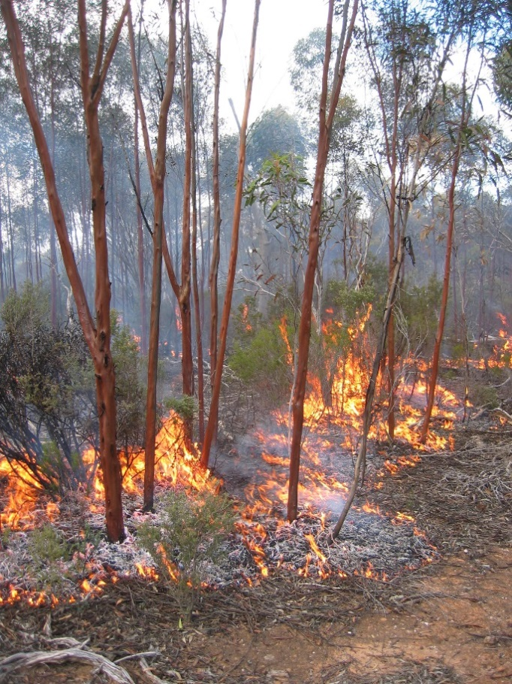 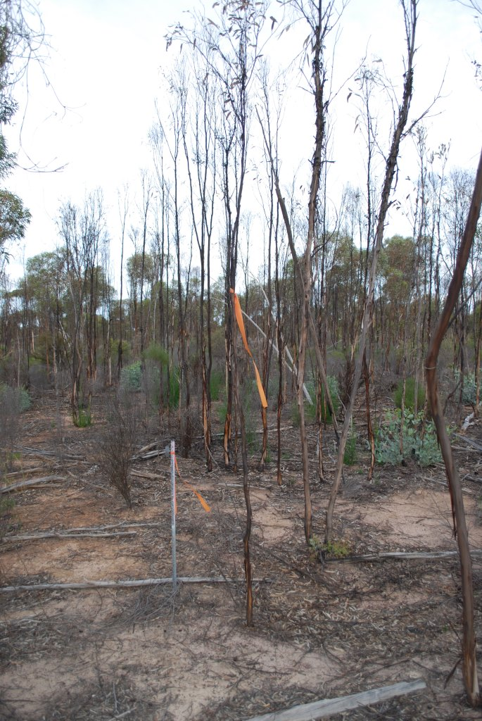

(b)

(a)

**Figure S1.** Photo of (a) *State* 2 *Eucalyptus salubris* woodland during the mild surface experimental fire (Table 2); (b) plot one year after experimental fire, showing widespread mortality of pre-fire individuals**.** Unburnt woodland is in the background, and in the middle right of the photo an individual of a co-occurring mallee eucalypt can be seen resprouting from a lignotuber.

**2)** *Hierarchical partitioning analysis of predictors of eucalypt recruits in* Eucalyptus salubris *woodlands that have not been burnt recently* (**Table 3**)

At 100 sites systematically placed along transects through the COO02 IBRA subregion in woodlands not burnt since ~1969 (Fig. S2), the presence or absence of visually obvious eucalypt recruits was recorded, along with other predictor variables as listed in Table 3. Mean *E. salubris* diameter and tree density were derived from a minimum of 20 *E. salubris* individuals and 24 eucalypts respectively sampled via 6 point-centred quarters (Cottam & Curtis 1956) spaced at 100 m intervals in a grid (total area ~4 ha). Time since fire was derived from a model relating *E. salubris* growth rings and plant size (based on Gosper *et al.* 2013a). Understorey type and disturbance from mineral exploration, off-road vehicles, prior timber harvesting and other anthropogenic detritus were assessed visually on site visits. Climatic data from Hijmans *et al.* (2005), using current conditions (1950-2000); 30 arc-seconds ESRI grids.

The effect of predictors on the presence of eucalypt recruits was tested in Hierarchical Partitioning using binomial hier.part (Chevan & Sutherland 1991; Walsh & Mac Nally 2013) in R v. 3.2.4 (<https://www.r-project.org/>), using r2 as the goodness of fit measure.



**Figure S2.** Location of sample plots (**+**) for assessing *Eucalyptus salubris* recruitment in the COO02 IBRA subregion of the GWW (see Table 3).

**3)** *Relationship between time since fire and the proportion of* Eucalyptus salubris *individuals in a population carrying closed fruit* (**Fig. 5.**)

The 24 sites of Gosper *et al.* (2014) were sampled, located between Lake Cronin (32°23’S, 119°46’E) and Parker Range in the GWW. The presence or absence of fruit was scored on 20 *E. salubris* individuals to calculate the proportion of individuals with fruit per site, using the method of Gosper *et al.* (2013d) but with 30 m intervals between sample points on a 300 m transect. A variety of model forms (linear, quadratic, exponential, power and logistic) were tested in regressions (as per Gosper *et al.* 2013d, using Sigmaplot 10.0; Systat Software Inc, Chicago, USA) using times since fire estimated by Model 2 of Gosper *et al.* (2013a) for sites with no record of fire (time since fire range 10-~260 years). The most parsimonious model was selected based on minimising the small sample size adjustment of Akaike’s Information Criterion (AICc) (Table S1).

**Table S1.** Alternative model forms for the relationship between the proportion of *Eucalyptus salubris* individuals with fruit and time since fire (Fig. 5).Best-fitting model is shown in bold.

|  |  |  |  |  |  |  |  |  |
| --- | --- | --- | --- | --- | --- | --- | --- | --- |
| **Function form** | | **Model** | **Adj. r2** | **df** | **F** | **P** | **AICc** | **∆AICc** |
| **Logistic** | **y = 0.998/[1 + (x/33.4)-3.41]** | | **0.93** | **2,21** | **159** | **<0.0001** | -**23.7** | **0** |
| Quadratic | y = -0.077 + 0.02x - 0.0001x2 | | 0.82 | 2,21 | 53.6 | <0.0001 | 0.11 | 23.1 |
| Power | y = 0.072x0.511 | | 0.69 | 1,22 | 51.3 | <0.0001 | 10.5 | 34.2 |
| Linear | y = 0.248 + 0.0041x | | 0.54 | 1,22 | 28.3 | <0.0001 | 19.9 | 43.6 |
| Exponential | y = 0.359e0.005x | | 0.43 | 1,22 | 18.1 | 0.0003 | 25.1 | 48.8 |

**4)** *Relationship between tree height and site productivity* (**Fig. 6.**)

*Eucalyptus salmonophloia* heights were measured at the 100 sites of Harvey (2014) distributed across the Western Australian wheatbelt and GWW. Per site, the heights of the ten trees closest to the centre of 20x20 m quadrats were measured using a Tangent Height Gauge (Kager Inc., Lunenburg Massachusetts, USA), with the tallest individual per site selected.

**References**

Chevan A. & Sutherland M. (1991) Hierarchical partitioning. *Am. Stat.* **45**, 90–96.

Cottam G. & Curtis J. T. (1956) The use of distance measures in phytosociological sampling. *Ecology* **37**, 451–460.

Gosper C. R., Prober S. M., Yates C. J. & Wiehl G. (2013a) Estimating the time since fire of long-unburnt *Eucalyptus salubris* (Myrtaceae) stands in the Great Western Woodlands. *Aust. J. Bot.* **61**, 11-21.

Gosper C. R., Prober S. M. & Yates C. J. (2013d) Estimating fire interval bounds using vital attributes: implications of uncertainty and among-population variability. *Ecol. Appl*. **23**, 924-935.

Gosper C. R., Yates C. J., Prober S. M. & Wiehl G. (2014) Application and validation of visual fuel hazard assessments in dry Mediterranean-climate woodlands. *Int. J. Wildland Fire* **23**, 385-393.

Harvey J. M. (2014) Regional variability in Salmon Gum (*Eucalyptus salmonophloia*) woodlands of south-western Australia, with particular focus on the Great Western Woodlands. MPhil Thesis, Curtin University, Perth.

Hijmans R. J., Cameron S. E., Parra J. L., Jones P. G. & Jarvis A. (2005) Very high resolution interpolated climate surfaces for global land areas. *Int. J. Clim.* **25**, 1965-1978.

Walsh C. & Mac Nally R. (2013) *Package hier.part: hierarchical partitioning, version 1.0-4*. [Cited 6 May 2017.] Available from URL: <http://cran.r-project.org/>