**Supplementary Material**

**Table S1: List of species, their functional types, Δ13C and calculated intrinsic WUEi (plant functional type codes: BlT= broad leaf tree, NIT= needle leaf tree and S=shrub).**

| Species | Site | PFT | Δ13C (‰) | Calculated WUEi |
| --- | --- | --- | --- | --- |
| *Acacia aneura* | AMU | NlT | 19.71±0.21 | 78.67 |
| *Acacia melanoxylon* | WR | BlT | 22.46±0.46 | 49.00 |
| *Acmena graveolens* | CT | BIT | 21.96±0.31 | 54.37 |
| *Alphitonia whitei* | RC | BlT | 24.81±0.58 | 23.63 |
| *Alstonia muelleriana* | RC | BlT | 23.42±0.4 | 38.58 |
| *Alstonia scholaris* | CT | BlT | 22.76±0.36 | 45.75 |
| *Anopterus glandulosus* | WR | S | 25.58±0.44 | 15.34 |
| *Argyrodendron peralatum* | CT | BIT | 24.89±0.26 | 22.75 |
| *Atherosperma moschatum* | WR | BlT | 22.57±0.85 | 47.80 |
| *Cardwellia sublimis* | CT | BlT | 22.46±0.58 | 48.92 |
| *Castanospermum australe* | CT | BlT | 22.04±0.4 | 53.48 |
| *Ceratopetalum succirubrum* | RC | BlT | 26.52±0.13 | 5.21 |
| *Corymbia terminalis* | AMU | BlT | 19.89±0.29 | 76.65 |
| *Cryptocarya mackinnoniana* | CT | BlT | 24.59±0.12 | 26.02 |
| *Daphnandra repandula* | RC | BlT | 23.69±0.57 | 35.69 |
| *Doryphora aromatica* | RC | BlT | 25.41±0.88 | 17.19 |
| *Dysoxylum papuanum* | CT | BlT | 20.83±0.44 | 66.59 |
| *Elaeocarpus grandis* | CT | BlT | 22.34±0.1 | 50.30 |
| *Endiandra leptodendron* | CT | BlT | 26.86±0.6 | 1.51 |
| *Eucalyptus amplifolia* | CP | BlT | 21.02±0.31 | 64.53 |
| *Eucalyptus camaldulensis* | AMU | BlT | 20.28±0.35 | 72.43 |
| *Eucalyptus clelandii* | GWW | BlT | 17.68±0.17 | 100.56 |
| *Eucalyptus dumosa* | CM | BlT | 19.01±0.42 | 86.15 |
| *Eucalyptus fibrosa* | CP | BlT | 23.24±0.32 | 40.57 |
| *Eucalyptus miniata* | LF | BlT | 21.86±0.07 | 55.39 |
| *Eucalyptus moluccana* | CP | BlT | 21.48±0.24 | 59.50 |
| *Eucalyptus obliqua* | WR | BlT | 22.01±0.73 | 53.79 |
| *Eucalyptus salmonophloia* | GWW | BlT | 18.88±0.09 | 87.56 |
| *Eucalyptus salubris* | GWW | BlT | 18.02±0.19 | 96.82 |
| *Eucalyptus socialis* | CM | BlT | 19.94±0.18 | 76.17 |
| *Eucalyptus tereticornis* | CP | BlT | 21.27±0.26 | 61.85 |
| *Eucalyptus tetrodonta* | LF | BlT | 19.82±0.34 | 77.39 |
| *Eucalyptus transcontinentalis* | GWW | BlT | 19.75±0.31 | 78.24 |
| *Eucryphia lucida* | WR | BlT | 22.07±0.06 | 53.16 |
| *Ficus leptoclada* | RC | BlT | 21.53±0.49 | 59.01 |
| *Ficus variegata* | CT | BlT | 21.85±0.29 | 55.60 |
| *Flindersia bourjotiana* | RC | BlT | 23.8±0.43 | 34.54 |
| *Gillbeea adenopetala* | RC | BlT | 24.41±0.26 | 27.94 |
| *Gillbeea whypallana* | CT | BlT | 23.22±0.42 | 40.79 |
| *Leptospermum lanigerum* | WR | BlT | 21.61±0.39 | 58.15 |
| *Litsea leefeana* | RC | BlT | 23.9±0.48 | 33.38 |
| *Melaleuca squarrosa* | WR | BlT | 21.94±0.25 | 54.60 |
| *Myristica globosa* | CT | BlT | 24.04±0.53 | 31.91 |
| *Notelaea ligustrina* | WR | BlT | 21.2±0.51 | 62.52 |
| *Nothofagus cunninghamii* | WR | BlT | 21.06±0.59 | 64.02 |
| *Phyllocladus aspleniifolius* | WR | S | 18.48±0.68 | 91.93 |
| *Pittosporum bicolor* | WR | BlT | 19.99±0.67 | 75.63 |
| *Polyscias elegans* | RC | BlT | 22.96±0.6 | 43.60 |
| *Pomaderris apetala* | WR | S | 23.55±0.44 | 37.21 |
| *Prunus turneriana* | RC | BlT | 25.83±0.74 | 12.59 |
| *Rockinghamia angustifolia* | CT | BlT | 22.69±0.35 | 46.49 |
| *Synima cordierorum* | CT | BIT | 22.8±0.39 | 45.33 |
| *Syzygium johnsonii* | RC | BlT | 25.7±0.07 | 13.99 |
| *Syzygium sayeri* | CT | BlT | 23.01±0.46 | 43.04 |
| *Tasmannia lanceolata* | WR | S | 21.8±0.26 | 56.03 |
| *Xanthophyllum octandrum* | CT | BlT | 22.64±0.6 | 47.08 |

**Table S2: List of climate variables used in climate analysis**

| WorldClim Code | Variables |
| --- | --- |
|
|  |
| BIO1 | Mean Annual Temperature |
| BIO2 | Mean Diurnal Range |
| BIO3 | Isothermality |
| BIO4 | Temperature Seasonality |
| BIO5 | Max Temperature of Warmest Month |
| BIO6 | Min Temperature of Coldest Month |
| BIO7 | Temperature Annual Range |
| BIO8 | Mean Temperature of Wettest Quarter |
| BIO9 | Mean Temperature of Driest Quarter |
| BIO10 | Mean Temperature of Warmest Quarter |
| BIO11 | Mean Temperature of Coldest Quarter |
| BIO12 | Mean Annual Precipitation |
| BIO13 | Precipitation of Wettest Month |
| BIO14 | Precipitation of Driest Month |
| BIO15 | Precipitation Seasonality |
| BIO16 | Precipitation of Wettest Quarter |
| BIO17 | Precipitation of Driest Quarter |
| BIO18 | Precipitation of Warmest Quarter |
| BIO19 | Precipitation of Coldest Quarter |

**Table S3: Relationships of leaf traits with Mean Annual Precipitation and Moisture Index**

| Traits | Correlated with ln MAP | | | | | | Correlated with MI | | | | | |
| --- | --- | --- | --- | --- | --- | --- | --- | --- | --- | --- | --- | --- |
|  | **Dry-season** | | | **Wet-season** | | | **Dry-season** | | | **Wet-season** | | |
| ***Adj r2*** | ***slope*** | ***p*** | ***Adj r2*** | ***slope*** | ***p*** | ***Adj r2*** | ***slope*** | ***p*** | ***Adj r2*** | ***slope*** | ***p*** |
| A400 | **0.224** | + | <0.0001 | NS |  | > 0.05 | **0.071** | + | < 0.05 | NS |  | > 0.05 |
| Ln E400 | **0.140** | + | <0.001 | **0.142** | + | < 0.01 | 0.04 | + | > 0.05 | NS |  | > 0.05 |
| Ln vpdL400 | **0.281** | - | <0.0001 | NS |  | > 0.05 | **0.119** | - | <0.0001 | NS |  | > 0.05 |
| sqrt gs400 | **0.414** | + | <0.0001 | **0.119** | + | < 0.01 | **0.142** | + | <0.01 | NS |  | > 0.05 |
| Ln WUEi | **0.481** | - | <0.0001 | **0.420** | - | <0.0001 | **0.206** | - | <0.0001 | **0.357** | - | <0.0001 |
| Ci/Ca | **0.332** | + | <0.0001 | **0.337** | + | <0.0001 | **0.192** | + | <0.0001 | **0.380** | + | <0.0001 |
| Ci400 | **0.352** | + | <0.0001 | **0.439** | + | <0.0001 | **0.199** | + | <0.0001 | **0.443** | + | <0.0001 |
| LDMC | **0.349** | - | <0.0001 | **0.331** | - | <0.0001 | **0.277** | - | <0.0001 | **0.366** | - | <0.0001 |
| Ln LMA | **0.569** | - | <0.0001 | **0.534** | - | <0.0001 | **0.412** | - | <0.0001 | **0.504** | - | <0.0001 |
| Ln FMA | **0.532** | - | <0.0001 | **0.516** | - | <0.0001 | **0.369** | - | <0.0001 | **0.452** | - | <0.0001 |
| Ln Leaf Nmass | **0.192** | + | <0.001 | **0.264** | + | <0.001 | NS |  | > 0.05 | **0.302** | + | <0.0001 |
| Ln Leaf Pmass | **0.259** | + | <0.0001 | NS |  | > 0.05 | NS |  | > 0.05 | NS |  | > 0.05 |
| Ln Ratio N/P | **0.102** | - | <0.01 | **0.167** | + | < 0.01 | NS |  | > 0.05 | **0.09** | + | < 0.05 |
| Ln Leaf Narea | **0.178** | - | <0.0001 | **0.269** | - | <0.001 | **0.363** | - | <0.0001 | **0.204** | - | <0.01 |
| Ln Leaf Parea | N/S |  | > 0.05 | **0.399** | - | <0.0001 | **0.228** | - | <0.001 | **0.286** | - | <0.0001 |
| A400.N | **0.403** | + | <0.0001 | **0.162** | + | <0.01 | **0.396** | + | <0.0001 | NS |  | > 0.05 |
| Ln A400.P | **0.106** | + | < 0.01 | **0.272** | + | <0.001 | **0.334** | + | <0.001 | **0.119** | + | <0.01 |

NS = Non-significant

**Table S4: Variation in Δ13C and WUEi by biome.**

Mean and s.e of wet and dry seasonΔ13C and WUEi. Means followed by different letters across sites in each season are significantly different (Tukey HSD, confidence level of 0.05).

|  |  |  |  |  |
| --- | --- | --- | --- | --- |
| **Site** | **∆13C (‰)** | | **WUEi (‰)** | |
| **Dry-season** | **Wet-season** | **Dry-season** | **Wet-season** |
| SW | 19.75±0.49c | 19.15±0.32a | 78.14±5.26a | 84.60±4.30a |
| STS | 19.82±0.25c | 20.15±0.40a | 77.35±2.74a | 73.85±3.45a |
| TW | 20.16±0.25c | 20.18±0.28a | 73.84±4.10a | 73.57±3.03a |
| HTS | 20.77±0.38b,c | - | 67.21±2.84a,b | - |
| TWF | 21.54±0.55b,c | 23.51±0.56b | 68.80±5.91a,b | 37.68±6.12a,b |
| LTR | 22.98±0.46a,b | 23.02±0.39b | 43.25±4.93a,b | 42.86±4.17a,b |
| UTR | 24.05±0.76a | 24.31±0.52b | 31.74±8.16a | 29.04±5.62b |

**Brief site descriptions of the seven Supersites (8 nodes)**

#### **Calperum Mallee**

The Calperum Mallee SuperSite is in the mallee semi-arid ecosystem located approximately 25 km north of Renmark in South Australia. The landscape is an extensive plain with undulating mallee woodland and riverine vegetation that fringes the River Murray and its anabranches. The vegetation is dominated by upper storey Eucalypt trees of four species (*Eucalyptus dumosa, Eucalyptus incrassata, Eucalyptus oleosa* and *Eucalyptus socialis*) (Meyer *et al.*, 2015).

#### **Great Western Woodlands**

The Great Western Woodlands located in south-west Western Australia is the largest remaining intact semi-arid temperate woodland in the world. The vegetation comprises a 16-million hectare mosaic of mallee, scrub–heath and woodland and is locally determined by edaphic factors and influenced by historic disturbances (Gosper *et al.*, 2013). Mean annual rainfall is ~250 mm with the highest-mean rainfall months in winter. *Eucalyptus salubris* constructs the dominant crown layer in association with other *Eucalyptus* species (*E. salmonophloia, E. longicornis and E. moderata)* (Gosper *et al.*, 2013).

#### **Alice Mulga**

The semi-arid Alice Mulga SuperSite is located approximately 200 km north of Alice Springs, in the Northern Territory of Australia. The climate is characterized as having hot summers and warm winters. Mean annual rainfall is ~300 mm and is highly seasonal, mostly occurring in large rainfall events during summer. Vegetation is dominated by Mulga (*Acacia aneura* and related species) woodlands, occasionally with large areas of spinifex under sparse woodland of *Corymbia* and other *Acacia* species (Cleverly et al., 2016).

#### **Cumberland Plain**

The Cumberland Plain is a sclerophyll *Eucalyptus* woodland west of Richmond in New South Wales. The soil is characterized by nutrient-poor alluvium from sandstone and shale bedrock in the Blue Mountains deposited by the Nepean River. Despite being nutrient poor, this SuperSite supports high regional biodiversity and endemic biota and is dominated by *Eucalyptus fibrosa*, *E. moluccana* and *E. tereticornis* in the overstorey. Mean annual precipitation of this site is 900 mm (Table 1).

#### **Warra Tall Eucalypt**

The Warra Tall Eucalypt SuperSite is a cool, wet temperate forest located in Tasmania. Vegetation is dominated by tall *Eucalyptus obliqua* occurring in a full range of successional stages from young regrowth forests to old-growth mixed forests (Hickey *et al.*, 1999). Mean annual temperature at this site is the lowest (~10°C), with a mean annual precipitation of 1474 mm (Table 1).

#### **Litchfield Savanna**

The Litchfield Savanna SuperSite is a ~1.5 km2 tropical savanna 70 km south of Darwin in northern Australia. This site is representative of the dominant ecosystem of that region. Climate of this site is typical of northern Australia with extremely seasonal and high rainfall and approximately 56% of this site is burnt annually (Murphy *et al.*, 2010). However, in this study, data collected from Howard Springs (approximately 65 km north of Litchfield SuperSite; (Cernusak *et al.*, 2011) have been used as a representative of this particular SuperSite. This approach is justified because both of these sites had very similar vegetation and climate conditions as well as frequency of occurrence of fire. The stand structure in these two sites are sufficiently similar as to not shift physiological properties at the leaf-scale given the species occurred in both sites largely overlap (Bowman *et al.*, 2001; Hutley and Beringer, 2010; Murphy *et al.*, 2010).

#### **FNQ Rainforest**

The FNQ Rainforest SuperSite is located in a tropical wet forest ~140 km north of Cairns in Far North Queensland. This SuperSite is structurally divided into two transects – a) the lowland rainforest based in the Daintree rainforest near Cape Tribulation (MAT = 25.2 °C, Ozflux site average MAP = 5700 mm) and b) the upland rainforest based around Robson Creek (MAT = 21 °C, MAP = 2140 mm). Precipitation is highly seasonal with most occurring during summer (Weerasinghe *et al.*, 2014). FNQ supports 10% of Australian flora despite of occurring in only 0.2% its landmass. Consequently a substantial number of the species in this study comes from this SuperSite. Data from two nodes of this SuperSite, i.e., Cape Tribulation and Robson Creek were collected and analysed independently in this study because of significantly different environmental clines (altitude, MAT and MAP) that exists in these two nodes of FNQ.



**Figure S1: Location of SuperSites (represented by black dots).**

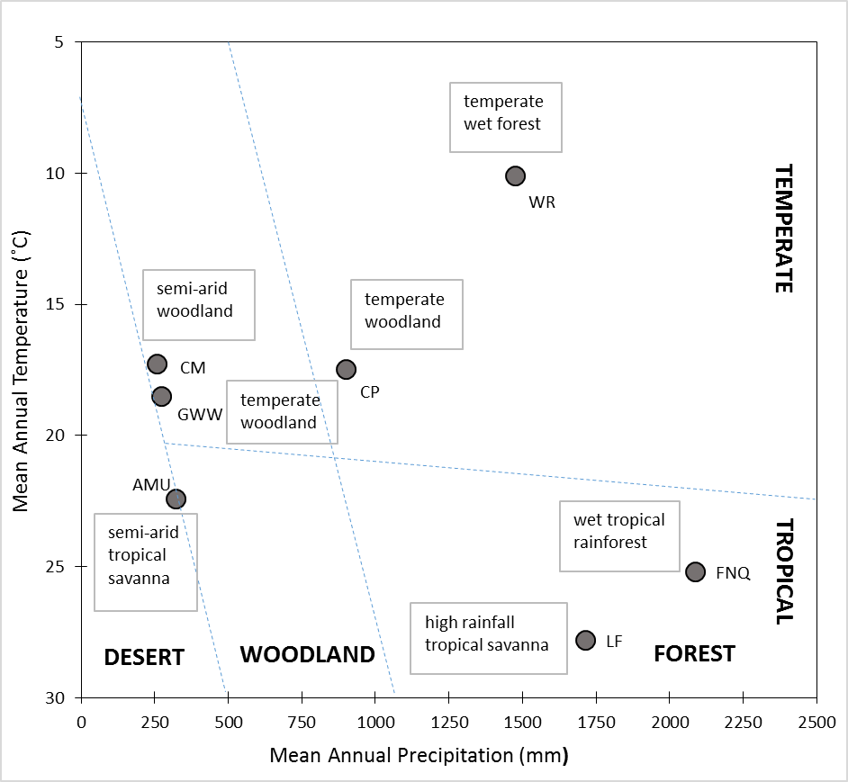

**Figure S2: Mean annual temperature, mean annual precipitation, and biomes of the study sites.**

Each SuperSite is plotted in the Whittaker Biome Diagram (Whittaker, 1975) using the MAT and MAP observations generated for each site from the WorldClim data.

|  |  |
| --- | --- |
| **(a)** | **(b)** |

**Figure S3: Site mean values of (a) Δ13C and (b) WUEi**

Dark and light bars represent mean of dry and wet-season respectively and the error bars represent standard errors.

|  |  |
| --- | --- |
| Adj r2 = 0.33, p < 0.0001  Ci/Ca = 0.1150 + 0.0712 ln MAP | Adj r2 = 0.34, p < 0.0001  Ci/Ca = 0.3160 + 0.0449 ln MAP |

**Figure S4: Ratio between intercellular and ambient [CO2] (Ci/Ca) for both seasons plotted as functions of mean annual precipitation (MAP).**

Left and right panels are plotted from dry- and wet-season data respectively. Statistically significant correlations with MAP are plotted with red regression lines.