# A quick look at BAAD

The Biomass And Allometry Database for woody plants (BAAD) contains 259634 measurements collected in 176 different studies, from 21084 individuals across 678 species.

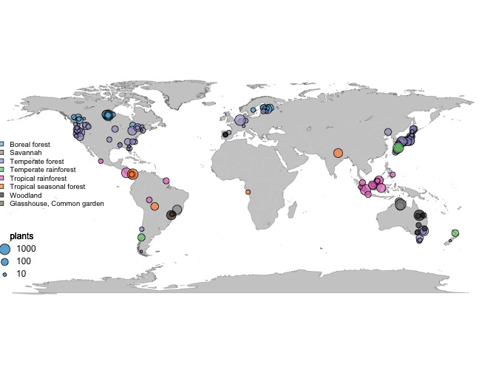

**Figure 1** Global distribution of studies included in the BAAD. Symbols are sized relative to the number of individual plants in each dataset.

## Variables

**Number of observations by variable**

|  |  |  |  |  |  |  |  |
| --- | --- | --- | --- | --- | --- | --- | --- |
| Variable | Label | Units | N | Studies | Min | Median | Max |
| latitude | latitude | deg | 21021 | 175 | -52 | 10 | 62 |
| longitude | longitude | deg | 21021 | 175 | -126 | -66 | 175 |
| age | age | yr | 7074 | 73 | 0.17 | 13 | 1847 |
| a.lf | leaf area | m2 | 13846 | 108 | 0.000018 | 0.047 | 6018 |
| a.ssba | sapwood area at base | m2 | 168 | 5 | 0.000015 | 0.0012 | 0.088 |
| a.ssbh | sapwood area at breast height | m2 | 1475 | 16 | 0.00000018 | 0.0044 | 0.67 |
| a.ssbc | sapwood area at crown base | m2 | 277 | 7 | 0.00016 | 0.011 | 0.19 |
| a.shba | heartwood area at base | m2 | 24 | 1 | 0 | 0.006 | 0.28 |
| a.shbh | heartwood area at breast height | m2 | 421 | 4 | 0 | 0.00075 | 0.2 |
| a.shbc | heartwood area at crown base | m2 | 36 | 1 | 0 | 0.00036 | 0.0068 |
| a.sbbh | bark area at breast height | m2 | 141 | 1 | 0.000059 | 0.0014 | 0.0063 |
| a.stba | stem area at base | m2 | 9704 | 56 | 0.0000000038 | 0.000026 | 1.5 |
| a.stbh | stem area at breast height | m2 | 8626 | 129 | 0.00000079 | 0.0068 | 33 |
| a.stbc | stem area at crown base | m2 | 1325 | 18 | 0.000000006 | 0.000012 | 0.13 |
| a.cp | crown area | m2 | 7414 | 55 | 0.0002 | 0.63 | 1257 |
| a.cs | crown surface area | m2 | 1187 | 9 | 0.00047 | 0.086 | 652 |
| h.t | height | m | 19586 | 169 | 0.004 | 1.2 | 113 |
| h.c | height to crown base | m | 10214 | 90 | 0 | 0.77 | 40 |
| d.ba | basal diameter | m | 9704 | 56 | 0.00007 | 0.0058 | 1.4 |
| d.bh | dbh | m | 8626 | 129 | 0.001 | 0.093 | 6.5 |
| h.bh | height of d.bh measurement | m | 10114 | 128 | 0.03 | 1.3 | 4.8 |
| d.cr | crown width | m | 7414 | 55 | 0.014 | 0.88 | 40 |
| c.d | crown depth | m | 9551 | 89 | 0 | 1.7 | 41 |
| m.lf | leaf mass | kg | 17069 | 163 | 0.0000002 | 0.0057 | 992 |
| m.ss | sapwood mass | kg | 239 | 4 | 0.021 | 31 | 2089 |
| m.sh | heartwood mass | kg | 212 | 3 | 0 | 3.4 | 1759 |
| m.sb | bark mass | kg | 1323 | 13 | 0.00008 | 5.4 | 1236 |
| m.st | total stem mass | kg | 14421 | 138 | 0.0000001 | 0.0038 | 322566 |
| m.so | aboveground mass | kg | 14972 | 143 | 0.0000008 | 0.011 | 323200 |
| m.br | branch mass | kg | 6552 | 114 | 0 | 0.86 | 9586 |
| m.rf | fine root mass | kg | 1672 | 16 | 0.000001 | 0.00019 | 20 |
| m.rc | coarse root mass | kg | 2095 | 20 | 0 | 0.0011 | 459 |
| m.rt | total root mass | kg | 9061 | 68 | 0.0000001 | 0.00065 | 505 |
| m.to | total mass | kg | 8878 | 70 | 0.000001 | 0.002 | 7410 |
| a.ilf | area of individual leaf | m2 | 5898 | 26 | 0.0000011 | 0.0025 | 0.19 |
| ma.ilf | leaf mass per area | kg/m2 | 9225 | 37 | 0.0015 | 0.045 | 0.81 |
| r.st | wood density | kg/m3 | 3529 | 12 | 61 | 410 | 1603 |
| r.ss | sapwood density | kg/m3 | 53 | 1 | 300 | 410 | 590 |
| r.sh | heartwood density | kg/m3 | 53 | 1 | 310 | 370 | 500 |
| n.lf | leaf [nitrogen] | kg/kg | 1303 | 11 | 0.0044 | 0.023 | 0.045 |
| n.ss | sapwood [nitrogen] | kg/kg | 425 | 7 | 0 | 0.0016 | 0.0082 |
| n.sb | bark [nitrogen] | kg/kg | 261 | 3 | 0.0021 | 0.0037 | 0.011 |
| n.sh | heartwood [nitrogen] | kg/kg | 143 | 2 | 0 | 0.00094 | 0.0029 |
| n.rf | fine root [nitrogen] | kg/kg | 148 | 5 | 0 | 0.0047 | 0.0083 |
| n.rc | coarse root [nitrogen] | kg/kg | 207 | 6 | 0 | 0.003 | 0.01 |

## Some plots

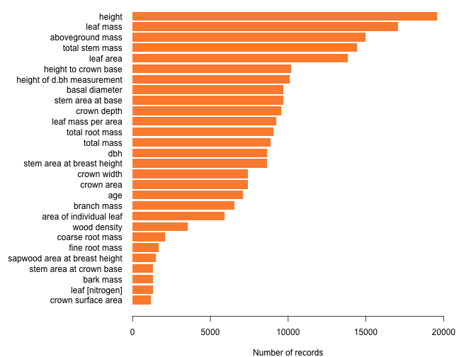

**Figure 2** Plot of most commonly recorded variables in BAAD.

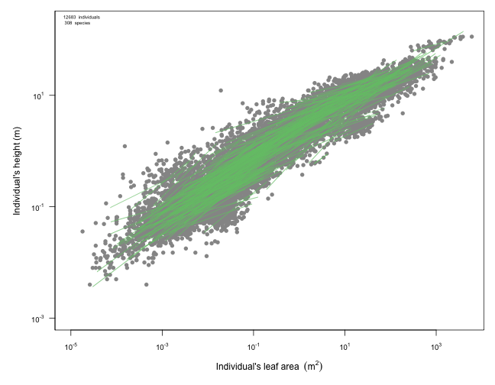

**Figure 3** Plot of leaf area vs height in BAAD.

For more info on the BAAD see the paper in Ecology or the [github repo](https://github.com/dfalster/baad).