

PROJECT REPORT
On
Emotion Detection from Text
Submitted in partial fulfilment of the Requirements for the award of the Degree of Bachelor of Technology
In
Computer science and Engineering Under the esteemed guidance of
Dr. K Swarna

By
T. N. S. Rama Charan 180030326
N. Naga Teja 180030346
J. Bhanu Chaitanya 180031078

K L EDUCATION FOUNDATION
Green Fields, Vaddeswaram, Guntur District-522 502 2020-2021
K L EDUCATION FOUNDATION DEPARTMENT OF COMPUTER SCIENCE AND ENGINEERING
(DST-FIST Sponsored Department)



CERTIFICATE

This is to certify that this project based lab report entitled “Emotion Detection from Text“ is a bonafide work done by T N S Rama Charan (180030326), N Naga Teja (180030346) and J Bhanu Chaitanya (180031078) in the course 18CS3074S Deep Learning in partial fulfillment of the requirements for the award of Degree in Bachelor of Technology in COMPUTER SCIENCE & ENGNEERING during the Even Semester of Academic year 2020-2021.

Faculty in Charge Head of the Department

Dr. Sk Sagar Imambi Hari Kiran V

K L EDUCATION FOUNDATION

DEPT OF COMPUTER SCINCE AND ENGINEERING

(DST-FIST Sponsored Department)

DECLARATION

We hereby declare that this project based lab report entitled “Emotion Detection from Text” has been prepared by us in the course 18CS3074S Deep Learning in partial fulfillment of the requirement for the award of degree bachelor of technology in COMPUTER SCIENCE & ENGINEERING during the Even Semester of the academic year 2020-2021. We also declare that this project-based lab report is of our own effort and it has not been submitted to any other university for the award of any degree.

Date: 10-04-2021

Place: Vijayawada
ACKNOWLEDGEMENT

Our sincere thanks to Dr. K Swarna in the Project for her outstanding support throughout the project for the successful completion of the work.
We express our gratitude to Dr Sk. Sagar Imambi Course Co-coordinator for 18CS3074S Deep Learning course in the Computer Science and Engineering Department for providing us with adequate planning and support and means by which we can complete this project-based Lab.
We express our gratitude to Mr. V. HARIKIRAN, Head of the Department for computer science and Engineering for providing us with adequate facilities, ways and means by which we can complete this project-based Lab.
We would like to place on record the deep sense of gratitude to the honorable Vice Chancellor, K L University for providing the necessary facilities to carry the project-based Lab.
Last but not the least, we thank all Teaching and Non-Teaching Staff of our department and especially our classmates and our friends for their support in the completion of our project-based Lab.

Name of the student

T N S Rama Charan (180030326)

N Naga Teja (180030346)

J Bhanu Chaitanya (180031078)

TABLE OF CONTENTS

CHAPTERS PAGE NO
ABSTRACT

CHAPTER 1: INTRODUCTION
1.1 INTRODUCTION 6
1.2 PROBLEM DEFINITION 8
CHAPTER 2: REQUIREMENTS
2.1 PLATFORM REQUIREMENTS 8
2.2 MODULE DESCRIPTION 8
CHAPTER 3: SOURCECODE 9-12
CHAPTER 4: SCREENSHOTS 13-15
CHAPTER 5: CONCLUSION 16
CHAPTER 6: REFERENCES 16

Introduction

Emotion detection algorithms are having a large demand in the current market as companies use them to get the result from customer reviews so that they can improve their product as well as personalize their product to improve the experience with their product. For perfoming this task we use various algoriths like LSTM, GRU. In this current project I am using LSTM algorithm to create a model.

Long Short-Term Memory (LSTM) networks are a type of recurrent neural network capable of learning order dependence in sequence prediction problems.

This is a behavior required in complex problem domains like machine translation, speech recognition, and more. LSTMs are a complex area of deep learning. It can be hard to get your hands around what LSTMs are, and how terms like bidirectional and sequence-to-sequence relate to the field.

The success of LSTMs is in their claim to be one of the first implements to overcome the technical problems and deliver on the promise of recurrent neural networks. The two technical problems overcome by LSTMs are vanishing gradients and exploding gradients, both related to how the network is trained.

The key to the LSTM solution to the technical problems was the specific internal structure of the units used in the model. Rather than go into the equations that govern how LSTMs are fit, analogy is a useful tool to quickly get a handle on how they work.

Multiple analogies can help to give purchase on what differentiates LSTMs from traditional neural networks comprised of simple neurons. It is important to get a handle on exactly what type of sequence learning problems that LSTMs are suitable to address.

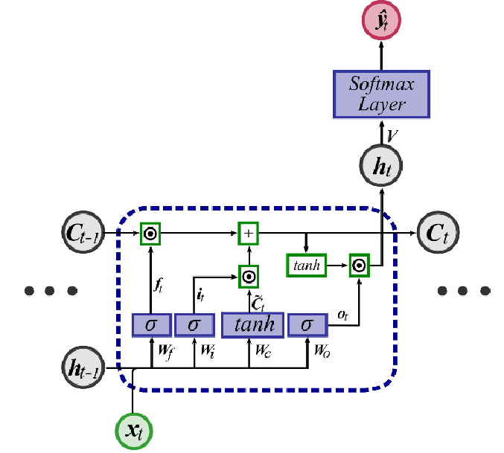

Problem Definition

In this project we are trying to predict the emotion that is positive or negative emotion for a statement.

Platform Requirements
speechrecognition
python3-pyaudio
pyaudio
pyttsx3

Modular Description

Modules present in code

1).Importing required Libraries

2).Getting the dataset

3).Removing useless columns

4).Changing the remaining data values into integers from strings

5).Data processing by removing stop words and getting root words using PottersStemmer

6).Remove special characters, tags and numbers

7).Splitting the data into train and test datasets in 0:30 ratio

8).Preparing the LSTM model with sigmoid activation function, binary cross entropy loss function and adam optimizer

9).Testing the model with new Data

Source Code

Emotion Detection from Text

import numpy as np
import pandas as pd
import matplotlib.pyplot as plt
df=pd.read_csv(r'F:\Experiences1.csv')
df.head()
df.drop(['User_ID','Browser_Used','Device_Used'],axis=1,inplace=True)
df.head()
df.info()
df.isnull().sum()
# Creating dictionary
dict={'happy':0,'not happy':1}
# Mapping dictionary to Is_Response feature
df['class']=df['Is_Response'].map(dict)
df.head( )
df.drop(['Is_Response'],axis=1,inplace=True)
df.head( )
# Text Preprocessing
from nltk.corpus import stopwords
from nltk.stem.porter import PorterStemmer
import re
ps = PorterStemmer()
corpus = []
for i in range(0, len(df)):
review = re.sub('[^a-zA-Z]',' ', df['Description'][i])
review = review.lower()
review = review.split()
review = [ps.stem(word) for word in review if not word in stopwords.words('english')]
review = ' '.join(review)
corpus.append(review)
corpus[15]
from sklearn.feature_extraction.text import TfidfVectorizer
tfidf=TfidfVectorizer(max_features=10000,ngram_range=(1,3))
tfidf_word=tfidf.fit_transform(corpus).toarray()
tfidf_class=df["class"]
df['class'].value_counts()

def remove_special_chars(text):
for remove in map(lambda r: re.compile(re.escape(r)), [',', ':', "=", "&", ";", '%', '$','@', '%', '^', '*', '(', ')', '{', '}','[', ']', '|', '/', '\\', '>', '<', '-','!', '?', '.',' — ', ' — — ', '#'," ' " ,"\""]):
text.replace(remove, '', inplace=True)
return text

def remove_tags(text):
return re.compile( r' <[^>]+> ').sub(' ', text)

def remove_num(text):
return ''.join(re.sub(r'([0–9+])',' ',text))

final_df=df.copy( )
#remove tags
final_df.Description=final_df.Description.apply(lambda x : remove_tags(x))
#remove numbers
final_df.Description=final_df.Description.apply(lambda x : remove_num(x))
#remove special charcters
remove_special_chars(final_df.Description)

import tensorflow as tf
from keras import preprocessing
import keras
tokenizer = tf.keras.preprocessing.text.Tokenizer(num_words=5000,filters='!"#$%&()*+,-./:;<=>?@[\\]^_`{|}~\t\n',lower=True,split=' ')
tokenizer.fit_on_texts(final_df["Description"])
X = tokenizer.texts_to_sequences(final_df["Description"])
X = keras.preprocessing.sequence.pad_sequences(X,maxlen=100)
print(X[500])#changng into 500
y= df['class']
vocab_size = len(tokenizer.word_index) + 1
vocab_size
import pickle
# saving
with open('tokenizer.pickle', 'wb') as handle:
pickle.dump(tokenizer, handle, protocol=pickle.HIGHEST_PROTOCOL)
from sklearn.model_selection import train_test_split
X_train, X_test, Y_train, Y_test = train_test_split(X, y, test_size=0.3, random_state = 24)
from keras.models import Sequential
from keras.layers import Dense
from keras.layers import Embedding
from keras.layers.recurrent import LSTM
embedding_vector_features=40
model=Sequential()
model.add(Embedding(vocab_size,embedding_vector_features,input_length=100))
model.add(LSTM(100))
model.add(Dense(1,activation='sigmoid'))
model.compile(loss='binary_crossentropy',optimizer='adam',metrics=['accuracy'])
print(model.summary())
history=model.fit(X_train, Y_train, batch_size=32, epochs=20, validation_data=(X_test, Y_test), )
plt.plot(history.history['loss'])
plt.plot(history.history['val_loss'])
plt.title('model loss')
plt.ylabel('loss')
plt.xlabel('epoch')
plt.legend(['train', 'test'], loc='upper left')
plt.show()
plt.plot(history.history['accuracy'])
plt.plot(history.history['val_accuracy'])
plt.title('model accuracy')
plt.ylabel('accuracy')
plt.xlabel('epoch')
plt.legend(['train', 'test'], loc='upper left')
plt.show()
final=df.copy( )
#remove tags
final.Description=final_df.Description.apply(lambda x : remove_tags(x))
#remove numbers
final.Description=final_df.Description.apply(lambda x : remove_num(x))
#remove special charcters
remove_special_chars(final_df.Description)
# New review
string11=''' i had handicapped family and they put us in the very end of the hallway. we stayed on -nd floor the ice machine didnt work. the hallways were extremely dark and the hotel smelled like dog urine and wet dog. our room was pretty dark even with curtains open. the carpets and bedspreads had cigarette burns all over. the refrigerator made a terrible sound at night. i found small roaches in the bathroom. and asked for deoderizer to be sprayed in the room while we were gone. that didnt happen. i needed to use the business center and had to argue to get the key for it on - occasions. the dayshift had given me a receipt with password for it and the night shift says we know nothing about it. they finally gave in & gave me the key. housekeeping couldnt speak english so i had to ask the front desk for our room to smell better. the cont breakfast were dried out donuts. needless to say we went to the double t for all but one breakfast. no mgmt ever helped me out with our problems or would give in on some reimbursement. i did write a letter after we returned and got a letter back thanking me for my comments and now they knew some things needed improved on. i wont stay there again. planning another trip in oct and will be staying at the comfort inn next door'''
# Evaluating trained mode with new review
x_1=tokenizer.texts_to_sequences([string11])
x_1 = keras.preprocessing.sequence.pad_sequences(x_1,maxlen=100)
if(model.predict(x_1)<=0.5):
print("Happy")
else:
print("Not Happy")

# New review
string22=''' We had a lovely suite with a great location to all the tourist areas. We had already checked out the day the blackout occurred and were scheduled to take a night train home. Unfortunately the trains are electric and couldn't get into New York! The staff at the Wyndham were great. They checked us back in and gave us a room with a view, helped us find out about Amtrak, etc. As it turned out the next AM there were still no trains South (and by now a lot of people had been flying into Logan because NYC was closed) but we did find out trains were running out of Manhattan South (we needed to get the Wilmington, Delaware). It was like the Amazing Race! Everyone trying to get out of town. We ended up taking a Greyhound to NYC and were able to get a train home. It cost us about an additional $---- but it could have been worse. Only down side was the staff didn't know much about the package deal I booked which was supposed to include nightly popcorn and sodas for the kids. ALso I was charged $--.-- for a - min phone call home (I stupidly left my calling card at home). I would recommend this Hotel to anyone!'''
# Evaluating trained mode with new review
x_2=tokenizer.texts_to_sequences([string22])
x_2= keras.preprocessing.sequence.pad_sequences(x_2,maxlen=100)
if(model.predict(x_2)<=0.5):
print("Happy")
else:
print("Not Happy")

OUTPUT SCREENSHOT

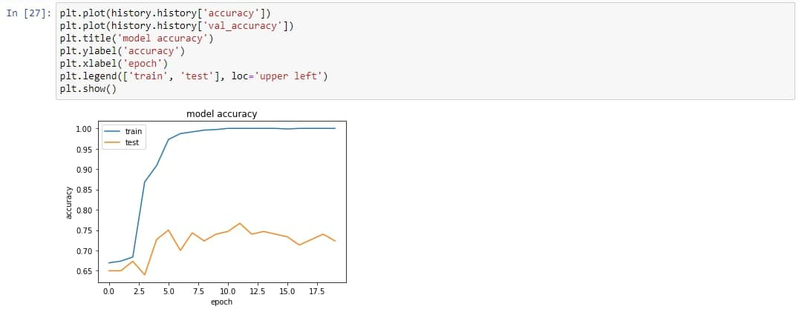

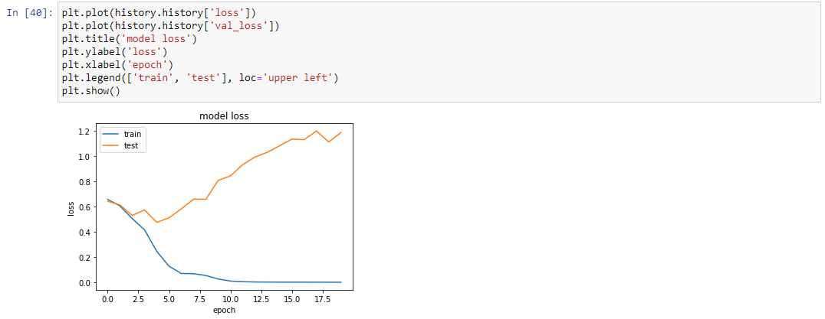

Input:‘’i had handicapped family and they put us in the very end of the hallway. we stayed on -nd floor the ice machine didnt work. the hallways were extremely dark and the hotel smelled like dog urine and wet dog. our room was pretty dark even with curtains open. the carpets and bedspreads had cigarette burns all over. the refrigerator made a terrible sound at night. i found small roaches in the bathroom. and asked for deoderizer to be sprayed in the room while we were gone. that didnt happen. i needed to use the business center and had to argue to get the key for it on - occasions. the dayshift had given me a receipt with password for it and the night shift says we know nothing about it. they finally gave in & gave me the key. housekeeping couldnt speak english so i had to ask the front desk for our room to smell better. the cont breakfast were dried out donuts. needless to say we went to the double t for all but one breakfast. no mgmt ever helped me out with our problems or would give in on some reimbursement. i did write a letter after we returned and got a letter back thanking me for my comments and now they knew some things needed improved on. i wont stay there again. planning another trip in oct and will be staying at the comfort inn next door'''

Output: Not Happy

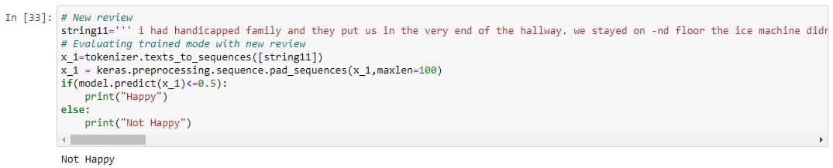

Input: We had a lovely suite with a great location to all the tourist areas. We had already checked out the day the blackout occurred and were scheduled to take a night train home. Unfortunately the trains are electric and couldn't get into New York! The staff at the Wyndham were great. They checked us back in and gave us a room with a view, helped us find out about Amtrak, etc. As it turned out the next AM there were still no trains South (and by now a lot of people had been flying into Logan because NYC was closed) but we did find out trains were running out of Manhattan South (we needed to get the Wilmington, Delaware). It was like the Amazing Race! Everyone trying to get out of town. We ended up taking a Greyhound to NYC and were able to get a train home. It cost us about an additional $---- but it could have been worse. Only down side was the staff didn't know much about the package deal I booked which was supposed to include nightly popcorn and sodas for the kids. ALso I was charged $--.-- for a - min phone call home (I stupidly left my calling card at home). I would recommend this Hotel to anyone!'''

Output:Happy

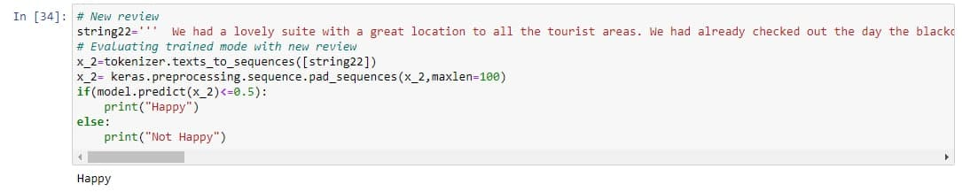

CONCLUSION

After working with various various algorithms and techniques like MLP Classifier and using various tools like pyaudio we came to a conclusion that LSTM gives the answer with highest accuracy and lowest computation requirement.

REFERENCES

https://towardsdatascience.com/text2emotion-python-package-to-detect-emotions-from-textual-data-b2e7b7ce1153

https://data-flair.training/blogs/python-mini-project-speech-emotion-recognition/
https://www.geeksforgeeks.org/python-convert-speech-to-text-and-text-to-speech/

