# 2022 UC Davis Data Challenge

# Proposition 30: Provides funding for programs to reduce air pollution and prevent wildfires by increasing tax on personal income above $2 million

## A-to-ZEV

## Tisura Gamage

## Jean Ji

## Trisha Ramadoss

October 24, 2022

### Background on Proposition 30

The Proposition was introduced in the general election taking place in California on November 8, 2022. The premise of the Proposition is to raise the marginal tax rate on income above $2 million from 13.3% to 15.05% for the period 2023 to 2043[1]. This increase of 1.75% in the marginal tax rate would generate annual revenue between $3 billion and $5 billion, which is dedicated to increasing zero-emissions vehicles (ZEVs) programs and to preventing wildfires in California. Out of the revenues generated by the Proposition, 35% of it will be directed towards funds to increase electric vehicles (EVs) charging infrastructures. Specifically, the Proposition directs the California Energy Commission (CEC) to expand charging infrastructures in disadvantaged communities. For the purpose of this project, we focused on understanding the geographical impacts of the Proposition by estimating the counties where the revenues will likely come from, where the EV chargers are going to be implemented, and how the spatial distribution of EVs chargers implemented under Proposition 30 would benefit the local communities.

### Methods

#### Estimating Revenues

California Franchise Tax board has previous income data based on Adjusted Gross income (AGI) classes as indicated in Table 1. The number of taxable returns by class as well as the total revenue of the taxpayers of that class is available for previous years. For the purpose of this analysis, we are only interested in individuals AGI above $2 million.

Table 1: Income class by number of taxable returns in 2020

|  |  |
| --- | --- |
| **Adjusted Gross income class** | **Number of taxable returns n(i)** |
| $2,000,000 to $2,999,999 | 14,911 |
| $3,000,000 to $3,999,999 | 6,280 |
| $4,000,000 to $4,999,999 | 3,479 |
| $5,000,000 and over | 10,335 |

Once we have data on the number of taxpayers in each AGI bracket for 2020, we computed the total tax revenues generated if Proposition 30 were to pass. We then forecasted it out from 2023 to 2043 at an annual growth rate of 3%.

Number of taxable returns - n(i)

Adjusted Gross Income - AGI

Taxable income > $2 million = l

Revenue forecast from a given class of taxpayers =

Total revenue forecast =

#### Estimating where the revenues come from

The American Community Survey (ACS) provides estimates of how many people in each census tract fall into different income brackets[2]. Using the 2015-2019 5-year estimates, we estimated the number of people per census tract who earn incomes in the highest bracket, over $200,000 annually. From this piece of data, we narrowed down the number of people who earn over $2 million annually by looking at data from the California Tax Franchise Board[3]. We calculated that 2.5% of those earning over $200,000 actually earned over $2 million. Thus, we estimated 2.5% of those in the highest income bracket in each census tract would be impacted by this proposition. We calculated the amount of revenue each tract generates by calculating the proportion of people in the highest reported income bracket who live in a census tract, and then we multiplied by the total revenue generated with this proposition to derive their contribution to the revenues. For example, if a specific tract has 1% of the population of people making over $200,000, then it generated 1% of the revenue from the new tax. We understand that this method is imperfect, and we are likely underestimating the number of millionaires in high-income areas and overestimating in low-income areas, but this is the greatest spatial resolution that’s possible to calculate with currently available public data.

#### Where will the chargers go?

To understand the spatial dimensions of the need for public direct current fast charging (DCFC) stations[4] to support EVs, we first accessed data on existing DCFC chargers in California from the Alternative Fuels Data Center[5]. This database is managed by the U.S. Department of Energy. We then covered a hypothetical radius of 25 miles around each DCFC station to understand the geographical coverage of service from the stations. The 25-mile radius of spatial coverage is partly informed by the proposed guidelines of the National Electric Vehicle Infrastructure (NEVI) formula established by the U.S. Bipartisan Infrastructure Law (signed into law on November 15th, 2021[6]). Almost all the public DCFC in California qualifies as a “corridor charger” because a vast majority of them are within a mile of California’s highway network. Lastly, we obtained data on electric substations from the California Energy Commission and plot them on the same graph as the existing DCFC stations[7]. The purpose of plotting electric substations is for the ease of identifying gaps between where DCFC chargers are currently located and where they can be implemented because an existing electric substation already exists and can support the interconnection between the charger and the grid.

### Findings

#### Total estimated revenue

In 2023, we estimated the revenue to be approximately $3.2 billion. Rising at an annual rate of 3%, the estimated revenues are expected to reach $5.5 billion by 2043.

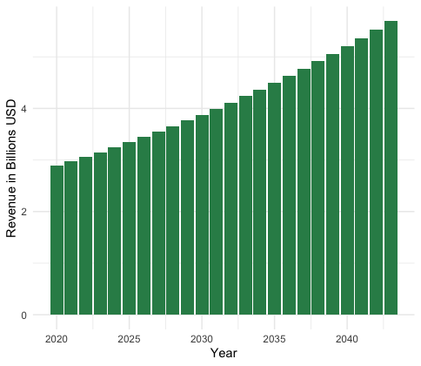

Figure 1. Projected annual revenue from Proposition expects to reach $5.5 billion in 2043.

#### Geographical distribution of millionaires

The geographical hotspots of millionaires are census tracts where most tax revenue is generated. Census tracts in San Francisco, Alameda, Contra Costa, Marin, Santa Clara, Orange, and Los Angeles San Diego counties are most likely to house millionaires.

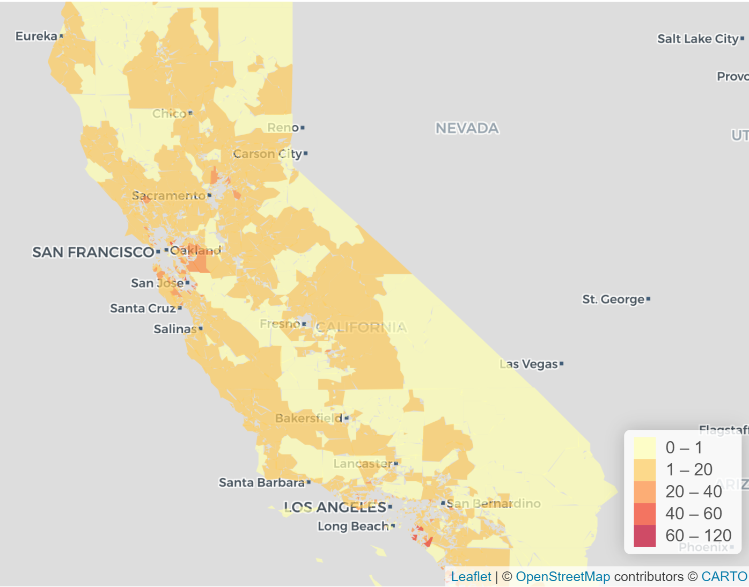

Figure 2. The dark red spots on the map are census tracts where most millionaires reside, and they are concentrated in a few counties of California.

#### DCFC stations and electric substations

Data on publicly available DCFC stations excluded any Tesla chargers since they are only accessible by Tesla drivers. Overlaying electric substations on existing chargers, we could visualize the gap between existing EV charging infrastructures and the policy goals of Proposition 30. Based on Figure 3, we clearly identified areas where DCFC stations are underdeveloped. For instance, the northeastern part of the State has plenty of electrical substations, but no DCFC chargers. We also observed that the current DCFC stations are being implemented in the wealthiest counties, such as San Francisco, Marin, Los Angeles, which indicates an inequity in access to EVs infrastructures.

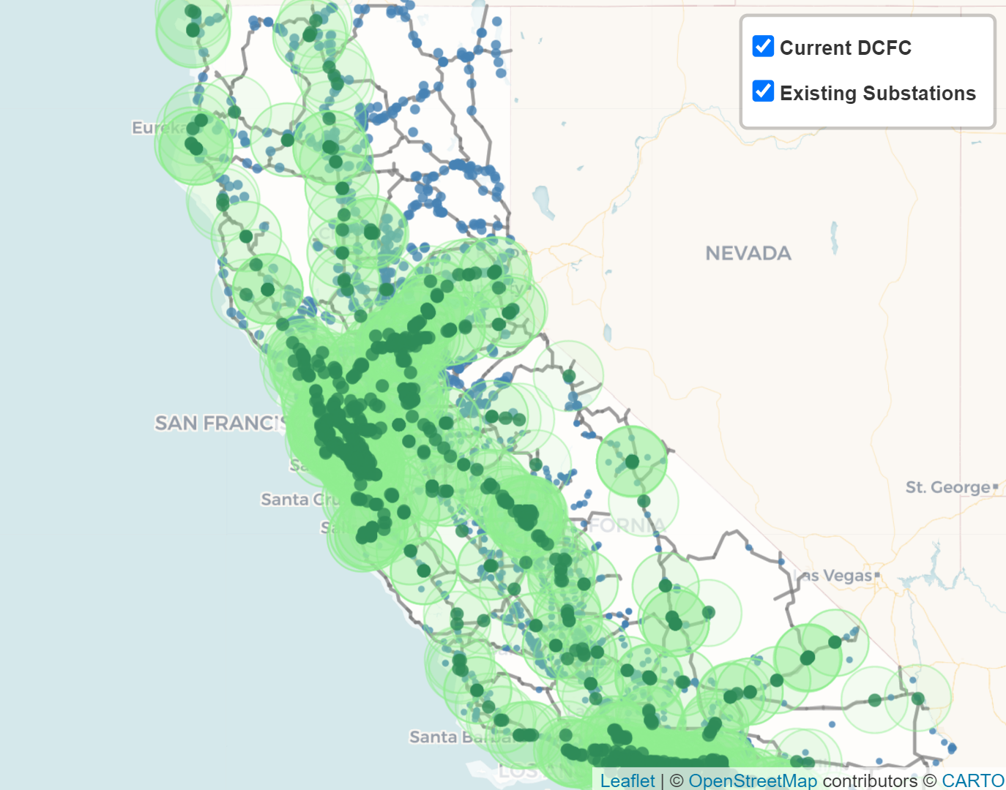

Figure 3. Currently available public DCFC stations with a radius of 25 miles coverage are the green dots with circles around them. Existing electrical substations are the blue dots.

### Conclusion

In conducting the analysis for this project, we demonstrated the geographical impacts of Proposition 30. In terms of revenue generation, we found that the proposition can generate $3 to $5 billion dollars annually between 2023 and 2043. About 35,000 taxpayers will be affected by this tax increase which is about 0.06% of total taxpayers in California. As demonstrated in our visualization, the tax revenues are likely to come from the wealthiest census tracts of California, specifically the ones around the San Francisco Bay Area and the Los Angeles Area. As dictated by the proposition, ZEV infrastructures should be prioritized in underserved areas, and our focus on evaluating the gap between existing DCFC stations and future locations demonstrated that more EV charging infrastructure is needed in rural and lower-income counties, namely the northwestern part of the State.

## Appendix

### Other indicators for identifying where millionaires are likely to reside

Some key metrics that we leveraged to determine where the tax revenues would likely come from are associated with estimating where people who have an annual income of more than $2 million are likely to reside. The first metric that we estimated is the total tax assessed per capita in a given county. To arrive at this metric, we first accessed data from the California Franchise Tax Board on the “Personal Income Tax Statistics: Comparison by County'' for Tax Year 2019[8]. From this data set, we are able to obtain the population of each county and the total tax assessed in each county. The variable: “total tax assessed” is of particular interest to this project because it reveals some information on the total amount of annual incomes of residents in a given county. While it does not directly offer us insights into the number of millionaires residing in different counties of California, it provides us with an understanding of what counties tend to have people of higher income and therefore larger total tax assessed. After obtaining the total tax assessed per county, we then divide this variable by population to get a better understanding of the per capita total tax assessed in order to compare this metric amongst counties.

Table 1. Rankings of the top ten counties in California by total tax assessed per capita in 2019

|  |  |
| --- | --- |
| County | Tax Assessed Per Capita (Thousands) |
| San Mateo | $8.94 |
| San Francisco | $8.52 |
| Marin | $7.95 |
| Santa Clara | $5.87 |
| Alameda | $3.53 |
| Napa | $3.17 |
| Contra Costa | $3.09 |
| Orange | $2.70 |
| Santa Cruz | $2.42 |
| Placer | $2.29 |

Table 1. above demonstrates that most of the wealthy counties as measured by the total tax assessed per capita metric are located in the San Francisco Bay Area, with one county located in the Los Angeles Area and one in the Sacramento area. These ten counties accounted for 50% of the total tax assessed per capita in California, which also supports the argument that more millionaires are likely to reside in these counties.

Another metric that we used to determine whether millionaires are likely to reside in that county or not is the median home price in each county. We obtained this data from the National Association of Realtors for the first quarter of 2022.[9] From this data set, we ranked the first ten counties with the highest median home price and displayed it in Table 2.

Table 2. Rankings of the top ten counties in California by median home prices

|  |  |
| --- | --- |
| County | Median Home Value (Thousands) |
| San Mateo | $1,384 |
| San Francisco | $1,297 |
| Santa Clara | $1,297 |
| Marin | 1,279 |
| Santa Cruz | $1,066 |
| Alameda | $966 |
| Orange | $932 |
| Napa | $881 |
| Santa Barbara | $879 |
| Monterey | $846 |

Across the two metrics used to determine where millionaires are likely to reside in California, eight counties are among the top ten counties in both cases. They are San Mateo, San Francisco, Santa Clara, Marin, Santa Cruz, Alameda, Orange, and Napa County. This trend provides us with some confidence in using these two metrics, since most of the top ten counties are observed under both metrics.

The last metric that we used to estimate whether millionaires are likely to reside in a county or not is the number of museums per county. Museums are often present in neighborhoods where people living in the neighborhoods have disposable income and leisure time to partake in such an activity. The data on number of museums per county across the United States is found on the website of the Institute of Museum and Library Services.[10] For comparison among different counties, we compute the metric: number of museums per square mile in each county. We obtained the area data from the California State Association of Counties[11] and the FIPS codes data from the National Weather Service.[12] This metric serves as a proxy for the attractiveness a county is to millionaires who fit the description of having high disposable income and leisure time.

Table 3. The top ten counties in California with the highest number of museums per square mile

|  |  |
| --- | --- |
| County | Number of Museums per Square Mile |
| San Francisco | 0.7 |
| Orange | 0.06 |
| Alameda | 0.05 |
| Los Angeles | 0.04 |
| San Mateo | 0.03 |
| Contra Costa | 0.03 |
| Santa Clara | 0.03 |
| Santa Cruz | 0.02 |
| Marin | 0.02 |
| San Diego | 0.01 |

Among the three metrics used to estimate what counties in California millionaires are likely to reside in, the consistently top-ranked counties are: San Mateo, San Francisco, Santa Clara, Marin, Santa Cruz, Alameda, and Orange County. For the purpose of our project, we are going to assume that most millionaires reside in these seven counties, and therefore, the tax revenues will be coming from these counties.

1. https://calmatters.org/california-voter-guide-2022/propositions/prop-30-income-tax-electric-cars/
2. <https://www.census.gov/programs-surveys/acs>
3. <https://data.ftb.ca.gov/>
4. Chargers with publicly accessible non-Tesla connectors were included.
5. <https://afdc.energy.gov/>
6. Notice of proposed rulemaking (NPRM), National Electric Vehicle Infrastructure (NEVI) Formula Program published on 06/22/2022: <https://www.federalregister.gov/documents/2022/06/22/2022-12704/national-electric-vehicle-infrastructure-formula-program>
7. <https://data.ca.gov/dataset/california-electric-substations1>
8. [Personal Income Tax (ca.gov)](https://data.ftb.ca.gov/stories/s/2it8-edzu)
9. https://www.nar.realtor/research-and-statistics/housing-statistics/county-median-home-prices-and-monthly-mortgage-payment
10. https://www.imls.gov/research-evaluation/data-collection/museum-data-files
11. https://www.counties.org/pod/square-mileage-county
12. https://www.weather.gov/hnx/cafips