
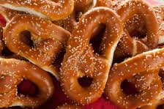
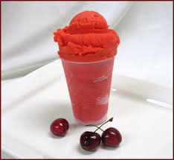
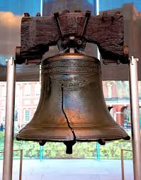
Jackson–Green Family Reunion 2016

The city of Brotherly Love welcomes the Jackson-Green Family
The 18th bi-annual Jackson-Green Reunion will be held in Philadelphia, Pennsylvania on August 4-7, 2016.

Issue: 18th

Contents
2
3

4
Hotel Information
Registration
Family Activities
Jackson-Green Family Reunion
Est. 1982

Philadelphia Jackson-Green Reunion Contacts
  - Website: jgreunion.com
  - Email: administrator@jgreunion.com.
- Address: 5643 Broomall St Philadelphia, PA 19143

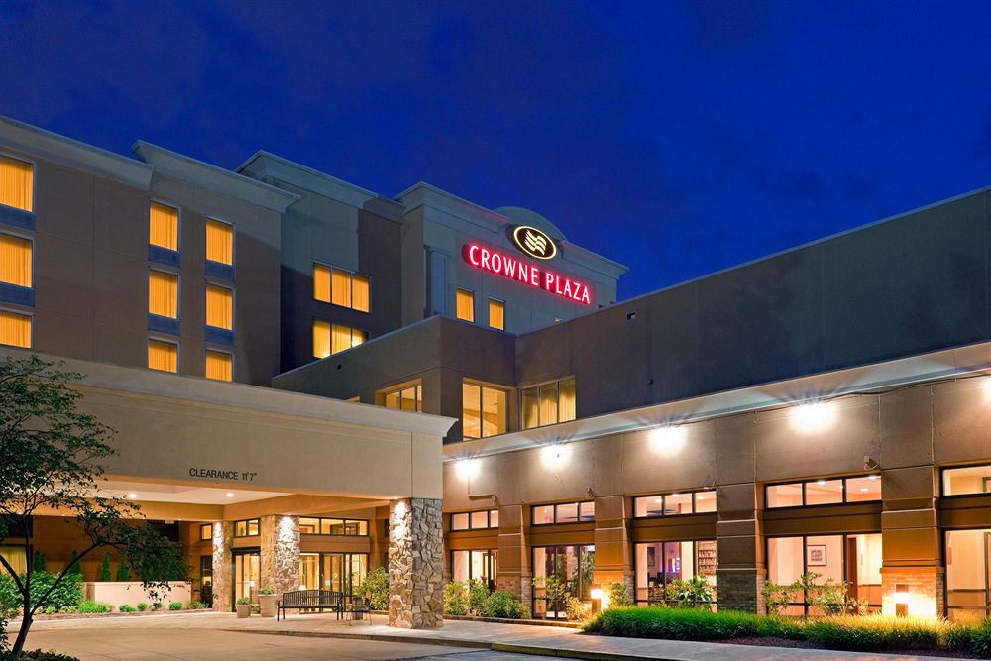
4700 Street Road Feasterville-Trevose, PA 19053 Ph: 215-364-2000
Room Rate: $109 per night plus tax for a standard room. Call for additional information on room upgrades.
*Reserve your room by visiting jgreunion.com*
Hotel Features:
Complimentary Wifi
Free Parking
Microwave/Refrigerator in guest room
Fitness Center
Swimming Pool
Sofa-Bed
Rollway Bed/Cot
Electronic Check Out Out

R
Blackout Drapes
Complimentary High-Speed Internet - Wireless & Wired
Internet Dataport
Complimentary Toiletries
Premium Cable Channels
Microwave
Refrigerator
Iron/Ironing Board
Work Desk With Lamp
Desk Level Electrical Outlet
Coffee/Tea Maker
Pay-Per-View Movies
Video Games Available
Two-Line Cordless Phone With VoicemailHousekeeping
Hairdryer
Crowne Plaza Sleep Advantage Program
Spacious Bathroom
Free Local Phone Calls
Complimentary Newspapers (Monday - Friday)
Crib (Upon Request)
Individually Controlled Air Conditioning
Sofa-Bed
Rollaway Bed/Cot Available
Separate Hanging Closet
Electronic Check Out
Wake Up Calls

Blackout Drapes
Complimentary High-Speed Internet - Wireless & Wired
Internet Dataport
Complimentary Toiletries
Premium Cable Channels
Microwave
Refrigerator
Iron/Ironing Board
Work Desk With Lamp
Desk Level Electrical Outlet
Coffee/Tea Maker
Pay-Per-View Movies
Video Games Available
Two-Line Cordless Phone With VoicemailHousekeeping
Hairdryer
Crowne Plaza Sleep Advantage Program
Spacious Bathroom
Free Local Phone Calls
Complimentary Newspapers (Monday - Friday)
Crib (Upon Request)
Individually Controlled Air Conditioning
Sofa-Bed
Rollaway Bed/Cot Available
Separate Hanging Closet
Electronic Check Out
Wake Up CallsBlackout Drapes
Complimentary High-Speed Internet - Wireless & Wired
Internet Dataport
Complimentary Toiletries
Premium Cable Channels
Microwave
Refrigerator
Iron/Ironing Board
Work Desk With Lamp
Desk Level Electrical Outlet
Coffee/Tea Maker
Pay-Per-View Movies
Video Games Available
Two-Line Cordless Phone With VoicemailHousekeeping
Hairdryer
Crowne Plaza Sleep Advantage Program
Spacious Bathroom
Free Local Phone Calls
Complimentary Newspapers (Monday - Friday)
Crib (Upon Request)
Individually Controlled Air Conditioning
Sofa-Bed
Rollaway Bed/Cot Available
Separate Hanging Closet
Electronic Check Out
Wake Up CallsBlackout Drapes
Complimentary High-Speed Internet - Wireless & Wired
Internet Dataport
Complimentary Toiletries
Premium Cable Channels
Microwave
Refrigerator
Iron/Ironing Board
Work Desk With Lamp
Desk Level Electrical Outlet
Coffee/Tea Maker
Pay-Per-View Movies
Video Games Available
Two-Line Cordless Phone With VoicemailHousekeeping
Hairdryer
Crowne Plaza Sleep Advantage Program
Spacious Bathroom
Free Local Phone Calls
Complimentary Newspapers (Monday - Friday)
Crib (Upon Request)
Individually Controlled Air Conditioning
Sofa-Bed
Rollaway Bed/Cot Available
Separate Hanging Closet
Electronic Check Out
Wake Up CallsBlackout Drapes
Complimentary High-Speed Internet - Wireless & Wired
Internet Dataport
Complimentary Toiletries
Premium Cable Channels
Microwave
Refrigerator
Iron/Ironing Board
Work Desk With Lamp
Desk Level Electrical Outlet
Coffee/Tea Maker
Pay-Per-View Movies
Video Games Available
Two-Line Cordless Phone With VoicemailHousekeeping
Hairdryer
Crowne Plaza Sleep Advantage Program
Spacious Bathroom
Free Local Phone Calls
Complimentary Newspapers (Monday - Friday)
Crib (Upon Request)
Individually Controlled Air Conditioning
Sofa-Bed
Rollaway Bed/Cot Available
Separate Hanging Closet
Electronic Check Out
Wake Up Calls

Hotel: Crown Plaza of Bucks County

Directions To Hotel

Philadelphia & South.
Follow I-95 North to Street Road (Route 132 West) Exit #37. Turn left on to Street Road and proceed five miles. The hotel will be on your left.

From Trenton/Lawrenceville/Princeton & North.
Follow I-95 South to Street Road (Route 132 West) Exit #37. Turn right on to Street Road and proceed five miles. The hotel will be on your left.

From Pennsylvania Turnpike.
PA Turnpike to Exit 351 and stay to right after toll to Route 1 South. Take first exit for Street Road West RT 132 and proceed one mile. The hotel will be a ½ mile on your left.

From New York City & New England
Take I-95 South to New Jersey Turnpike South. Use Exit 6 of the NJ Turnpike for the Pennsylvania Turnpike. Follow the direction from the PA Turnpike

Transportation to Hotel
- Philadelphia International Airport (PHL) - 28 miles
- Philadelphia 30th Street Train Station- 22 miles
- Trevose Train Station - 1.6 miles (Free Hotel Shuttle)


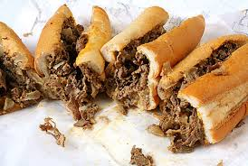

Registration and Payment Options:
- Paper Registration and Payment
  - Mail registration form and checks to Mr. & Mrs. Lorenzo Jackson at 5643 Broomall Street Philadelphia, PA 19143
Make checks payable to Jackson-Green Family Reunion
- Electronic Payment and Payment
  - Online registration form can be completed on the Jackson/Green Reunion Website at jgreunion.com/philly2016.php
  - Electronic invoices will be email after completion of the online registration form.
  - Downloaded forms can be emailed to administrator@jgreunion.com.

Family Reunion Fees:
(Covers: T-shirt, Family Picnic and Family Banquet)
Adults- $100.00
Youth (6-16 yrs.) $75.00
Children (2-6 yrs. old)- $20.00


Philadelphia Jackson-Green Family Reunion

Itinerary:

Thursday, August 4th

12pm- Reunion Check in starts

6-8pm- Meet and Greet (Hospitality Suite)

6-8pm- Line Dancing Fun

Friday, August 5th

12-6pm- Neshimany State Park

Family Picnic

(Family, Fun, and Food!!)

6pm- until- Enjoy Philadelphia Night Attractions

(see bottom of page)

Saturday, August 6th

Enjoy Philadelphia during the day

(see bottom of page)

7-10pm- Family Banquet

Attire: Black and Gold

Sunday, August 7th

10am-12pm- Church Service

On Friday evening and Saturday morning, you are free to partake in the many Philadelphia activities. We have included activates you can choose from. Some places (Philadelphia Zoo, Sesame Place and Philly Bus Tour) the committee will set up group rates, if enough people show interest in going.

Friday Evening and Saturday Morning
* Parx Casino
*Philadelphia Zoo *Franklin Mills Mall
*Sesame Place
*Skyzone Trampoline Park
*Arnold’s Family Fun ( bowling, Go-carts)
*Philadelphia Bus Tour
*Movie Tavern ( Dinner & a Movie)
* Downtown Philly (Shopping, South St)

